Zenith uncovers a never-before-seen prototype dial for the special Chronomaster Revival Manufacture Edition.

2019 was a year of commemoration for the El Primero, the world’s first automatic high-frequency chronograph movement, which marked its 50th anniversary last year. While the anniversary is over, Zenith continues to celebrate the venerable calibre with a number of new and exclusive watches. For its first Manufacture Edition, Zenith has reproduced a previously unknown prototype dial of its most iconic chronograph. The Chronomaster Revival Manufacture Edition is exclusively available on Zenith’s newly launched e-commerce platform, as well as to visitors of the Zenith Manufacture in Le Locle.

Like a time capsule sheltered from our ever-changing world, the grenier or attic of the Zenith Manufacture is a special place indeed, with many secrets still being uncovered today. While going through the grenier or attic of the main historical Zenith Manufacture building last year during the El Primero’s 50th anniversary, an unexpected discovery was made.

There in the attic, among the countless artifacts and pristinely preserved tools that the heroic Charles Vermot had hidden away in the 1970s during the quartz crisis, a small, unassuming and unlabeled box was uncovered. In it, remarkably preserved after decades, were a number of dials: The signature El Primero tri-color dial of the A386 that became a design icon, and more remarkably, another version of the tri-color dials, using three different shades of blue. No records exist of these presumably prototype blue tri-color dials, but considering that they were kept with prototype dials of the A386 in the same configuration it was commercialized in 1969, one can assume that is was part of the original prototype dials for the A386, and that Charles Vermot himself hid them in the attic along with all the other El Primero tools. We may never know if the dial with three shades of blue was intended as an alternative to the A386’s dial or intended for a different model, but its striking beauty and intriguing history compelled the watchmakers at Zenith to finally put it into production.

To bring this prototype to life, it was only appropriate that Zenith produces it as a Revival piece. The 38mm stainless steel case with pump-style pushers is an exact reproduction of the A386 from 1969, using the blueprints of the original to preserve the proportions of the iconic chronograph. What makes this edition significant and even more unique is that the Chronomaster Revival Manufacture Edition is in fact the final version of the A386 available with the original “Revival” case. Beating within it is the same movement it would have had if it was made in 1969, the venerable El Primero high-frequency automatic chronograph with column wheel.

As a Manufacture piece, this revival edition is intended to be an exclusive piece, available uniquely to visitors of the Zenith Manufacture. Nonetheless, given the current situation, which does not allow to offer tours of the manufacture, Zenith is making the Manufacture Edition available on e-commerce, giving customers the opportunity to purchase the watch until the Manufacture reopens to the public for visits. The e-commerce site will be rolled out gradually across different markets, starting with Italy, France and Switzerland in May, followed by Germany, Spain, the United Kingdom and then in United States. The watch comes in a special packaging, mimicking a book that can be displayed on a bookshelf and bearing a blueprint of the Zenith manufacture on its cover. It will also include a comic book about Charles Vermot by renowned Swiss cartoonist Cosey, as well as a reproduction of the vintage dial found in the attic.

ZENITH: TIME TO REACH YOUR STAR.

Zenith exists to inspire individuals to pursue their dreams and make them come true – against all odds. Since its establishment in 1865, Zenith became the first watch manufacture in the modern sense of the term, and its watches have accompanied extraordinary figures that dreamt big and strived to achieve the impossible – from Louis Blériot’s history-making flight across the English Channel to Felix Baumgartner’s record-setting stratospheric free-fall jump.

With innovation as its guiding star, Zenith features exceptional in-house developed and manufactured movements in all its watches. From the first automatic chronograph, the El Primero, to the fastest chronograph with a 1/100th of a second precision, the El Primero 21, as well as the Inventor that reinvents the regulating organ by replacing the 30+ components with a single monolithic element, the manufacture is always pushing the boundaries of what's possible. Zenith has been shaping the future of Swiss watchmaking since 1865, accompanying those who dare to challenge themselves and break barriers. The time to reach your star is now.

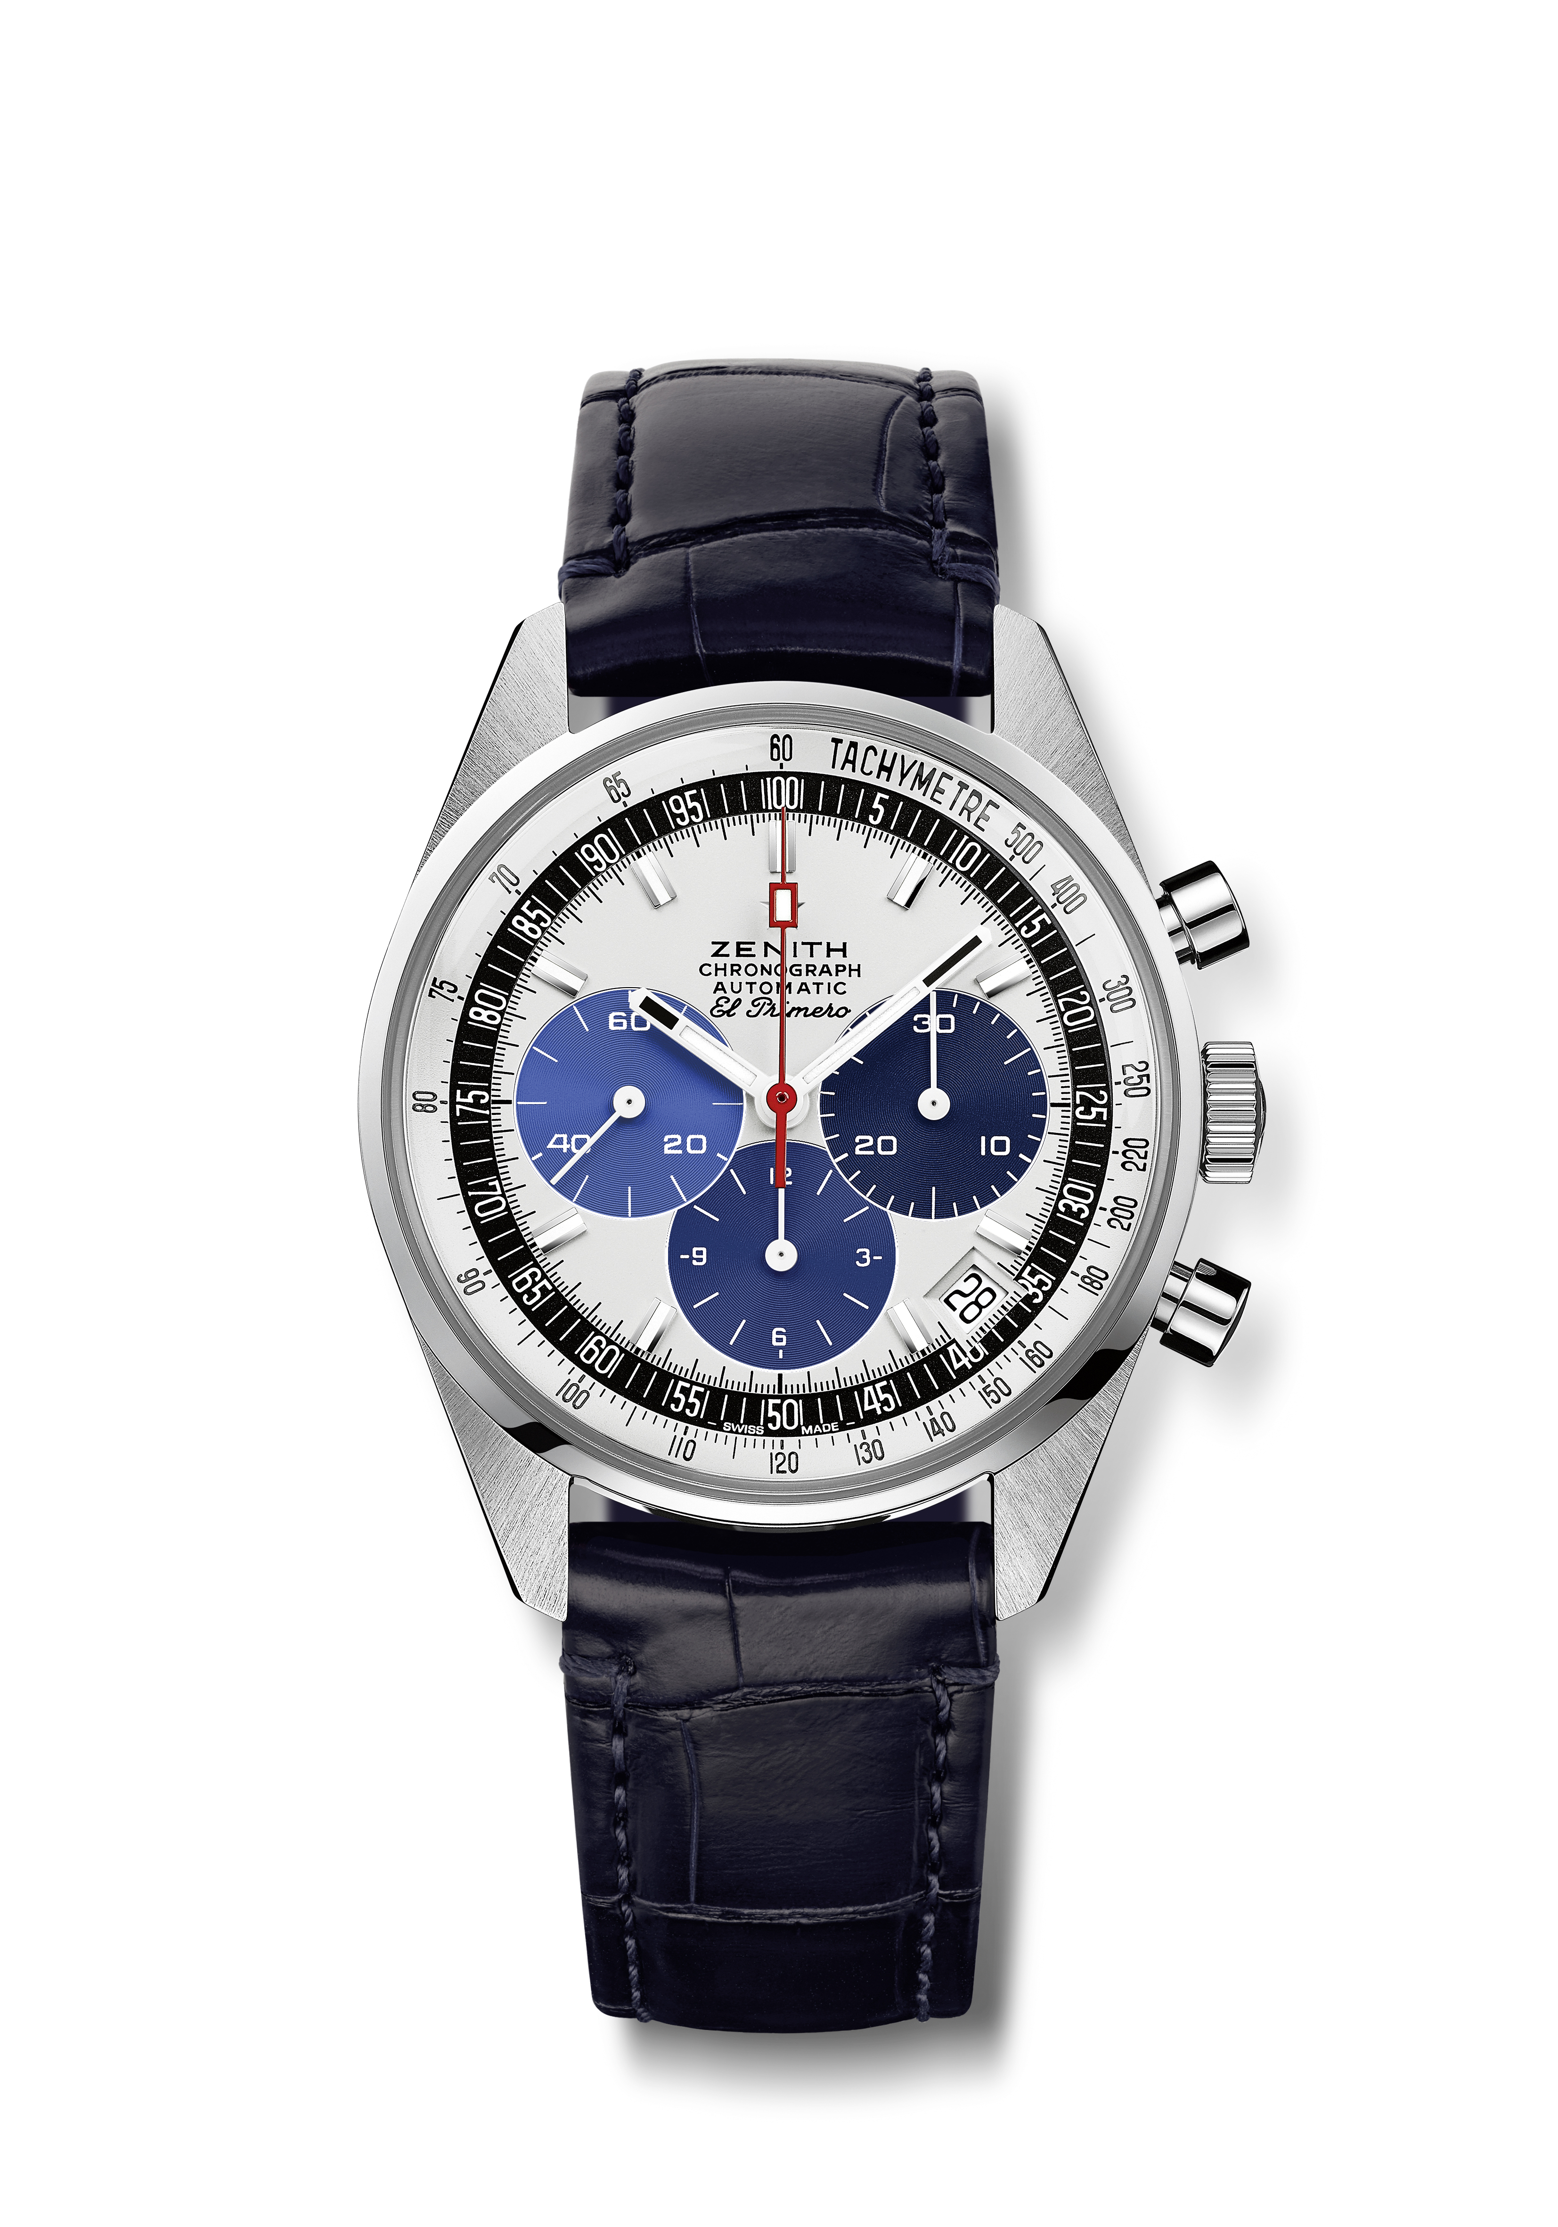
Chronomaster Revival “Manufacture Edition”
Reference: 03.Z386.400/60.C843

Key points: Dial inspired by vintage prototypes never released and found in the attic of the Manufacture. Exclusive Manufacture Edition. Original 1969 case with 38mm diameter, Automatic El Primero column-wheel chronograph
Movement: El Primero 400 Automatic
Frequency: 36,000 VpH (5 Hz)
Power reserve: min. 50 hours
Functions: Hours and minutes in the centre. Small seconds at nine o’clock. Chronograph: central chronograph hand, 12-hour counter at six o’clock, 30-minute counter at three o’clock. Tachymetric scale. Date indication at 4:30.
Case: 38-mm
Material: stainless steel
Dial: White-lacquered dial with three shades of blue counters
Water-resistance: 5 ATM
Price: 8900 CHF
Hour-markers: Rhodium-plated, faceted and coated with Super-LumiNova®SLN C1
Hands: White, faceted and coated with Super-LumiNova®SLN C1
Bracelet & Buckle: Blue alligator leather strap with protective rubber lining. Stainless steel pin buckle.

