ZENITH EXPLORES A NEW SPECTRUM OF COLOUR WITH THE FIRST VIOLET CHRONOGRAPH MOVEMENT: DEFY 21 ULTRAVIOLET

If all the colours that our eyes can perceive are to be considered as frequencies of visible light, then violet has the highest frequency of them all, beyond which is invisible ultraviolet light. It was only natural to pair this intense, energetic colour with the highest-frequency chronograph in regular production, the DEFY 21.

In past centuries, violet was coveted as the most sought-after colour dye for garments, the production of which was a closely held secret by certain civilizations such as the Phoenicians. Its rarity and compelling beauty made it the stuff of royalty. Today, violet tones portray a sense of daring, confidence and whimsy, from sports cars to bespoke tailoring. Yet in the world of watchmaking, violet remains a rarity.

A world-first in watchmaking, Zenith has treated an automatic chronograph movement in the regal, opulent tones of violet. Not just any chronograph, Zenith chose its revolutionary 1/100thof a second El Primero 21 chronograph calibre beating at an incredible frequency of 50Hz as the canvas for this visually and mechanically striking creation.

Visible through the open dial, which features three grey chronograph registers and a grey flange ring, the vibrant violet movement is accentuated by the DEFY 21’s uniquely avant-garde movement conception and design with open, angular bridges. A white-tipped central 1/100th of a second chronograph hand makes a complete revolution above the dial in one second. Besides the DEFY 21 El Primero 50th Anniversary edition, which was only available as a box-set with two other watches, the DEFY 21 Ultraviolet is the first stand-alone DEFY 21 with an open dial paired with closed chronograph counters.

Allowing the purple-treated bridges of the movement to truly stand out while providing a more striking contrast, the faceted 44mm case of the DEFY is given an entirely matte sandblasted finish, bringing out the darker metallic nuances of titanium. Complementing the tones of the open movement, which can shift from warm violet to cool purple tones, the black rubber strap features a violet insert that mimics the look of woven textile.

ZENITH: TIME TO REACH YOUR STAR.

Zenith exists to inspire individuals to pursue their dreams and make them come true – against all odds. Since its establishment in 1865, Zenith became the first watch manufacture in the modern sense of the term, and its watches have accompanied extraordinary figures that dreamt big and strived to achieve the impossible – from Louis Blériot’s history-making flight across the English Channel to Felix Baumgartner’s record-setting stratospheric free-fall jump.

With innovation as its guiding star, Zenith features exceptional in-house developed and manufactured movements in all its watches. From the first automatic chronograph, the El Primero, to the fastest chronograph with a 1/100th of a second precision, the El Primero 21, as well as the Inventor that reinvents the regulating organ by replacing the 30+ components with a single monolithic element, the manufacture is always pushing the boundaries of what's possible. Zenith has been shaping the future of Swiss watchmaking since 1865, accompanying those who dare to challenge themselves and break barriers. The time to reach your star is now.

DEFY 21 ULTRAVIOLET Reference: 97.9001.9004/80.R922

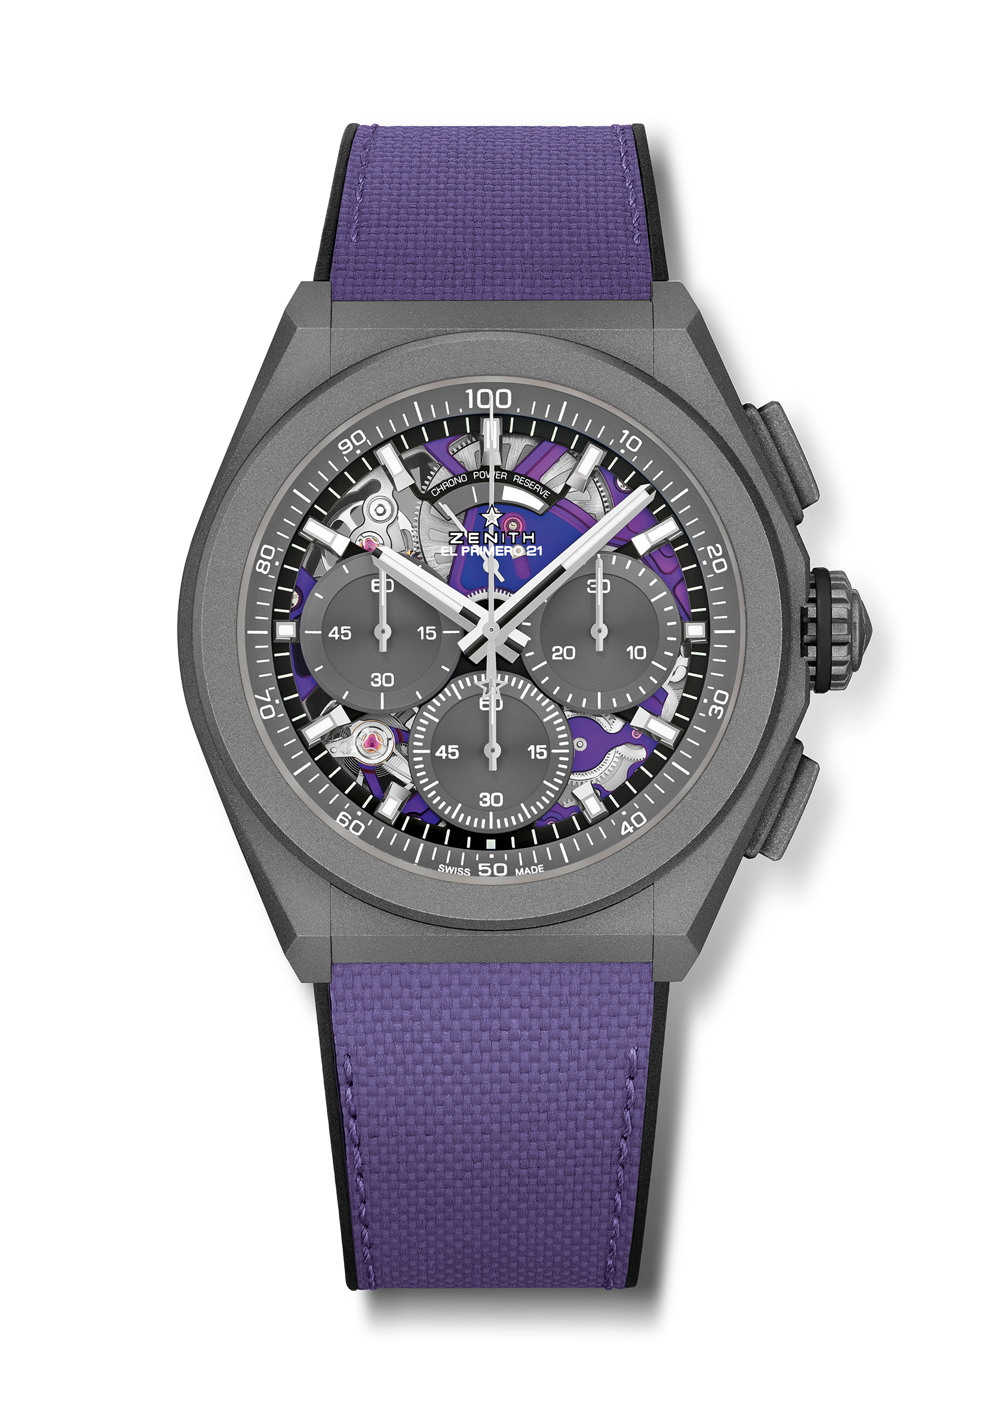
Key points: Unique Violet 1/100th of a second chronograph movement. Exclusive dynamic signature of one rotation per second. 1 escapement for the Watch (36,000 VpH - 5 Hz); 1 escapement for the Chronograph (360,000 VpH - 50 Hz).Special linear power reserve indicator. TIME LAB Chronometer certified.
Movement: El Primero 9004 automatic – Ultraviolet finishings
Frequency 36,000 VpH (5 Hz)
Power reserve approx. 50 hours
Functions : 1/100th of a second chronograph functions. Chronograph power-reserve indication at 12 o'clock. Hours and minutes in the centre. Small seconds at 9 o'clock, Central chronograph hand, 30-minute counter at 3 o'clock, 60-second counter at 6 o'clock
Price 13400 CHF
Material: Microblasted Titanium
Water resistance: 10 ATM
Dial: Special open dial with grey closed chronograph registers
Hour markers: rhodium-plated, faceted and coated with Super-LumiNova®SLN C1
Hands : rhodium-plated, faceted and coated with Super-LumiNova®SLN C1
Bracelet & Buckle: Violet fabric effect strap. Microblasted titanium double folding clasp

