ZENITH CELEBRATES FRIEND OF THE BRAND PATRICK MOURATOGLOU’S ULTIMATE TENNIS SHOWDOWN WITH HIS OWN SPECIAL EDITION OF THE DEFY 21

A new era of tennis has begun. Zenith Friend of the Brand Patrick Mouratoglou, outspoken tennis and life coach extraordinaire, has always dreamed of making a name for himself in the world of tennis. His unique energy and tireless vision led him to become one of the most influential and outspoken coaches in the game; training some of the greatest tennis players.

Parallel to Swiss watchmaking, tennis is a sport that places great importance in tradition. And just as Zenith strives to break the boundaries of the past and craft the watchmaking of the future, Patrick Mouratoglou has left a lasting mark on tennis by elevating the game through his unique approach to coaching and the astounding success of the players he has worked with that include Marcos Baghdatis, Grigor Dimitrov and since 2012, Serena Williams. Mouratoglou also mentors a whole new generation of rising tennis stars at his academy like Coco Gauff. Patrick Mouratoglou has reached his star by transmitting his knowledge and passion so that others can reach theirs.

Now, Mouratoglou is reaching another star in his career: The creation of his own tennis league, in a totally new and innovative format that seeks to appeal to a younger, more inclusive demographic while emphasizing the sense of entertainment in the sport. Dubbed the Ultimate Tennis Showdown, the tournament was conceived during the COVID-19 pandemic as a way of bringing tennis to the masses in an unprecedented format that features a lighter code of conduct, where players can bring out more of their personalities on the court. Zenith is proud to support Patrick Mouratoglou in his new endeavour.

“Since many years, I have realized that tennis stands in a danger zone. The world around us has changed, but tennis has failed to adapt to those changes. Although I love it just as it is, it desperately needs to reinvent itself. I decided to turn these challenging times into an opportunity: the opportunity to modernize tennis. This is why I have created UTS, a new independent and innovative tennis league that puts forward suspense, emotion and immersion with the dual objective of attracting a larger audience and younger tennis fans”, said Patrick Mouratoglou of his Ultimate Tennis Showdown.

“Here in Switzerland, tennis is something of a national sport”, said Zenith CEO Julien Tornare. “We’ve all grown up watching local players battle on the court to become global sensations. But today, there is something of a disconnection between younger sports fans and tennis, which is often perceived by them as rigid and elitist. Just like Zenith strives to bring the codes of watchmaking into the 21st century, our dear friend Patrick Mouratoglou is revolutionizing tennis to keep the sport relevant for future generations”.

To celebrate the debut Ultimate Tennis Showdown tournament and Zenith’s burgeoning friendship with Patrick Mouratoglou, a special rendition of its 1/100th of a second chronograph was in order: the DEFY 21 Patrick Mouratoglou edition, featuring a case and bezel crafted in light yet robust carbon, a composite material used in professional tennis rackets, the sleek and sporty chronograph style and performance are not mutually exclusive. The partially open dial with closed chronograph counters are treated in a blue tone, matching the tennis courts of the Ultimate Tennis Showdown tournament. Touches of yellow are applied in the same tone as the ubiquitous tennis ball. For some words of wisdom from the coach himself, the rim of the carbon bezel is engraved and filled in luminescent pigments with a motto Patrick Mouratoglou lives by: “Little details make big difference”.

A limited edition of just 50 pieces, the collaborative DEFY 21 Patrick Mouratoglou edition is slated for a commercial release in November 2020 at Zenith Boutiques around the world as well as the Zenith Online Boutique. Those interested can sign up to receive an alert as soon as the watch is available to purchase online. The winner of the Ultimate Tennis Showdown will be awarded the watch as a commemorative prize. And for the 50 lucky owners of the watch, they will receive the exclusive opportunity to spend one night at the Mouratoglou Academy in the south of France and enjoy a one-on-one training session with Patrick Mouratoglou.

ZENITH: TIME TO REACH YOUR STAR.

Zenith exists to inspire individuals to pursue their dreams and make them come true – against all odds. Since its establishment in 1865, Zenith became the first watch manufacture in the modern sense of the term, and its watches have accompanied extraordinary figures that dreamt big and strived to achieve the impossible – from Louis Blériot’s history-making flight across the English Channel to Felix Baumgartner’s record-setting stratospheric free-fall jump.

With innovation as its guiding star, Zenith features exceptional in-house developed and manufactured movements in all its watches. From the first automatic chronograph, the El Primero, to the fastest chronograph with a 1/100th of a second precision, the El Primero 21, as well as the Inventor that reinvents the regulating organ by replacing the 30+ components with a single monolithic element, the manufacture is always pushing the boundaries of what's possible. Zenith has been shaping the future of Swiss watchmaking since 1865, accompanying those who dare to challenge themselves and break barriers. The time to reach your star is now.

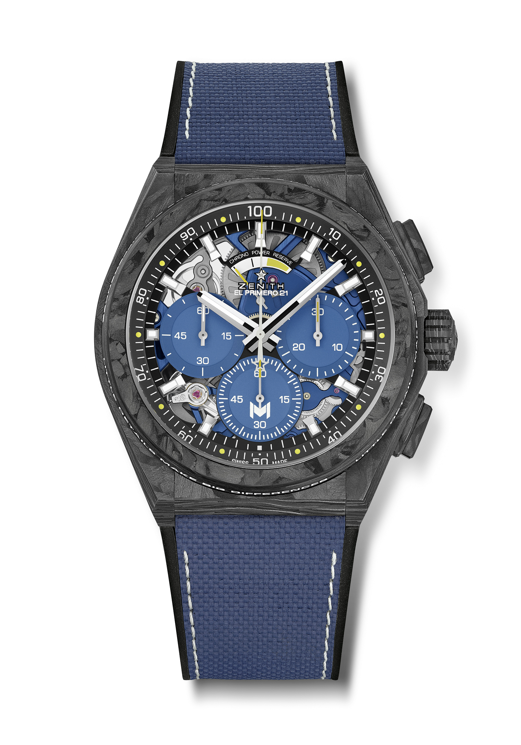
DEFY 21 PATRICK MOURATOGLOU EDITION
Reference: 10.9000.9004/M99.R939

Key points:
Full carbon model: case, bezel, pushers, crown and buckle head.
Bezel adorned with Patrick Mouratoglou’s motto: “Little details make big difference”
This sentence is engraved and filled with SuperLuminova
1/100th of a second chronograph movement.
Exclusive dynamic signature of one rotation per second for the Chrono hand.
1 escapement for the Watch (36,000 VpH - 5 Hz)
1 escapement for the Chronograph (360,000 VpH - 50 Hz).
TIME LAB Chronometer certified.
Limited edition of 50 units
Movement : El Primero 9004 automatic
Frequency 36,000 VpH (5 Hz)
Power reserve approx. 50 hours
Blue colored main plate on movement and rotor
Functions:
Hours and minutes in the centre.
1/100th of a second chronograph with yellow dots recalling tennis balls
Central chronograph hand – one turn per second
30-minute counter at 3 o'clock
60-second counter at 6 o'clock with “M” Mouratoglou logo
Chronograph power-reserve indication at 12 o'clock
Material: Black carbon case and bezel. Bezel filled with SLN
Water resistance: 10 ATM
Dial: Black with 3 blue colored counters inspired from tennis court.
Touch of yellow on the hand of the 6 o’clock counter and on power reserve indication.
Hour markers: Rhodium-plated, faceted and coated with Super-LumiNova SLN
Hands: Rhodium-plated, faceted and coated with Super-LumiNova SLN
Bracelet & Buckle: Black rubber with blue “Cordura effect”.
Titanium double folding clasp with black carbon head
Price 19500 CHF
Ltd Edition of 50 units

