Zenith goes for strikingly bold contrast with the DEFY 21 and DEFY Classic Black & White, two pieces made exclusively for Zenith’s boutiques and online shop.

Black & white is far more than just a choice of tones. It’s an entire design language that echoes towering urban landscapes and edgy art and fashion movements. While the DEFY 21 and DEFY Classic have gone through numerous iterations that incorporate exotic materials and vibrant colors, the Zenith Boutique-exclusive Black & White editions take on a drastically different approach with an achromatic palette.

These on-trend reinterpretations of the two most emblematic models in the DEFY collection emphasize their singularly bold architecture through heavily contrasting black and white tones put forth in an enticing manner, providing a decidedly contemporary yet versatile choice for the style-conscious watch aficionado of today.

Featuring a matte microblasted black ceramic case in 44mm for the DEFY 21 and 41mm for the DEFY Classic, the muted finish enhances the sleek lines of the faceted case as it absorbs light rather than reflect it. The two emblematic DEFY pieces are paired with white ceramic bezels for a sharp contrast, giving way to the three dimensional dials of both models.

On the DEFY 21, a white 1/100th of a second scale and 30-minute chronograph counter appear to seemingly float above the blackened movement. On the DEFY Classic, the ultra-modern open dial with a central star motif is given a similar treatment in this Boutique-exclusive edition, with a white flange ring and a blackened symmetrical open dial. As the finishing touch, a black and white cordura-effect rubber strap completes the theme. For a more understated look, both editions of the DEFY Black & White also come with a second strap in textured black rubber.

The DEFY 21 Black & White and DEFY Classic Black & White are available exclusively at Zenith Boutiques and e-shop from August 31st 2020.

ZENITH: TIME TO REACH YOUR STAR.

Zenith exists to inspire individuals to pursue their dreams and make them come true – against all odds. Since its establishment in 1865, Zenith became the first watch manufacture in the modern sense of the term, and its watches have accompanied extraordinary figures that dreamt big and strived to achieve the impossible – from Louis Blériot’s history-making flight across the English Channel to Felix Baumgartner’s record-setting stratospheric free-fall jump.

With innovation as its guiding star, Zenith features exceptional in-house developed and manufactured movements in all its watches. From the first automatic chronograph, the El Primero, to the fastest chronograph with a 1/100th of a second precision, the El Primero 21, as well as the Inventor that reinvents the regulating organ by replacing the 30+ components with a single monolithic element, the manufacture is always pushing the boundaries of what's possible. Zenith has been shaping the future of Swiss watchmaking since 1865, accompanying those who dare to challenge themselves and break barriers. The time to reach your star is now.

DEFY 21 BLACK & WHITE
Reference: 49.9007.9004/11.R923

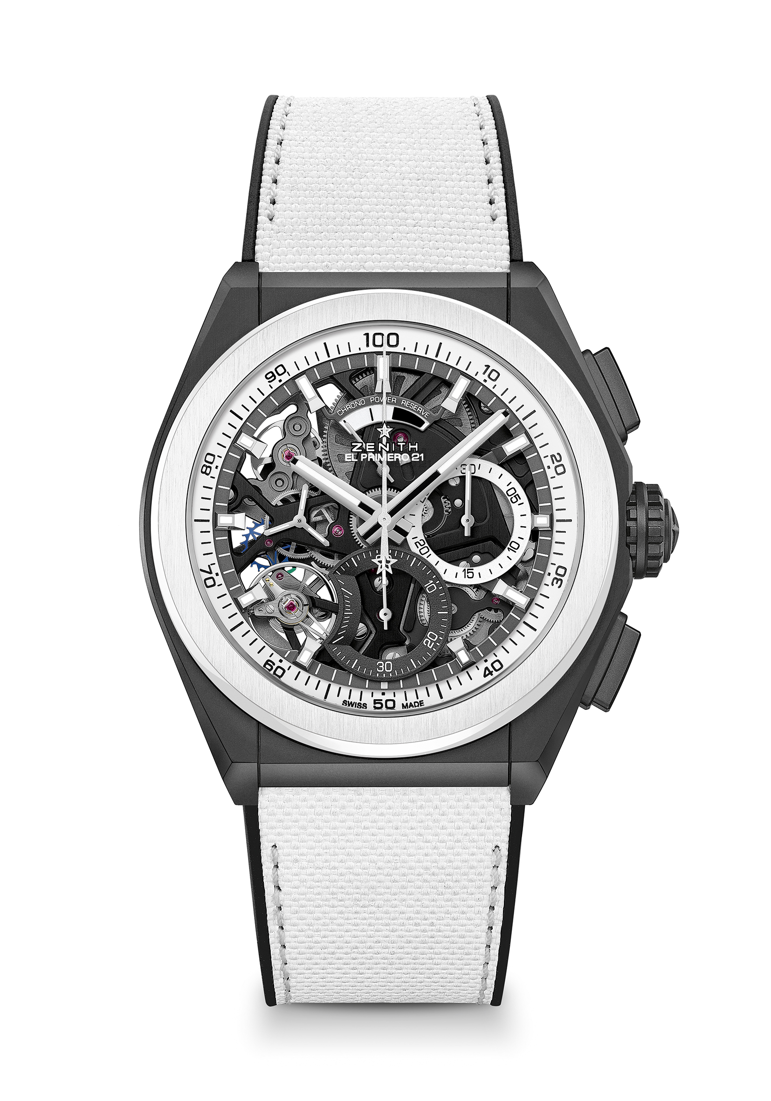
Key points: 1/100th of a second Chronograph movement. Exclusive dynamic signature of one rotation per second. 1 escapement for the Watch (36,000 VpH - 5 Hz); 1 escapement for the Chronograph (360,000 VpH - 50 Hz). TIME LAB Chronometer certified.
Movement: El Primero 9004 automatic
Frequency 36,000 VpH (5 Hz)
Power reserve approx. 50 hours
Functions : 1/100th of a second chronograph functions. Chronograph power-reserve indication at 12 o'clock. Hours and minutes in the centre. Small seconds at 9 o'clock, Central chronograph hand, 30-minute counter at 3 o'clock, 60-second counter at 6 o'clock
Price 13900 CHF
Material: Black matte Ceramic with white ceramic bezel
Case 44mm
Dial: Openworked with two different-coloured counters
Water resistance: 10 ATM
Hour markers: Rhodium-plated, faceted and coated with Super-LumiNova®SLN C1
Hands : Rhodium-plated, faceted and coated with Super-LumiNova®SLN C1
Bracelet & Buckle: Black rubber with white "cordura effect" rubber. Titanium double folding clasp with Black DLC coating.

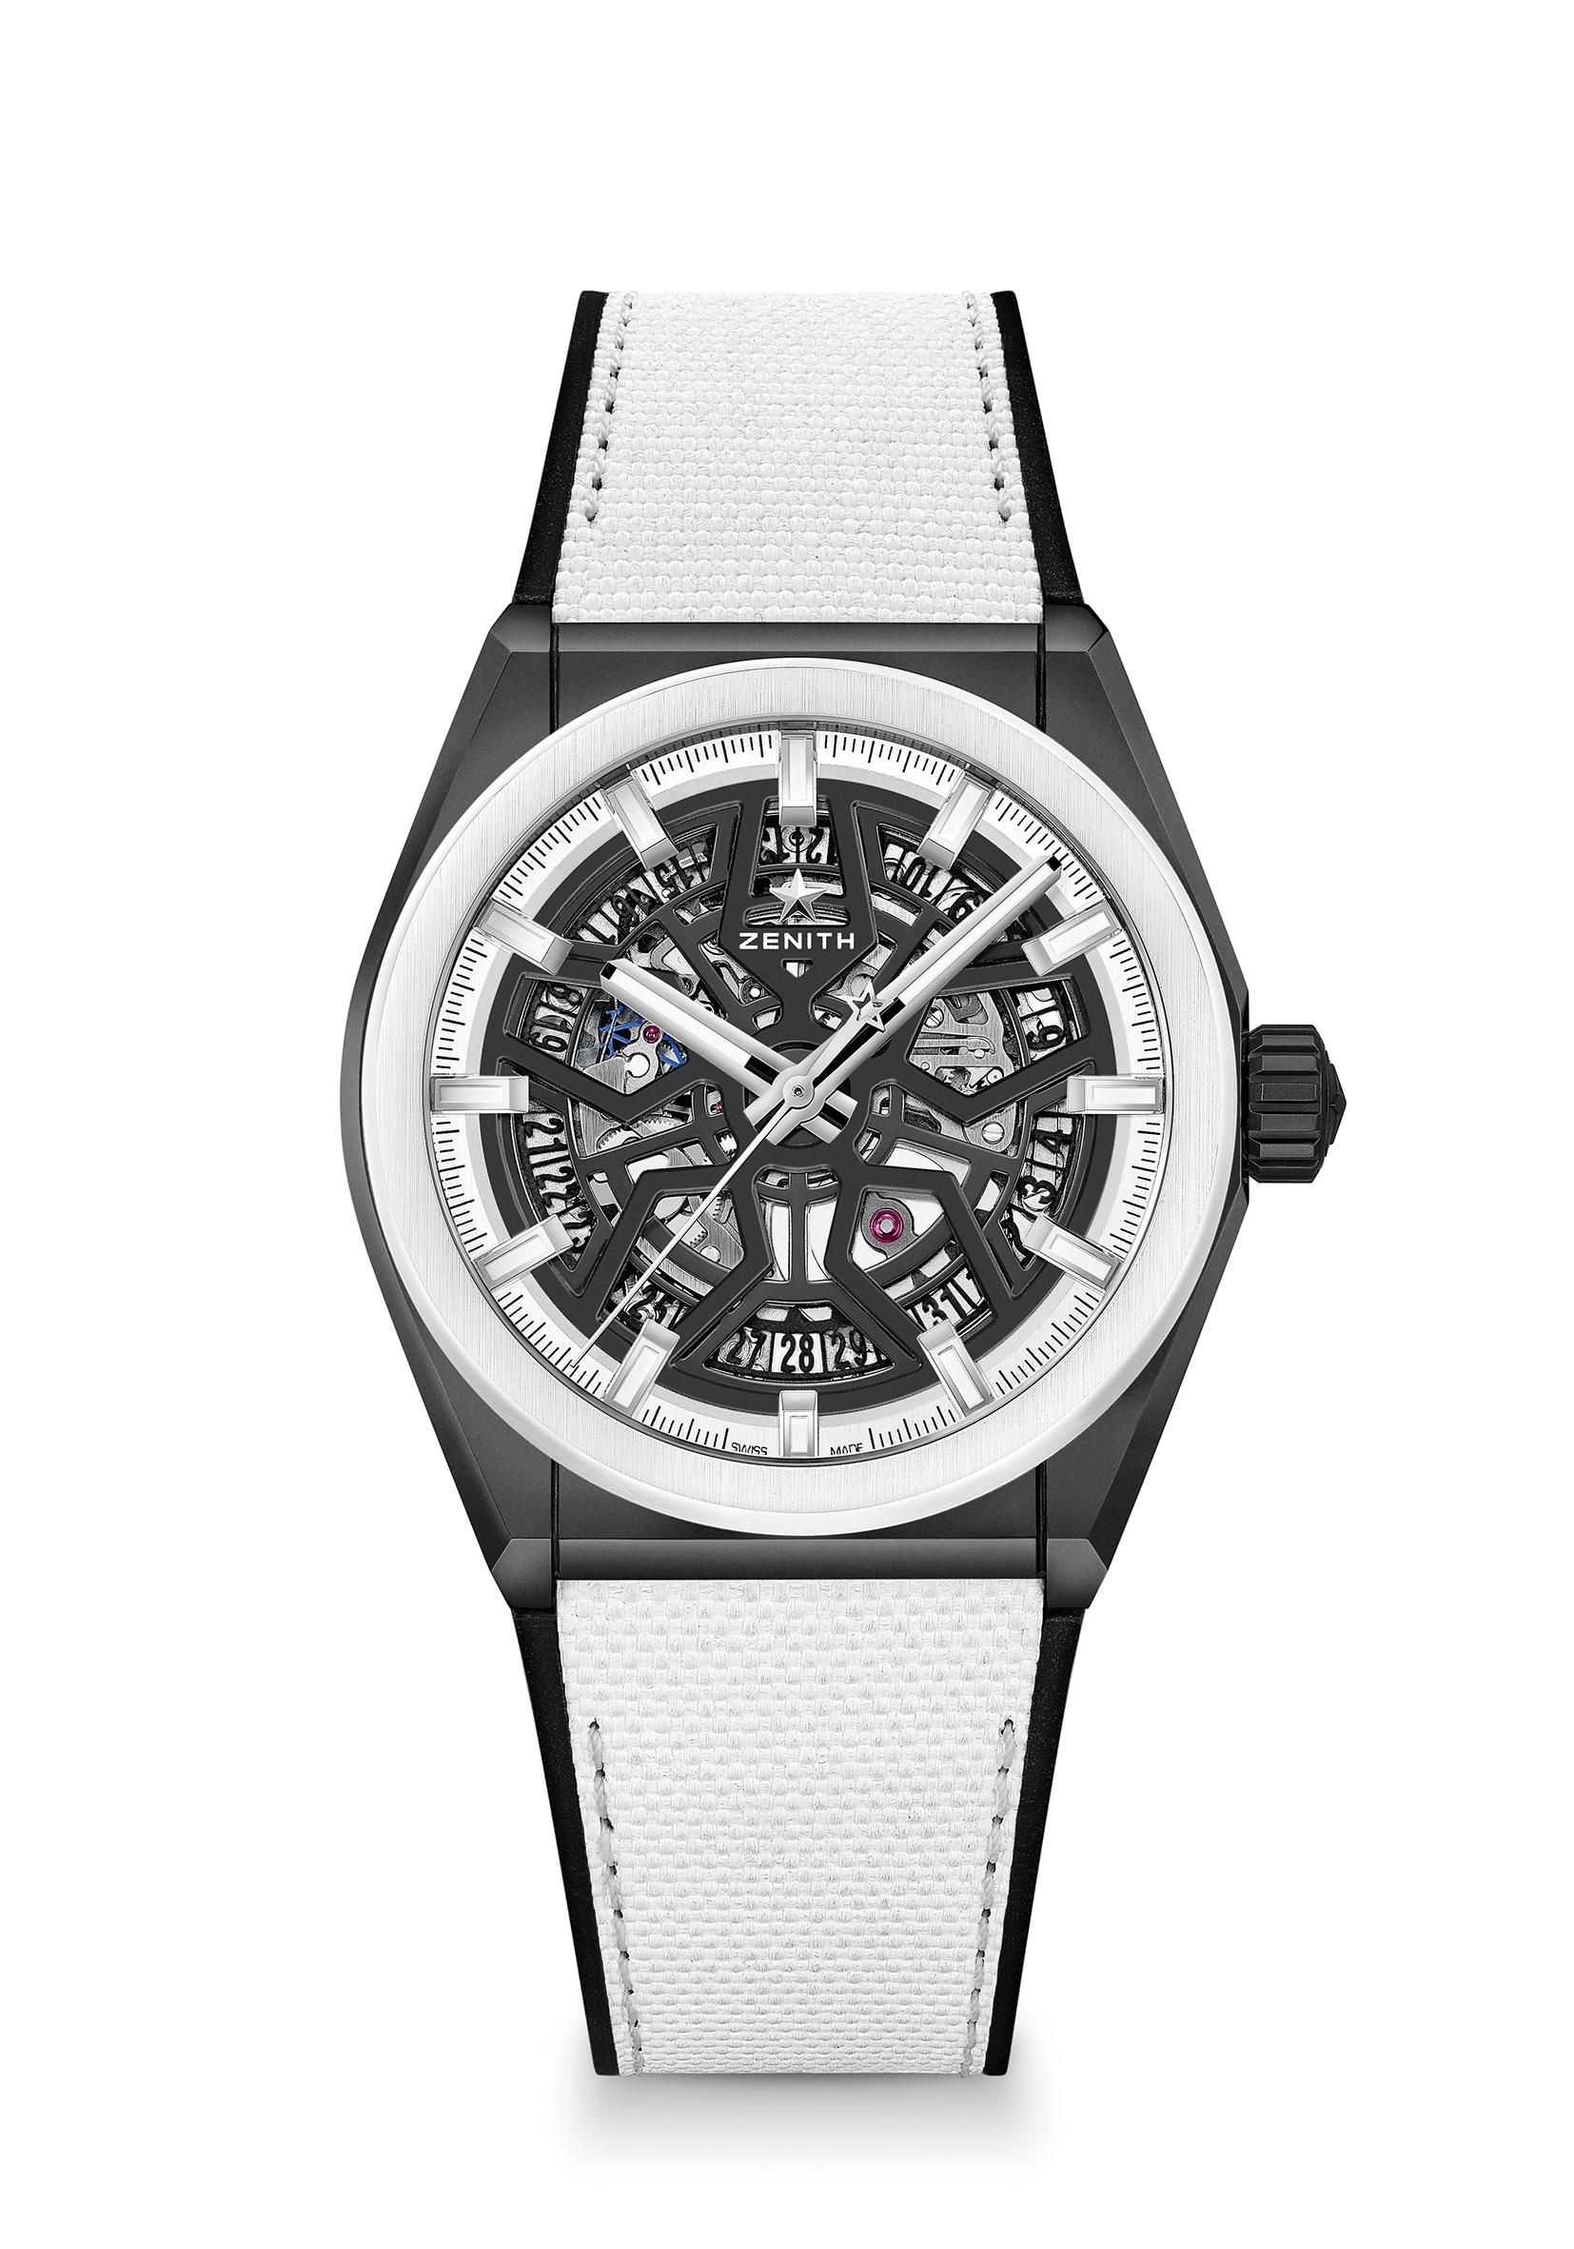
DEFY CLASSIC BLACK & WHITE
Reference: 49.9005.670/11.R943

Key points: 41mm Black Ceramic case. In house Elite skeletonised movement. Silicon escape-wheel and lever.
Movement Elite 670 SK, Automatic.
Frequency: 28,800 VpH (4Hz)
Power-reserve: min. 48 hours
Functions Hours and minutes in the centre. Central seconds hand. Date indication at 6 o’clock
Price 8400 CHF
Material: Black matte Ceramic with white ceramic bezel
Case 41mm
Dial: Black Openworked
Water resistance: 10 ATM
Hour-markers: Rhodium-plated, faceted and coated with Super-LumiNova® SLN C1
Hands: Rhodium-plated, faceted and coated with Super-LumiNova® SLN C1
Bracelet & Buckle: Black rubber with white “cordura effect” rubber. Titanium double folding clasp with Black DLC coating.

