ZENITH UNVEILS THE SECOND EDITION OF THE CHRONOMASTER REVIVAL LUPIN THE THIRD AT THE OPENING OF ITS GINZA BOUTIQUE

TOKYO - Wednesday October 14th 2020: The doors of the new Ginza Boutique officially opened, unveiling the new Chronomaster Revival Lupin The Third – 2nd Edition and introducing Zenith Icons, a curated selection of restored vintage watches.

The new Ginza location is Zenith’s first flagship boutique to showcase the brand’s new concept, placing storytelling as a central element and offering visitors multisensory experience by unfolding the unique tales of Zenith in new and interactive ways. Ideally situated on Namiki Street in Ginza district, Tokyo’s premier luxury shopping area, the Zenith boutique stands out with its atmosphere as well as the services it provides.

Upon entering the boutique, warm neutral tones give way to a central blue element, stretching from the floor to the ceiling and backlit to evoke a starry night sky. Beyond discovering its watches and comprehensive assortment of limited and exclusive editions, the boutique’s “Story Bar” allows visitors to take a moment to relax and delve deeper into the Zenith universe, with videos about its most emblematic watches as well as the individuals from Zenith’s past and present that have made a lasting mark on the Manufacture. Even when the boutique is closed, visitors can launch the immersive 360-degree video experience that takes them on a journey through space and time to the Zenith Manufacture with historical figures such as its founder Georges-Favre Jacot and the saviour of the El Primero Charles Vermot, by simply scanning a symbol of the manufacture on the exterior windows of the boutique.

Zenith Icons reaches its first stop at the Ginza Boutique

The new Zenith Ginza Boutique is also the first to host Zenith Icons, a new concept offering the possibility of acquiring a curated selection of iconic and highly sought-after vintage Zenith watches sourced, restored and certified by the Manufacture and sold exclusively at Zenith’s boutiques. Emblematic chronographs can be expected, with all details of each watch’s provenance thoroughly researched and documented by the Manufacture’s Heritage department.

With an archive spanning Zenith’s entire production since its foundation in 1865, as well as a vast inventory of spare parts, Zenith Icons vintage watches are restored in the very same place that they were originally made and using historical components; a feat very few watch manufactures can claim.

Zenith now invites its customers to discover and shop some of its most significant creations from the comfort and convenience of a Zenith boutique, with the peace of mind in knowing that there can be no doubt about the watch’s provenance and history, and that it has been restored faithfully by the Manufacture with complete traceability.

Lupin the Third – The Second Chapter

In 2019, Zenith launched a watch that one could say was nearly 50 years in the making, the Chronomaster A384 “Lupin The Third”, the first watch ever made to be inspired by a Japanese anime series. After the overwhelming success of the first series and the fact of a second Zenith watch appearance in the anime series Lupin The Third, Zenith is proud to unveil the Chronomaster Revival Lupin The Third – 2nd Edition.

Limited to 200 pieces, the special series is directly inspired by a second appearance of a Zenith watch in the Lupin The Third anime series, seemingly based on an A384 El Primero chronograph and a testament to its wide-reaching significance in the 1970s. It features a white dial with contrasting black chronograph counters; a so-called “panda” dial as colloquially referred to by watch aficionados. It comes on the steel ladder bracelet, just as the original A384 did and as depicted in Lupin The Third. The sapphire display back revealing the El Primero chronograph calibre is engraved with a drawing of Daisuke Jigen, the partner of the title character Lupin III. The Chronomaster Revival Lupin The Third – 2nd Edition is exclusively available at the Zenith Ginza Boutique, before making its way to other Zenith boutiques and e-shop as well as its retailers in the coming weeks.

ZENITH: TIME TO REACH YOUR STAR.

Zenith exists to inspire individuals to pursue their dreams and make them come true – against all odds. Since its establishment in 1865, Zenith became the first watch manufacture in the modern sense of the term, and its watches have accompanied extraordinary figures that dreamt big and strived to achieve the impossible – from Louis Blériot’s history-making flight across the English Channel to Felix Baumgartner’s record-setting stratospheric free-fall jump.

With innovation as its guiding star, Zenith features exceptional in-house developed and manufactured movements in all its watches. From the first automatic chronograph, the El Primero, to the fastest chronograph with a 1/100th of a second precision, the El Primero 21, as well as the Inventor that reinvents the regulating organ by replacing the 30+ components with a single monolithic element, the manufacture is always pushing the boundaries of what's possible. Zenith has been shaping the future of Swiss watchmaking since 1865, accompanying those who dare to challenge themselves and break barriers. The time to reach your star is now.

Chronomaster Revival Lupin The Third – 2nd Edition
Reference: 03.L384-2.400/07.M384

Key points: Creation of the watch depicted in the Original Japanese manga "Lupin the Third". Original 1969 case with 37 mm diameter. Automatic El Primero column-wheel chronograph.
Limited edition of 200 pieces.

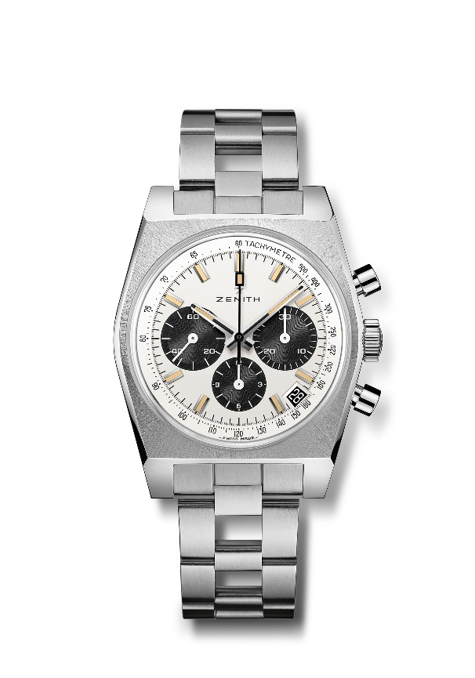
Movement: El Primero 400 Automatic

Frequency: 36,000 VpH (5 Hz)

Power reserve: min. 50 hours

Functions: Hours and minutes in the centre. Small seconds at nine o’clock. Chronograph: central chronograph hand, 12-hour counter at six o’clock, 30-minute counter at three o’clock. Tachymetric scale. Date indication at 4:30.
Case: 37-mm

Material: stainless steel

Dial: White dial with black-coloured counters
Water-resistance: 5 ATM

Price: 9400 CHF
Hour-markers: Rhodium-plated, faceted and coated with beige Super-LumiNova®SLN
Hands: Black rhodium-plated, faceted and coated with beige Super-LumiNova®SLN

Bracelet & Buckle: Stainless steel "ladder" bracelet

