PILOT TYPE 20 BLUEPRINT

Zenith reveals the unseen schematics of its dials in a special rendition of the Pilot Type 20, aptly named the “Blueprint”.

When the team at the Zenith Manufacture came across a blueprint of its historical building, it immediately reminded them of the blueprints they had seen of earliest Aeronefs, the earliest aircrafts conceived by the pioneers of flight, most notably Louis Blériot and his Type XI aircraft that he flew across the English Channel. As the preeminent watchmaker that accompanied the earliest aviators, Zenith sought to highlight their ingenuity in a surprising way with the Pilot Type 20 Blueprint.

There’s something about blueprints that sparks intrigue and curiosity. It’s what translates the wildest dreams into feasible, tangible objects. Typical of production and engineering plans in the mid-19th and early 20th centuries, each element was carefully calculated and precisely drawn as the basis of a project. Now a relic from a bygone era, the blueprint continues to fascinate, and is synonymous with thorough planning and ingenious vision.

When looking at a watch’s dial, one tends to pay attention to the colors, the finish, the shape of the hands and markers, the typography of the numerals, without giving much thought the precise calculations and design considerations that go into making it. And yet, each Zenith dial is meticulously thought out and developed, where no detail is left to chance. The designers at the Manufacture sought to highlight this “unseen” aspect of the dial, by incorporating its production plans directly onto it. Unexpected and captivating, the dial is created in two parts: a matte blue base with all technical plans and notes used by the dial-maker, and above it a sapphire crystal and a sapphire crystal layer with the usual markers and logo. This creates a captivatingly deep visual effect, where the various markings cast a slight shadow on the blue base and give the impression that they’re hovering above the blueprint dial.

Limited to 250 pieces, the Pilot Type 20 Blueprint remains true to the legacy of Zenith’s ubiquitous Pilot watch. The oversized steel case, finished with a mix of polished and satin-brushed surfaces, features the signature oversized “onion” shaped crown that allows the time to be adjusted even while wearing flight gloves. The side of the case features a screwed plaque bearing the unique limited edition number of the watch. Powering this wearable flight instrument is the Elite manufacture automatic movement, providing a minimum autonomy of 50 hours. In a nod to the earliest years of aviation, the blue calfskin leather strap recalls the classic shearling leather flight jacket, with rivets and a titanium pin buckle as well as a distinctive tab one would find on a vintage pilot’s helmet.

ZENITH: TIME TO REACH YOUR STAR.

Zenith exists to inspire individuals to pursue their dreams and make them come true – against all odds. Since its establishment in 1865, Zenith became the first watch manufacture in the modern sense of the term, and its watches have accompanied extraordinary figures that dreamt big and strived to achieve the impossible – from Louis Blériot’s history-making flight across the English Channel to Felix Baumgartner’s record-setting stratospheric free-fall jump.

With innovation as its guiding star, Zenith features exceptional in-house developed and manufactured movements in all its watches. From the first automatic chronograph, the El Primero, to the fastest chronograph with a 1/100th of a second precision, the El Primero 21, as well as the Inventor that reinvents the regulating organ by replacing the 30+ components with a single monolithic element, the manufacture is always pushing the boundaries of what's possible. Zenith has been shaping the future of Swiss watchmaking since 1865, accompanying those who dare to challenge themselves and break barriers. The time to reach your star is now.

Pilot Type 20 “Blueprint”
Reference: 03.2435.679/51.I012

Key points: New 45-MM Brushed steel case, Unique Double layered dial, Case-back engraved with Zenith flying instruments logo, Inspired by the legendary Zenith aviation watches
Limited edition 250 pieces
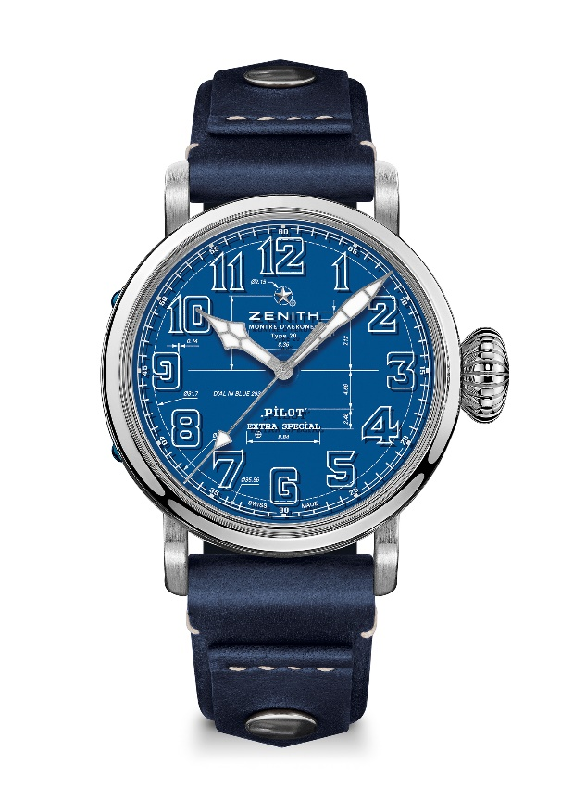
Movement: Elite 679

Frequency: 28’800 VpH (4 Hz)

Power reserve: min. 50 hours

Functions: Hours and minutes in the centre. Central seconds hand
Case: 45-mm

Material: stainless steel

Dial: Double layered dial : 1 Blue dial + 1 Sapphire dial
Water-resistance: 10 ATM

Price: 8400 CHF
Hour-markers: Arabic numerals in white varnish
Hands: Rhodium-plated, faceted coated with SuperLuminova SLN C1

Bracelet & Buckle: Blue calfskin leather strap with rivets, Titanium pin buckle

