DEFY Classic Carbon

Lighter. Bolder. More innovative: Zenith gives a new carbon fiber makeover for the DEFY Classic with an integrated carbon bracelet– a first for an automatic watch.
Zenith has repeatedly demonstrated its mastery of innovative and exceptional materials in the DEFY collection, expressing its vision of the future of watchmaking with groundbreaking pieces. The DEFY Classic Carbon explores uncharted territory of innovation, with a full carbon fiber construction – including the integrated bracelet.

Carbon fiber is prized for its rare combination of lightness and durability as well as its unique and futuristic appearance. Yet its use in watchmaking has been fairly limited. One part in particular has eluded watchmakers: the bracelet. Up until now, so-called carbon fiber watch bracelets have either been superficial plaques of the composite material fixed to a metal base or reserved for a handful of highly complicated watches produced in very small numbers. With the DEFY Classic Carbon, Zenith brings forth an ergonomic and eye-catching solid carbon bracelet to an automatic watch, an unprecedented technical feat and edgy design statement.

Producing a full carbon fiber bracelet required the Manufacture to take on an entirely new set of technical challenges. Weighing a mere 65 grams in total with its carbon bracelet and titanium clasp, the DEFY Classic Carbon sets a new benchmark of precision for Zenith that extends beyond the movement. In relative terms, it weighs almost half as much as an equivalent DEFY Classic model in titanium with a bracelet in the same metal, which is already significantly lighter than traditional metals like stainless steel and gold. Its intriguingly nuanced appearance gives way to a sensation that’s unexpectedly silky and smooth to the touch. It’s incredibly light but balanced weight makes it easy to forget that one is wearing a watch at all.

Following the angular lines of the DEFY Classic case that’s made in the same material, each link in the bracelet is a piece of solid carbon fiber, molded and milled with precision in such a way that it highlights the layers or “strata” of the carbon fiber, while providing superior ergonomics on the wrist. Its lightness, comfort and visual impact are bound to intrigue. Because the patterns are layering of carbon fiber can differ from one component to the next, no two watches will be exactly alike. And for those who prefer the contrast of the carbon fiber case against strap, the DEFY Classic Carbon is also available with a black rubber cordura-effect strap, with a carbon and titanium folding buckle.
The DEFY Classic Carbon’s aesthetic is homogenous with the dark allure of the carbon fiber case and bracelet, emphasizing the unabashedly futuristic and architectural design language of the singular skeleton watch. Highlighted by the open dial with a star-shaped motif, the automatic Elite manufacture calibre has also been given a dark treatment in ruthenium. And in spite of its palette of anthracite and black tones, legibility is guaranteed with bright green Super-LumiNova on the blackened hands and applied hour markers.

The DEFY Classic Carbon will be available at Zenith Boutiques and retailers as well as its online shop from November 2020.

ZENITH: TIME TO REACH YOUR STAR.

Zenith exists to inspire individuals to pursue their dreams and make them come true – against all odds. Since its establishment in 1865, Zenith became the first watch manufacture in the modern sense of the term, and its watches have accompanied extraordinary figures that dreamt big and strived to achieve the impossible – from Louis Blériot’s history-making flight across the English Channel to Felix Baumgartner’s record-setting stratospheric free-fall jump.

With innovation as its guiding star, Zenith features exceptional in-house developed and manufactured movements in all its watches. From the first automatic chronograph, the El Primero, to the fastest chronograph with a 1/100th of a second precision, the El Primero 21, as well as the Inventor that reinvents the regulating organ by replacing the 30+ components with a single monolithic element, the manufacture is always pushing the boundaries of what's possible. Zenith has been shaping the future of Swiss watchmaking since 1865, accompanying those who dare to challenge themselves and break barriers. The time to reach your star is now.

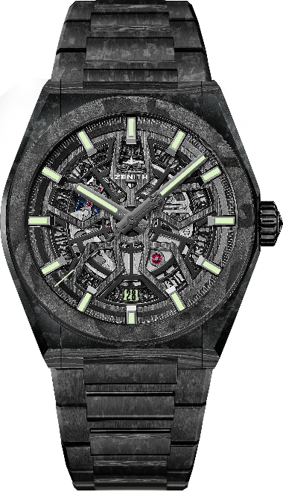
DEFY CLASSIC CARBON
Reference:
10.9001.670/80.M9000 (carbon bracelet)
10.9000.670/80.R795 (rubber bracelet)

KEY POINTS : NEW 41mm Black Carbon case. Available on full carbon bracelet or rubber bracelet. In house Elite skeletonised movement. Silicon escape-wheel and lever. Total watch weight: 65 grams.
Movement: Elite 670 SK, Automatic
Calibre: 11 ½``` (Diameter: 25.60mm)
Frequency: 28,800 VpH (4Hz)
Power-reserve: min. 48 hours
Finishing: Special oscillating weight with satin-brushed finish
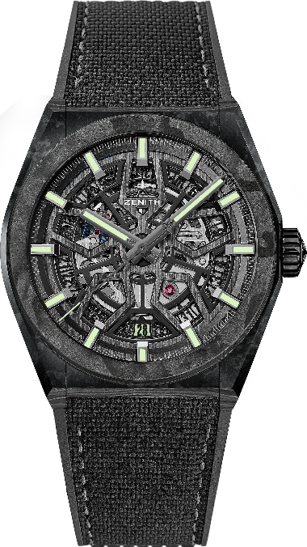
Functions: Hours and minutes in the centre, Central seconds hand, Date indication at 6 o’clock
Price: 19900 CHF on carbon bracelet. 11900 CHF on rubber bracelet.
Material: Carbon
Diameter: 41mm
Dial: Openworked
Case-back: Transparent sapphire crystal
Water-resistance: 10 ATM
Hour-markers: Ruthenium-plated, faceted and coated with Super-LumiNova® SLN C3
Hands: Ruthenium-plated, faceted and coated with Super-LumiNova® SLN C3
Bracelet & Buckle: Full carbon bracelet. Also available on rubber bracelet. Carbon folding buckle.

