FASTER, SLEEKER AND SPORTIER THAN EVER: ZENITH UNVEILS THE CHRONOMASTER SPORT, WITH AN EVOLVED EL PRIMERO CALIBRE MEASURING 1/10TH OF A SECOND

Some of life’s most decisive moments happen in a fraction of a second. A tight race towards the finish line, a perfectly struck ball scoring a goal, or even an instinctive decision at the crossroads of life, these instances are what shape the future. Zenith accompanies those who are always on the move towards achieving their dreams with an equally fast-paced chronograph: the new Chronomaster Sport collection, capable of measurements with an accuracy of 1/10th of a second.

Rebirth of a Legend
The latest Chronomaster Sport collection marks the beginning of new era for the quintessential Zenith sporty-chic chronograph. Once again pushing the boundaries of high-frequency precision, the Chronomaster Sport is the culmination point in Zenith’s unequalled legacy of automatic chronographs that combines the spirit of the El Primero A386, the form of the Chronomaster De Luca and the high-frequency performance established by the El Primero calibre for over 50 years in a sporty chronograph like no other – in both style and substance.

Always moving towards building the future of watchmaking, Zenith has built on the foundation of the El Primero caliber with a marked increase in performance directly perceptible by the user. The new El Primero 3600 calibre offers even more performance and precision than its forebearer, with its ultra-readable 1/10th of a second display etched directly on its black ceramic bezel - the only watch to do so.

Built for Motion
A descendant of the Chronomaster lineage through and through, the unique heritage of this emblematic chronograph line unfolds with a more refined dial, an integrated steel bracelet with optimized comfort, enhanced finishing details, an ever more accurate search for proportions and an extremely precise tenth of a second reading. Crafted in a sleek and robust steel case measuring 41 mm wide with pump-style pushers, the polished black ceramic bezel sets the new Chronomaster Sport apart from its predecessors. Graduated over 10 seconds, its bold contrast offers exceptional legibility on the periphery of the dial.

The Chronomaster Sport comes in two references. Whether the black or white dial, both feature the signature El Primero tri-color chronograph registers in blue, anthracite and light grey, just like the A386 from 1969. Each of the counters is graduated to 60 for an intuitive and instantaneous reading of the chronograph. Befitting the modern yet timeless aesthetic of this exceptional chronograph, the Chronomaster Sport comes on an integrated steel bracelet similar to those conceived by Gay Frères, who supplied many of Zenith’s metal bracelets in the past. A textured cordura-effect rubber strap option with a steel deployant buckle is also available.

El Primero Evolution
Always in the pursuit of improvement, the Chronomaster Sport line is equipped with a new version of the Manufacture’s most renowned movement, dubbed the El Primero 3600 calibre. With the experience gained after over five decades of the El Primero and high-frequency chronographs in general, Zenith is able to precisely offer a 1/10th of second display from the 5 Hz (36’000 VpH) escapement, as well as an extended power reserve of 60 hours. Visible through the sapphire display back, the new architecture is strikingly evident, revealing a blue column wheel and open rotor marked with the five-pointed star Zenith.

The Chronomaster Sport asserts itself as a sporty companion for all of life’s moments where even a fraction of a second is an instance of performance.

ZENITH: TIME TO REACH YOUR STAR.

Zenith exists to inspire individuals to pursue their dreams and make them come true – against all odds. Since its establishment in 1865, Zenith became the first watch manufacture in the modern sense of the term, and its watches have accompanied extraordinary figures that dreamt big and strived to achieve the impossible – from Louis Blériot’s history-making flight across the English Channel to Felix Baumgartner’s record-setting stratospheric free-fall jump.

With innovation as its guiding star, Zenith features exceptional in-house developed and manufactured movements in all its watches. From the first automatic chronograph, the El Primero, to the fastest chronograph with a 1/100th of a second precision, the El Primero 21, as well as the Inventor that reinvents the regulating organ by replacing the 30+ components with a single monolithic element, the manufacture is always pushing the boundaries of what's possible. Zenith has been shaping the future of Swiss watchmaking since 1865, accompanying those who dare to challenge themselves and break barriers. The time to reach your star is now.

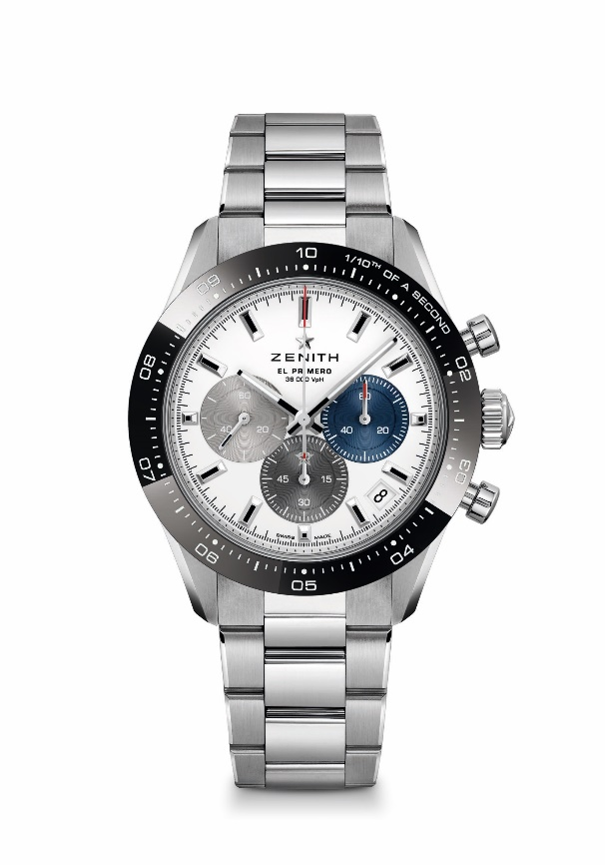
CHRONOMASTER SPORT

Reference : 03.3100.3600/69.M3100 (metal bracelet)
03.3100.3600/69.C823 (blue cordura bracelet)

Movement : El Primero 3600 automatic

Frequency: 36000 VpH (5 Hz)

Power-reserve : min. 60 hours

Functions : Hours and minutes in the centre. Small seconds at 9 o'clock, 1/10th of a second Chronograph: Central chronograph hand that makes one turn in 10 seconds, 60-minute counter at 6 o'clock, 60-second counter at 3 o'clock

Price : 10900 CHF (metal bracelet) & 10400 CHF (Cordura effect bracelet)

Diameter: 41 mm

Material: Stainless steel with black ceramic bezel

Water-resistance: 10 ATM

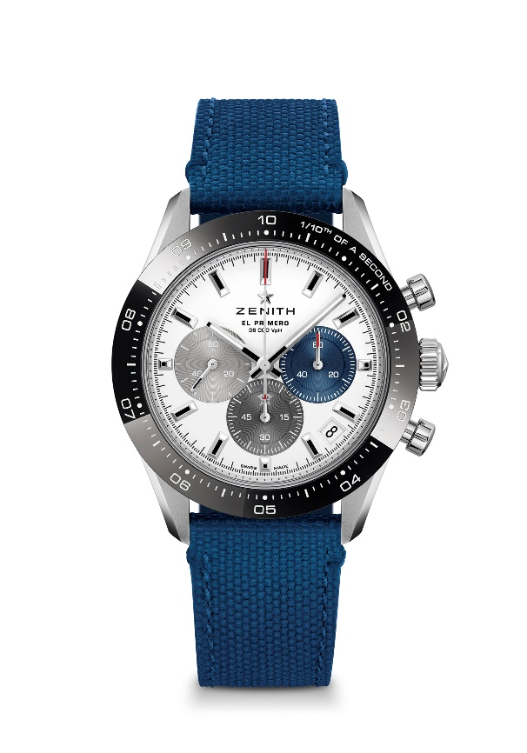
Dial: White matte dial with three different applied coloured counters

Hour-markers: Rhodium-plated, faceted and coated with Super-LumiNova SLN C1

Hands: Rhodium-plated, faceted and coated with Super-LumiNova SLN C1

Bracelet & bucle : Available on metal bracelet or blue rubber bracelet with « Cordura » effect. Double folding clasp with security mechanism.

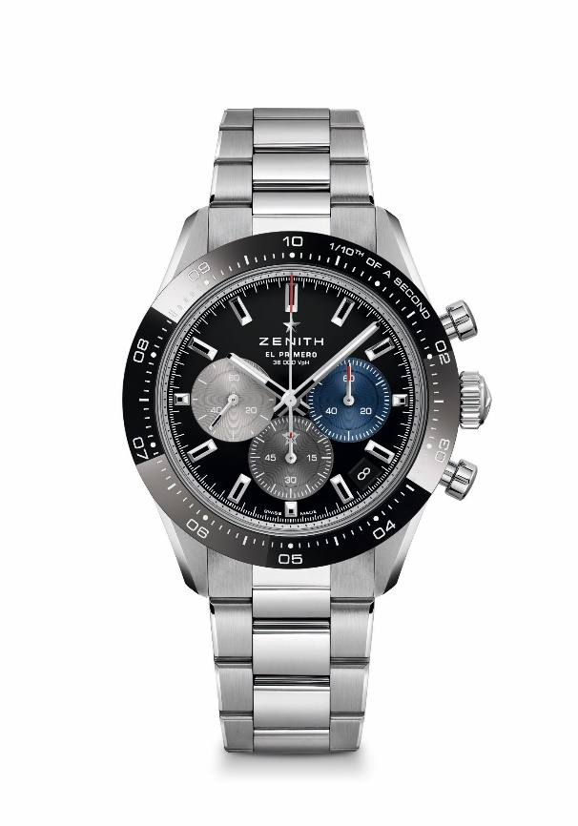
CHRONOMASTER SPORT

Reference: 03.3100.3600/21.M3100 (metal bracelet)
03.3100.3600/21.C822 (black cordura bracelet)

Movement : El Primero 3600 automatic

Frequency: 36000 VpH (5 Hz)

Power-reserve : min. 60 hours

Functions : Hours and minutes in the centre. Small seconds at 9 o'clock, 1/10th of a second Chronograph: Central chronograph hand that makes one turn in 10 seconds, 60-minute counter at 6 o'clock, 60-second counter at 3 o'clock

Price : 10900 CHF (metal bracelet) & 10400 CHF (Cordura effect bracelet)

Diameter: 41 mm

Material: Stainless steel with black ceramic bezel

Water-resistance: 10 ATM
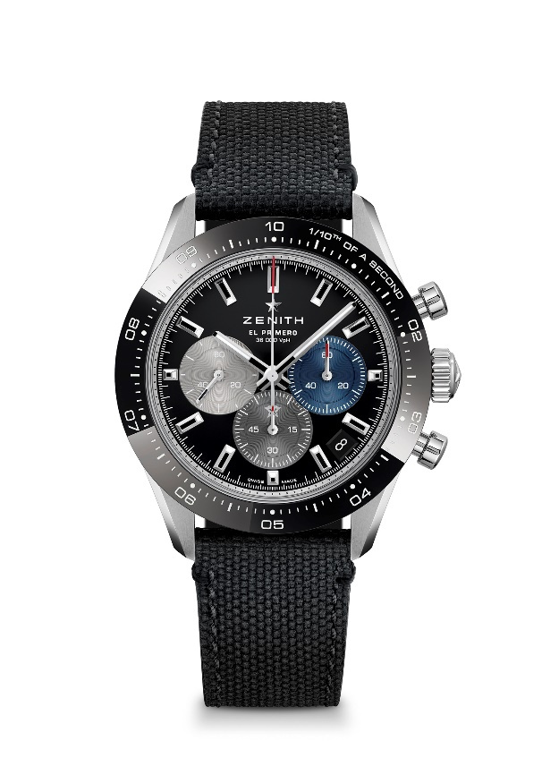
Dial: Black matte dial with three different applied coloured counters

Hour-markers: Rhodium-plated, faceted and coated with Super-LumiNova SLN C1

Hands: Rhodium-plated, faceted and coated with Super-LumiNova SLN C1

Bracelet & bucle : Available on metal bracelet or black rubber bracelet with « Cordura » effect. Double folding clasp with security mechanism.

