ZENITH UNVEILS ITS LATEST CREATIONS AT LVMH DIGITAL WATCH WEEK

Following the immense success for Zenith at LVMH Watch Week 2020 in Dubai, Zenith, alongside LVMH brands Bulgari and Hublot, has chosen to unveil its latest watches and news about the brand in an online, one-week event. Through a mix of digital and physical presentations and one-to-one meetings in 15 countries, Zenith will create a unique environment to discover its latest developments.

For Zenith, 2021 is the year of the Chronomaster and during the LVMH watch week, the focus is on its evolved version of the El Primero, allowing for 1/10th of a second time measurement in the most legible manner ever. On the event and the importance of the Chronomaster this year, Zenith CEO Julien Tornare shares, “My team and I are thrilled to finally be able to share with you something we’ve been working on for quite some time – a true evolution of a modern Zenith signature piece! The Chronomaster Sport sets a new standard of precision, performance and design for the staple Zenith automatic chronograph. We can’t wait to show you this watch in your markets very soon, so that you can touch, feel and experience one of our most significant launches for 2021 in person.”

CHRONOMASTER SPORT

The new era of the seminal Zenith Chronomaster has just begun. The Chronomaster line has been one of the most emblematic chronograph collections of the 21st century; steeped in Zenith’s tradition of making exceptional, standard-setting automatic chronographs. Now, the all-new Chronomaster Sport puts forth an entirely redesigned aesthetic accompanied by an evolution of the coveted El Primero calibre. Built for those always on the move towards achieving their dreams when every instant counts, the Chronomaster Sport is capable of accurately measuring and intuitively displaying 1/10th of a second.

Pushing the boundaries of high-frequency precision, the Chronomaster Sport is the culmination point in Zenith’s unequalled legacy of automatic chronographs. While the legendary El Primero A386 serves as the foundation for the Chonomaster Sport, design elements from other notable Zenith chronographs have been reinterpreted, including the pre-El Primero A277 with its black bezel and dot markers, the El Primero Rainbow with its polished bezel engraved with a tachymetric scale, the polished and satin-brushed bracelet of the El Primero De Luca. These are just some of the details that have been drawn from Zenith’s illustrious heritage of chronographs through the decades.

Some of the immediately perceptible evolutions are the more refined and legible tri-colour dial, a steel bracelet with optimized comfort, enhanced finishing details, and an ever more accurate search for proportions and an extremely precise tenth of a second reading. Crafted in a sleek and robust steel case measuring 41 mm wide with pump-style pushers, the polished black ceramic bezel sets the new Chronomaster Sport apart from its predecessors. Graduated over 10 seconds, the bezel’s bold contrast offers exceptional legibility on the periphery of the dial.

The result of over 50 years of working and perfecting the El Primero, the Chronomaster Sport line is equipped with the newest version of the legendary calibre, the El Primero 3600. With its high frequency of 5 Hz (36’000 VpH), the movement is able to precisely offer a 1/10th of second that’s easily readable, displayed directly on the bezel as well as the dial. Its autonomy has also been rendered more efficient, with an extended power reserve of 60 hours. Visible through the sapphire display back, the new architecture is strikingly evident, revealing a blue column wheel and open rotor marked with the five-pointed star Zenith.

Aaron Rodgers: The New Face of Zenith in North America

Time to Reach Your Star, a creed Zenith has followed since its foundation, is all about realizing one’s full potential and turning the wildest dream or idea into a tangible reality. In this spirit, Zenith is proud to announce its partnership with NFL quarterback Aaron Rodgers, who lives this philosophy to the fullest. After decades of hard work, passion, perseverance and discipline, Rodgers is at the peak of his career. He is rated the number one quarterback in the NFL, has set many records, been named the Most Valuable Player in the NFL, and led his team, the Green Bay Packers, to victory in Superbowl XLV. Today he continues to challenge himself to be the best and play at the highest levels of the game, as he has for the past decade.

Julien Tornare, CEO of Zenith, says, “Aaron Rodgers is undoubtedly a name that will go down in sports history for fundamentally changing the game of football. His focus, determination, and relentless ambition to always outdo himself and lead his team to spectacular victories have made him someone to admire and look up to. Aaron has reached his star, and changed the game while doing it, but remains incredibly humble and charming when he’s off the field. On behalf of Zenith, I’m honoured to welcome Aaron Rodgers as our new brand ambassador.”

Of the partnership, Aaron Rodgers says, “I couldn’t be more thrilled to join Zenith as its ambassador. I love how this brand is always pushing boundaries and literally building the future of watchmaking. What really moved me with Zenith is how they’re always working to inspire young men and women to go out there to reach for the stars and turn their dreams into reality.”

Rodgers’ commitment to excellence and precision make him the perfect ambassador for Zenith’s Chronomaster Sport, an evolution of the seminal El Primero column-wheel chronograph calibre with improved performance and a new, dynamic design language.

**************

NEW CREATIONS FOR LVMH DIGITAL WATCH WEEK 2021

CHRONOMASTER REVIVAL A385

This year, Zenith is bringing back the first El Primero watch with a gradient dial from 1969 in the Chronomaster Revival A385. One of the most significant pieces in the El Primero story, the A385 was one of the original three stainless steel chronographs housing the world’s first automatic high-frequency chronograph. Within its tonneau-shaped steel case was an eye-catching brown gradient dial, which was possibly the first “smoked” dial ever to be made in the watch industry and certainly the first for Zenith.

The Chronomaster Revival collection has witnessed the return of several iconic Zenith chronographs in stunningly accurate details. More than just vintage-inspired watches, the Chronomaster Revival collection consists of faithful reproductions of historical references, using the original production plans from 1969. It preserves the original proportions and finishing of the 37mm steel case with pump-style pushers.

The original A385 actually made headlines back in 1970, when it took part in Zenith’s “Operation Sky”. To prove that a mechanical movement was superior to the nascent quartz movements of the time, an A385 was strapped to the landing gear of an Air France Boeing 707 on a flight from Paris to New York to test its resistance to external aggressions such as drastic temperature fluctuations, wind force and changing air pressure. Upon landing, the watch was still functioning perfectly.

At the time of the A385’s launch in 1969, the gradient-effect dial was an intriguing choice that had never done before in a watch. Adding contrast and depth to the dial, it is a design trait that has recently seen a surge in popularity. The Revival of this model succeeds in bringing out the same warm metallic tones as the original. Keeping with the retro theme, the Chronomaster Revival A385 is available in two options that could have come straight from 1969: The first is the steel “ladder” bracelet, a modern remake of the Gay Frères bracelets that became emblematic of the early El Primero watches. The second option is a light brown calf leather strap that will develop a unique patina with wear and time.

DEFY 21 URBAN JUNGLE

The fastest chronograph in production gets a new, bold colourway in shades of green: Meet the DEFY 21 Urban Jungle.

Through the DEFY collection, Zenith continues to set new standards in both precision and avant-garde design, using innovative and high-performance materials paired with ground-breaking manufacture movements. An exceptional 1/100th of a second chronograph that pushes the limits of high-frequency precision with a futuristic design language, the DEFY 21 Urban Jungle stands out with its khaki green tones. This special rendition of the DEFY 21 is made for those who see the sprawling metropolis as their playground; where a horizon of towering concrete, steel and glass opens up a world where every day is an adventure full of dreams and infinite possibilities. Audacious yet subtle, the DEFY 21 Urban Jungle deftly blends into its surroundings.

In a first for Zenith, the manufacture has cladded its 1/100th of a second chronograph in a green ceramic armour for the DEFY 21 Urban Jungle. Highly scratch-resistant and intensely coloured, the Urban Jungle’s khaki green ceramic case is finished entirely with matte surface, flying under the radar while still standing out to its wearer. Visible through the open dial with matte silver and black counters, the unrivalled high-frequency chronograph with two regulating organs is decorated with a khaki green coloured main plate and star-shaped oscillating rotor. Completing the look is a grey rubber strap with a green cordura-effect rubber insert.

PILOT TYPE 20 SILVER CHRONOGRAPH

Revisiting its iconic and historical Pilot aesthetic while drawing inspiration from vintage aircraft design, Zenith unveils the Pilot Type 20 Chronograph Silver, a compelling and richly detailed aviation-themed chronograph crafted in precious sterling silver – a first for a Zenith Pilot chronograph.

A limited edition of 250 pieces, the Pilot Type 20 Chronograph Silver recalls Zenith’s unique pedigree in the world of aviation timepieces spanning over a century, having accompanied the pioneers of flight in the early 20th century, most notably with Louis Bleriot and his history-making voyage across the English Channel in 1909. With a more direct visual inspiration from historical aircrafts, the 45mm case is made from sterling silver. Like the fuselage of an aircraft, the silver dial features riveted details resembling metal panels, with an erratic satin-brushed surface to bring out the raw beauty of the metal. For maximum legibility at all times, the signature Pilot oversized Arabic hour-markers and “cathedral” hands feature white luminescent paint. Completing the aviator look is the brown calfskin leather strap with a rivet and polished steel pin buckle with a distinctive tab, recalling vintage pilot helmets.

ZENITH: TIME TO REACH YOUR STAR.

Zenith exists to inspire individuals to pursue their dreams and make them come true – against all odds. Since its establishment in 1865, Zenith became the first watch manufacture in the modern sense of the term, and its watches have accompanied extraordinary figures that dreamt big and strived to achieve the impossible – from Louis Blériot’s history-making flight across the English Channel to Felix Baumgartner’s record-setting stratospheric free-fall jump.

With innovation as its guiding star, Zenith features exceptional in-house developed and manufactured movements in all its watches. From the first automatic chronograph, the El Primero, to the fastest chronograph with a 1/100th of a second precision, the El Primero 21, as well as the Inventor that reinvents the regulating organ by replacing the 30+ components with a single monolithic element, the manufacture is always pushing the boundaries of what's possible. Zenith has been shaping the future of Swiss watchmaking since 1865, accompanying those who dare to challenge themselves and break barriers. The time to reach your star is now.

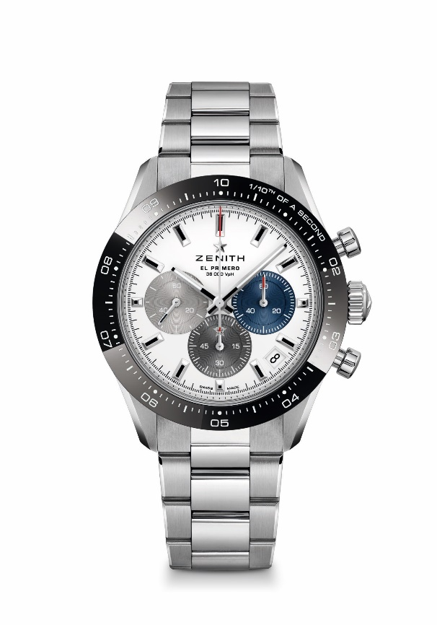
CHRONOMASTER SPORT

References:
03.3100.3600/69.M3100 (metal bracelet)
03.3100.3600/69.C823 (blue cordura bracelet)

Key points: Automatic El Primero column-wheel chronograph able to measure and display the 1/10th of a second. 1/10th of a second indication on the ceramic bezel. Increased power reserve of 60 hours. Date indication at 4:30. Stop second mechanism
Movement : El Primero 3600 automatic
Frequency: 36000 VpH (5 Hz)
Power-reserve : min. 60 hours
Functions : Hours and minutes in the centre. Small seconds at 9 o'clock, 1/10th of a second Chronograph: Central chronograph hand that makes one turn in 10 seconds, 60-minute counter at 6 o'clock, 60-second counter at 3 o'clock
Price : 9900 CHF (metal bracelet) & 9400 CHF (Cordura effect bracelet)
Diameter: 41 mm
Material: Stainless steel with black ceramic bezel
Water-resistance: 10 ATM
Dial: White matte dial with three different applied coloured counters
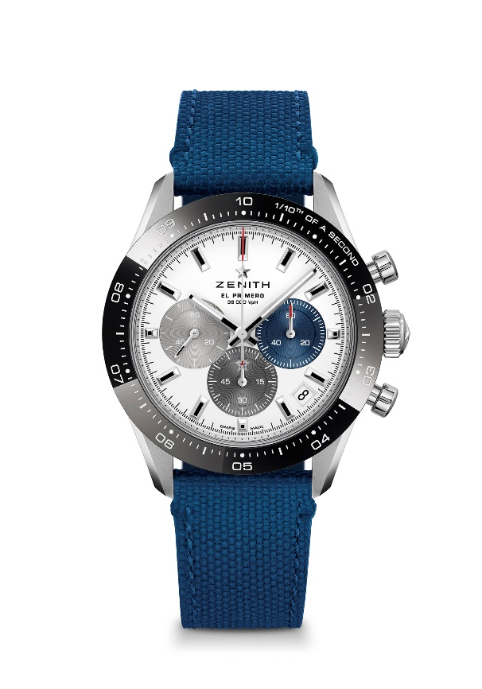
Hour-markers: Rhodium-plated, faceted and coated with Super-LumiNova SLN C1
Hands: Rhodium-plated, faceted and coated with Super-LumiNova SLN C1
Bracelet & buckle : Available on metal bracelet or blue rubber bracelet with « Cordura » effect. Double folding clasp with security mechanism.

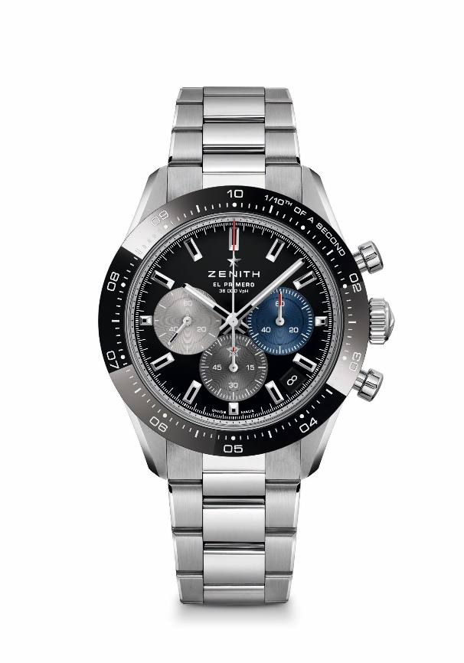
CHRONOMASTER SPORT

References:
03.3100.3600/21.M3100 (metal bracelet)
03.3100.3600/21.C822 (black cordura bracelet)

Key points: Automatic El Primero column-wheel chronograph able to measure and display the 1/10th of a second. 1/10th of a second indication on the ceramic bezel. Increased power reserve of 60 hours. Date indication at 4:30. Stop second mechanism
Movement : El Primero 3600 automatic
Frequency: 36000 VpH (5 Hz)
Power-reserve : min. 60 hours
Functions : Hours and minutes in the centre. Small seconds at 9 o'clock, 1/10th of a second Chronograph: Central chronograph hand that makes one turn in 10 seconds, 60-minute counter at 6 o'clock, 60-second counter at 3 o'clock
Price : 9900 CHF (metal bracelet) & 9400 CHF (Cordura effect bracelet)
Diameter: 41 mm
Material: Stainless steel with black ceramic bezel
Water-resistance: 10 ATM
Dial: Black lacquered dial with three different applied coloured counters
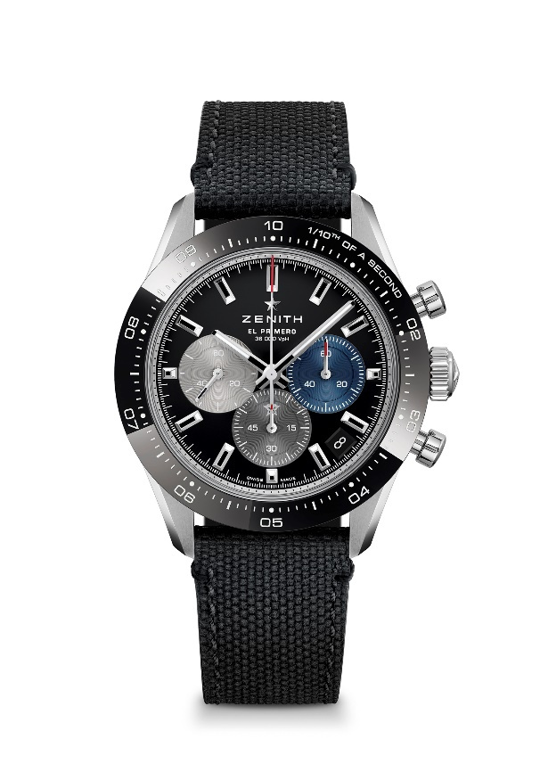
Hour-markers: Rhodium-plated, faceted and coated with Super-LumiNova SLN C1
Hands: Rhodium-plated, faceted and coated with Super-LumiNova SLN C1
Bracelet & buckle : Available on metal bracelet or black rubber bracelet with « Cordura » effect. Double folding clasp with security mechanism.

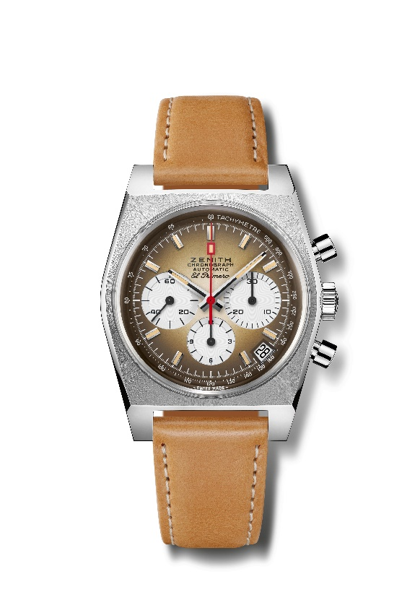
CHRONOMASTER REVIVAL A385
Reference: 03.A384.400/385.C855

Key points: First gradient dial in watchmaking industry back in 1969. Original Revival of the 1969 Reference A385 with 37 mm diameter.
Automatic El Primero column-wheel chronograph movement.
Movement: El Primero 400 Automatic
Frequency: 36,000 VpH (5 Hz)
Power-reserve.: min. 50 hours
Functions: Hours and minutes in the centre. Small seconds at 9 o'clock
Chronograph: Central chronograph hand, 12-hour counter at 6 o'clock, 30-minute counter at 3 o'clock. Tachymetric scale. Date indication at 4:30
Price 7900 CHF
Material: Stainless steel
Water-resistance: 5 ATM
Dial: Smoked brown gradient dial with white-coloured counters
Hour-markers: Rhodium-plated, faceted and coated with beige Super-LumiNova®SLN
Hands: Rhodium-plated, faceted and coated with beige Super-LumiNova®SLN
Bracelet & Buckle: Light brown calf leather strap with protective rubber lining and a stainless steel pin buckle.

CHRONOMASTER REVIVAL A385
Reference: 03.A384.400/385.M385

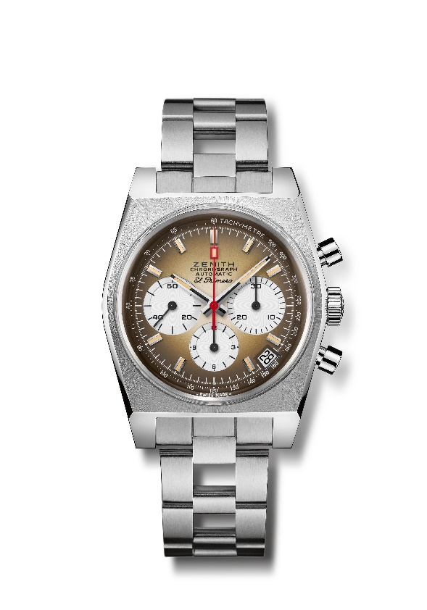
Key points: First gradient dial in watchmaking industry back in 1969.
Original Revival of the 1969 Reference A385 with 37 mm diameter.
Automatic El Primero column-wheel chronograph movement.
Movement: El Primero 400 Automatic
Frequency: 36,000 VpH (5 Hz)
Power-reserve.: min. 50 hours
Functions: Hours and minutes in the centre. Small seconds at 9 o'clock
Chronograph: Central chronograph hand, 12-hour counter at 6 o'clock, 30-minute counter at 3 o'clock. Tachymetric scale. Date indication at 4:30
Price 8400 CHF
Material: Stainless steel
Water-resistance: 5 ATM
Dial: Smoked brown gradient dial with white-coloured counters
Hour-markers: Rhodium-plated, faceted and coated with beige Super-LumiNova®SLN
Hands: Rhodium-plated, faceted and coated with beige Super-LumiNova®SLN
Bracelet & Buckle: “Ladder” bracelet with stainless steel double folding clasp.
PILOT TYPE 20 CHRONOGRAPH SILVER
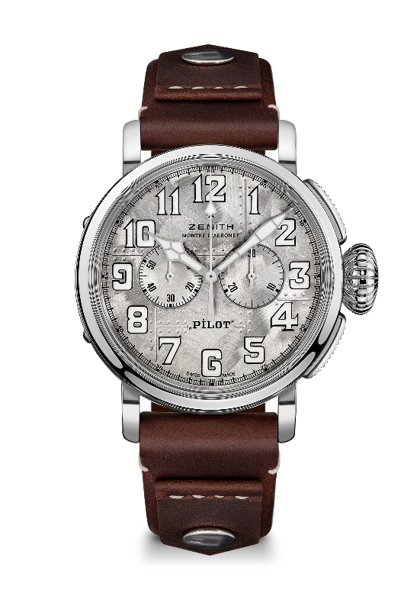
Reference: 05.2430.4069/17.I011
Key points: Genuine Silver 925 case: Limited Edition of 250 units. Case-back engraved with Zenith flying instruments logo. Inspired by the legendary Zenith aviation watches. Arabic numerals entirely made of SuperLuminova
Movement: El Primero 4069 Automatic
Frequency: 36,000 VpH (5 Hz)
Power-reserve.: min. 50 hours
Functions: Hours and minutes in the centre. Small seconds at 9 o'clock. Chronograph: Central chronograph hand, 30-minute counter at 3 o'clock.
Price: 9900 CHF
Material: Silver 925
Case back: Silver case-back engraved with the Zenith flying instruments logo
Water-resistance: 10 ATM
Dial: Brushed riveted dial with shiny reflections
Hour-markers: Arabic numerals in SuperLuminova SLN C1®SLN
Hands: Rhodium-plated, coated with SuperLuminova SLN C1®SLN
Bracelet & Buckle: Brown calfskin leather strap with rivets. Polished steel pin buckle

DEFY 21 URBAN JUNGLE
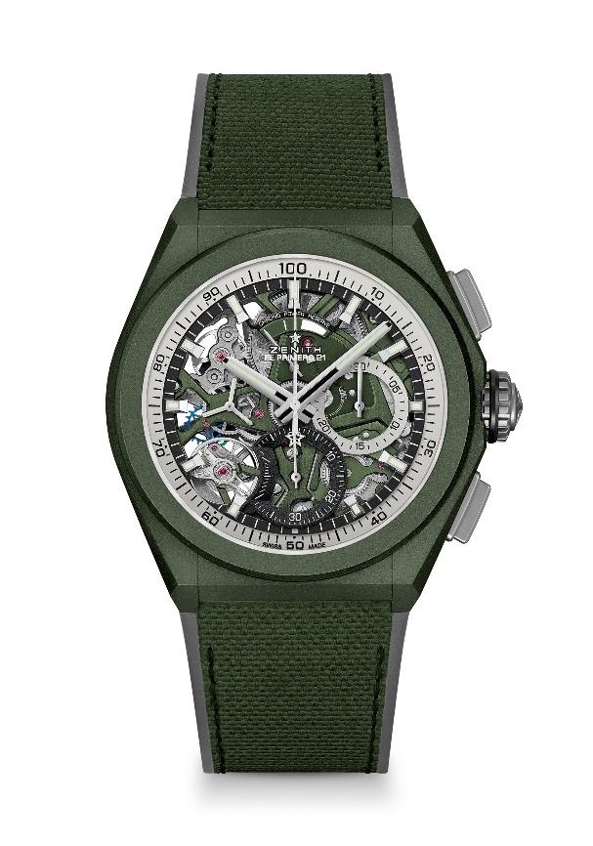
Reference: 49.9006.9004/90.R942

Key points: 1/100th of a second Chronograph movement. Exclusive dynamic signature of one rotation per second. 1 escapement for the Watch (36,000 VpH - 5 Hz); 1 escapement for the Chronograph (360,000 VpH - 50 Hz). Chronometer certified.
Movement: El Primero 9004 automatic
Frequency 36,000 VpH (5 Hz)
Power reserve approx. 50 hours
Functions : 1/100th of a second chronograph functions. Chronograph power-reserve indication at 12 o'clock. Hours and minutes in the centre. Small seconds at 9 o'clock, Central chronograph hand, 30-minute counter at 3 o'clock, 60-second counter at 6 o'clock
Finishes: Khaki green colored main plate on movement + Special khaki green colored oscillating weight with satined finishings
Price 14400 CHF
Material: Khaki green ceramic
Water resistance: 10 ATM
Dial: Openworked with two different-coloured counters
Hour markers: Rhodium-plated, faceted and coated with Super-LumiNova®SLN C3
Hands : Rhodium-plated, faceted and coated with Super-LumiNova®SLN C3
Bracelet & Buckle: Black Rubber with khaki green "Cordura effect" rubber. Microblasted titanium double folding clasp.

