ZENITH AND FELIPE PANTONE COLLABORATE TO CREATE THE MANUFACTURE’S FIRST WATCH DESIGNED WITH A CONTEMPORARY ARTIST: INTRODUCING THE DEFY 21 FELIPE PANTONE, A HIGHLY CHROMATIC AND VISUALLY STRIKING TIMEPIECE THAT BRINGS A DIFFERENT NOTION OF ART TO WATCHMAKING.

A global sensation in the world of contemporary art, Argentinian-Spanish artist Felipe Pantone has reached his star in becoming one of the brightest talents in the world of contemporary art. Instantly recognizable, polarizing and never leaving observers indifferent, Felipe Pantone’s work is coveted by art-lovers and those with an eye for radical design. Zenith and Felipe Pantone began their collaboration in 2020, when the Manufacture offered the façade of its main building as a canvas to the contemporary artist. Now, Felipe Pantone has reimagined Zenith’s most advanced chronograph to date, created an object that is at once a feat exceptional watchmaking prowess and a piece of wearable kinetic art.

The result from this unexpected yet coherent collaboration is the DEFY 21 Felipe Pantone, a strikingly colourful creation that is all about playing with frequencies - visually and mechanically. With its 1/100th of a second El Primero 21 chronograph movement beating at an extremely high frequency of 360’000 vibrations per hour for unrivalled precision, the DEFY 21 is a logical choice of canvas onto which Felipe Pantone could express his “visible spectrum concept”, where all the detectable frequencies of light and its refracted colours come into play with the highest-frequency chronograph in production. Limited to 100 pieces, the DEFY 21 Felipe Pantone is a new kind of collaboration for Zenith and watchmaking at large.

On his first watch collaboration, Felipe Pantone shared “I’m thrilled and humbled to be able to give my personal touch to a watch for the first time, and especially with a manufacture that I deeply admire for its innovation and daringness. From the start, the concept was to transform this spectacular piece of watchmaking into a wearable work of kinetic art, where time and light converge into a single object. I couldn’t be more thrilled with the result.”

Just as Felipe Pantone constantly explores novel techniques and tools to create his bold works of art, Zenith pushed the boundaries of innovation when it came to executing Felipe Pantone’s version of the DEFY 21 – to the extent of having to develop new techniques previously unheard of in watchmaking. One of its most striking features are the multi-coloured bridges, a signature trait in Pantone’s work. Using the principal of interference colours, the coating on the bridges reflects a gradient of metallic rainbow tones. Requiring months of trials and finding the appropriate solution with specialists to achieve this rainbow effect, the DEFY 21 Felipe Pantone is the first watch to ever use this innovative kind of three-dimensional PVD with silicon particles as a surface treatment on a movement to produce a spectrum of perfectly transitioning colours. While the process has been standardized, each piece will take on slightly different colours, essentially becoming a unique work of art.

The central hour and minute hands are no less extraordinary, taking on an intentionally distorted look resembling the lightning bolts that figure in much of Pantone’s work with a rainbow gradient of colours applied through the same state-of-the-art process as the movement’s bridges. Both the unusual shape and scale of the hands as well as the precise application of the gradient PVD so that the colours transition perfectly between the different segments of the hands proved far more challenging to create than anyone could have anticipated. But the engineers at Zenith refused to compromise even the littlest details. In the process, the development of this collaborative edition allowed Zenith to think out of the box and accomplish several world-firsts in watchmaking.

The moiré optical effect produced by thin alternating white and black bands is a recurring theme in Felipe Pantone’s paintings and sculptures, which has been miniaturized and reproduced on the top bridges and portions of the dial of the DEFY 21 Felipe Pantone, using fine laser-engraving and lacquering techniques so precise that they provide an optical illusion of fluidic movement in the contrast of the stripes. The open dial is no less dynamic, with a mix of gradient and block colours on the markers and counters.

Even the inanimate, external parts of the DEFY 21 Felipe Pantone case have been revisited by Felipe Pantone for a dynamic overhaul. The black ceramic DEFY 21 features a grid pattern engraved on the bezel, and “FP#1” engraved on the four corners of the case, denoting “Felipe Pantone El Primero”. Allowing the various details of the chromatic dial and movement to stand out, the artist opted for a black textured rubber strap with a warped grid motif.

For those who prefer an even bolder look that matches the striking tones of the dial and movement, a second rubber strap is offered, with a central insert that goes from dark grey to a flash of all the colours in the spectrum, depending on the angle of light. The colours are not actually embedded in the strap, but are the result of iridescence caused by the surface of the material and how it reflects light.

Fit for the work of art that it is, the DEFY 21 Felipe Pantone comes in a presentation box that mimics a hardcover book. On its cover is a miniaturized painting that Felipe Pantone created exclusively for this special series, complete with a signed certificate.

With the DEFY 21 Felipe Pantone 100-piece limited edition, Zenith is deftly merging the worlds of contemporary art and watchmaking to produce a watch that is as much a high-precision instrument as it is a piece of kinetic, wearable art. The DEFY 21 Felipe Pantone will drop on March 15 2021 at Zenith Boutiques around the world as well as on the Zenith online shop.

ZENITH: TIME TO REACH YOUR STAR.

Zenith exists to inspire individuals to pursue their dreams and make them come true – against all odds. Since its establishment in 1865, Zenith became the first watch manufacture in the modern sense of the term, and its watches have accompanied extraordinary figures that dreamt big and strived to achieve the impossible – from Louis Blériot’s history-making flight across the English Channel to Felix Baumgartner’s record-setting stratospheric free-fall jump.

With innovation as its guiding star, Zenith features exceptional in-house developed and manufactured movements in all its watches. From the first automatic chronograph, the El Primero, to the fastest chronograph with a 1/100th of a second precision, the El Primero 21, as well as the Inventor that reinvents the regulating organ by replacing the 30+ components with a single monolithic element, the manufacture is always pushing the boundaries of what's possible. Zenith has been shaping the future of Swiss watchmaking since 1865, accompanying those who dare to challenge themselves and break barriers. The time to reach your star is now.

DEFY 21 FELIPE PANTONE
Reference: 49.9008.9004/49.R782

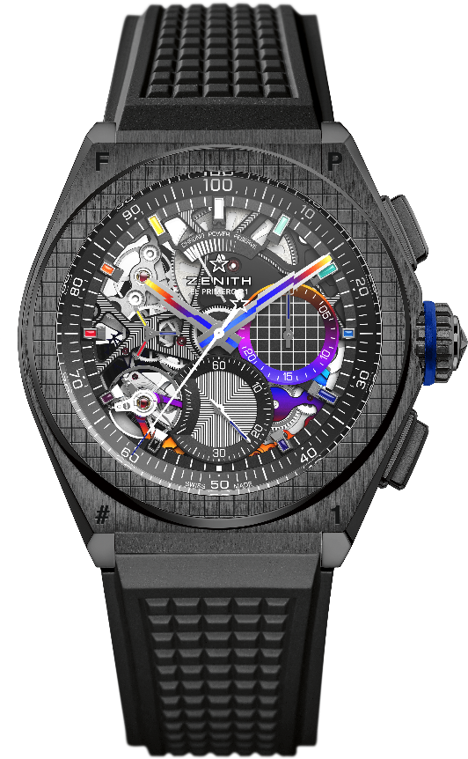
Key points: 1/100th of a second Chronograph movement. Exclusive dynamic signature of one rotation per second. 1 escapement for the Watch (36,000 VpH - 5 Hz); 1 escapement for the Chronograph (360,000 VpH - 50 Hz). Chronometer certified. Limited edition of 100 pieces.
Movement: El Primero 9004 automatic
Frequency 36,000 VpH (5 Hz)
Power reserve min. 50 hours
Functions : 1/100th of a second chronograph functions. Chronograph power-reserve indication at 12 o'clock. Hours and minutes in the centre. Small seconds at 9 o'clock, Central chronograph hand, 30-minute counter at 3 o'clock, 60-second counter at 6 o'clock
Finishes: "Rainbow" PVD-coated bridges. Black laser engraved main plate on movement. Special black colored oscillating weight with satined finishings.
Price 18900 CHF
Material: Black ceramic
Water resistance: 10 ATM
Dial: Openworked
Hour markers: Rhodium-plated, faceted and coated with "Rainbow" varnish
Hands : Rhodium-plated, faceted and "Rainbow" PVD coated
Bracelet & Buckle: Black Rubber. Titanium double folding clasp with black DLC coating. A second rubber strap is offered with a central insert that goes from dark grey to a flash of all the colours in the spectrum, depending on the angle of light as a result of iridescence caused by the surface of the material and how it reflects light.

