CHROMATICS IN MOTION: ZENITH EXPLORES FREQUENCIES OF LIGHT AND MOVEMENT WITH THE DEFY 21 ULTRABLUE

Never afraid to express its singular vision of watchmaking of the future, Zenith continues to highlight the concept of high-frequency precision through striking creations in its 1/100th of a second chronograph, the DEFY 21. This translation of high oscillation frequencies into single regions of the visible light spectrum began with the DEFY 21 Ultraviolet in 2020, which features the world’s first violet-coloured chronograph movement, standing out against the entirely muted case in matte sandblasted titanium. Now, Zenith applies the same striking effect in cool tones of deep indigo and electric blue in the DEFY 21 Ultrablue.

The colour blue holds a special place in Zenith lore. It was the backdrop to the starry night sky from which the manufacture’s founder Georges-Favre Jacot was inspired to name his award-winning calibre and eventually, his brand. In more recent times, it was one of the defining colours of the A386, one of the first watches to be equipped with the legendary El Primero automatic high-frequency chronograph calibre. It is also a colour that has been extensively explored by the Manufacture in its most intricate watches, becoming a mark of futuristic haute horlogerie by Zenith.

The partially open dial features slightly overlapping closed chronograph counters, finished in a grey tone matching the deep grey of the case with contrasting white markings for legibility. The vividly blue movement is accentuated by the DEFY 21’s uniquely avant-garde movement conception and design with open and angular bridges. A white-tipped central 1/100th of a second chronograph hand makes a complete revolution above the dial in one second.

Allowing the blue bridges of the movement to truly stand out while providing a more striking contrast, the faceted 44mm titanium case of the DEFY is given an entirely matte sandblasted finish, bringing out its darker metallic nuances and absorbing much of the light that hits its surface. Complementing the tones of the open movement, the black rubber strap features a blue cordura-effect rubber insert with tone-matching stitching.

The DEFY 21 Ultrablue will be available at Zenith Boutiques around the world as well as its regional online boutiques from March 2021.

ZENITH: TIME TO REACH YOUR STAR.

Zenith exists to inspire individuals to pursue their dreams and make them come true – against all odds. Since its establishment in 1865, Zenith became the first watch manufacture in the modern sense of the term, and its watches have accompanied extraordinary figures that dreamt big and strived to achieve the impossible – from Louis Blériot’s history-making flight across the English Channel to Felix Baumgartner’s record-setting stratospheric free-fall jump.

With innovation as its guiding star, Zenith features exceptional in-house developed and manufactured movements in all its watches. From the first automatic chronograph, the El Primero, to the fastest chronograph with a 1/100th of a second precision, the El Primero 21, as well as the Inventor that reinvents the regulating organ by replacing the 30+ components with a single monolithic element, the manufacture is always pushing the boundaries of what's possible. Zenith has been shaping the future of Swiss watchmaking since 1865, accompanying those who dare to challenge themselves and break barriers. The time to reach your star is now.

DEFY 21 ULTRABLUE
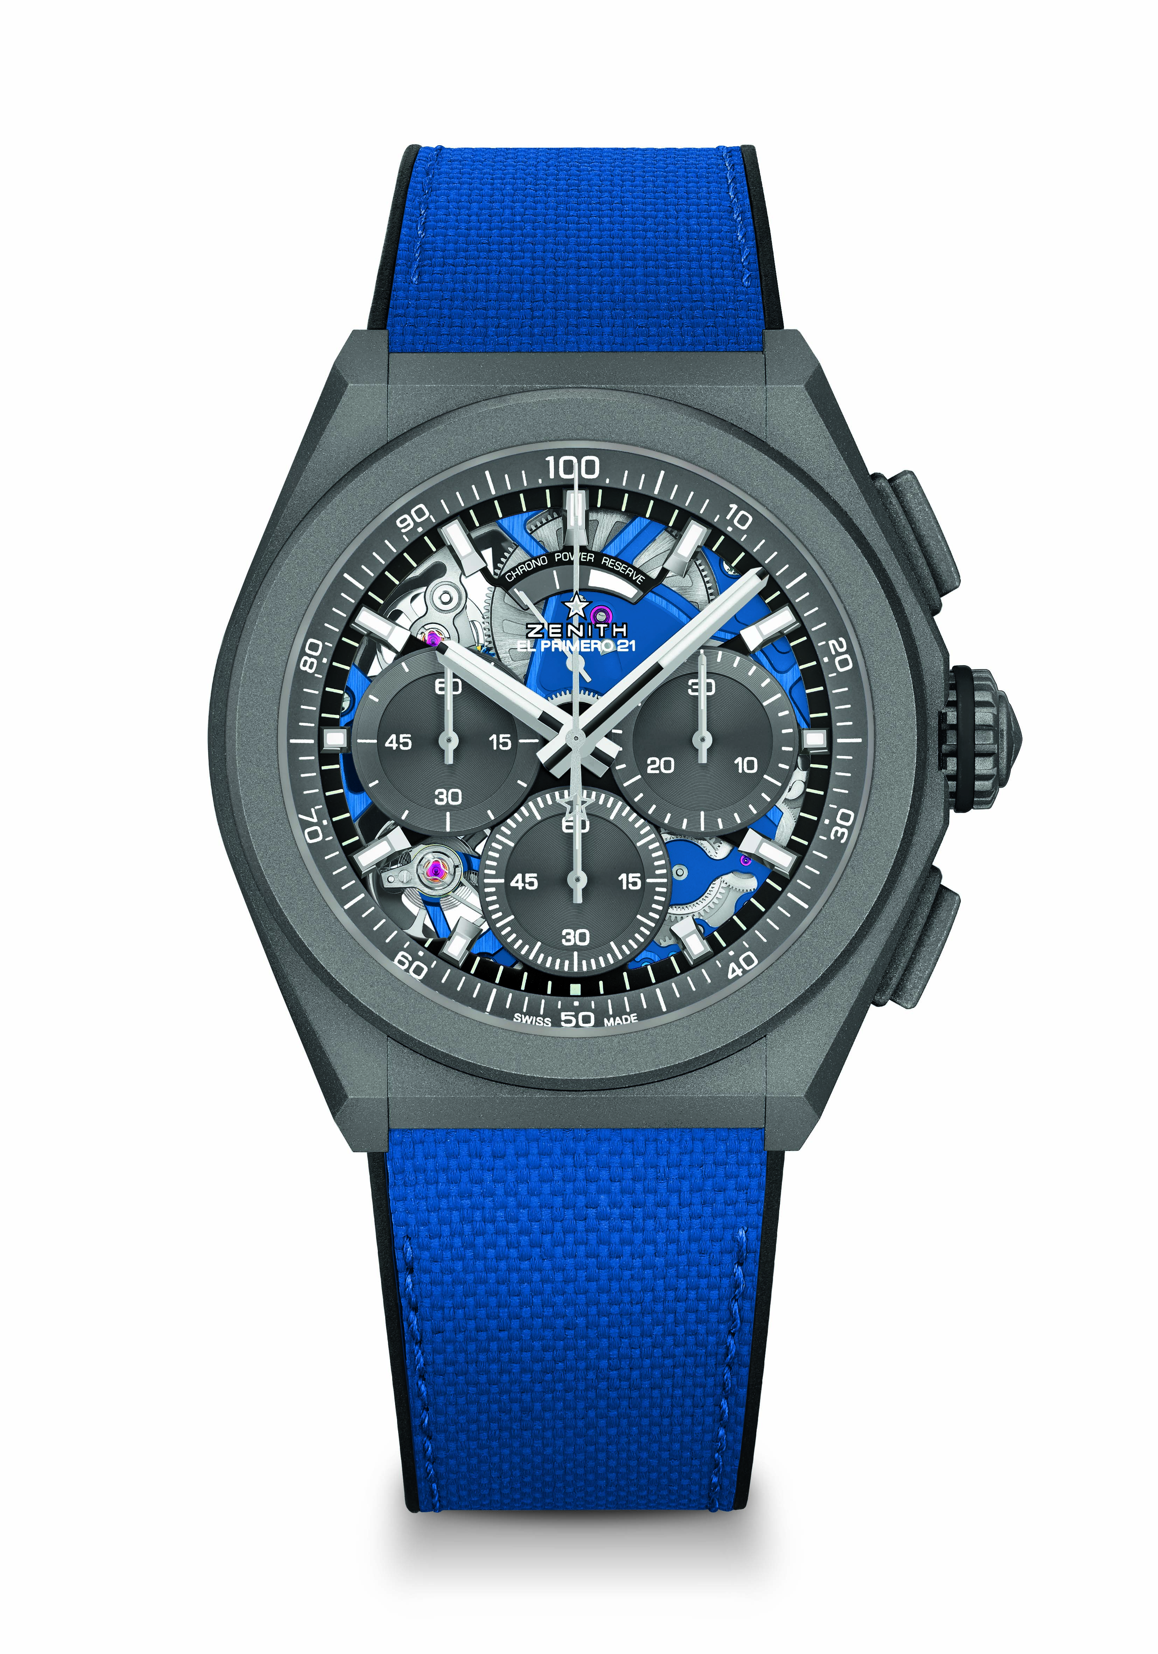
Reference: 97.9001.9004/81.R946

Key points: 1/100th of a second Chronograph movement. Exclusive dynamic signature of one rotation per second. 1 escapement for the Watch (36,000 VpH - 5 Hz); 1 escapement for the Chronograph (360,000 VpH - 50 Hz). Chronometer certified.
Movement: El Primero 9004 automatic
Frequency 36,000 VpH (5 Hz)
Power reserve min. 50 hours
Functions : 1/100th of a second chronograph functions. Chronograph power-reserve indication at 12 o'clock. Hours and minutes in the centre. Small seconds at 9 o'clock, Central chronograph hand, 30-minute counter at 3 o'clock, 60-second counter at 6 o'clock
Finishes: Blue colored main plate on movement. Special blue colored oscillating weight with satined finishings
Price 13400 CHF
Material: Microblasted titanium
Water resistance: 10 ATM
Dial: Openworked with grey subdials
Hour markers: Rhodium-plated, faceted and coated with Superluminova SLN C1
Hands : Rhodium-plated, faceted and coated with Superluminova SLN C1
Bracelet & Buckle: Black rubber with ultrablue “cordura effect”. Microblasted titanium double folding clasp.

