BRILLIANT, PRECIOUS FREQUENCIES: ZENITH HIGHLIGHTS NATURAL COLOURS IN THE DEFY 21 SPECTRUM SERIES

Zenith continues to express the theme of high-frequency chronometry through light and colours in the scintillating DEFY 21 Spectrum bejewelled collection.

While brightly coloured dials have recently enjoyed a comeback in watchmaking, Zenith has taken an unexpected and novel approach in the DEFY 21 Spectrum series, by incorporating striking colours everywhere but the dial. Whether it’s the coloured chronograph movements achieved through innovative pigmentation processes or the natural brilliance and hue of precious stones, the DEFY 21 Spectrum is a whole new take on vivid, kinetic vibrancy.

At the core of this striking and highly exclusive collection is the El Primero 21, Zenith’s revolutionary 1/100th of a second chronograph calibre that beats at the astonishing rate of 50Hz (360’000 VpH). The fastest chronograph in production and the only one to accurately and legibly measure and display 1/100th of a second time measurements, the El Primero 21 elevates high-frequency chronometry to uncharted new heights. To express this exceptional mechanical prowess, Zenith has sought to visualize the notion of frequencies through colour and lights.

Aptly named Spectrum after the range of colours produced by the different wavelengths of visible light, this collection of dazzling DEFY 21 pieces consists of five models that take on different frequencies of visible light. The common element across these five models is the 44mm stainless steel case, which has been entirely embellished with 288 brilliant-cute white diamonds. Each version features a bezel set with 44 baguette-cut precious stones, with matching coloured movements and rubber straps: green tsavorites for the green edition, orange sapphires for the orange edition, blue sapphires for the blue edition, amethyst for the purple edition, and black spinels for the black edition.

Creating these exceptional feats of both advanced watchmaking and traditional gem-setting requires the laborious selection of stones of the same size, colour and VVS quality, then meticulously setting them into the metal by the hands of skilled artisans.

Each limited to 10 pieces, the DEFY 21 Spectrum collection is exclusively available at Zenith boutiques around the world.

ZENITH: TIME TO REACH YOUR STAR.

Zenith exists to inspire individuals to pursue their dreams and make them come true – against all odds. Since its establishment in 1865, Zenith became the first watch manufacture in the modern sense of the term, and its watches have accompanied extraordinary figures that dreamt big and strived to achieve the impossible – from Louis Blériot’s history-making flight across the English Channel to Felix Baumgartner’s record-setting stratospheric free-fall jump.

With innovation as its guiding star, Zenith features exceptional in-house developed and manufactured movements in all its watches. From the first automatic chronograph, the El Primero, to the fastest chronograph with a 1/100th of a second precision, the El Primero 21, as well as the Inventor that reinvents the regulating organ by replacing the 30+ components with a single monolithic element, the manufacture is always pushing the boundaries of what's possible. Zenith has been shaping the future of Swiss watchmaking since 1865, accompanying those who dare to challenge themselves and break barriers. The time to reach your star is now.

DEFY 21 SPECTRUM
Reference: 32.9005.9004/05.R944
Limited Edition of 10 units – Boutiques Only

Key points: Exclusive dynamic signature of one rotation per second for the
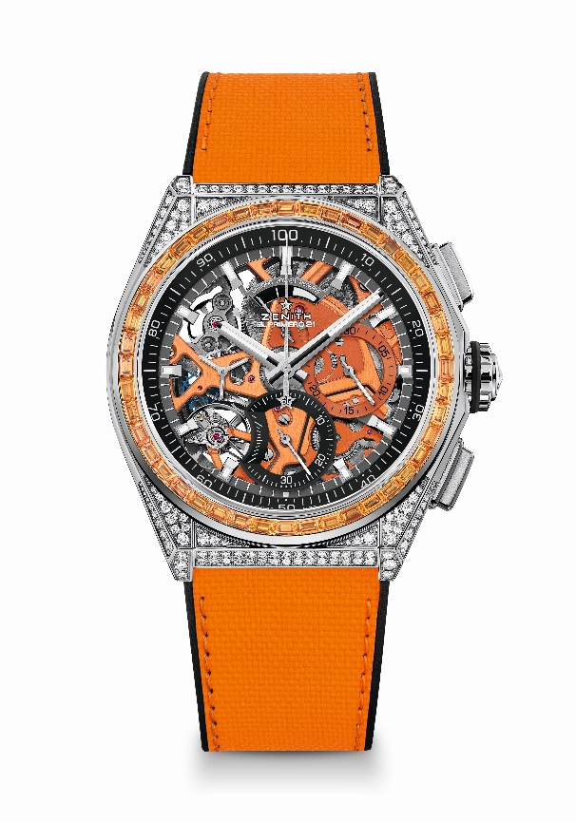
Chrono hand. 1 escapement for the Watch (36,000 VpH - 5 Hz) ; 1 escapement for the Chronograph (360,000 VpH - 50Hz) Certified Chronometer
Movement: El Primero 9004 automatic
Frequency 36,000 VpH (5 Hz)
Power reserve min. 50 hours
Functions : Hours and minutes in the centre. Small seconds at 9 o'clock
1/100th of a second Chronograph: Central chronograph hand that makes one turn each second, 30-minute counter at 3 o'clock, 60-second counter at 6 o'clock, Chronograph power-reserve indication at 12 o'clock
Finishes: Orange colored main plate on movement + Special orange colored
oscillating weight with satined finishings
Price 34900 CHF
Material: Stainless steel set with diamonds
Carats ~5.00 cts
Case 288 VVS brilliant-cut diamonds
Bezel 44 VVS orange baguette-cut sapphire
Water resistance: 3 ATM
Diameter: 44 mm
Thickness: 15.40 mm
Dial: Openworked with two different-coloured counters
Hour markers: Rhodium-plated, faceted and coated with Superluminova SLN C1
Hands : Rhodium-plated, faceted and coated with Superluminova SLN C1
Bracelet & Buckle: Black Rubber with Orange "Cordura effect" rubber. Titanium double folding clasp

DEFY 21 SPECTRUM
Reference: 32.9006.9004/06.R918
Limited Edition of 10 units – Boutiques Only

Key points: Exclusive dynamic signature of one rotation per second for the
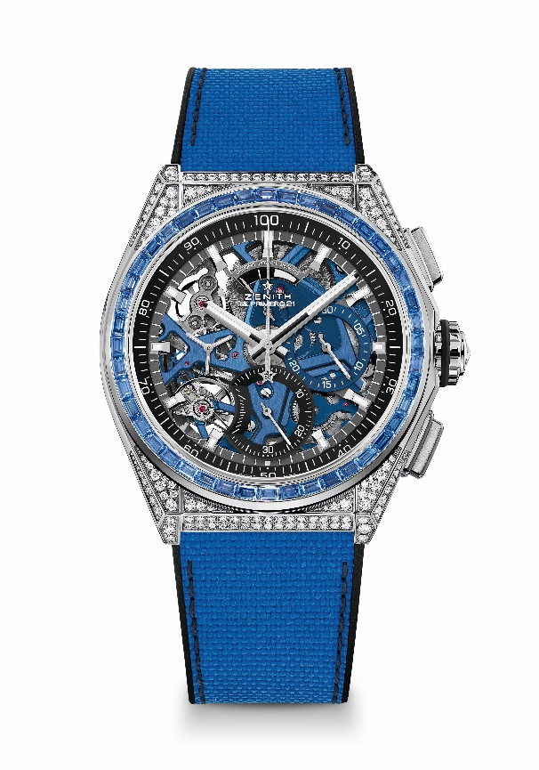
Chrono hand. 1 escapement for the Watch (36,000 VpH - 5 Hz) ; 1 escapement for the Chronograph (360,000 VpH - 50Hz) Certified Chronometer
Movement: El Primero 9004 automatic
Frequency 36,000 VpH (5 Hz)
Power reserve min. 50 hours
Functions : Hours and minutes in the centre. Small seconds at 9 o'clock
1/100th of a second Chronograph: Central chronograph hand that makes one turn each second, 30-minute counter at 3 o'clock, 60-second counter at 6 o'clock, Chronograph power-reserve indication at 12 o'clock
Finishes: Blue colored main plate on movement + Special blue colored
oscillating weight with satined finishings
Price 34900 CHF
Material: Stainless steel set with diamonds
Carats ~5.00 cts
Case 288 VVS brilliant-cut diamonds
Bezel 44 VVS blue baguette-cut sapphire
Water resistance: 3 ATM
Diameter: 44 mm
Thickness: 15.40 mm
Dial: Openworked with two different-coloured counters
Hour markers: Rhodium-plated, faceted and coated with Superluminova SLN C1
Hands : Rhodium-plated, faceted and coated with Superluminova SLN C1
Bracelet & Buckle: Black Rubber with Blue "Cordura effect" rubber. Titanium double folding clasp

DEFY 21 SPECTRUM
Reference: 32.9007.9004/07.R922
Limited Edition of 10 units – Boutiques Only

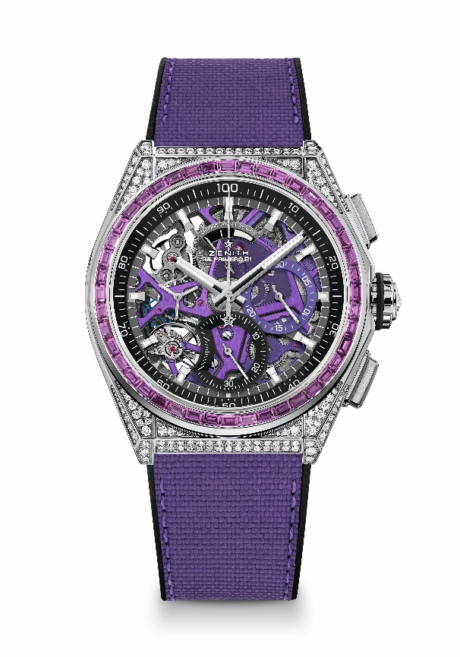
Key points: Exclusive dynamic signature of one rotation per second for the Chrono hand. 1 escapement for the Watch (36,000 VpH - 5 Hz) ; 1 escapement for the Chronograph (360,000 VpH - 50Hz) Certified Chronometer
Movement: El Primero 9004 automatic
Frequency 36,000 VpH (5 Hz)
Power reserve min. 50 hours
Functions : Hours and minutes in the centre. Small seconds at 9 o'clock
1/100th of a second Chronograph: Central chronograph hand that makes one turn each second, 30-minute counter at 3 o'clock, 60-second counter at 6 o'clock, Chronograph power-reserve indication at 12 o'clock
Finishes: Ultraviolet colored main plate on movement + Special ultraviolet colored oscillating weight with satined finishings
Price 34900 CHF
Material: Stainless steel set with diamonds
Carats ~5.00 cts
Case 288 VVS brilliant-cut diamonds
Bezel 44 VVS violet baguette-cut sapphire (Ametyst type)
Water resistance: 3 ATM
Diameter: 44 mm
Thickness: 15.40 mm
Dial: Openworked with two different-coloured counters
Hour markers: Rhodium-plated, faceted and coated with Superluminova SLN C1
Hands : Rhodium-plated, faceted and coated with Superluminova SLN C1
Bracelet & Buckle: Black rubber with ultraviolet "Cordura effect" rubber. Titanium double folding clasp

DEFY 21 SPECTRUM
Reference: 32.9008.9004/08.R943
Limited Edition of 10 units – Boutiques Only

Key points: Exclusive dynamic signature of one rotation per second for the
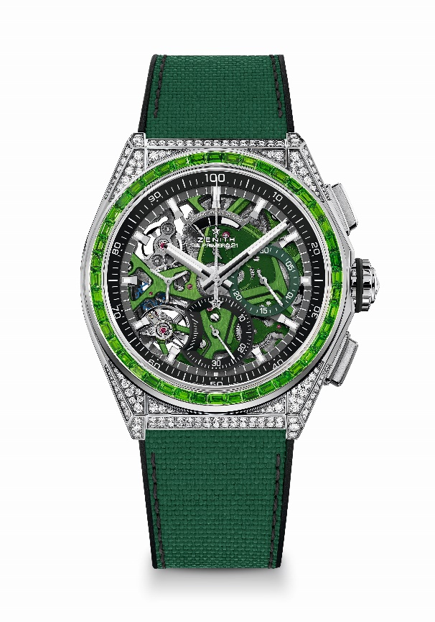
Chrono hand. 1 escapement for the Watch (36,000 VpH - 5 Hz) ; 1 escapement for the Chronograph (360,000 VpH - 50Hz) Certified Chronometer
Movement: El Primero 9004 automatic
Frequency 36,000 VpH (5 Hz)
Power reserve min. 50 hours
Functions : Hours and minutes in the centre. Small seconds at 9 o'clock
1/100th of a second Chronograph: Central chronograph hand that makes one turn each second, 30-minute counter at 3 o'clock, 60-second counter at 6 o'clock, Chronograph power-reserve indication at 12 o'clock
Finishes: Green colored main plate on movement + Special green colored
oscillating weight with satined finishings
Price 34900 CHF
Material: Stainless steel set with diamonds
Carats ~5.00 cts
Case 288 VVS brilliant-cut diamonds
Bezel 44 VVS green baguette-cut sapphire (tsavorite type)
Water resistance: 3 ATM
Diameter: 44 mm
Thickness: 15.40 mm
Dial: Openworked with two different-coloured counters
Hour markers: Rhodium-plated, faceted and coated with Superluminova SLN C1
Hands : Rhodium-plated, faceted and coated with Superluminova SLN C1
Bracelet & Buckle: Black Rubber with green "Cordura effect" rubber. Titanium double folding clasp

DEFY 21 SPECTRUM
Reference: 32.9009.9004/09.R921
Limited Edition of 10 units – Boutiques Only

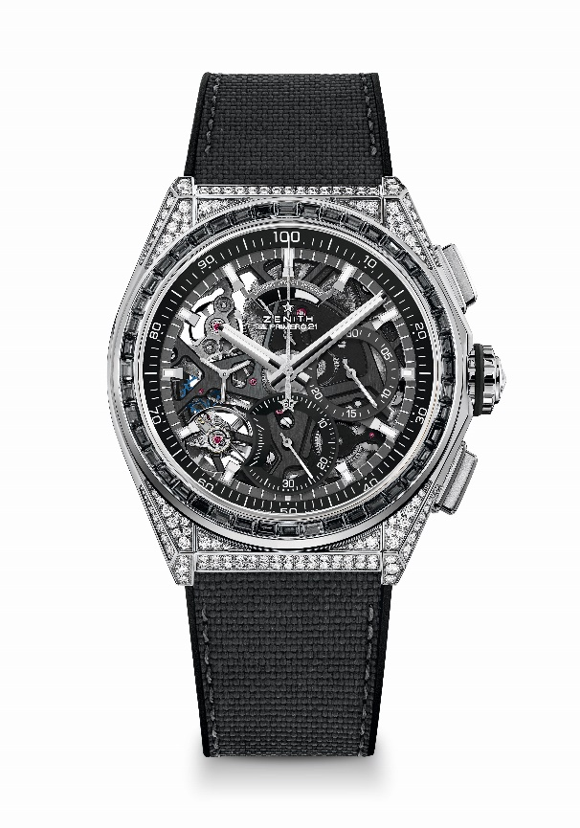
Key points: Exclusive dynamic signature of one rotation per second for the Chrono hand. 1 escapement for the Watch (36,000 VpH - 5 Hz) ; 1 escapement for the Chronograph (360,000 VpH - 50Hz) Certified Chronometer
Movement: El Primero 9004 automatic
Frequency 36,000 VpH (5 Hz)
Power reserve min. 50 hours
Functions : Hours and minutes in the centre. Small seconds at 9 o'clock
1/100th of a second Chronograph: Central chronograph hand that makes one turn each second, 30-minute counter at 3 o'clock, 60-second counter at 6 o'clock, Chronograph power-reserve indication at 12 o'clock
Finishes: Black colored main plate on movement + Special black colored
oscillating weight with satined finishings
Price 34900 CHF
Material: Stainless steel set with diamonds
Carats ~5.00 cts
Case 288 VVS brilliant-cut diamonds
Bezel 44 VVS black baguette-cut sapphire (Spinel type)
Water resistance: 3 ATM
Diameter: 44 mm
Thickness: 15.40 mm
Dial: Openworked with two different-coloured counters
Hour markers: Rhodium-plated, faceted and coated with Superluminova SLN C1
Hands : Rhodium-plated, faceted and coated with Superluminova SLN C1
Bracelet & Buckle: Black rubber with black "cordura effect" rubber & grey stitchings. Titanium double folding clasp

