WATCHES & WONDERS 2021: ZENITH REACHES NEW EXTREMES WITH BOLD NEW ADDITIONS TO THE DEFY COLLECTION

Zenith continues to push the limits of performance and design to the extreme for the trailblazers who forge their own path and leave a mark on time with the DEFY EXTREME, an all-terrain 1/100th of a second chronograph. Zenith is also continuing to express the notion of high-frequency precision through light, colours and motion across the DEFY collection with a number of new highly chromatic creations.

BUILT FOR THE ELEMENTS: DEFY EXTREME COLLECTION

Zenith is pushing form and function to new heights in its DEFY collection of resolutely futuristic watchmaking with the DEFY Extreme, a new expression of superlative precision and ruggedness. This is the high-performance chronograph for those who forge their own path on the road less travelled and leave their mark.

The DEFY Extreme is essentially a supercharged DEFY, where the outlines and details are accentuated and further holistic details are masterfully integrated: A larger 45mm case with a water-resistance of 200 metres, sharper lines, more pronounced edges, and an overall silhouette that exudes robustness, resilience and a penchant for exploring new horizons. The design is reinforced by the addition of components protecting the pushers, and screw-down crown. One of the DEFY Extreme’s most striking elements is the twelve-sided ring placed under the bezel that extends down to the twelve-sided case back; reminiscent of the DEFY A3642 from the 1960s and its faceted bezel. The interplay between materials and their finishes serves to add another dimension of modernity. The matte titanium and matte titanium with rose gold versions feature an entirely matte-finished microblasted surface for a monolithic look, while the titanium version with blue accents is finished to bring out the different facets of the metal with polished, satin-brushed and matte surfaces.

The dial of the DEFY Extreme has been conceived in a way to enhance legibility while allowing a clear view of the groundbreaking 1/100th of a second chronograph calibre, with two escapements beating at 36’000 VpH for the timekeeping part and 360’000 VpH for the chronograph. Consisting of a transparent sapphire crystal, the dial features applied oversized and slightly overlapping chronograph counters that emphasize volume and legibility. The hands as well as the applied hour markers are also extra-large and filled with copious amounts of Super-LumiNova guarantee readability in the darkest situations. And to further enhance the tonality of the watch and the depth of the movement, the movements are coloured galvanically to match and complement their sturdy exterior: Black for the matte titanium, blue for the polished titanium and gold for the titanium and rose gold.

Because uncompromising performance in extreme conditions also means adapting to the environment around us, each DEFY Extreme comes with three different straps with quick strap-change mechanisms: A mircroblasted or polished and satin-brushed titanium bracelet, a rubber strap with a folding buckle matching the case and, a first for Zenith and the DEFY line, a Velcro® strap that can be easily and precisely adjusted on the go, with the textile material perfectly suited for any situation – and certainly not afraid of getting wet. Going beyond a simple cosmetic switch-up, each option offers different properties for a different wearing experience, perfectly adapted to its surroundings and the activities it takes on, no matter how extreme.

Zenith has found a most suitable setting for the DEFY Extreme collection, by becoming Official Timekeeper and Founding Partner of Extreme E, a new off-road electric racing championship. On this exciting new partnership, Zenith CEO Julien Tornare shared “Building a green and sustainable future is something very much at the core of what Zenith is doing today and the reason why we began the ZENITH IS GREEN initiative two years ago. We are absolutely thrilled to join Extreme E as its Official Timing Keeper and Founding Partner. It’s exciting to be at the start of what will undoubtedly become the future of off-road extreme racing, while also bringing environmental issues to the forefront. When we conceived the DEFY Extreme, this is exactly the kind of environment we envisioned for it: Innovative, off the beaten path and pushing the limits of performance to the extreme, where every millisecond counts and every racer can leave his mark.”

***************

CREATIONS PRESENTED AT W&W 2021: ZENITH EXPLORES HIGH-FREQUENCY IN COLOURS

DEFY 21 FELIPE PANTONE - CHROMATIC ART IN MOTION
After coming together to drape the Zenith Manufacture in Le Locle with a unique work of art, Zenith and Felipe Pantone have collaborated in creating an object that is at once a feat exceptional watchmaking prowess and a piece of wearable kinetic art: the DEFY 21 Felipe Pantone.

Using the DEFY 21 1/100th of a second chronograph as his canvas, world-renowned contemporary artist Felipe Pantone reinterpreted it to incorporate his strikingly colourful aesthetic while playing with frequencies - visually and mechanically. To achieve his “visible spectrum concept”, where all the detectable frequencies of light and its refracted colours come into play with the highest-frequency chronograph in production, Zenith sought new solutions and technologies to make it a reality. This includes the “rainbow” PVD silicon coating applied for the very first time on a movement’s bridges, the intentionally distorted lightning-bolt central hour and minute hands filled with the same rainbow PVD treatment as the movement, and a moiré optical effect produced by fine alternating white and black bands using precise laser-engraving and lacquering techniques.

Limited to 100 pieces and sold out within 24 hours of its commercial release, the DEFY 21 Felipe Pantone comes with a second iridescent rainbow-effect strap, as well as an artwork and certificate signed by the artist himself.

DEFY 21 ULTRABLUE - HIGH FREQUENCIES OF BLUE
Zenith continues to highlight the concept of high-frequency precision through striking creations in its 1/100th of a second chronograph, the DEFY 21. This translation of high oscillation frequencies into single regions of the visible light spectrum began with the DEFY 21 Ultraviolet in 2020, which features the world’s first violet-coloured chronograph movement, standing out against the entirely muted case in matte microblasted titanium. Now, Zenith applies the same striking effect in cool tones of deep indigo and electric blue in the DEFY 21 Ultrablue.

The partially open dial features slightly overlapping closed chronograph counters, finished in a grey tone matching the deep grey of the case with contrasting white markings for legibility. The vividly blue movement is accentuated by the DEFY 21’s uniquely avant-garde movement conception and design with open and angular bridges. A white-tipped central 1/100th of a second chronograph hand makes a complete revolution above the dial in one second.

DEFY 21 SPECTRUM - BRILLIANT, PRECIOUS FREQUENCIES
Zenith has taken an unexpected and novel approach when it comes to colourful watches with the bejewelled DEFY 21 Spectrum series. Whether it’s the coloured chronograph movements achieved through innovative pigmentation processes or the natural brilliance and hue of precious stones, the DEFY 21 Spectrum is exploring the notion of high-frequency precision in a vivid and precious manner.

Aptly named Spectrum after the range of colours produced by the different wavelengths of visible light, this collection of dazzling DEFY 21 pieces consists of five models that take on different frequencies of visible light. The common element across these five models is the 44mm stainless steel case, which has been entirely embellished with 288 brilliant-cut white diamonds. Each version features a bezel set with 44 baguette-cut precious stones, with matching coloured movements and rubber straps: green tsavorites for the green edition, orange sapphires for the orange edition, blue sapphires for the blue edition, amethyst for the purple edition, and black spinels for the black edition. Each version is limited to 10 pieces.

ZENITH: TIME TO REACH YOUR STAR.

Zenith exists to inspire individuals to pursue their dreams and make them come true – against all odds. Since its establishment in 1865, Zenith became the first watch manufacture in the modern sense of the term, and its watches have accompanied extraordinary figures that dreamt big and strived to achieve the impossible – from Louis Blériot’s history-making flight across the English Channel to Felix Baumgartner’s record-setting stratospheric free-fall jump. Zenith is also highlighting visionary and trailblazing women – past and present – by celebrating their accomplishments and creating in 2020 its first-ever collection dedicated entirely to them, Defy Midnight.

With innovation as its guiding star, Zenith features exceptional in-house developed and manufactured movements in all its watches. Since the creation of the El Primero in 1969, the world’s first automatic chronograph calibre, Zenith has gone on to master fractions of the second with the Chronomaster Sport and its 1/10th of a second precision and the DEFY 21 with a precision of 1/100th of a second. Zenith has been shaping the future of Swiss watchmaking since 1865, accompanying those who dare to challenge themselves and break barriers. The time to reach your star is now.

DEFY EXTREME
Reference: 97.9100.9004/02.I001

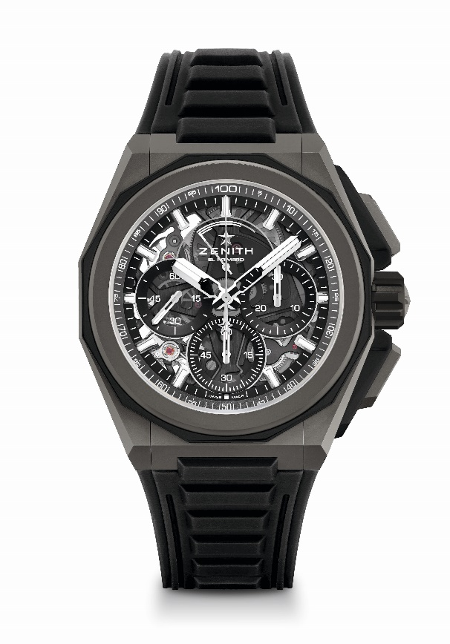
Key points: Stronger, bolder and more powerful design, 1/100th of a second Chronograph movement, Exclusive dynamic signature of one rotation per second for the Chrono hand, 1 escapement for the Watch (36,000 VpH - 5 Hz) ; 1 escapement for the Chronograph (360,000 VpH - 50Hz), Certified Chronometer, New Interchangeable strap system, 2 straps included : 1 Rubber with folding buckle & 1 Velcro. Sapphire dial, Screwed-in crown.
Movement: El Primero 9004 automatic
Frequency 36,000 VpH (5 Hz)
Power reserve min. 50 hours
Functions : Hours and minutes in the centre. Small seconds at 9 o'clock. 1/100th of a secon d Chronograph: Central chronograph hand that makes one turn each second, 30-minute counter at 3 o'clock, 60-second counter at 6 o'clock, Chronograph power-reserve indication at 12 o'clock.
Finishes: Black colored main plate on movement + Special black colored
oscillating weight with satined finishings
Price 17900 CHF
Material: Microblasted titanium
Water resistance: 20 ATM
Diameter: 45 mm
Thickness: 15.40 mm
Dial: Tinted sapphire with three black-coloured counters
Hour markers: Rhodium-plated, faceted and coated with Superluminova SLN C1
Hands : Rhodium-plated, faceted and coated with Superluminova SLN C1
Bracelet & Buckle: Microblasted titanium bracelet. Also comes with a rubber strap and a Velcro® strap.

DEFY EXTREME
Reference: 95.9100.9004/01.I001

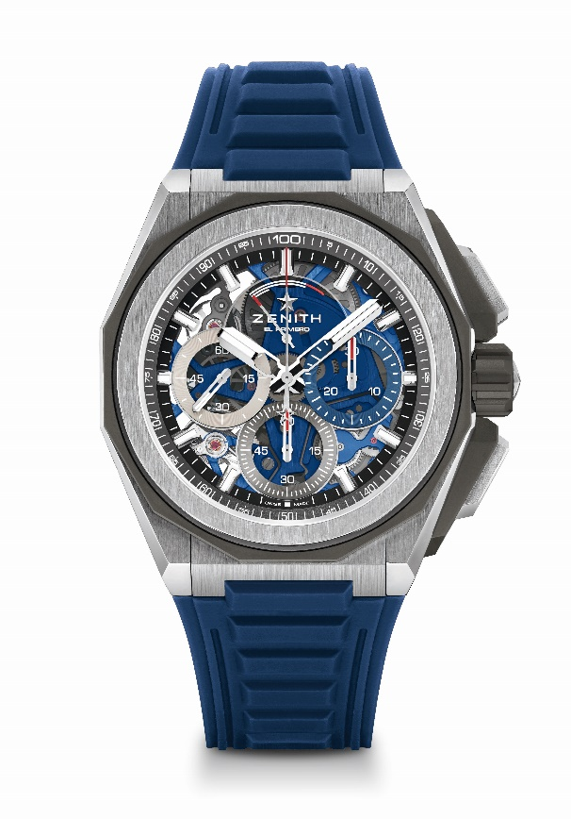
Key points: Stronger, bolder and more powerful design, 1/100th of a second Chronograph movement, Exclusive dynamic signature of one rotation per second for the Chrono hand, 1 escapement for the Watch (36,000 VpH - 5 Hz) ; 1 escapement for the Chronograph (360,000 VpH - 50Hz), Certified Chronometer, New Interchangeable strap system, 2 straps included : 1 Rubber with folding buckle & 1 Velcro. Sapphire dial, Screwed-in crown.
Movement: El Primero 9004 automatic
Frequency 36,000 VpH (5 Hz)
Power reserve min. 50 hours
Functions : Hours and minutes in the centre. Small seconds at 9 o'clock. 1/100th of a second Chronograph: Central chronograph hand that makes one turn each second, 30-minute counter at 3 o'clock, 60-second counter at 6 o'clock, Chronograph power-reserve indication at 12 o'clock.
Finishes: Blue colored main plate on movement + Special blue colored oscillating weight with satined finishings
Price 17900 CHF
Material: Brushed, polished and microblasted titanium
Water resistance: 20 ATM
Diameter: 45 mm
Thickness: 15.40 mm
Dial: Tinted sapphire with three different-coloured counters
Hour markers: Rhodium-plated, faceted and coated with Superluminova SLN C1
Hands : Rhodium-plated, faceted and coated with Superluminova SLN C1
Bracelet & Buckle: Microblasted titanium bracelet. Also comes with a rubber strap and a Velcro® strap.

DEFY EXTREME
Reference: 87.9100.9004/03.I001
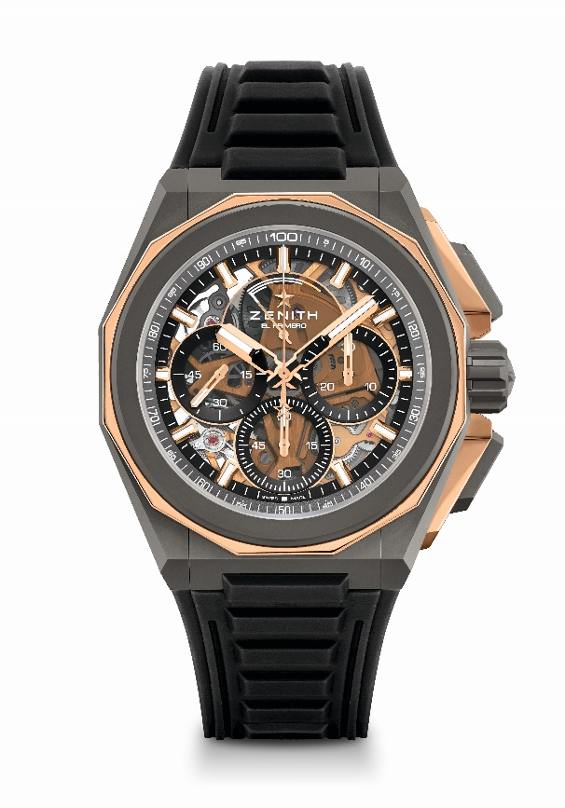
Key points: Stronger, bolder and more powerful design, 1/100th of a second Chronograph movement, Exclusive dynamic signature of one rotation per second for the Chrono hand, 1 escapement for the Watch (36,000 VpH - 5 Hz) ; 1 escapement for the Chronograph (360,000 VpH - 50Hz), Certified Chronometer, New Interchangeable strap system, 2 straps included : 1 Rubber with folding buckle & 1 Velcro. Sapphire dial, Screwed-in crown.
Movement: El Primero 9004 automatic
Frequency 36,000 VpH (5 Hz)
Power reserve min. 50 hours
Functions : Hours and minutes in the centre. Small seconds at 9 o'clock. 1/100th of a second Chronograph: Central chronograph hand that makes one turn each second, 30-minute counter at 3 o'clock, 60-second counter at 6 o'clock, Chronograph power-reserve indication at 12 o'clock.
Finishes: Gold colored main plate on movement + Special gold colored oscillating weight with satined finishings
Price 21900 CHF
Material: Microblasted titanium and polished rose gold
Water resistance: 20 ATM
Diameter: 45 mm
Thickness: 15.40 mm
Dial: Tinted sapphire with three black-coloured counters
Hour markers: Gold-plated, faceted and coated with Superluminova SLN C1
Hands : Gold-plated, faceted and coated with Superluminova SLN C1
Bracelet & Buckle: Microblasted titanium bracelet. Also comes with a rubber strap and a Velcro® strap.

DEFY 21 SPECTRUM
Reference: 32.9005.9004/05.R944
Limited Edition of 10 units – Boutiques Only

Key points: Exclusive dynamic signature of one rotation per second for the
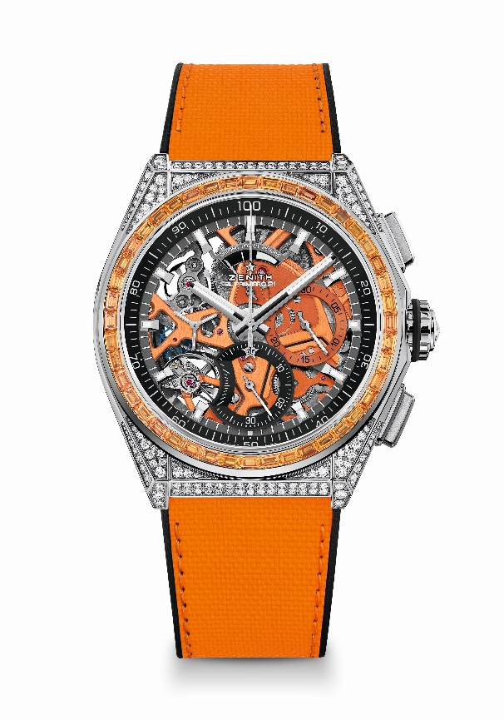
Chrono hand. 1 escapement for the Watch (36,000 VpH - 5 Hz) ; 1 escapement for the Chronograph (360,000 VpH - 50Hz) Certified Chronometer
Movement: El Primero 9004 automatic
Frequency 36,000 VpH (5 Hz)
Power reserve min. 50 hours
Functions : Hours and minutes in the centre. Small seconds at 9 o'clock
1/100th of a second Chronograph: Central chronograph hand that makes one turn each second, 30-minute counter at 3 o'clock, 60-second counter at 6 o'clock, Chronograph power-reserve indication at 12 o'clock
Finishes: Orange colored main plate on movement + Special orange colored
oscillating weight with satined finishings
Price 34900 CHF
Material: Stainless steel set with diamonds
Carats ~5.00 cts
Case 288 VVS brilliant-cut diamonds
Bezel 44 VVS orange baguette-cut sapphire
Water resistance: 3 ATM
Diameter: 44 mm
Thickness: 15.40 mm
Dial: Openworked with two different-coloured counters
Hour markers: Rhodium-plated, faceted and coated with Superluminova SLN C1
Hands : Rhodium-plated, faceted and coated with Superluminova SLN C1
Bracelet & Buckle: Black Rubber with Orange "Cordura effect" rubber. Titanium double folding clasp

DEFY 21 SPECTRUM
Reference: 32.9006.9004/06.R918
Limited Edition of 10 units – Boutiques Only

Key points: Exclusive dynamic signature of one rotation per second for the
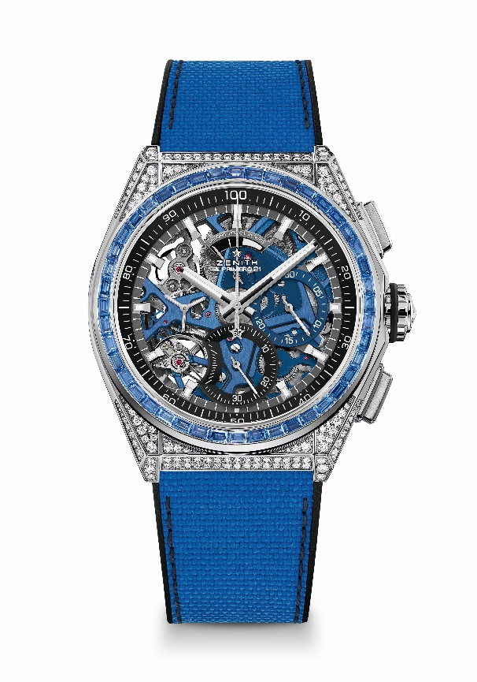
Chrono hand. 1 escapement for the Watch (36,000 VpH - 5 Hz) ; 1 escapement for the Chronograph (360,000 VpH - 50Hz) Certified Chronometer
Movement: El Primero 9004 automatic
Frequency 36,000 VpH (5 Hz)
Power reserve min. 50 hours
Functions : Hours and minutes in the centre. Small seconds at 9 o'clock
1/100th of a second Chronograph: Central chronograph hand that makes one turn each second, 30-minute counter at 3 o'clock, 60-second counter at 6 o'clock, Chronograph power-reserve indication at 12 o'clock
Finishes: Blue colored main plate on movement + Special blue colored
oscillating weight with satined finishings
Price 34900 CHF
Material: Stainless steel set with diamonds
Carats ~5.00 cts
Case 288 VVS brilliant-cut diamonds
Bezel 44 VVS blue baguette-cut sapphire
Water resistance: 3 ATM
Diameter: 44 mm
Thickness: 15.40 mm
Dial: Openworked with two different-coloured counters
Hour markers: Rhodium-plated, faceted and coated with Superluminova SLN C1
Hands : Rhodium-plated, faceted and coated with Superluminova SLN C1
Bracelet & Buckle: Black Rubber with Blue "Cordura effect" rubber. Titanium double folding clasp

DEFY 21 SPECTRUM
Reference: 32.9007.9004/07.R922
Limited Edition of 10 units – Boutiques Only

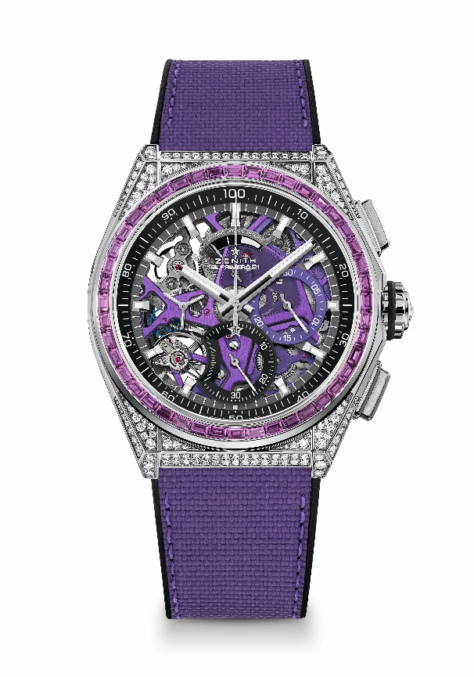
Key points: Exclusive dynamic signature of one rotation per second for the Chrono hand. 1 escapement for the Watch (36,000 VpH - 5 Hz) ; 1 escapement for the Chronograph (360,000 VpH - 50Hz) Certified Chronometer
Movement: El Primero 9004 automatic
Frequency 36,000 VpH (5 Hz)
Power reserve min. 50 hours
Functions : Hours and minutes in the centre. Small seconds at 9 o'clock
1/100th of a second Chronograph: Central chronograph hand that makes one turn each second, 30-minute counter at 3 o'clock, 60-second counter at 6 o'clock, Chronograph power-reserve indication at 12 o'clock
Finishes: Ultraviolet colored main plate on movement + Special ultraviolet colored oscillating weight with satined finishings
Price 34900 CHF
Material: Stainless steel set with diamonds
Carats ~5.00 cts
Case 288 VVS brilliant-cut diamonds
Bezel 44 VVS violet baguette-cut sapphire (Amethyst type)
Water resistance: 3 ATM
Diameter: 44 mm
Thickness: 15.40 mm
Dial: Openworked with two different-coloured counters
Hour markers: Rhodium-plated, faceted and coated with Superluminova SLN C1
Hands : Rhodium-plated, faceted and coated with Superluminova SLN C1
Bracelet & Buckle: Black rubber with ultraviolet "Cordura effect" rubber. Titanium double folding clasp

DEFY 21 SPECTRUM
Reference: 32.9008.9004/08.R943
Limited Edition of 10 units – Boutiques Only

Key points: Exclusive dynamic signature of one rotation per second for the
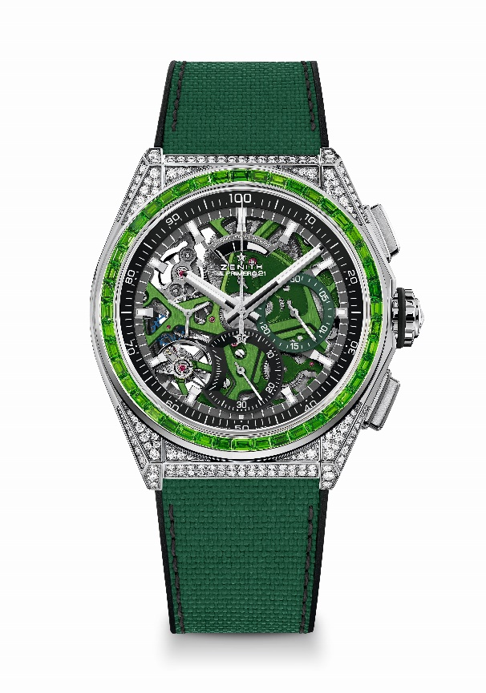
Chrono hand. 1 escapement for the Watch (36,000 VpH - 5 Hz) ; 1 escapement for the Chronograph (360,000 VpH - 50Hz) Certified Chronometer
Movement: El Primero 9004 automatic
Frequency 36,000 VpH (5 Hz)
Power reserve min. 50 hours
Functions : Hours and minutes in the centre. Small seconds at 9 o'clock
1/100th of a second Chronograph: Central chronograph hand that makes one turn each second, 30-minute counter at 3 o'clock, 60-second counter at 6 o'clock, Chronograph power-reserve indication at 12 o'clock
Finishes: Green colored main plate on movement + Special green colored
oscillating weight with satined finishings
Price 34900 CHF
Material: Stainless steel set with diamonds
Carats ~5.00 cts
Case 288 VVS brilliant-cut diamonds
Bezel 44 VVS green baguette-cut sapphire (tsavorite type)
Water resistance: 3 ATM
Diameter: 44 mm
Thickness: 15.40 mm
Dial: Openworked with two different-coloured counters
Hour markers: Rhodium-plated, faceted and coated with Superluminova SLN C1
Hands : Rhodium-plated, faceted and coated with Superluminova SLN C1
Bracelet & Buckle: Black Rubber with green "Cordura effect" rubber. Titanium double folding clasp

DEFY 21 SPECTRUM
Reference: 32.9009.9004/09.R921
Limited Edition of 10 units – Boutiques Only

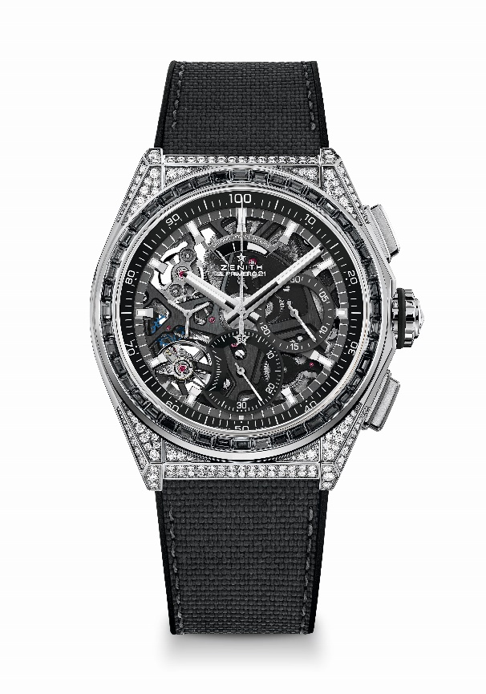
Key points: Exclusive dynamic signature of one rotation per second for the Chrono hand. 1 escapement for the Watch (36,000 VpH - 5 Hz) ; 1 escapement for the Chronograph (360,000 VpH - 50Hz) Certified Chronometer
Movement: El Primero 9004 automatic
Frequency 36,000 VpH (5 Hz)
Power reserve min. 50 hours
Functions : Hours and minutes in the centre. Small seconds at 9 o'clock
1/100th of a second Chronograph: Central chronograph hand that makes one turn each second, 30-minute counter at 3 o'clock, 60-second counter at 6 o'clock, Chronograph power-reserve indication at 12 o'clock
Finishes: Black colored main plate on movement + Special black colored
oscillating weight with satined finishings
Price 34900 CHF
Material: Stainless steel set with diamonds
Carats ~5.00 cts
Case 288 VVS brilliant-cut diamonds
Bezel 44 VVS black baguette-cut sapphire (Spinel type)
Water resistance: 3 ATM
Diameter: 44 mm
Thickness: 15.40 mm
Dial: Openworked with two different-coloured counters
Hour markers: Rhodium-plated, faceted and coated with Superluminova SLN C1
Hands : Rhodium-plated, faceted and coated with Superluminova SLN C1
Bracelet & Buckle: Black rubber with black "cordura effect" rubber & grey stitchings. Titanium double folding clasp

DEFY 21 ULTRABLUE
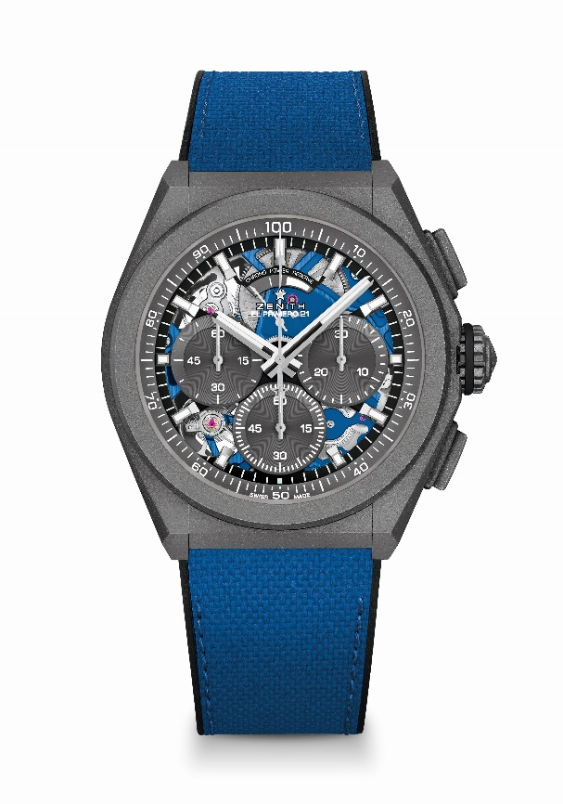
Reference: 97.9001.9004/81.R946

Key points: 1/100th of a second Chronograph movement. Exclusive dynamic signature of one rotation per second. 1 escapement for the Watch (36,000 VpH - 5 Hz); 1 escapement for the Chronograph (360,000 VpH - 50 Hz). Chronometer certified.
Movement: El Primero 9004 automatic
Frequency 36,000 VpH (5 Hz)
Power reserve min. 50 hours
Functions : 1/100th of a second chronograph functions. Chronograph power-reserve indication at 12 o'clock. Hours and minutes in the centre. Small seconds at 9 o'clock, Central chronograph hand, 30-minute counter at 3 o'clock, 60-second counter at 6 o'clock
Finishes: Blue colored main plate on movement. Special blue colored oscillating weight with satined finishings
Price 13400 CHF
Material: Microblasted titanium
Water resistance: 10 ATM
Dial: Openworked with grey subdials
Hour markers: Rhodium-plated, faceted and coated with Superluminova SLN C1
Hands : Rhodium-plated, faceted and coated with Superluminova SLN C1
Bracelet & Buckle: Black rubber with ultrablue “cordura effect”. Microblasted titanium double folding clasp.

DEFY 21 FELIPE PANTONE
Reference: 49.9008.9004/49.R782
Limited Edition of 100 units

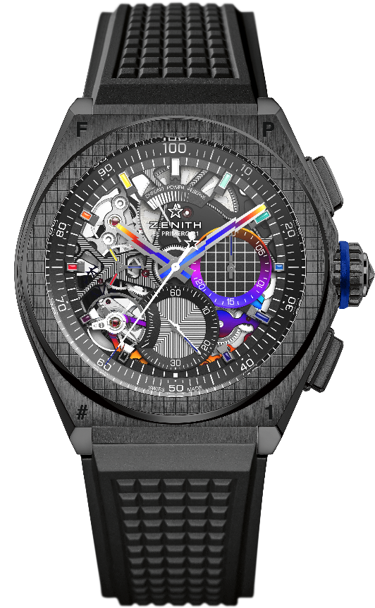
Key points: 1/100th of a second Chronograph movement. Exclusive dynamic signature of one rotation per second. 1 escapement for the Watch (36,000 VpH - 5 Hz); 1 escapement for the Chronograph (360,000 VpH - 50 Hz). Chronometer certified.
Movement: El Primero 9004 automatic
Frequency 36,000 VpH (5 Hz)
Power reserve min. 50 hours
Functions : 1/100th of a second chronograph functions. Chronograph power-reserve indication at 12 o'clock. Hours and minutes in the centre. Small seconds at 9 o'clock, Central chronograph hand, 30-minute counter at 3 o'clock, 60-second counter at 6 o'clock
Finishes: "Rainbow" PVD-coated bridges. Black laser engraved main plate on movement. Special black colored oscillating weight with satined finishings.
Price 18900 CHF
Material: Black ceramic
Water resistance: 10 ATM
Dial: Openworked
Hour markers: Rhodium-plated, faceted and coated with "Rainbow" varnish
Hands : Rhodium-plated, faceted and "Rainbow" PVD coated
Bracelet & Buckle: Black Rubber. Titanium double folding clasp with black DLC coating. A second rubber strap is offered with a central insert that goes from dark grey to a flash of all the colours in the spectrum, depending on the angle of light as a result of iridescence caused by the surface of the material and how it reflects light.

