BACK TO 1971: ZENITH BRINGS BACK ONE OF THE MORE ELUSIVE HISTORICAL EL PRIMERO REFERENCES WITH THE CHRONOMASTER REVIVAL A3817

When the El Primero calibre made its groundbreaking debut in 1969, Zenith chose to house it in two broad but distinct watch categories. On one hand, there were sportier models in tonneau-shaped steel cases, such as the A384, and on the other, more classical round cases in steel or gold, most notably the A386.

Released in 1971, the A3817 was the exception to the rule. It combined the sportier steel tonneau-shaped case of the earliest steel El Primero references with the striking tri-colour dial of the A386, resulting in a unique and appealing aesthetic that continues to resonate with vintage chronograph enthusiasts. Given that only 1000 of the A3817 were ever produced, it remains one of the most distinguished, elusive and sought-after references among the early El Primero watches.

The Chronomaster Revival A3817 is crafted in the same angled tonneau-shaped case with pump-style pushers as the original, using historical blueprints and reverse-engineering to preserve the original proportions and finishes. Zenith waited two years after the launch of the El Primero in 1969 before introducing the iconic tri-colour dial to its sportier tonneau case, albeit with a slightly different execution in both function and aesthetic when compared to the A386. Like its progenitor of 1971, the Chronomaster Revival A3817 features a white lacquered dial with chronograph counters done in the instantly recognizable tones of grey and blue, with the running seconds counter at 9 o’clock done with blue markers, indicated by the single blue hand on the dial. The outer tachymeter scale also serves as a pulsometer, an especially handy and precise function provided by the high-frequency 5Hz (36’000 VpH) escapement of the El Primero movement. The seconds track is done in a pyramid pattern affectionately nicknamed the “shark tooth” scale, which enhances legibility with a distinctly retro touch.

Through the open display case back, one of the few differences between the original A3817 with a solid steel case back and the Revival model, one can admire the legendary El Primero high-frequency automatic chronograph calibre that has remained a staple among chronograph movements for over 50 years.

Completing the retro look and feel of the Chronomaster Revival A3817, two strap options are proposed: the first is the steel “ladder” bracelet, a modern remake of the Gay Frères bracelets that became emblematic of the early El Primero watches; and the other is a light brown calf leather strap that will develop a patina unique to each wearer.

The Chronomaster Revival A3817 is undoubtedly a welcome addition to the collection for those who appreciate one of the rarer early steel El Primero references, faithfully reproduced with all the charm and performance of the original.

The Chronomaster A3817 is exclusively available at Zenith Boutiques around the world as well as its online shop from May 2021.

ZENITH: TIME TO REACH YOUR STAR.

Zenith exists to inspire individuals to pursue their dreams and make them come true – against all odds. Since its establishment in 1865, Zenith became the first watch manufacture in the modern sense of the term, and its watches have accompanied extraordinary figures that dreamt big and strived to achieve the impossible – from Louis Blériot’s history-making flight across the English Channel to Felix Baumgartner’s record-setting stratospheric free-fall jump. Zenith is also highlighting visionary and trailblazing women – past and present – by celebrating their accomplishments and creating in 2020 its first-ever collection dedicated entirely to them, Defy Midnight.

With innovation as its guiding star, Zenith features exceptional in-house developed and manufactured movements in all its watches. Since the creation of the El Primero in 1969, the world’s first automatic chronograph calibre, Zenith has gone on to master fractions of the second with the Chronomaster Sport and its 1/10th of a second precision and the DEFY 21 with a precision of 1/100th of a second. Zenith has been shaping the future of Swiss watchmaking since 1865, accompanying those who dare to challenge themselves and break barriers. The time to reach your star is now.

Chronomaster Revival A3817
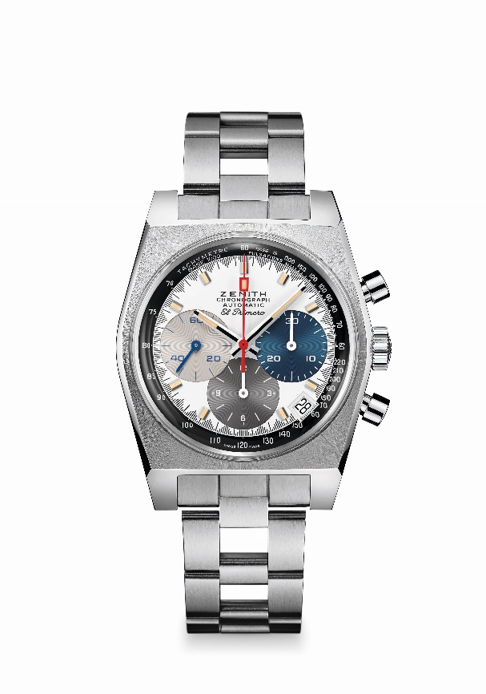
Reference: 03.A384.400/3817.M3817

Key points: Only 3-coloured counters dial in this tonneau-shaped case. Original 1969 case with 37 mm diameter. Automatic El Primero column-wheel chronograph movement. Boutique edition.
Movement: El Primero 400 Automatic
Frequency: 36,000 VpH (5 Hz)
Power reserve: min. 50 hours
Functions: Hours and minutes in the centre. Small seconds at nine o’clock. Chronograph: central chronograph hand, 12-hour counter at six o’clock, 30-minute counter at three o’clock. Tachymetric scale. Pulsometer scale. Date indication at 4:30
Case: 37-mm
Material: stainless steel
Dial: White-lacquered dial with three different-coloured counters
Water-resistance: 5 ATM
Price: 8400 CHF
Hour-markers: Rhodium-plated, faceted and coated with beige Super-LumiNova®SLN
Hands: Rhodium-plated, faceted and coated with beige Super-LumiNova®SLN
Bracelet & Buckle: Stainless steel "ladder" bracelet and double folding clasp.

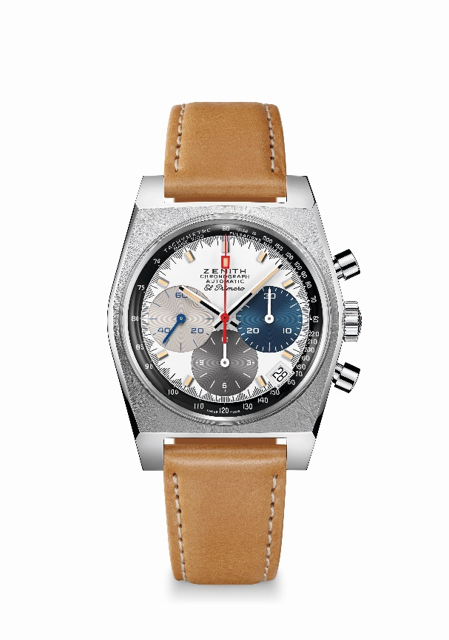
Chronomaster Revival A3817
Reference: 03.A384.400/3817.C855
Key points: Only 3-coloured counters dial in this tonneau-shaped case. Original 1969 case with 37 mm diameter. Automatic El Primero column-wheel chronograph movement. Boutique edition.
Movement: El Primero 400 Automatic
Frequency: 36,000 VpH (5 Hz)
Power reserve: min. 50 hours
Functions: Hours and minutes in the centre. Small seconds at nine o’clock. Chronograph: central chronograph hand, 12-hour counter at six o’clock, 30-minute counter at three o’clock. Tachymetric scale. Pulsometer scale. Date indication at 4:30
Case: 37-mm
Material: stainless steel
Dial: White-lacquered dial with three different-coloured counters
Water-resistance: 5 ATM
Price: 7900 CHF
Hour-markers: Rhodium-plated, faceted and coated with beige Super-LumiNova®SLN
Hands: Rhodium-plated, faceted and coated with beige Super-LumiNova®SLN
Bracelet & Buckle: Light brown calfskin leather strap with protective rubber lining. Stainless steel pin buckle.

