ZENITH GOES FOR GOLD WITH THE LATEST ADDITION TO THE CHRONOMASTER SPORT LINE

At the start of 2021, Zenith reaffirmed its position as the undisputed master of high-frequency automatic chronographs with the all-new Chronomaster Sport, merging quintessential Zenith design codes with a new level of performance and precision. Now, a new reference of the exceptional 1/10th of a second chronograph is being added to the collection in lustrous rose gold.

Since the earliest days of the El Primero dating back to 1969, Zenith has offered gold models of its automatic chronographs, with iconic references such as the G381 and G581. Zenith continues to keep this tradition alive with the latest generation of the El Primero calibre in the Chronomaster Sport in rose gold.

The Chronomaster Sport collection is the beginning of a new chapter for Zenith and its ongoing saga of groundbreaking automatic chronographs. Elevating high-frequency precision to new heights, it demonstrates the Manufacture’s prowess in mastering time measurements in fractions of a second. Combining emblematic elements from past Zenith Icons while bringing out its own unique identity, the result is a contemporary and versatile chronograph – with the added flair of rose gold for this new reference.

For this lavish version of Zenith’s modern yet timeless sporty-chic chronograph, the 41mm case is crafted in18k rose gold with pump-style pushers. The polished black ceramic bezel is engraved with 1/10th of a second scale, filled with matte gold lacquer matching the case and dial for a bold contrast and exceptional legibility of the fractional elapsed time display on the bezel. The white lacquered dial features the iconic tri-colour chronograph counters in shades of rhodium, anthracite and blue, while the hands and applied markers carry on the gold and black palette. A black calfskin strap completes the look by allowing the case and bezel to stand out even more, fixed to a rose gold folding buckle.

The result of over fifty years of constant innovation and improvement, the Chronomaster Sport is equipped with the latest version of the Manufacture’s most renowned movement, dubbed the El Primero 3600 calibre. Pushing its acclaimed performance even higher, Zenith is able to precisely offer a 1/10th of second display from the 5 Hz (36’000 VpH) escapement, as well as an extended power reserve of 60 hours. Its overall form and finish have also been modernised with a new, more open architecture, complete with a blue column wheel and open rotor marked with the five-pointed Zenith star motif.

The Chronomaster Sport in rose gold complements the collection with an alternative version that easily goes from sporty to elegant and is available as of now at Zenith boutiques and retailers around the world.

ZENITH: TIME TO REACH YOUR STAR.

Zenith exists to inspire individuals to pursue their dreams and make them come true – against all odds. Since its establishment in 1865, Zenith became the first watch manufacture in the modern sense of the term, and its watches have accompanied extraordinary figures that dreamt big and strived to achieve the impossible – from Louis Blériot’s history-making flight across the English Channel to Felix Baumgartner’s record-setting stratospheric free-fall jump. Zenith is also highlighting visionary and trailblazing women – past and present – by celebrating their accomplishments and creating in 2020 its first-ever collection dedicated entirely to them, Defy Midnight.

With innovation as its guiding star, Zenith features exceptional in-house developed and manufactured movements in all its watches. Since the creation of the El Primero in 1969, the world’s first automatic chronograph calibre, Zenith has gone on to master fractions of the second with the Chronomaster Sport and its 1/10th of a second precision and the DEFY 21 with a precision of 1/100th of a second. Zenith has been shaping the future of Swiss watchmaking since 1865, accompanying those who dare to challenge themselves and break barriers. The time to reach your star is now.

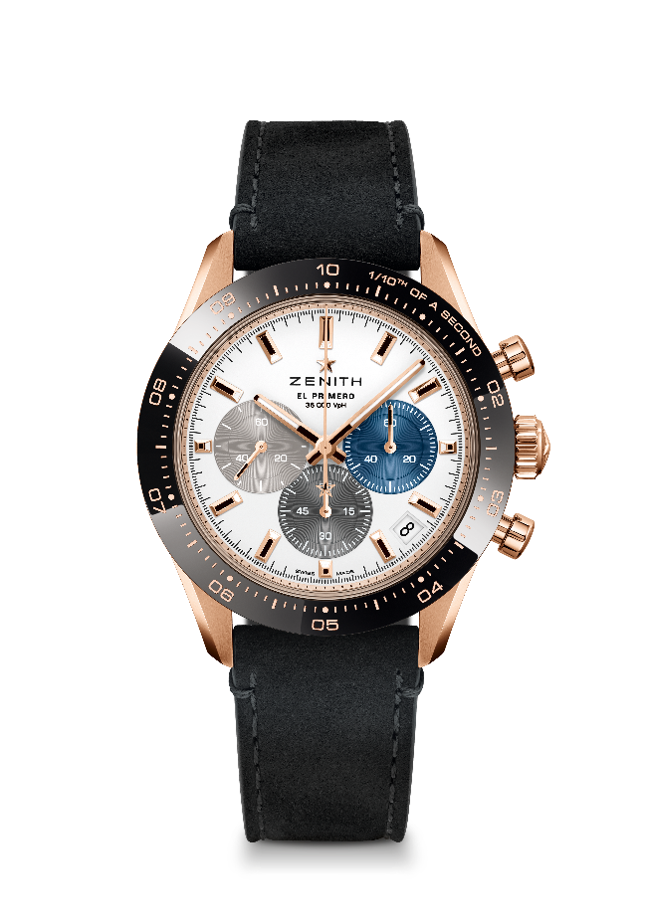
CHRONOMASTER SPORT

Reference : 18.3100.3600/69.C920

Key points: Automatic El Primero column-wheel chronograph able to measure and display 1/10th of a second. 1/10th of a second indication on the ceramic bezel. Increased power reserve of 60 hours. Date indication at 4:30. Stop-second mechanism
Movement : El Primero 3600 automatic
Frequency: 36000 VpH (5 Hz)
Power-reserve : min. 60 hours
Functions : Hours and minutes in the centre. Small seconds at 9 o'clock, 1/10th of a second Chronograph: Central chronograph hand that makes one turn in 10 seconds, 60-minute counter at 6 o'clock, 60-second counter at 3 o'clock
Price : 19900 CHF
Diameter: 41 mm
Material: 18-ct Rose gold with Black ceramic bezel
Water-resistance: 10 ATM
Dial: White matte dial with three different applied coloured counters
Hour-markers: Gold-plated, faceted and coated with Super-LumiNova SLN C1
Hands: Gold-plated, faceted and coated with Super-LumiNova SLN C1
Bracelet & buckle : Black calfskin leather bracelet. Rose gold triple folding clasp.

