ZENITH JOINS PATRICK MOURATOGLOU AS THE OFFICIAL TIMEKEEPER OF UTS SEASON 2

May 24 marked the start of the second season of UTS (Ultimate Tennis Showdown), a new tennis league created by Zenith Friend of the Brand Patrick Mouratoglou.

A supporter and partner since its first edition in 2020, Zenith is proud to take on the role of “Official Timekeeper” for this innovative, intense and spectacular showdown of rising tennis stars. In a bid to bring tennis to a younger and wider audience, UTS breaks away from the conventional format and rules of tennis tournaments with a lighter code of conduct and emphasis on entertainment. Here, players can bring out their personalities on the court like never before.

Taking place at the Mouratoglou Academy in the French Rivera, on clay courts, UTS4 – the first event of the second season – saw ATP-ranked players Diego Schwartzman, Grigor Dimitrov, Cristian Garin, Alexander Bublik, Daniil Medvedev, Fabio Fognini, Taylor Fritz and Corentin Moutet battle it out on the court in a fun and dynamic series of matches over two days.

On Tuesday May 26th, Corentin Moutet “The Tornado” lifted the fourth UTS lightning bolt trophy, defeating Taylor Fritz “The Hotshot” 3-1 in the final. The lowest-ranked player at UTS4, the Frenchman showed that mastering the format is key at UTS. Undefeated, Moutet breezed past Fritz, Fognini, Garin, and World No. 2 Medvedev to win his first UTS title. “The Tornado” was the most experienced player of the field, competing in the league for the third time. After falling short in the UTS2 semifinal, Moutet had revenge on his mind at UTS4.

“LITTLE DETAILS MAKE BIG DIFFERENCES”

Patrick Mouratoglou’s words to live by, this motto is inscribed on his eponymous DEFY 21 edition. Crafted in light yet robust carbon, a composite material used in professional tennis rackets, the sleek and sporty 1/100th of a second chronograph is all about adding style to exceptional performance. The partially open dial’s chronograph counters are done in a blue tone, matching the tennis courts of UTS while the electric yellow accents evoke the ubiquitous tennis ball. Limited to just 50 pieces, the collaborative DEFY 21 Patrick Mouratoglou edition is available at Zenith Boutiques around the world as well as the Zenith Online Boutique. With the purchase of the watch comes the exclusive opportunity to spend one night at the Mouratoglou Academy in the South of France and enjoy a one-on-one training session with the coach himself.

ZENITH: TIME TO REACH YOUR STAR.

Zenith exists to inspire individuals to pursue their dreams and make them come true – against all odds. Since its establishment in 1865, Zenith became the first watch manufacture in the modern sense of the term, and its watches have accompanied extraordinary figures that dreamt big and strived to achieve the impossible – from Louis Blériot’s history-making flight across the English Channel to Felix Baumgartner’s record-setting stratospheric free-fall jump. Zenith is also highlighting visionary and trailblazing women – past and present – by celebrating their accomplishments and creating in 2020 its first-ever collection dedicated entirely to them, Defy Midnight.

With innovation as its guiding star, Zenith features exceptional in-house developed and manufactured movements in all its watches. Since the creation of the El Primero in 1969, the world’s first automatic chronograph calibre, Zenith has gone on to master fractions of the second with the Chronomaster Sport and its 1/10th of a second precision and the DEFY 21 with a precision of 1/100th of a second. Zenith has been shaping the future of Swiss watchmaking since 1865, accompanying those who dare to challenge themselves and break barriers. The time to reach your star is now.

About UTS

UTS (Ultimate Tennis Showdown) is a competitive and innovative tennis league streamed live around the world. Experimenting with a different format and rules, UTS is a continuous laboratory whose goal is to attract a larger and younger tennis fanbase. UTS stands out by its fast-paced showdown matches, composed of 4 quarters and a potential sudden death, a looser code of conduct, mid-match interviews, unique camera angles, and an emphasis on strategy with UTS cards. Inspired by e-sports, it’s a fan-centric league that places the players’ and coaches’ personalities at the center of the show.

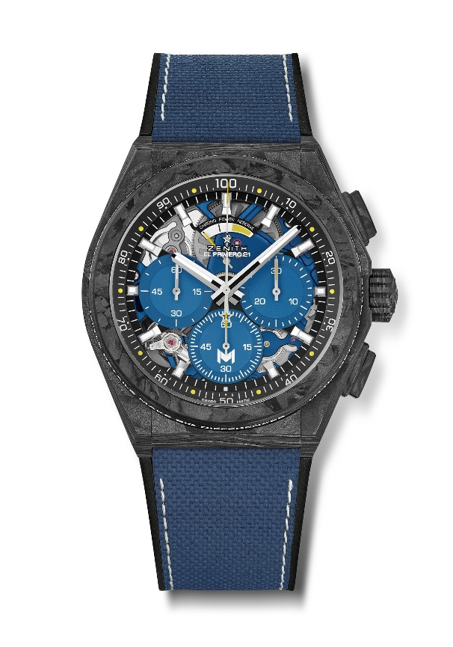
DEFY 21 PATRICK MOURATOGLOU EDITION
Reference: 10.9000.9004/M99.R939

Key points:
Full carbon model: case, bezel, pushers, crown and buckle head.
Bezel adorned with Patrick Mouratoglou’s motto: “Little details make big difference”. Sentence engraved and filled with SuperLuminova
1/100th of a second chronograph movement. Exclusive dynamic signature of one rotation per second for the Chrono hand.
1 escapement for the Watch (36,000 VpH - 5 Hz). 1 escapement for the Chronograph (360,000 VpH - 50 Hz). TIME LAB Chronometer certified.
Limited edition of 50 units
Movement : El Primero 9004 automatic
Frequency 36,000 VpH (5 Hz)
Power reserve approx. 50 hours
Blue colored main plate on movement and rotor
Functions:
Hours and minutes in the centre.
1/100th of a second chronograph with yellow dots recalling tennis balls
Central chronograph hand – one turn per second
30-minute counter at 3 o'clock
60-second counter at 6 o'clock with “M” Mouratoglou logo
Chronograph power-reserve indication at 12 o'clock
Material: Black carbon case and bezel. Bezel filled with SLN
Water resistance: 10 ATM
Price 19500 CHF
Dial: Black with 3 blue colored counters inspired from tennis court.
Touch of yellow on the hand of the 6 o’clock counter and on power reserve indication.
Hour markers: Rhodium-plated, faceted and coated with Super-LumiNova SLN
Hands: Rhodium-plated, faceted and coated with Super-LumiNova SLN
Bracelet & Buckle: Black rubber with blue “Cordura effect”.
Titanium double folding clasp with black carbon head.

