THE LONG-AWAITED SUCCESSOR TO THE A386 IS FINALLY HERE: ZENITH PRESENTS THE CHRONOMASTER ORIGINAL – THE 21ST CENTURY RENDITION OF THE MOST ICONIC EL PRIMERO

Original by name, original by substance. Few watches have been as influential and truly iconic as the Zenith A386, which made its debut in 1969 as one of the first steel watches to be equipped with the revolutionary El Primero calibre – the world’s first automatic high-frequency integrated chronograph movement. Over 50 years later, the El Primero remains the benchmark of precision among automatic chronograph movements, giving way to new versions and iterations in a constant evolution of technicity and performance.

While Zenith has paid tribute to many of its emblematic historical references, including gold versions of the A386 in its Chronomaster Revival collection that debuted during the El Primero’s 50th anniversary, a steel re-edition as part of the permanent Zenith collection has long been something that Zenith collectors and chronograph aficionados have been eagerly awaiting. But beyond a modern reinterpretation of this enduring staple among chronographs, Zenith has gone a step further with the Chronomaster Original, which masterfully retains the singular and enduringly relevant design of the A386 while packing the performance of the 21st century version of the El Primero boasting 1/10th of a second precision and time measurement.

Upon a first glance, the Chronomaster Original, and the A386 it’s based on, appear nearly identical. The 38mm round bezel-less steel case with a raised and domed crystal, the pump-style chronograph pushers, the faceted lugs and the mix of radial brushed and polished surfaces throughout are indistinguishable between the past and present models. The steel bracelet has been reimagined, foregoing the open “ladder” design of the 1960s for solid links that are sumptuously chamfered and decorated in the same fashion as the case.

Undoubtedly, the most visually distinctive design element of the A386 is its dial. Its unique aesthetic language includes the emblematic tri-colour chronograph registers in shades of grey and blue, the trapezoid date window at 04:30 and the red chronograph second hand. All these intrinsic parts have been passed down to the Chronomaster Original, with a few subtle updates to match the boost in performance. The black inner scale surrounding the dial of the A386, once used to calculate time spent working using a 1/100th of an hour time division system, finds a new purpose in the Chronomaster Original, with its 1/10th of a second chronograph hand making a rotation around the dial in 10 seconds, totalling 100 measurable time units. Substituting the tachymeter scale on the outer circumference on the dial, a 1/10th of a second chronograph scale takes its place, allowing for the measurement and reading of elapsed time in precise fractions of a second. And for instantaneous, precise reading of the 10th of a second, the paddle-shaped seconds hand of the original A386 has been replaced with a straight, red-lacquered hand. The logo has also been updated to the more contemporary script Zenith uses today.

The result of 50 years of gradual improvement and a true mastery of the automatic high-frequency chronograph movement, the Chronomaster Original is equipped with the latest version of the El Primero calibre, dubbed the El Primero 3600. With its high frequency of 5 Hz (36’000 VpH), the movement is able to precisely offer a true 1/10th of second indication. Its autonomy has also been rendered more efficient, with an extended power reserve of 60 hours. Visible through the sapphire display back, the new architecture features a sleeker and more open design, revealing a blue column wheel and open rotor marked with the five-pointed star Zenith.

Apart from the signature steel with tri-colour dial configuration, the Chronomaster Original is available in two other versions: A steel case with a “reverse panda” black dial with silver chronograph registers, and an 18k rose gold version with the tri-colour dial.

They say true icons never fade away. The Chronomaster Original not only upholds the legacy of the A386, one of the most important chronograph wristwatches ever made, but sets a new standard of exemplary performance through the Zenith Manufacture’s everlasting pursuit of precision. The collection is available now at Zenith Boutiques, e-commerce and authorized retailers around the world.
ZENITH: TIME TO REACH YOUR STAR.

Zenith exists to inspire individuals to pursue their dreams and make them come true – against all odds. Since its establishment in 1865, Zenith became the first watch manufacture in the modern sense of the term, and its watches have accompanied extraordinary figures that dreamt big and strived to achieve the impossible – from Louis Blériot’s history-making flight across the English Channel to Felix Baumgartner’s record-setting stratospheric free-fall jump. Zenith is also highlighting visionary and trailblazing women – past and present – by celebrating their accomplishments and creating in 2020 its first-ever collection dedicated entirely to them, Defy Midnight.

With innovation as its guiding star, Zenith features exceptional in-house developed and manufactured movements in all its watches. Since the creation of the El Primero in 1969, the world’s first automatic chronograph calibre, Zenith has gone on to master fractions of the second with the Chronomaster Sport and its 1/10th of a second precision and the DEFY 21 with a precision of 1/100th of a second. Zenith has been shaping the future of Swiss watchmaking since 1865, accompanying those who dare to challenge themselves and break barriers. The time to reach your star is now.

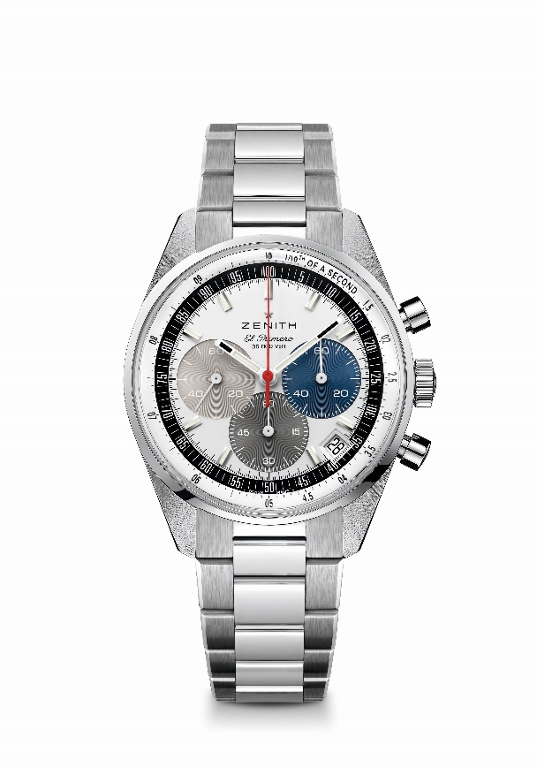
Chronomaster Original
Reference: 03.3200.3600/69.M3200

Key points: Automatic El Primero column-wheel chronograph able to measure and display 1/10th of a second. Increased power reserve of 60 hours. Date indication at 4:30. Stop-second mechanism
Movement: El Primero 3600 Automatic
Frequency: 36,000 VpH (5 Hz)
Power reserve: approx. 60 hours
Functions: Hours and minutes in the centre. Small seconds at nine o’clock. 1/10th of a second Chronograph: central chronograph hand that makes one turn in 10 seconds, 60 minute counter at six o’clock, 60 second counter at three o’clock.
Case: 38-mm
Material: stainless steel
Dial: Silver with three-colors sub dials signature
Water-resistance: 5 ATM
Caseback: sapphire crystal
Price: 8900 CHF
Hour-markers: Rhodium-plated, faceted and coated with Super-LumiNova®SLN C1
Hands: Rhodium-plated, faceted and coated with Super-LumiNova®SLN C1
Bracelet & Buckle: Stainless steel bracelet and stainless steel double folding clasp.

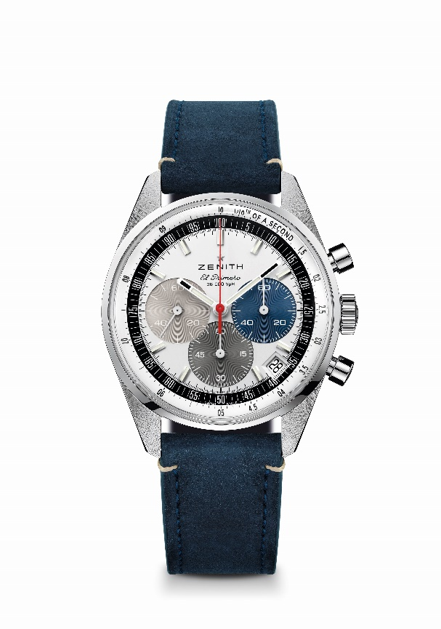
Chronomaster Original
Reference: 03.3200.3600/69.C902

Key points: Automatic El Primero column-wheel chronograph able to measure and display 1/10th of a second. Increased power reserve of 60 hours. Date indication at 4:30. Stop-second mechanism
Movement: El Primero 3600 Automatic
Frequency: 36,000 VpH (5 Hz)
Power reserve: approx. 60 hours
Functions: Hours and minutes in the centre. Small seconds at nine o’clock. 1/10th of a second Chronograph: central chronograph hand that makes one turn in 10 seconds, 60 minute counter at six o’clock, 60 second counter at three o’clock.
Case: 38-mm
Material: stainless steel
Dial: Silver with three-colors sub dials signature
Water-resistance: 5 ATM
Caseback: sapphire crystal
Price: 8400 CHF
Hour-markers: Rhodium-plated, faceted and coated with Super-LumiNova®SLN C1
Hands: Rhodium-plated, faceted and coated with Super-LumiNova®SLN C1
Bracelet & Buckle: Blue calfskin strap with stainless steel triple folding clasp.

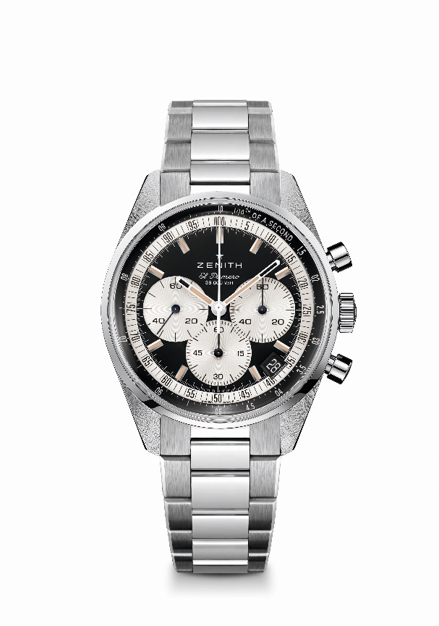
Chronomaster Original
Reference: 03.3200.3600/21.M3200

Key points: Automatic El Primero column-wheel chronograph able to measure and display 1/10th of a second. Increased power reserve of 60 hours. Date indication at 4:30. Stop-second mechanism
Movement: El Primero 3600 Automatic
Frequency: 36,000 VpH (5 Hz)
Power reserve: approx. 60 hours
Functions: Hours and minutes in the centre. Small seconds at nine o’clock. 1/10th of a second Chronograph: central chronograph hand that makes one turn in 10 seconds, 60 minute counter at six o’clock, 60 second counter at three o’clock.
Case: 38-mm
Material: stainless steel
Dial: Black matte with silver-toned counters
Water-resistance: 5 ATM
Caseback: sapphire crystal
Price: 8900 CHF
Hour-markers: Rhodium-plated, faceted and coated with beige Super-LumiNova®SLN
Hands: Rhodium-plated, faceted and coated with beige Super-LumiNova®SLN
Bracelet & Buckle: Stainless steel bracelet and stainless steel double folding clasp

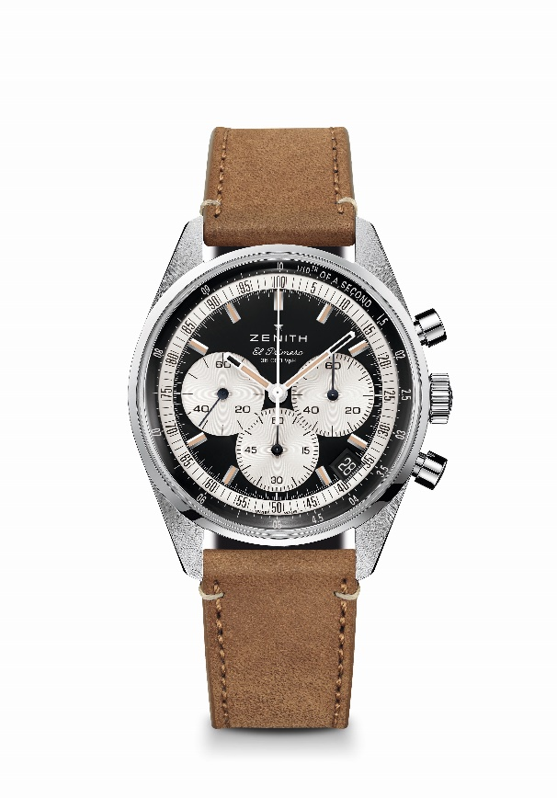
Chronomaster Original
Reference: 03.3200.3600/21.C903
Key points: Automatic El Primero column-wheel chronograph able to measure and display 1/10th of a second. Increased power reserve of 60 hours. Date indication at 4:30. Stop-second mechanism
Movement: El Primero 3600 Automatic
Frequency: 36,000 VpH (5 Hz)
Power reserve: approx. 60 hours
Functions: Hours and minutes in the centre. Small seconds at nine o’clock. 1/10th of a second Chronograph: central chronograph hand that makes one turn in 10 seconds, 60 minute counter at six o’clock, 60 second counter at three o’clock.
Case: 38-mm
Material: stainless steel
Dial: Black matte with silver-toned counters
Water-resistance: 5 ATM
Caseback: sapphire crystal
Price: 8400 CHF
Hour-markers: Rhodium-plated, faceted and coated with beige Super-LumiNova®SLN
Hands: Rhodium-plated, faceted and coated with beige Super-LumiNova®SLN
Bracelet & Buckle: Beige calfskin strap with stainless steel triple folding clasp.

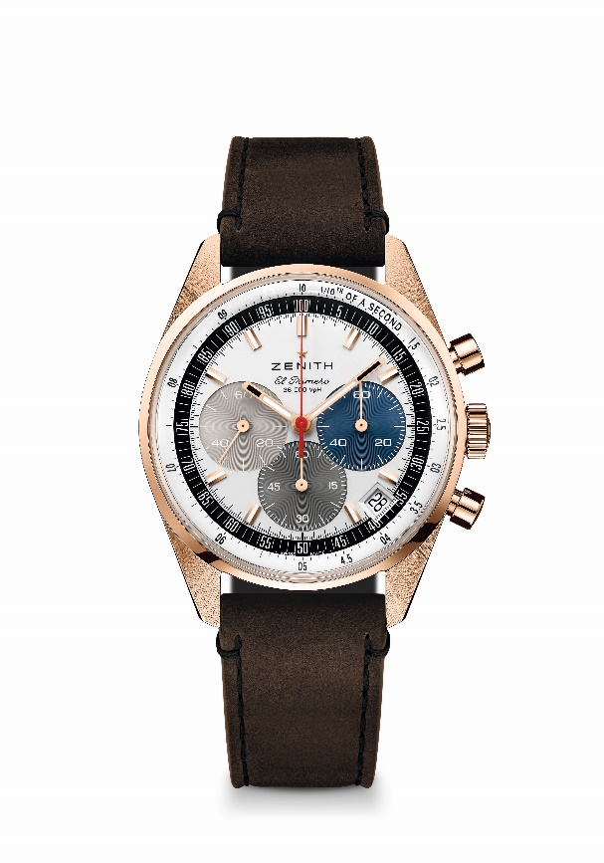
Chronomaster Original
Reference: 18.3200.3600/69.C901

Key points: Automatic El Primero column-wheel chronograph able to measure and display 1/10th of a second. Increased power reserve of 60 hours. Date indication at 4:30. Stop-second mechanism
Movement: El Primero 3600 Automatic
Frequency: 36,000 VpH (5 Hz)
Power reserve: approx. 60 hours
Functions: Hours and minutes in the centre. Small seconds at nine o’clock. 1/10th of a second Chronograph: central chronograph hand that makes one turn in 10 seconds, 60 minute counter at six o’clock, 60 second counter at three o’clock.
Case: 38-mm
Material: 18-ct Rose gold
Dial: Silver with three-colors sub dials signature
Water-resistance: 5 ATM
Caseback: sapphire crystal
Price: 18900 CHF
Hour-markers: Gold-plated, faceted and coated with Super-LumiNova®SLN C1
Hands: Gold-plated, faceted and coated with Super-LumiNova®SLN C1
Bracelet & Buckle: Brown calfskin strap with rose gold triple folding clasp.

