THE EL PRIMERO STEPS INTO THE WILD SIDE WITH THE
CHRONOMASTER REVIVAL SAFARI

When the designers at Zenith asked themselves what an El Primero from 1969 inspired by the great outdoors would look like, they imagined something entirely different from what the Manufacture had produced in over 50 years since the famed calibre’s introduction; something that evoked the vivid colours and textures found on wild terrains with the same utility and ergonomics as its most prized chronographs. The result is the Chronomaster Revival Safari, a lush reinterpretation of a signature vintage chronograph icon.

The geometry and overall proportions of this fresh and modern chronograph are identical to those of the historical A384, but the look and feel of the case couldn’t be more different. Instead of the traditionally finished stainless steel in a mix of satin-brushed and polished surfaces, the Safari is crafted in titanium that’s lighter yet harder than steel. The entire case including the star-emblazoned crown and pump-style pushers are fashioned in an intriguingly muted finish that’s entirely microblasted to bring out the dark nuances of titanium by absorbing light rather than reflecting it.

Exhibiting tones ranging from deep olive-green to cooler spruce tones, the dial of the Chronomaster Revival Safari is a deep matte green with contrasting black registers and tachymeter scale, with a touch of vintage inspiration with its warm beige-coloured SuperLumiNova on the applied baton markers and hands. The white on green date wheel is perfectly camouflaged with the rest of the dial; legible when you need it but never distracting. The rubber and cordura-effect strap takes on the same khaki-green tone as the dial, and is fixed to a matte microblasted titanium pin buckle.

Powering this retro-inspired but resolutely modern and edgy chronograph is the El Primero automatic high-frequency chronograph calibre, visible through the display back. In production since 1969 and gradually evolved throughout the years, this is the closest iteration to the original version of the seminal chronograph movement.

The Chronomaster Revival Safari is ready to go where no El Primero has gone before, and is available from Zenith boutiques & e-commerce from June 2021.

ZENITH: TIME TO REACH YOUR STAR.

Zenith exists to inspire individuals to pursue their dreams and make them come true – against all odds. Since its establishment in 1865, Zenith became the first watch manufacture in the modern sense of the term, and its watches have accompanied extraordinary figures that dreamt big and strived to achieve the impossible – from Louis Blériot’s history-making flight across the English Channel to Felix Baumgartner’s record-setting stratospheric free-fall jump. Zenith is also highlighting visionary and trailblazing women – past and present – by celebrating their accomplishments and creating in 2020 its first-ever collection dedicated entirely to them, Defy Midnight.

With innovation as its guiding star, Zenith features exceptional in-house developed and manufactured movements in all its watches. Since the creation of the El Primero in 1969, the world’s first automatic chronograph calibre, Zenith has gone on to master fractions of the second with the Chronomaster Sport and its 1/10th of a second precision and the DEFY 21 with a precision of 1/100th of a second. Zenith has been shaping the future of Swiss watchmaking since 1865, accompanying those who dare to challenge themselves and break barriers. The time to reach your star is now.

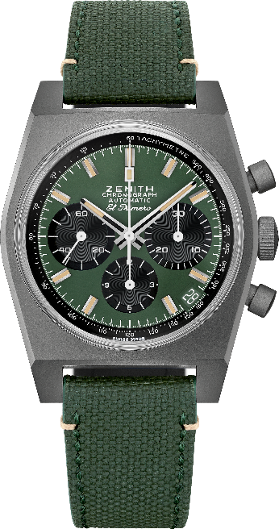
Chronomaster Revival “Safari”
Reference: 97.T384.400.57.C856

Key points: Microblasted titanium case, Original 1969 case with 37mm diameter, Automatic El Primero column-wheel chronograph. Boutiques & e-commerce edition.
Movement: El Primero 400 Automatic
Frequency: 36,000 VpH (5 Hz)
Power reserve: min. 50 hours
Functions: Hours and minutes in the centre. Small seconds at nine o’clock. Chronograph: central chronograph hand, 12-hour counter at six o’clock, 30-minute counter at three o’clock. Tachymetric scale. Date indication at 4:30.
Case: 37-mm
Material: microblasted titanium
Dial: Khaki green with black counters
Water-resistance: 5 ATM
Price: 8900 CHF
Hour-markers: Rhodium-plated, faceted and coated with beige Super-LumiNova®SLN
Hands: Rhodium-plated, faceted and coated with beige Super-LumiNova®SLN
Bracelet & Buckle: Khaki green “cordura effect” strap and white stitching. Microblasted titanium pin buckle.

