ZENITH OPENS THE DOORS TO ITS NEWLY REVAMPED SHANGHAI AND PARIS LE BON MARCHÉ BOUTIQUES WITH TWO EXCLUSIVE ZENITH ICONS COLLECTIONS

Zenith is continuing its revamping of existing boutiques and opening of new to roll-out its new design concept around the world. After the opening of its redesigned Ginza boutique, Zenith now welcomes clients at its freshly refurbished boutiques in Shanghai and Paris to step into the brand’s universe and browse the full range of its watches and exclusive editions. Visitors will be able to discover a different ZENITH ICONS thematic capsule collection of vintage watches at each boutique, which vary in terms of the offering as well as the theme that unites them.

The recently inaugurated Zenith Shanghai flagship boutique on Nanjing West Road is the ultimate destination for watch lovers and Zenith fans in China. With a novel, immersive boutique concept, Zenith has imagined new ways to recount the many stories that have shaped Switzerland’s first and most innovative integrated manufacture.
From the outside, the façade of the Zenith Shanghai flagship boutique incites intrigue and curiosity, with backlit stars taking on the four-pointed shape that was once Zenith’s logo from 1969, composed of intertwined “Z” characters. These stars surrounding the logo light up then fade away, evoking the twinkling stars embellishing the night sky. Upon entering, visitors are greeted to warm neutral tones give way to a central blue element, stretching from the floor to the ceiling and backlit to evoke a starry night sky – a symbolic element central to Zenith’s lore from the time of its foundation.
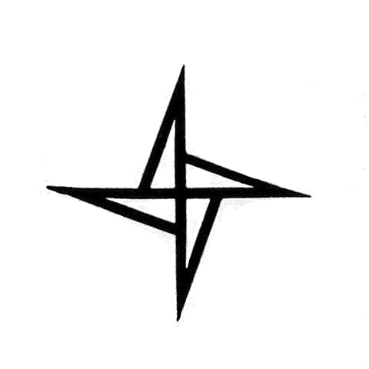

Beyond discovering its watches and comprehensive assortment of limited and exclusive editions, the redesign of the two boutiques in Shanghai and Paris now accommodates a “Story Bar”, allowing visitors to take a moment to relax and delve deeper into the Zenith universe in a surprising and unexpected way. When interacting with any of the various objects on and around the Story Bar, videos about the significance of what these objects represent as well as the inspirational stories of individuals from Zenith’s past and present begin to play on a screen at the end of the bar. Each of the brand’s four main collections are displayed in specially coloured and designed display cases. And for those who prefer privacy while shopping, the cosy VIP room allows for a more intimate experience.

The Shanghai flagship boutique is the second to receive its own ZENITH ICONS thematic capsule collection, featuring some of the earliest and most important El Primero references in steel from 1969 to 1972 in what has been dubbed “ZENITH ICONS – ACT I”.

For the Paris Le Bon Marché Boutique, a new type of category within ZENITH ICONS is making its debut, where the capsule collection highlights some of the historical references that have inspired current Zenith creations rather than a specific period. Named “ZENITH ICONS – GENESIS – Chronomaster Sport”, this capsule collection explores some of the most emblematic past models from which the Chronomaster Sport has taken design cues from.

ZENITH ICONS – ACT I @ Shanghai Boutique
A384
The A384 made its debut in 1969 as the face of the El Primero that figured on launch press cuttings and on the cover of the first El Primero brochures. It stands out with its "square barrel" case signed with the Zenith 4-pointed star logo and its “panda” dial – which has turned tropical in this case, making it all the more desirable.
A385
One of the original trio of stainless steel references that launched alongside the El Primero calibre, the A385 is the model Zenith chose for its advertisements and photo-shoots in 1969. It left its mark on the era with its "shaded smoky brown" gradient dial, unprecedented at the time, and its "square barrel" case, signed with the Zenith 4-pointed star logo.
A386
What would become the template for Zenith’s signature Chronomaster line, the A386 was launched in 1969 in a more classical round-case with straight lugs variant of the first El Primero-equipped watch. It garnered attention for its unprecedented tri-colour chronograph counters and decimal scale, becoming one of the most significant references in the history of the El Primero calibre and an icon among chronograph wristwatches.
A3818
Nicknamed the “Cover Girl” for its appearance on the cover of Manfred Rössler’s book “Zenith: Swiss Watch Manufacture Since 1865”, the A3818 made its debut in 1971 and stood out for its vertically satin-brushed oxidized blue dial, with a “pyramid track” fractional scale. Only 1’000 examples of the A3818 were produced in total.

ZENITH ICONS – GENESIS – CHRONOMASTER SPORT @ Paris Boutique

A277
A chronograph that predates the El Primero by a year, the A277 was produced from 1968 to 1970 and featured a “reverse panda” dial with a black rotating bezel featuring both dot and baton markers. These types of markings inspired the engraved black ceramic bezel of the Chronomaster Sport.

A386
Perhaps the most iconic of all Zenith El Primero chronographs, the A386 was launched in 1969 and is immediately recognizable with its tri-colour chronograph counters; a design element that has been transmitted across generations of the Chronomaster line, including the Chronomaster Sport.

El Primero “De Luca”
Produced between 1988 and 1996, the El Primero "De Luca" line was featured several references throughout the years with different dial configurations. Across the series however, the De Luca was always fitted on a steel three-link bracelet with satin-brushed side links and polished centre links; a predecessor to the Chronomaster Sport’s metal bracelet in form and finish.

