ZENITH CELEBRATES ONE OF ITS MOST EMBLEMATIC DESIGN ELEMENTS IN THE TRI-COLOURFUL ONLINE-EXCLUSIVE CHRONOMASTER ORIGINAL

Since the launch of the A386 in 1969, the tri-colour chronograph counters have become one of Zenith’s most instantly recognizable traits that has been prominently featured in many El Primero-equipped models over the years. Now, Zenith is proposing the ultimate creation for lovers of the tri-colour dial with its most extensive use of the three iconic shades of grey and blue yet and going beyond just the dial in the Chronomaster Original E-commerce edition, exclusively available on the Zenith online boutique.

Serving customers from around the world for just over a year, the Zenith online boutique now welcomes its second exclusive creation, the Chronomaster Original E-commerce edition. Launched earlier this summer, the new Chronomaster Original reinterprets the iconic A386 steel El Primero reference from 1969 with the latest generation of the acclaimed automatic chronograph calibre – a veritable successor to one of the most coveted automatic chronographs ever made. Its 38mm bezel-less steel case retains the same proportions as the original, along with the pump-style pushers and raised glass “box”. In contrast, the movement within it beating at the high frequency of 5Hz (36’000 VpH) is the El Primero 3600, a redesigned evolution of the original that allows for a 1/10th of a second chronograph function as well as an extended power reserve of 60 hours; all in a more modern and open architecture with sleek grey tones.

One of the most distinguishable features of the Chronomaster Original and the A386 that came before is the tri-colour dial. A striking design element that has become synonymous with the El Primero, the dial of this online-exclusive Chronomaster Original goes even further chromatically to celebrate the tri-colour theme. Surrounding the main portion of the dial, is split into three sections that take on the same shades of grey and blue as the chronograph counters. The scale surrounding the dial is a historical feature of the A386 that has been cleverly readapted to the Chronomaster Original. Beyond simply adding a vibrant touch of colour to the dial, the division of the scale into three distinct portions in the E-Commerce edition simplifies reading the 1/10th of a second scale. This marks the first time that another part of the dial besides the chronograph counters are fashioned in the three colours that are linked to the El Primero.

The tri-colour theme also extends to the strap, which is made of dark grey nubuck leather matching the chronograph’s minute counter at 6 o’clock of the dial, while a looped stitch is done in blue on the right side matching the chronograph’s second counter at 3 0’clock, and a light grey stitch on the left side matching the running seconds register for a subtle but remarkable nod to the most iconic Zenith dial of all.

Joining a handful of other exclusive and special editions online, the Chronomaster Original E-commerce edition is delivered in a special watch box that mimics the look of a coffee table book, depicting a 2D drawing of the watch on the cover. Upon opening the box, buyers will have the pleasant surprise of discovering a small gift to complete the tri-colour experience and share the passion around. Three different postcards fashioned in the signature shades of grey and blue depict the watch in a minimalist flat style; instantly recognizable as the iconic Zenith El Primero chronograph.

Offering a unique and colourful twist on the modern El Primero staple, The Chronomaster Original E-commerce edition celebrates the tri-colour dial in a striking yet cohesive manner and is available as of now exclusively on the Zenith online boutique.

ZENITH: TIME TO REACH YOUR STAR.

Zenith exists to inspire individuals to pursue their dreams and make them come true – against all odds. Since its establishment in 1865, Zenith became the first watch manufacture in the modern sense of the term, and its watches have accompanied extraordinary figures that dreamt big and strived to achieve the impossible – from Louis Blériot’s history-making flight across the English Channel to Felix Baumgartner’s record-setting stratospheric free-fall jump. Zenith is also highlighting visionary and trailblazing women – past and present – by celebrating their accomplishments and creating in 2020 its first-ever collection dedicated entirely to them, Defy Midnight.

With innovation as its guiding star, Zenith features exceptional in-house developed and manufactured movements in all its watches. Since the creation of the El Primero in 1969, the world’s first automatic chronograph calibre, Zenith has gone on to master fractions of the second with the Chronomaster Sport and its 1/10th of a second precision and the DEFY 21 with a precision of 1/100th of a second. Zenith has been shaping the future of Swiss watchmaking since 1865, accompanying those who dare to challenge themselves and break barriers. The time to reach your star is now.

Chronomaster Original E-commerce
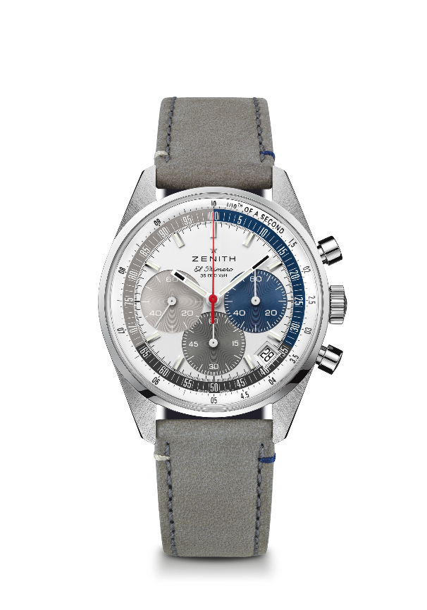
Reference: 03.3200.3600/34.C869

Key points: Automatic El Primero column-wheel chronograph able to measure and display 1/10th of a second. Increased power reserve of 60 hours. Date indication at 4:30. Stop-second mechanism. E-commerce exclusive.
Movement: El Primero 3600 Automatic
Frequency: 36,000 VpH (5 Hz)
Power reserve: approx. 60 hours
Functions: Hours and minutes in the centre. Small seconds at nine o’clock. 1/10th of a second Chronograph: central chronograph hand that makes one turn in 10 seconds, 60 minute counter at six o’clock, 60 second counter at three o’clock.
Case: 38-mm
Material: stainless steel
Dial: White-lacquered dial with three different colored counters & special 1/10th of a second scale divided in three colors
Water-resistance: 5 ATM
Caseback: sapphire crystal
Price: 8400 CHF
Hour-markers: Rhodium-plated, faceted and coated with Super-LumiNova®SLN C1
Hands: Rhodium-plated, faceted and coated with Super-LumiNova®SLN C1
Bracelet & Buckle: Grey calfskin leather with special stitchings and stainless steel triple folding clasp.

