THE DOORS ARE OPEN: ZENITH CELEBRATES THE OPENING OF ITS BOUTIQUE IN SWITZERLAND WITHIN ITS MANUFACTURE WITH THE LAUNCH OF THE CHRONOMASTER ORIGINAL BOUTIQUE EDITION

The time has finally come for Zenith to open the doors to its one and only boutique in Switzerland in the most symbolic location of all: its Manufacture in Le Locle. Long regarded as the birthplace of the very first vertically integrated Swiss watchmaking site in 1865, the Zenith Manufacture makes for a uniquely immersive watch shopping experience. Whether to immortalize a memorable tour of the Manufacture or to purchase a Zenith timepiece from the place of its creation, the Zenith Manufacture Boutique is the perfect place to dive into Zenith’s lore while shopping its full range of watches in a harmonious space blending centuries-old tradition with a contemporary atmosphere.

Upon arriving at the Manufacture in Le Locle, visitors are ushered to the boutique area, where warm neutral tones are juxtaposed against a stretching central blue element from the floor to the spiralling staircase that’s backlit to evoke a starry night sky – a symbolic element central to Zenith’s lore from the time of its foundation and a nod to its “Time to Reach Your Star” philosophy. For those wanting to learn more about Zenith, the “Story Bar” allows visitors to take a moment while diving deeper into the Zenith universe in a surprising and unexpected way. When interacting with any of the four objects behind the Story Bar, videos about the significance of what these objects represent as well as the inspirational stories of individuals from Zenith’s past and present begin to play on the screen. Making the visit of its Manufacture Boutique more convenient, visitors can book an appointment in advance through the Zenith website and request to see specific models prior to their arrival or place orders remotely.

To celebrate the opening of its Manufacture boutique, Zenith introduces its latest boutique-exclusive special edition, the Chronomaster Original Boutique Edition. This special edition combines the instantly recognizable and lauded design codes of the earliest El Primero steel chronographs from 1969 with the iconic automatic high-frequency chronograph calibre’s latest iteration that measures and displays elapsed time in 1/10th fractions of a second. Making this Boutique Edition is the striking blue dial, paired with silver chronograph registers for a historically inspired yet totally original look. The Zenith Blue colour is central to the identity of the brand, from the starry night sky that inspired its founder over 150 years ago to the striking colour found in many of its movements and dials. Available on either a steel bracelet or blue calfskin leather strap, the Chronomaster Original Boutique Edition is available at all Zenith boutiques around the world as well its online shop.

The Zenith Manufacture is excited to be able to offer guided tours on a regular basis again. Whether group tours organized by the Neuchâtel Tourism Office or private group visits, the entire team at the Manufacture is eager to share its passion and unparalleled history with newcomers and seasoned Zenith aficionados alike.

Offering ever more immersive and educational experiences for those who embark to visit the Zenith Manufacture in Le Locle, a Watch Clinic workshop is now proposed with three distinct modules adapted to each visitor’s level of knowledge and interest. Lasting up to three hours and available in four languages, the modules include a basic course on how mechanical movements function, a chronograph course that delves into the specifics of the El Primero 3600 1/10th of a second chronograph function and finally, for those with a passion for vintage watches, a course on restoration watchmaking and how Zenith preserves its historical works. Whichever workshop one chooses, it is bound to be a unique and memorable experience to cherish.

The Zenith Manufacture now welcomes visitors to discover upon request its restoration atelier, where they can witness the meticulous process of restoring Zenith Icons and vintage Zenith watches back to their former glory. With its archives spanning the entire company’s history, the restoration department can work on any watch that Zenith has produced since 1865. Visitors can witness the immensity of the archives, a veritable time capsule within the Manufacture.

ZENITH: TIME TO REACH YOUR STAR.

Zenith exists to inspire individuals to pursue their dreams and make them come true – against all odds. Since its establishment in 1865, Zenith became the first watch manufacture in the modern sense of the term, and its watches have accompanied extraordinary figures that dreamt big and strived to achieve the impossible – from Louis Blériot’s history-making flight across the English Channel to Felix Baumgartner’s record-setting stratospheric free-fall jump. Zenith is also highlighting visionary and trailblazing women – past and present – by celebrating their accomplishments and creating in 2020 its first-ever collection dedicated entirely to them, Defy Midnight.

With innovation as its guiding star, Zenith features exceptional in-house developed and manufactured movements in all its watches. Since the creation of the El Primero in 1969, the world’s first automatic chronograph calibre, Zenith has gone on to master fractions of the second with the Chronomaster Sport and its 1/10th of a second precision and the DEFY 21 with a precision of 1/100th of a second. Zenith has been shaping the future of Swiss watchmaking since 1865, accompanying those who dare to challenge themselves and break barriers. The time to reach your star is now.

Chronomaster Original Boutique Edition
Reference: 03.3200.3600/51.M3200

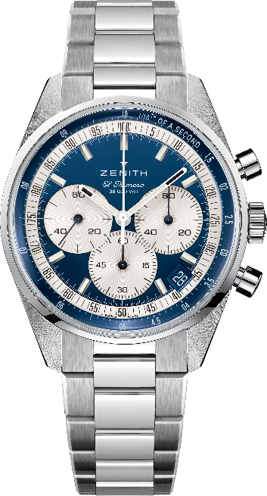
Key points: Automatic El Primero column-wheel chronograph able to measure and display 1/10th of a second. Increased power reserve of 60 hours. Date indication at 4:30. Stop-second mechanism
Movement: El Primero 3600 Automatic. Boutique edition.
Frequency: 36,000 VpH (5 Hz)
Power reserve: approx. 60 hours
Functions: Hours and minutes in the centre. Small seconds at nine o’clock. 1/10th of a second Chronograph: central chronograph hand that makes one turn in 10 seconds, 60-minute counter at six o’clock, 60 second counter at three o’clock.
Case: 38-mm
Material: stainless steel
Dial: Blue-toned with silver-toned counters
Water-resistance: 5 ATM
Caseback: sapphire crystal
Price: 8900 CHF
Hour-markers: Rhodium-plated, faceted and coated with Super-LumiNova®SLN C1
Hands: Rhodium-plated, faceted and coated with Super-LumiNova®SLN C1
Bracelet & Buckle: Stainless steel bracelet and stainless steel double folding clasp.

Chronomaster Original Boutique Edition
Reference: 03.3200.3600/51.C902

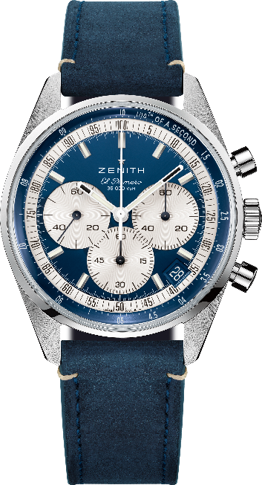
Key points: Automatic El Primero column-wheel chronograph able to measure and display 1/10th of a second. Increased power reserve of 60 hours. Date indication at 4:30. Stop-second mechanism
Movement: El Primero 3600 Automatic. Boutique edition.
Frequency: 36,000 VpH (5 Hz)
Power reserve: approx. 60 hours
Functions: Hours and minutes in the centre. Small seconds at nine o’clock. 1/10th of a second Chronograph: central chronograph hand that makes one turn in 10 seconds, 60-minute counter at six o’clock, 60 second counter at three o’clock.
Case: 38-mm
Material: stainless steel
Dial: Blue-toned with silver-toned counters
Water-resistance: 5 ATM
Caseback: sapphire crystal
Price: 8400 CHF
Hour-markers: Rhodium-plated, faceted and coated with Super-LumiNova®SLN C1
Hands: Rhodium-plated, faceted and coated with Super-LumiNova®SLN C1
Bracelet & Buckle: Blue calfskin leather strap with stainless steel triple folding clasp.

