ZENITH UNVEILS REINTERPRETATIONS OF THE CHRONOMASTER ORIGINAL AT “MEET THE DREAMHERS” EVENT

Thursday, October 7, Madrid: During the first “MEET THE DREAMHERS” event, where guests were invited to discover a group of accomplished and outspoken women known as the ZENITH DREAMHERS, Zenith unveiled a pair of Chronomaster Original models in diamonds with either a multicoloured mother-of-pearl dial or taupe tri-colour dial. Whether for women seeking a lavish chronograph or men who appreciate its flamboyance, the new Chronomaster Original adorned with precious stones and a playfully chic use of the iconic tri-colour dial are definite showstoppers.

In the first version, the tri-colour dial with chronograph counters in the distinctive shades of grey and blue is replaced by a similar but brighter palette entirely rendered in mother-of-pearl. No less than four different colours of mother-of-pearl are used: White mother-of-pearl for the dial, two shades of blue for the chronograph counters and grey mother-of-pearl for the constant seconds. The second version plays with three tones of taupe-brown in the signature tri-colour layout against a satin-white dial. Making each hour more precious, both dials are set with 9 diamonds for the hour markers.

Perfectly proportioned for both men and women, the 38mm steel case is identical in shape and size to the regular Chronomaster Original, though with the added pop of light and colour brought out by 56 expertly set brilliant white diamonds on the lugs. Rather than take away from the instantly recognizable Chronomaster Original silhouette with its bezel-less constructions and geometric forms, the gem-setting enhances its allure with just the right touch of audacity. Both versions of the Chronomaster Original are paired with sensual and soft calfskin leather straps in either light blue or taupe with tone-on-tone stitching, matching the colours of their dials without taking away from the splendour of the diamond-embellished case and radiant dials.

And while their exteriors are decidedly flamboyant, the new Chronomaster Original references are equipped with a serious feat of mechanical prowess: The latest generation of the renowned automatic chronograph calibre, the El Primero 3600. It beats at the same high frequency of 5Hz (36’000 VpH) as its predecessor, though its performance has been elevated to offer a 1/10th of a second chronograph function. It’s also more efficient, with an extended power reserve of 60 hours. Its design leans towards the contemporary, with a more modern and open architecture finished with sleek grey tones.

MEET THE DREAMHERS: Established in 2020, ZENITH DREAMHERS is far more than a campaign: It’s a platform that gives visionary, independent and inspirational women from all walks of life a space to share their voices and passion with likeminded women who are also reaching their stars against all odds.

A group of selected members of the press were invited to spend the evening with some of the DREAMHERS in a private villa in Madrid and had the opportunity to participate live at a panel discussion about women in the 21st century and the need for change towards more inclusiveness and equal rights. The panel discussion was broadcasted live on social media. Among the Zenith DREAMHERS that participated in the inaugural physical event were contemporary artist Teresa Juevas, chef Amandine Chaignot, professional ballerina Precious Adams, fashion retail pioneer Ghizlan Guenez, influencer and beauty entrepreneur Laura Noltemeyer and former Miss Switzerland and medical professional Laetitia Guarino.

The MEET THE DREAMHERS event also allowed guests to get hands-on with new accessories for the DEFY Midnight, Zenith’s first-ever collection dedicated entirely to women. One of its most adored features is its quick strap-change mechanism, allowing the wearer to quickly swap between the supplied steel bracelet and rubber or fabric straps without requiring any tools. Guests were invited to try on the new 100% vegan leather straps that look and feel like leather, available in khaki and beige colours with more options coming soon.

ZENITH: TIME TO REACH YOUR STAR.

Zenith exists to inspire individuals to pursue their dreams and make them come true – against all odds. Since its establishment in 1865, Zenith became the first watch manufacture in the modern sense of the term, and its watches have accompanied extraordinary figures that dreamt big and strived to achieve the impossible – from Louis Blériot’s history-making flight across the English Channel to Felix Baumgartner’s record-setting stratospheric free-fall jump. Zenith is also highlighting visionary and trailblazing women – past and present – by celebrating their accomplishments and creating the DREAMHERS platform where women share their experiences and inspire others to fulfill their dreams.

Zenith exclusively uses its own in-house developed and manufactured movements across all of its watches. Since the creation of the El Primero in 1969, the world’s first automatic chronograph calibre, Zenith has gone on to master the complication with even more precision, capable of measurements to the closest 1/10th of a second in the most recent Chronomaster lines, and 1/100th of a second in the DEFY collection. Zenith has been shaping the future of Swiss watchmaking since 1865, accompanying those who dare to challenge themselves and break barriers. The time to reach your star is now.

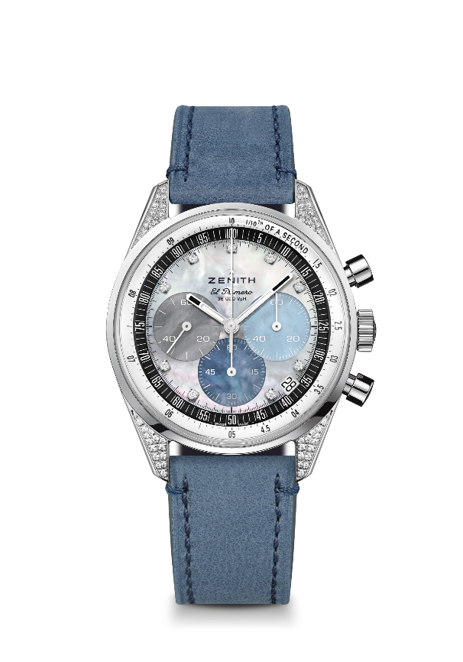
Chronomaster Original
Reference: 16.3200.3600/02.C907

Key points: Automatic El Primero column-wheel chronograph able to measure and display 1/1 0th of a second. Increased power reserve of 60 hours. Date indication at 4:30. Stop-second mechanism
Movement: El Primero 3600 Automatic
Frequency: 36,000 VpH (5 Hz)
Power reserve: approx. 60 hours
Functions: Hours and minutes in the centre. Small seconds at nine o’clock. 1/10th of a second Chronograph: central chronograph hand that makes one turn in 10 seconds, 60 minute counter at six o’clock, 60 second counter at three o’clock.
Case: 38-mm
Material: stainless steel set with diamonds
Dial: Mother-of-Pearl : 4 different colors of MOP
Gemsetting: Total carats ~0.22 cts, Stones (lugs) 56 VS brilliant-cut diamonds, Stones (dial) 9 VS brilliant-cut diamonds
Water-resistance: 5 ATM
Caseback: sapphire crystal
Price: 12900 CHF
Hour-markers: 9 applied diamonds indices
Hands: Rhodium-plated, faceted and coated with Super-LumiNova®SLN C1
Bracelet & Buckle: Light blue calfskin leather strap and stainless steel triple folding clasp.

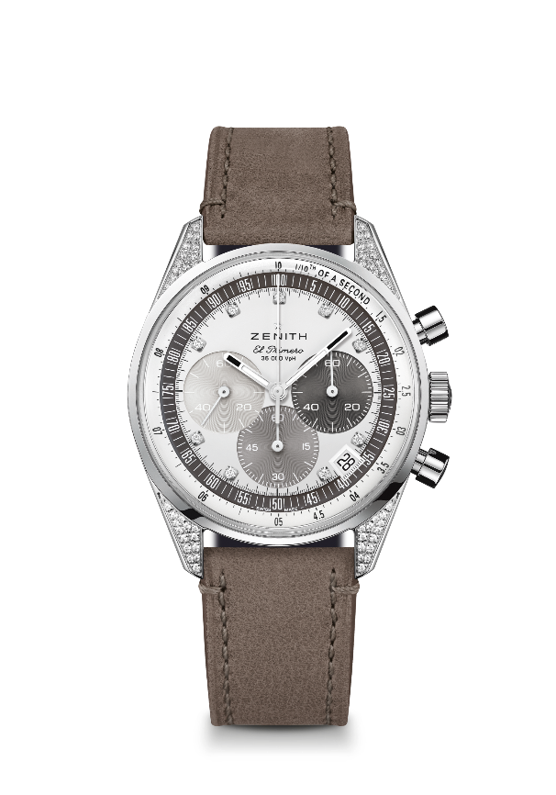
Chronomaster Original
Reference: 16.3200.3600/03.C906

Key points: Automatic El Primero column-wheel chronograph able to measure and display 1/1 0th of a second. Increased power reserve of 60 hours. Date indication at 4:30. Stop-second mechanism
Movement: El Primero 3600 Automatic
Frequency: 36,000 VpH (5 Hz)
Power reserve: approx. 60 hours
Functions: Hours and minutes in the centre. Small seconds at nine o’clock. 1/10th of a second Chronograph: central chronograph hand that makes one turn in 10 seconds, 60 minute counter at six o’clock, 60 second counter at three o’clock.
Case: 38-mm
Material: stainless steel set with diamonds
Dial: Silver-toned velvet-finish with 3 shades of Taupe coloured counters
Gemsetting: Total carats ~0.22 cts, Stones (lugs) 56 VS brilliant-cut diamonds, Stones (dial) 9 VS brilliant-cut diamonds
Water-resistance: 5 ATM
Caseback: sapphire crystal
Price: 11900 CHF
Hour-markers: 9 applied diamonds indices
Hands: Rhodium-plated, faceted and coated with Super-LumiNova®SLN C1
Bracelet & Buckle: Light brown calfskin leather strap and stainless steel triple folding clasp.

