ZENITH CONTINUES TO SUPPORT THE GLOBAL MOVEMENT OF BREAST CANCER AWARENESS BY CREATING A UNIQUE DEFY MIDNIGHT FOR PINK RIBBON SWITZERLAND’S ANNUAL CHARITY AUCTION

On October 30, 2021, at the prestigious Dolder Grand Hotel overlooking Zürich, Pink Ribbon Switzerland – a charitable organization that spreads awareness about the disease and the importance of early detection through various activities and fundraising initiative – will host its annual music gala with a charity auction where a unique Zenith DEFY Midnight will be offered for sale.

This year, the 11th annual Pink Ribbon breast cancer gala will take place at the Dolder Grand Hotel, where guests can look forward to an evening full of culinary delights and emotional highlights. Numerous Swiss artists and personalities will be joining, with presenter Sven Epiney hosting the evening’s various activities. A silent auction will be held during the gala dinner, where several one-off items will be sold to help finance breast cancer studies for young patients of the "International Breast Cancer Study Group", one of the few research projects that focuses on early detection of a breast cancer in a younger demographic of women.

Among the lots in the silent auction is a truly exceptional piece of watchmaking for the modern, confident woman that forges her own path in life. The DEFY Midnight Pink Ribbon edition is a unique piece created exclusively for the Pink Ribbon gala. Perfectly proportioned for any wrist, the DEFY Midnight is crafted in a 36mm steel case with contemporary sleek lines. What makes this one-off piece so special is its glossy pink dial, with a vertical gradient effect that darkens from the bottom to the top. Embellished with stars and diamond hour-markers, the dial evokes the break of dawn. Further enriching the dial, the bezel is set with 44 pink sapphires of varying colours that are arranged to match the gradient effect of the dial. Like all DEFY Midnight pieces, the Pink Ribbon unique piece comes with a steel bracelet as well as a white rubber strap with pink leather and a black rubber strap with a velvet effect, which can easily be interchanged using the quick strap-change mechanism integrated in the case.

With the donation of this unique piece and its continued support of Pink Ribbon Switzerland, Zenith stands in solidarity with women in the face of breast cancer by spreading awareness and raising funds to promote early detection and develop new treatments.

More information about Pink Ribbon Switzerland and the charity auction can be found here: www.pink-ribbon.ch/gala

ZENITH: TIME TO REACH YOUR STAR.

Zenith exists to inspire individuals to pursue their dreams and make them come true – against all odds. Since its establishment in 1865, Zenith became the first watch manufacture in the modern sense of the term, and its watches have accompanied extraordinary figures that dreamt big and strived to achieve the impossible – from Louis Blériot’s history-making flight across the English Channel to Felix Baumgartner’s record-setting stratospheric free-fall jump. Zenith is also highlighting visionary and trailblazing women – past and present – by celebrating their accomplishments and creating in 2020 its first-ever collection dedicated entirely to them, Defy Midnight.

With innovation as its guiding star, Zenith features exceptional in-house developed and manufactured movements in all its watches. Since the creation of the El Primero in 1969, the world’s first automatic chronograph calibre, Zenith has gone on to master fractions of the second with the Chronomaster Sport and its 1/10th of a second precision and the DEFY 21 with a precision of 1/100th of a second. Zenith has been shaping the future of Swiss watchmaking since 1865, accompanying those who dare to challenge themselves and break barriers. The time to reach your star is now.

PINK RIBBON SWITZERLAND

In Switzerland, an average of 6,200 women are diagnosed with breast cancer each year and more than 1,400 women die from it. Since 2007 the goal of Pink Ribbon Schweiz is to break a taboo and to draw attention to the importance of early detection, because the earlier a tumor is discovered, the higher the chances of recovery. Pink Ribbon Schweiz wants to save lives with their projects and give with the solidarity events courage and confidence to all patients. With the collected funds Pink Ribbon Schweiz passed on over 2 million Swiss francs to important breast cancer projects and research studies over the past years.

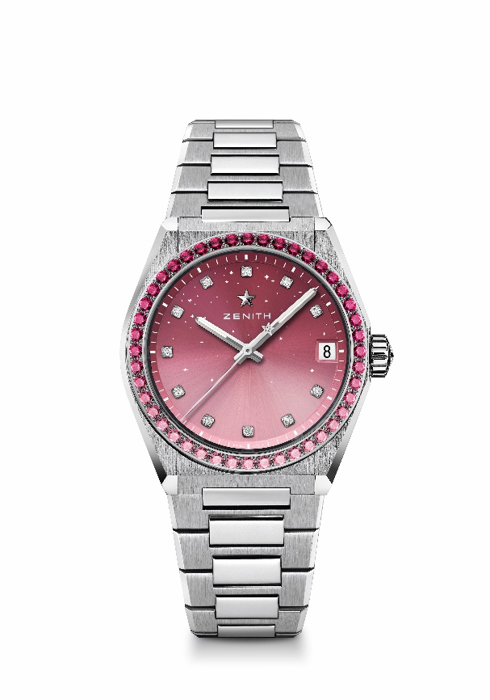
DEFY MIDNIGHT Reference: 16.9201.670/10.MI001
Key points: 36-MM case dedicated for Women. Gradient dial with starry sky pattern. Interchangeable strap system. Unique piece.
Movement: Elite 670 SK, Automatic
Frequency: 28,800 VpH (4Hz)
Power-reserve: min. 50 hours
Functions: Hours and minutes in the centre. Central seconds hand. Date indication at 3 o’clock
Price Estimate 13900-15900 CHF
Gemsetting: Carats 1.9 cts total, Bezel 44 VS brilliant-cut pink gradient sapphires, Dial 11 VS brilliant-cut diamonds
Material: Stainless steel with diamond-set bezel
Water-resistance: 10 ATM
Dial: Gradient pink
Hour-markers: Diamond hour-markers
Hands: Rhodium-plated and faceted, coated with Super-Luminova SLN
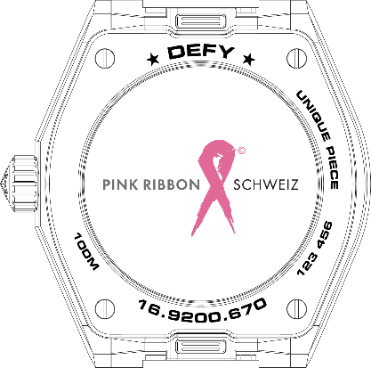
Bracelet & Buckle: Stainless steel with interchangeable strap system. Comes with 2 additional straps: a white rubber strap covered in pink leather and a black rubber strap covered in a velvet effect.

