Zenith and Time+Tide capture the Australian night sky with the Defy Classic Skeleton “Night Surfer”
Le Locle, 12th of October 2021: During an unlikely meeting of Zenith CEO Julien Tornare and Time+Tide Founder, Andrew McUtchen at Zenith’s Le Locle manufacture, the home of the brand since 1865, Zenith and Time+Tide unveiled an exclusive Defy Classic Skeleton model affectionately nicknamed the “Night Surfer”.
The “Night Surfer” is so named for the inspiration that the vertical gradient dial and Zenith logo - comprised for the first time here in Super-LumiNova® - takes from the sky-show that greets surfers who dare to stay out after sunset. Regarded as a national pastime in one of the world's premier surfing destinations, surfing is enjoyed by millions of Australians and is a vital aspect of the coastal lifestyle in many regions. After riding the waves into the sunset, a line of light appears on the horizon. Then, a deepening gradient of blue, fringing to black in the heavens above. And finally, the literal star of the show, an “evening star” appears that, for a time, is the only visible star in the Southern Hemisphere.
The framing for this moment in time, captured by the Night Surfer dial, is a desaturated matt black bezel, care of the microblasted titanium material that is sparingly used across Zenith’s range to always great effect. Together with Time+Tide, Zenith is flexing its creativity in this series of 100 pieces, housing several premieres for the brand, to be exclusively available on Time+Tide platforms and in Zenith physical and online boutiques worldwide.
The meeting is unlikely because Andrew emerged at Le Locle from Melbourne, Australia, the most locked down city in the world for this occasion, and is delighted to launch, with Julien, a model in person after such a long string of virtual releases. While the scope of the event was limited to a tip of two glasses of champagne, the spirit of being in the same place at the same time to mark a special moment was not lost.
“I have spent many years travelling to and from Australia, and this model, for me, really captures what is special about the place, and the power of the natural elements there: The vividness of the sky, the brightness of the evening star, which is presented here as the Zenith logo in luminous material for the first time. It is fitting that I can connect with our Aussie collaborators, Time+Tide, in person to launch this special model,” said Julien Tornare, Zenith CEO.
Andrew McUtchen, founder of Time+Tide added “It’s no secret that the Defy Classic Skeleton is an underrated model on the market, and in the Night Surfer we have sought to highlight its many qualities. The watche’s high polished, gradient, luminous, layered and matt elements give the Defy Classic Skeleton a new way to shine. The results speak for themselves, and are a credit to the creative and production team at Zenith, led by the extraordinary Romain Marietta. This was a tough brief - capture a totally magical natural moment in a timepiece - and he and his team have absolutely crushed it.”
The premieres contained in the watch are as follows: the first microblasted titanium bracelet in a Zenith Defy Classic model. The first Zenith model to have a Zenith star logo comprised of solid Super-LumiNova®. The first Defy Classic Skeleton with a gradient dial. The first Defy Classic Skeleton with a luminous date frame, allowing the day’s date on the skeletonised date wheel to be backlit at night, enabling legibility.

All the existing attributes of the Defy Classic Skeleton 41mm are on hand to impress, including but not limited to 100 metres water-resistance, a stunning exhibition caseback offering a view of the Elite 670SK calibre, and a featherlight weight of just 95 grams on the wrist. A lug-to-lug measurement of 45mm, coupled with a height of a mere 11.4mm defies any categorisations, appealing to wrists equally.
The Zenith Defy Classic Skeleton “Night Surfer” will be limited to 100 pieces, with 50 pieces allocated to Time+Tide and 50 pieces for Zenith boutiques around the world.

ABOUT ZENITH

ZENITH: TIME TO REACH YOUR STAR.

Zenith exists to inspire individuals to pursue their dreams and make them come true – against all odds. Since its establishment in 1865, Zenith became the first watch manufacture in the modern sense of the term, and its watches have accompanied extraordinary figures that dreamt big and strived to achieve the impossible – from Louis Blériot’s history-making flight across the English Channel to Felix Baumgartner’s record-setting stratospheric free-fall jump. Zenith is also highlighting visionary and trailblazing women – past and present – by celebrating their accomplishments and creating the DREAMHERS platform where women share their experiences and inspire others to fulfill their dreams.

Zenith exclusively uses its own in-house developed and manufactured movements across all of its watches. Since the creation of the El Primero in 1969, the world’s first automatic chronograph calibre, Zenith has gone on to master the complication with even more precision, capable of measurements to the closest 1/10th of a second in the most recent Chronomaster lines, and 1/100th of a second in the DEFY collection. Zenith has been shaping the future of Swiss watchmaking since 1865, accompanying those who dare to challenge themselves and break barriers. The time to reach your star is now.

ABOUT TIME+TIDE

Time+Tide is one of the world’s leading publishers of watch content, posting a minimum of three stories a day on the website www.timeandtidewatches.com There is also a regular stream of videos on YouTube, several major print syndication partnerships, and thriving newsfeeds on social media. Time+Tide can tend to pop up on screens where you least expect it, care of partnerships with CNN and other major global media outlets. Time+Tide’s passion for watches is real, and it’s everywhere. The Zenith Defy Classic Skeleton Night Surfer joins just two other Time+Tide Limited Editions.

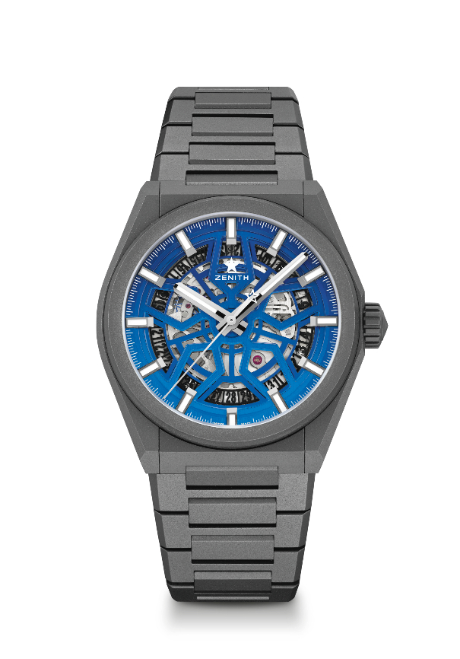
DEFY CLASSIC NIGHT SURFER
Reference: 97.9000.670/26.M9000

Key points: In house Elite skeletonised movement. First ever Microblasted titanium bracelet in a Defy Classic at Zenith, The first Defy Classic Skeleton with a gradient dial, Applied star logo in SuperLuminova, Silicon escape-wheel and lever. Limited edition of 100 pieces: 50 pieces for Zenith Boutiques and at www.zenith-watches.com in the US, 50 pieces for Time+Tide
Movement: Elite 670 SK automatic
Frequency 28,800 VpH (4 Hz)
Power reserve min. 50 hours
Functions : Hours and minutes in the centre. Central seconds hand. Date indication at 6 o'clock
Finishes: Special oscillating weight with satined finishings
Price 8900 CHF
Material: Microblasted titanium
Water resistance: 10 ATM
Diameter: 41 mm
Thickness: 10.75 mm
Dial: Openworked
Hour markers: Rhodium-plated, faceted and coated with Superluminova SLN C1
Hands : Rhodium-plated, faceted and coated with Superluminova SLN C1
Bracelet & Buckle: Microblasted Titanium bracelet.

