INSPIRED BY THE DESERT: ZENITH UNVEILS ITS FIRST LIMITED EDITION OF THE DEFY EXTREME, ACCOMPANIED BY AN EXCLUSIVE SERIES OF PHOTOGRAPHS BY KOUROSH KEYNEJAD

October 20, 2021, Paris: Zenith celebrates the launch of the first special edition of its most rugged chronograph to date, the DEFY Extreme Desert, with acclaimed nature photographer Kourosh Keynejad. Expressing the raw beauty of the desert environment through his eyes and lens, Zenith and Kourosh are embarking together to showcase original and previously unpublished works by the photographer, inspired by the elemental watch. The photographs will be unveiled and sold during a traveling exhibition tour, beginning with FIAC in Paris before making its way to Dubai and Tokyo before the end of the year.

For this first special edition of the rugged DEFY Extreme, Zenith has stepped out onto uncharted territories, resulting in a piece that’s as much precision watchmaking as it is a wearable piece of art. Inspired by the wild and barren desert landscapes, the DEFY Extreme Desert represents a more artistic reimagining of the monolithic 1/100th of a second chronograph, and the first in a developing series of DEFY EXTREME models inspired by extreme environments. Crafted in a titanium case, the Defy Extreme Desert evokes the endless sandy horizon in a singular and unprecedented manner. The component that protects the pushers as well as the dodecagonal bezel are crafted from falcon’s eye, a blue-grey opaque macrocrystalline quartz gemstone that’s named after the bird-of-prey that has accompanied desert nomads for centuries, soaring high above the horizon and symbolizing determination and endurance. When polished, the stone can appear fluid with its chatoyancy, evoking a mirage of an oasis in the scorching desert heat. The hand-working of such an exotic gemstone into an integral part of the complex case’s structure is something that has never been attempted before in any watch. And as each stone is different and exhibits slightly different colours and fibrous structures, each of the 50 DEFY Extreme Desert watches is essentially a unique piece.

The open dial of the DEFY Extreme Desert reveals the inner workings of the El Primero 21 movement beneath, topped by a tinted sapphire crystal for the counters and power reserve indicator in a warm beige-brown hue, complemented by beige luminescent markers and hands as well as applied chronograph counters in a matching tone. Completing the look of this conceptual piece are the supplied durable black Velcro strap and beige rubber strap, which can be easily swapped with the titanium bracelet using the quick strap-change mechanism on the back of the case.

“The DEFY Extreme Desert certainly captures the majestic grandness and inspiring beauty of the dry plateaus and mountains of sand.” Exclaimed Kourosh Keynejad about the DEFY Extreme Desert edition.

After years of traveling solo across the globe to the most extreme and remote destinations and capturing them in stunning images, the British-born photographer based in California has made a name for himself with his breath-taking images, bringing out the unseen beauty of wilderness. This marks the artist’s first project with a brand. Sharing Zenith’s green values of environmental conservation, sustainability and diversity, the connection was natural and immediate. Just as Zenith blends tradition and innovation to craft the future of watchmaking, Kourosh plays with light and colour to create imagery that transports the viewer and deeply resonates the themes and messages that drive his work.

“The only true constant in my field is the sun. We use it to control the days, and watch it paint our world with light. The elements and weather are always unpredictable, but the sun never fails to rise. It rises on time. It sets on time. It’s never late. When Zenith approached me with the idea for a collaboration, I couldn’t have thought of a better fit. Precision of time and light are key to a great photograph. With optimal planning and the flawless engineering of Zenith watches, I never miss my moment.” Shared Kourosh Keynejad about working with Zenith.

“I’ve been following Kourosh’s work for some time now and I have to say, I’m always blown away by the way he’s able to transport us to these faraway, untouched locations and showing us a side of nature that we never really knew – or simply overlooked. The great thing about Kourosh is that by reaching his star, he is also spreading awareness about the environmental issues and challenges that we all must face together.” Shared Zenith CEO, Julien Tornare.

Accompanying the launch of the DEFY Extreme Desert edition, Kourosh has captured an exclusive set of images for Zenith inspired by the evocative chronograph, marking the first time the artist takes on a photography project for a brand. Comprising of nine images in three triptychs with the themes of “Wind Carved Canyons”, “Deserted Dunes” and “Starry Nights”, the photographs were taken across all four deserts in North America: The Great Basin, Mojave, Sonoran and Chihuahuan deserts. Over the coming weeks and months, the photographs can be discovered during a traveling exhibition tour, beginning with FIAC in Paris before making its way to Dubai and Tokyo before the end of the year. The original photographs will be sold during the exhibitions. The DEFY Extreme Desert is available now at all Zenith boutiques around the world as well its online shop.
ZENITH: TIME TO REACH YOUR STAR.

Zenith exists to inspire individuals to pursue their dreams and make them come true – against all odds. Since its establishment in 1865, Zenith became the first watch manufacture in the modern sense of the term, and its watches have accompanied extraordinary figures that dreamt big and strived to achieve the impossible – from Louis Blériot’s history-making flight across the English Channel to Felix Baumgartner’s record-setting stratospheric free-fall jump. Zenith is also highlighting visionary and trailblazing women – past and present – by celebrating their accomplishments and creating the DREAMHERS platform where women share their experiences and inspire others to fulfill their dreams.

Zenith exclusively uses its own in-house developed and manufactured movements across all of its watches. Since the creation of the El Primero in 1969, the world’s first automatic chronograph calibre, Zenith has gone on to master the complication with even more precision, capable of measurements to the closest 1/10th of a second in the most recent Chronomaster lines, and 1/100th of a second in the DEFY collection. Zenith has been shaping the future of Swiss watchmaking since 1865, accompanying those who dare to challenge themselves and break barriers. The time to reach your star is now.

DEFY EXTREME DESERT EDITION
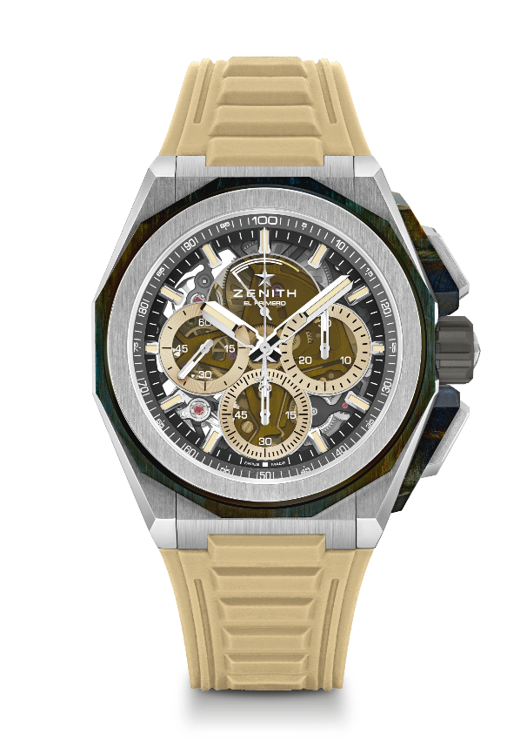
Reference: 95.9200.9004/77.I204

Key points: Pushers protectors & bezel made of Falcon's eye gemstone
Stronger, bolder and more powerful design. Stronger, bolder and more powerful design, 1/100th of a second Chronograph movement, Exclusive dynamic signature of one rotation per second for the Chrono hand, 1 escapement for the Watch (36,000 VpH - 5 Hz) ; 1 escapement for the Chronograph (360,000 VpH - 50Hz), C ertified Chronometer, New Interchangeable strap system, 2 straps included : 1 Rubber with folding buckle & 1 Velcro. Sapphire dial, Screwed-in crown. Limited edition of 50 pieces.
Movement: El Primero 9004 automatic
Frequency 36,000 VpH (5 Hz)
Power reserve min. 50 hours
Functions : Hours and minutes in the centre. Small seconds at 9 o'clock. 1/100th of a second Chronograph: Central chronograph hand that makes one turn each second, 30-minute counter at 3 o'clock, 60-second counter at 6 o'clock, Chronograph power-reserve indication at 12 o'clock.
Finishes: Black colored main plate on movement + Special black colored
oscillating weight with satined finishings
Price 21900 CHF
Material: Brushed titanium & falcon’s eye gemstone
Water resistance: 20 ATM
Diameter: 45 mm
Thickness: 15.40 mm
Dial: Tinted sapphire with three beige-coloured counters
Hour markers: Rhodium-plated, faceted and coated with beige Superluminova
Hands : Rhodium-plated, faceted and coated with beige Superluminova
Bracelet & Buckle: Titanium triple folding clasp and microblasted titanium bracelet. Also comes with a beige rubber strap and a black Velcro® strap.

