THE ZENITH CHRONOMASTER SPORT WINS THE
CHRONOGRAPH PRIZE AT GPHG 2021

Geneva, Thursday November 4, 2021: At the annual Grand Prix d’Horlogerie de Genève, the world of watchmaking’s most prestigious annual award ceremony, the Zenith Chronomaster Sport was distinguished by the jury as the winner of the “Chronograph” category and represents the latest chapter in Zenith’s longstanding legacy of exceptional chronographs.

The Chronomaster line has been one of the most emblematic chronograph collections of the 21st century; steeped in Zenith’s tradition of making exceptional, standard-setting automatic chronographs. Pushing the boundaries of high-frequency precision, the Chronomaster Sport is the culmination point in Zenith’s unequalled legacy of automatic chronographs. Crafted in a sleek and robust steel case measuring 41 mm wide with pump-style pushers, the polished black ceramic bezel sets the new Chronomaster Sport apart from its predecessors. Graduated over 10 seconds, the bezel’s bold contrast offers exceptional legibility on the periphery of the dial.

The result of over 50 years of working and perfecting the El Primero, the Chronomaster Sport line is equipped with the newest version of the legendary calibre, the El Primero 3600. With its high frequency of 5 Hz (36’000 VpH), the movement is able to precisely offer a 1/10th of second function that’s easily readable, displayed directly on the bezel as well as the dial. Its autonomy has also been rendered more efficient, with an extended power reserve of 60 hours. Visible through the sapphire display back, the new architecture is strikingly evident, revealing a blue column wheel and open rotor marked with the five-pointed star Zenith.

Julien Tornare, Zenith CEO stated at the GPHG ceremony: “Today, the teams at the Zenith Manufacture and I are both humbled and proud of this reward. The El Primero, now over 50 years old, was a revolution for Zenith and all of watchmaking when it was released as the world’s first automatic high-frequency chronograph in 1969. Half-a-century later, it still inspires us to continue to innovate and push boundaries. The Chronomaster Sport represents the best of our past and the next chapter of the El Primero’s legacy, with a new level of performance in a dynamic and sporty design. I would like to extend my deepest thanks to the jury and academy members, and to all those who passionately support Zenith.”

ZENITH: TIME TO REACH YOUR STAR.

Zenith exists to inspire individuals to pursue their dreams and make them come true – against all odds. Since its establishment in 1865, Zenith became the first watch manufacture in the modern sense of the term, and its watches have accompanied extraordinary figures that dreamt big and strived to achieve the impossible – from Louis Blériot’s history-making flight across the English Channel to Felix Baumgartner’s record-setting stratospheric free-fall jump. Zenith is also highlighting visionary and trailblazing women – past and present – by celebrating their accomplishments and creating the DREAMHERS platform where women share their experiences and inspire others to fulfill their dreams.

Zenith exclusively uses its own in-house developed and manufactured movements across all of its watches. Since the creation of the El Primero in 1969, the world’s first automatic chronograph calibre, Zenith has gone on to master the complication with even more precision, capable of measurements to the closest 1/10th of a second in the most recent Chronomaster lines, and 1/100th of a second in the DEFY collection. Zenith has been shaping the future of Swiss watchmaking since 1865, accompanying those who dare to challenge themselves and break barriers. The time to reach your star is now.

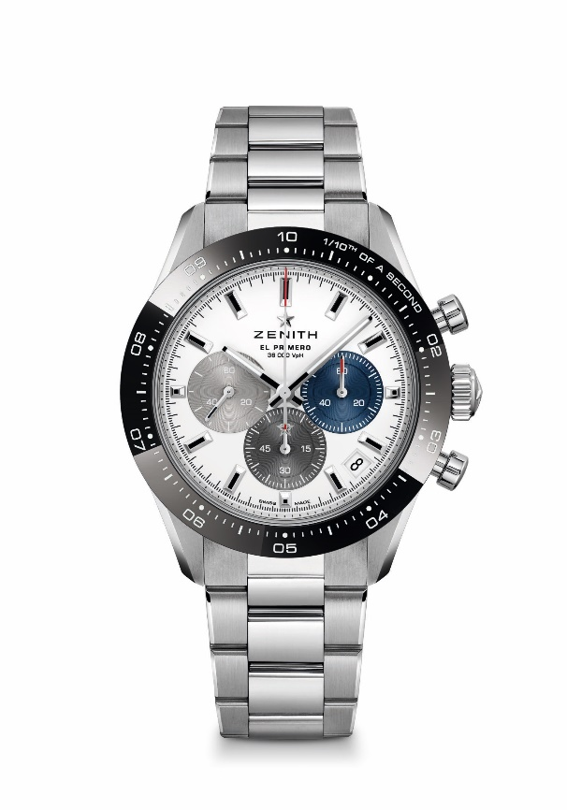
CHRONOMASTER SPORT

Reference : 03.3100.3600/69.M3100 (metal bracelet)
03.3100.3600/69.C823 (blue cordura bracelet)

Movement : El Primero 3600 automatic

Frequency: 36000 VpH (5 Hz)

Power-reserve : min. 60 hours

Functions : Hours and minutes in the centre. Small seconds at 9 o'clock, 1/10th of a second Chronograph: Central chronograph hand that makes one turn in 10 seconds, 60-minute counter at 6 o'clock, 60-second counter at 3 o'clock

Price : 9900 CHF (metal bracelet) & 9400 CHF (Cordura effect bracelet)

Diameter: 41 mm

Material: Stainless steel with black ceramic bezel

Water-resistance: 10 ATM

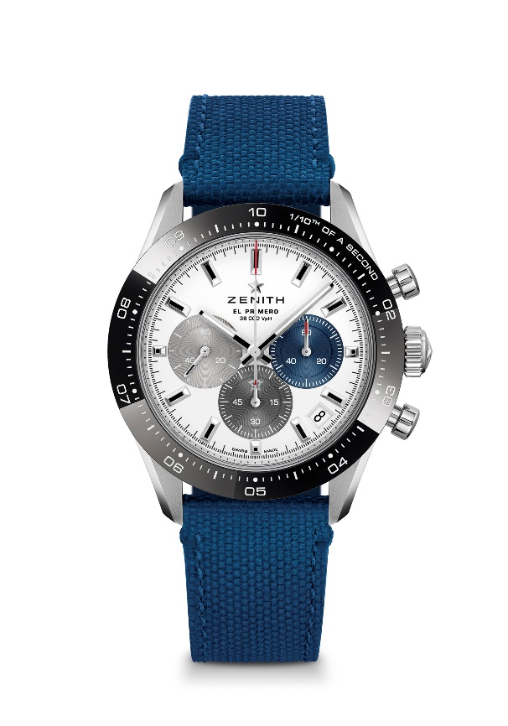
Dial: White matte dial with three different applied coloured counters

Hour-markers: Rhodium-plated, faceted and coated with Super-LumiNova SLN C1

Hands: Rhodium-plated, faceted and coated with Super-LumiNova SLN C1

Bracelet & bucle : Available on metal bracelet or blue rubber bracelet with « Cordura » effect. Double folding clasp with security mechanism.

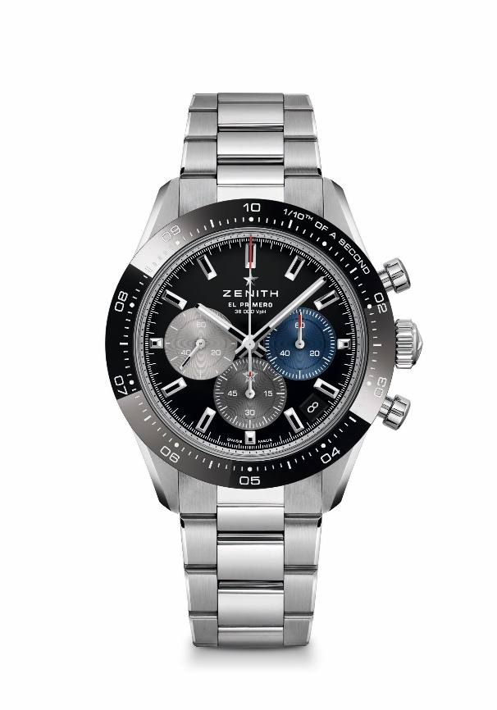
CHRONOMASTER SPORT

Reference: 03.3100.3600/21.M3100 (metal bracelet)
03.3100.3600/21.C822 (black cordura bracelet)

Movement : El Primero 3600 automatic

Frequency: 36000 VpH (5 Hz)

Power-reserve : min. 60 hours

Functions : Hours and minutes in the centre. Small seconds at 9 o'clock, 1/10th of a second Chronograph: Central chronograph hand that makes one turn in 10 seconds, 60-minute counter at 6 o'clock, 60-second counter at 3 o'clock

Price : 9900 CHF (metal bracelet) & 9400 CHF (Cordura effect bracelet)

Diameter: 41 mm

Material: Stainless steel with black ceramic bezel

Water-resistance: 10 ATM
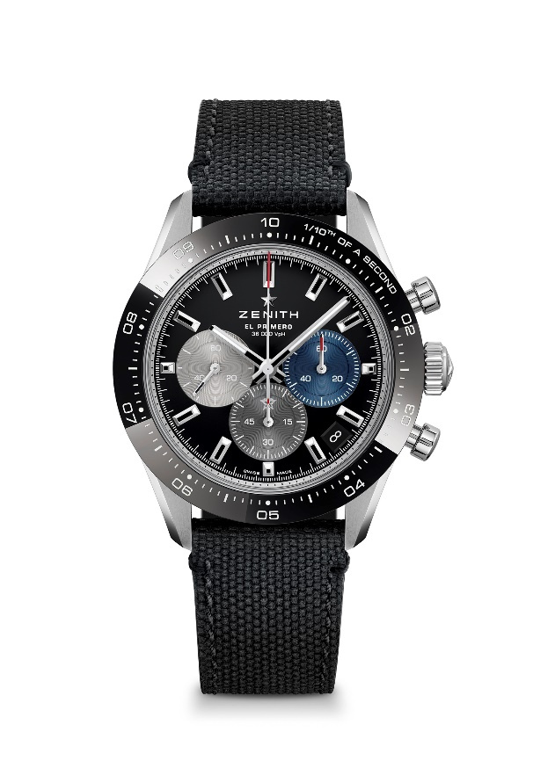
Dial: Black matte dial with three different applied coloured counters

Hour-markers: Rhodium-plated, faceted and coated with Super-LumiNova SLN C1

Hands: Rhodium-plated, faceted and coated with Super-LumiNova SLN C1

Bracelet & bucle : Available on metal bracelet or black rubber bracelet with « Cordura » effect. Double folding clasp with security mechanism.

