Zenith Chronomaster Revival “Poker Chip”

Singapore, November 15, 2021: Zenith and SJX Watches present a sleek reinterpretation of one of the brand’s most desirable vintage watches with the Chronomaster Revival “Poker Chip”, inspired by the El Primero G383. Affectionately nicknamed “Poker Chip” by collectors, the G383 is considered one of the most intriguing models in Zenith’s archives. The G383 was introduced in 1969 and is among the rarest and most sought-after iterations of the early El Primero variants.

Clearly a design with roots in the psychedelic era of the late 1960s, and reminiscent of the A386 and its tri-coloured dial, the G383 was characterised by a wildly sectored layout, making it one of the most extravagant designs of the decade. Developed in partnership with one of Zenith’s trusted dial suppliers at the time, the dial immediately stood out with its boldly alternating colours that recall a poker chip, earning it the nickname. The inimitable style of the G383 formed the genesis of this collaboration, a project that began in May 2020 when Su Jiaxian, founder of Singapore-based watch magazine SJX Watches, reached out to Zenith’s Director of Product & Heritage, Romain Marietta, with a proposal to revive the G383 with a distinctive, modern twist.

The goal for the pair was to reproduce the key elements of the G383, while injecting a sleek, contemporary flavour. That gave birth to the Poker Chip, a design that relies on shades of grey and a generous helping of Super-Luminova to recreate the G383 in daylight – and in darkness.

“I’ve long admired the El Primero for its longevity, and Zenith for its rich heritage,” explains SJX, “I wanted to do something that would combine both the movement and its history, but rather than a remake, I wanted something that might sound like a paradox: a design immediately recognisable as the G383 but unmistakably novel and different.”

The Poker Chip dial is dark grey with printed segments in matte black and Super-Luminova. More “lume” can be found on the hour markers, chronograph scales, as well as the radial patterns around each register. In a nod to Zenith’s landmark wristwatch, it uses the same 38 mm case as the El Primero A386, but executed in micro-blasted titanium, giving it a finely grained, dark-grey finish that echoes the colours of the dial. Within the titanium case – and visible through the sapphire back – is the El Primero movement, essentially the same calibre that made history in 1969.

Each Chronomaster Revival Poker Chip is delivered with two fabric straps, one in matte black and the other in pale green coated with Super-Luminova and is limited to 200 watches, available at Zenith boutiques and e-commerce worldwide and via SJX Watches.

ZENITH: TIME TO REACH YOUR STAR.

Zenith exists to inspire individuals to pursue their dreams and make them come true – against all odds. Since its establishment in 1865, Zenith became the first watch manufacture in the modern sense of the term, and its watches have accompanied extraordinary figures that dreamt big and strived to achieve the impossible – from Louis Blériot’s history-making flight across the English Channel to Felix Baumgartner’s record-setting stratospheric free-fall jump. Zenith is also highlighting visionary and trailblazing women – past and present – by celebrating their accomplishments and creating the DREAMHERS platform where women share their experiences and inspire others to fulfill their dreams.

Zenith exclusively uses its own in-house developed and manufactured movements across all of its watches. Since the creation of the El Primero in 1969, the world’s first automatic chronograph calibre, Zenith has gone on to master the complication with even more precision, capable of measurements to the closest 1/10th of a second in the most recent Chronomaster lines, and 1/100th of a second in the DEFY collection. Zenith has been shaping the future of Swiss watchmaking since 1865, accompanying those who dare to challenge themselves and break barriers. The time to reach your star is now.

Zenith Chronomaster Revival “Poker Chip”

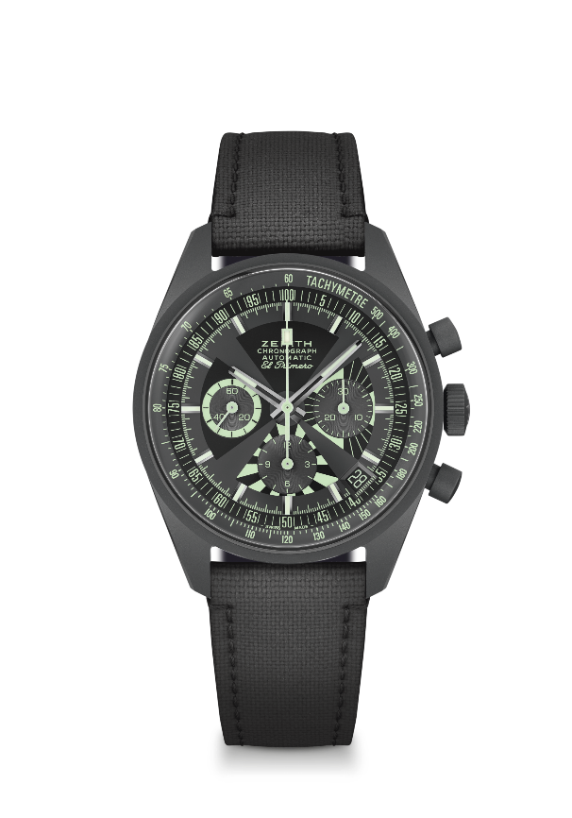
Reference: 97.G383.400.38.C880

Key points: Reinterpretation of the Iconic "Poker Chip" dial. Microblasted titanium case
Original 1969 case with 38 mm diameter. Automatic El Primero column-wheel chronograph movement. Limited edition of 200 pieces. Available via SJX and on Zenith boutiques and e-commerce.
Movement: El Primero 400 Automatic
Frequency: 36,000 VpH (5 Hz)
Power reserve: min. 50 hours
Functions: Hours and minutes in the centre. Small seconds at nine o’clock. Chronograph: central chronograph hand, 12-hour counter at six o’clock, 30-minute counter at three o’clock. Tachymetric scale. Pulsometer scale. Date indication at 4:30
Case: 38-mm
Material: Microblasted titanium
Dial: Dark grey with printed segments in matt black and Super-LumiNova®
Water-resistance: 5 ATM

Price: 9900 CHF
Hour-markers: Rhodium-plated, faceted and coated with Super-LumiNova®SLN C3
Hands: Rhodium-plated, faceted and coated with Super-LumiNova®SLN C3
Bracelet & Buckle: Comes with two fabric straps, one in matt black and a full Luminova “Cordura” effect strap.

