FOLLOW YOUR LIGHT TO REACH YOUR STAR: ZENITH UNVEILS THE LATEST ADDITION TO ITS FUTURISTIC DEFY COLLECTION, THE DEFY SKYLINE

Since the earliest days of the DEFY collection, Zenith has sought to make its mark with sturdy and singularly designed timekeepers that would accompany their wearers throughout whatever life journey they chose to embark on. The story began in 1902 with the original “DEFI” line of rugged and precise pocket-watches, which later inspired Zenith to keep the same audacious spirit alive in a line of wristwatches in 1969 named DEFY. It exuded an affirmed and resolutely modern aesthetic that complemented its hardy construction and reliable performance , earning it the nickname of coffre-fort, French for vault of safe. Today, in an ever-fast-moving world where every fraction of a second can be a decisive one, the latest creation in the DEFY line is up to the pace with a sleek and evocative design paired with an unprecedented function.

Recalling the seemingly still night sky above a bustling city that never sleeps, the DEFY Skyline is dedicated to those who follow their light and forge their own path on their journey towards their star. At once geometrically structured and whimsically celestial, the star-studded dial with a sunburst finish is embellished with a perfectly aligned pattern consisting of engraved four-pointed stars, which are in fact a modern reimagining of the Zenith “double Z” logo of the 1960s. A central element in Zenith’s story that can be traced back to the very beginning, the night sky was a major source of inspiration for the Manufacture’s visionary founder Georges-Favre Jacot, who fulfilled his dream of creating the most precise watch of the time and decided to name his manufacture after the highest point in the night sky. The unique alchemy of coloured metallic dials and the shimmery spectacle of light from the engraved motif adds a subtle but distinctive layer of depth and intrigue and transports the wearer to experience a different notion of time.

Audaciously bold in its silhouette yet inherently familiar within Zenith’s repertoire, the DEFY Skyline draws inspiration from the unique octagonal geometry of the early DEFY models including the recently revived Defy A3642 without attempting to merely recreate the past. Outstanding in its angular form, the DEFY Skyline retains the same DNA of robustness and durability as its predecessors while bringing an edgier and more architectural aesthetic, as well as a host of new functions to the metropolis-ready companion. Fixed atop the 41mm stainless steel case with sharply defined edges, the faceted bezel is similar to those from early DEFY models, reimagined with twelve sides that are positioned to echo the hour markers. With an emphasis on performance in the largest possible range of activities and situations, the screw-down crown emblazoned with the star emblem provides a water-resistance of 10 ATM (100 metres).

Besides the central hour and minute hands and a date window at 3 o’clock finished in the same colour as the dial, the DEFY Skyline brings something new to the table that’s as much a demonstration of technical prowess as it is a visually captivating animation rarely ever seen on a wristwatch. On the small counter at 9 o’clock, a constantly running 1/10th of a second hand makes steady jumps in fixed increments, completing one revolution every 10 seconds and reminding the wearer of the fleeting nature of time and the precision of the 5Hz movement within. With the DEFY Skyline’s cosmic inspiration, it should come as no surprise that such fractional time-measuring functions requiring the highest levels of precision were once used to calculate the movement of celestial bodies and sidereal time.

This exceptional performance is delivered by the new El Primero 3620. Built with a similar architecture as the El Primero 3600 1/10th of a second chronograph, this automatic manufacture movement visible through the sapphire display back drives the 1/10th of a second hand directly from the escapement, which beats at 5Hz (36’000 VpH), thus making it a “natural” fraction-of-a-second indication. It is also endowed with a stop-second mechanism for precise time-setting. Efficient in its performance, the automatic winding mechanism with bi-directional rotor with a star motif delivers a power reserve of approximately 60 hours. Keeping with the purely contemporary palette of the DEFY Skyline the movement is finished in tones of grey and silver with elements in blued metal.

Following your light and reaching for your star requires versatility and adaptability. As such, the DEFY Skyline is delivered on a steel bracelet with a satin-brushed surface with chamfered and polished edges, seamlessly following the contours of the faceted case. A rubber strap with a starry sky pattern in continuity with the dial made in blue for the blue dial, black for the black dial and olive-green for the silver dial is also provided with a steel folding clasp and can be easily swapped without any tools using the DEFY case’s ingenious quick strap-change mechanism consisting of secure buttons on the back.

Available at Zenith boutiques and authorized retailers around the world, the DEFY Skyline collection completes the Manufacture’s line of futuristic watchmaking with a piece that exudes stylish versatility combined with exceptional performance and an unmistakably Zenith flare.

ZENITH: TIME TO REACH YOUR STAR.

Zenith exists to inspire individuals to pursue their dreams and make them come true – against all odds. Since its establishment in 1865, Zenith became the first watch manufacture in the modern sense of the term, and its watches have accompanied extraordinary figures that dreamt big and strived to achieve the impossible – from Louis Blériot’s history-making flight across the English Channel to Felix Baumgartner’s record-setting stratospheric free-fall jump. Zenith is also highlighting visionary and trailblazing women – past and present – by celebrating their accomplishments and creating the DREAMHERS platform where women share their experiences and inspire others to fulfill their dreams.

Zenith exclusively uses its own in-house developed and manufactured movements across all of its watches. Since the creation of the El Primero in 1969, the world’s first automatic chronograph calibre, Zenith has gone on to master the complication with even more precision, capable of measurements to the closest 1/10th of a second in the most recent Chronomaster lines, and 1/100th of a second in the DEFY collection. Zenith has been shaping the future of Swiss watchmaking since 1865, accompanying those who dare to challenge themselves and break barriers. The time to reach your star is now.

DEFY SKYLINE
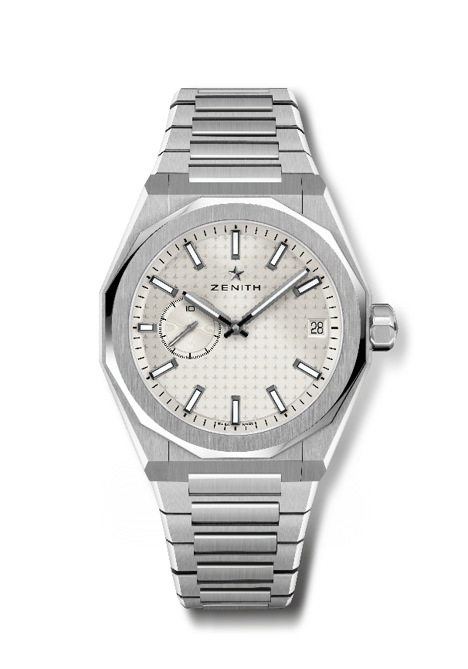
Reference: 03.9300.3620/01.I001

Key points: El Primero 3-hand watch. High frequency indication : 1/10th of a second subdial at 9 o'clock. Silicon escape-wheel and lever. Starry sky pattern on the dial. Screwed-in crown. Full Interchangeable strap system.
Movement: El Primero 3620, automatic
Frequency 36,000 VpH (5 Hz)
Power reserve approx. 60 hours
Functions : Hours and minutes in the centre. 1/10th of a second counter at 9 o'clock. Date indication at 3 o'clock.
Finishes: Special oscillating weight with satined finishings
Price 8400 CHF
Material: Stainless steel
Water resistance: 10 ATM
Case: 41mm
Dial: Silver-toned sunburst-patterned
Hour markers: Black ruthenium-plated, faceted and coated with SuperLuminova SLN C1
Hands : Black ruthenium-plated, faceted and coated with SuperLuminova SLN C1
Bracelet & Buckle: Stainless steel bracelet and folding clasp. Comes with a khaki green rubber strap with starry sky pattern and folding clasp.

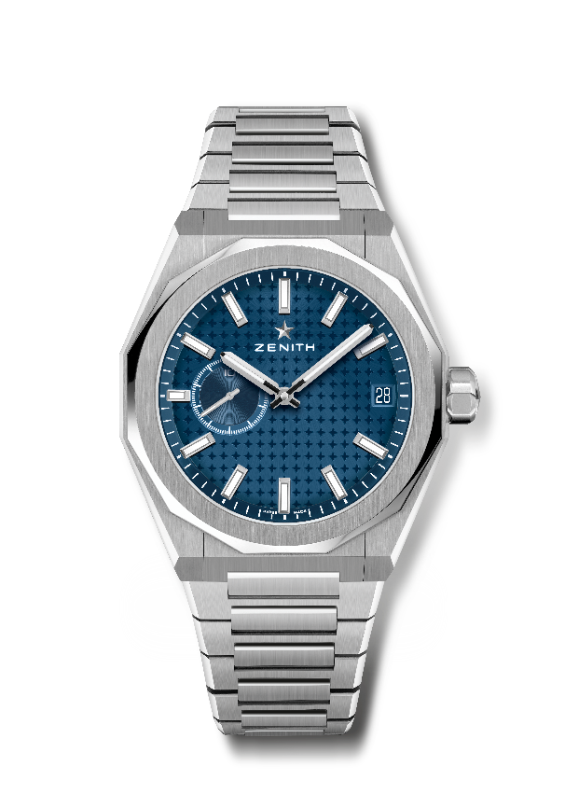
DEFY SKYLINE
Reference: 03.9300.3620/51.I001

Key points: El Primero 3-hand watch. High frequency indication : 1/10th of a second subdial at 9 o'clock. Silicon escape-wheel and lever. Starry sky pattern on the dial. Screwed-in crown. Full Interchangeable strap system.
Movement: El Primero 3620, automatic
Frequency 36,000 VpH (5 Hz)
Power reserve approx. 60 hours
Functions : Hours and minutes in the centre. 1/10th of a second counter at 9 o'clock. Date indication at 3 o'clock.
Finishes: Special oscillating weight with satined finishings
Price 8400 CHF
Material: Stainless steel
Water resistance: 10 ATM
Case: 41mm
Dial: Blue-toned sunburst-patterned
Hour markers: Rhodium-plated, faceted and coated with SuperLuminova SLN C1
Hands : Rhodium-plated, faceted and coated with SuperLuminova SLN C1
Bracelet & Buckle: Stainless steel bracelet and folding clasp. Comes with a blue rubber strap with starry sky pattern and folding clasp.

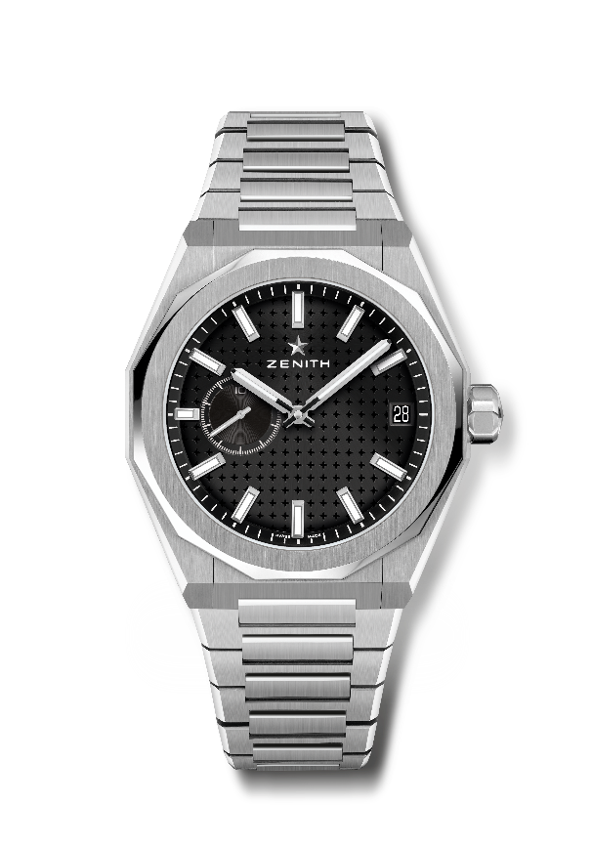
DEFY SKYLINE
Reference: 03.9300.3620/21.I001

Key points: El Primero 3-hand watch. High frequency indication : 1/10th of a second subdial at 9 o'clock. Silicon escape-wheel and lever. Starry sky pattern on the dial. Screwed-in crown. Full Interchangeable strap system.
Movement: El Primero 3620, automatic
Frequency 36,000 VpH (5 Hz)
Power reserve approx. 60 hours
Functions : Hours and minutes in the centre. 1/10th of a second counter at 9 o'clock. Date indication at 3 o'clock.
Finishes: Special oscillating weight with satined finishings
Price 8400 CHF
Material: Stainless steel
Water resistance: 10 ATM
Case: 41mm
Dial: Black-toned sunburst-patterned
Hour markers: Rhodium-plated, faceted and coated with SuperLuminova SLN C1
Hands : Rhodium-plated, faceted and coated with SuperLuminova SLN C1
Bracelet & Buckle: Stainless steel bracelet folding clasp. Comes with a black rubber strap with starry sky pattern and folding clasp.

