ZENITH UNVEILS ITS LATEST CREATIONS AT LVMH WATCH WEEK 2022

Starting the year at full throttle, Zenith is unveiling some of its latest creations at LVMH Digital Watch Week 2022 alongside LVMH Maisons Bulgari, Hublot and Tag Heuer. Taking place over several days, Zenith will host a series of digital events and presentations, supported by physical one-to-one presentations in local markets.

This year, the spotlight is back on the DEFY collection, the Zenith Manufacture’s platform for innovation and unprecedented expressions in the art of watchmaking. At the forefront is the new DEFY Skyline, a collection that builds upon the legacy of robustness and performance that has defined the line since the earliest Zenith “Defi” pocket watches of the early 20th century right through to its most recent references. Reinterpreting elements from the 1969 DEFY A3642 in a contemporary context and packed with the performance of the Manufacture’s latest generation of the El Primero movement, the DEFY Skyline is set to become a staple model for Zenith.

On the new DEFY Skyline, Zenith CEO Julien Tornare shares, “After a lot of time spent perfecting the design, proportions and precision, my team and I are extremely proud of the way the DEFY Skyline turned out. It’s the purest expression of the modernistic DEFY line that stands out without ever feeling out of place, and really solidifies the DEFY’s position at the forefront of the future of watchmaking”.

DEFY Skyline

Follow your light to reach your star. In an ever-fast-moving world where every fraction of a second can be a decisive one, the DEFY Skyline is up to the pace with a sleek and evocative design paired with an unprecedented function.

Its architectural and highly faceted silhouette draws inspiration from the unique octagonal geometry of the early DEFY models including the recently revived DEFY A3642, without attempting to merely recreate the past. It retains the same DNA of robustness and durability as its predecessors while bringing an edgier aesthetic. Fixed atop the 41mm stainless steel case with sharply defined edges, the faceted bezel is similar to those from early DEFY models, reimagined with twelve sides that echo the hour markers. The screw-down crown emblazoned with the star emblem provides a water-resistance of 10 ATM (100 metres).

Recalling the seemingly still night sky above a bustling city that never sleeps, the DEFY Skyline features a geometrically structured and whimsically celestial star-studded dial, with a sunburst finish embellished with a perfectly aligned pattern consisting of engraved four-pointed stars, which are in fact a modern reimagining of the Zenith “double Z” logo of the 1960s.

Besides the central hour and minute hands and a date window at 3 o’clock finished in the same colour as the dial, the DEFY Skyline brings something new to the table that’s as much a demonstration of technical prowess as it is a visually captivating animation rarely ever seen on a wristwatch. On the small counter at 9 o’clock, a constantly running 1/10th of a second hand makes steady jumps in fixed increments, reminding the wearer of the fleeting nature of time and the precision of the 5Hz movement within and completing a full revolution every 10 seconds.

This exceptional performance is delivered by the new El Primero 3620 calibre. Built with a similar architecture as the El Primero 3600 1/10th of a second chronograph, this automatic manufacture movement visible through the sapphire display back drives the 1/10th of a second hand directly from the escapement, which beats at 5Hz (36’000 VpH). It is also endowed with a stop-second mechanism for precise time-setting. The efficient automatic winding mechanism with bi-directional rotor with a star motif delivers a power reserve of approximately 60 hours.

The DEFY Skyline is delivered on a steel bracelet with a satin-brushed surface with chamfered and polished edges, seamlessly following the contours of the faceted case. A colour-coordinated rubber strap with a starry sky pattern in continuity with the dial is also provided with a steel folding clasp and can be easily swapped without any tools using the DEFY case’s ingenious quick strap-change mechanism consisting of secure buttons on the back.

**************

NEW CREATIONS FOR LVMH WATCH WEEK 2022

DEFY Revival A3642

To understand the genesis of the new DEFY Skyline collection, one must look back to the very beginning of the disruptive collection. Following the highly acclaimed and sought-after “Revival” reproductions of historical El Primero models from the 1960s and 1970s, the Zenith Manufacture has turned its attention to another monumental piece from 1969: the DEFY A3642.

Reproduced as a limited edition of 250 pieces in stunningly accurate detail using the original production plans from 1969, the DEFY Revival A3642 brings back all the details and singular design elements that made the original so outstanding in its era and how it established the codes that continues to inspire modern DEFY references, including the most recent Skyline. This includes an octagonal case paired with a fourteen-sided bezel, a warm grey dial with a striking gradient effect that darkens towards the edges, unusual applied square hour markers feature horizontal grooves, and the now-iconic Gay Frères steel “ladder” bracelet. The wide sword-shaped hands are generously filled with SuperLumiNova in a similar tone to Tritium found in the original, paired with a paddle-shaped seconds hand that is a prominent feature in numerous Zenith watches of the same era. In fact, the only cosmetic differences between the Revival and its progenitor are the sapphire crystal, the display case back and the type of luminescent pigments. The water-resistance of 30ATM (300 metres) has also been maintained from the original, even with the addition of a display back.

The other main difference beats away inside. Instead of the original’s solid case back emblazoned with a four-pointed star that become one of the brand’s logos and recurring design element for years to come, the DEFY Revival A3642 features a sapphire display back showing the automatic Elite 670 manufacture movement, operating at a frequency of 4 Hz (28’800 VpH) and delivering a power reserve of 50 hours when fully wound.

With the DEFY Revival A3642, Zenith is not only bringing back one of its most daring and outstanding references from the 1960s, but also highlighting the unique genesis of the Manufacture’s boldest and most innovative collection by returning to the source.

DEFY Extreme Carbon

Built to withstand the elements and equipped with the world’s fastest and most precise automatic chronograph movement, the DEFY Extreme is the embodiment of the Manufacture’s spirit of innovation and emphasizes the DEFY line’s core attributes of ruggedness and exceptional performance. Introduced in 2021 as the boldest and most rugged iteration of Zenith’s groundbreaking 1/100th of a second automatic high-frequency chronograph to date, the DEFY Extreme has already proven that it’s more than capable of withstanding even the harshest elements during the first season of EXTREME E. Now, the DEFY Extreme arrives in a resolutely sporty carbon fibre execution inspired by the world’s first off-road electric rally racing championship, of which Zenith is proud to be the Official Timekeeper and Founding Partner.

Visually striking and astonishingly light, the case as well as the pushers and crown are made of highly durable layered carbon fibre. Commonly used in the automotive and aviation industries among many others, carbon fibre offers a unique set of performance properties that simply cannot be matched by metals. It also offers an unmistakable aesthetic that’s synonymous with cutting-edge. Highlighting the audaciously angular geometry of the case, the pusher protectors as well as the twelve-sided bezel are made in microblasted titanium.

Within the monolithic case, the open multi-layered dial features a mix of racy colours inspired by the EXTREME E’s “X Prix” colour schemes adapted for each race. The 1/100th of a second chronograph scale features bright yellow markers, while the tinted sapphire crystal dial’s chronograph counters are in bright blue, green and white, with matching-coloured small hands. Partially visible through the dial as well as the case back is the fastest automatic high-frequency chronograph calibre, offering1/100th of a second time measurements, with two escapements beating at 5Hz (36’000 VpH) for the timekeeping part and 50Hz (360’000 VpH) for the chronograph.

The DEFY Extreme is delivered with three straps that are easily interchangeable without requiring any tools, simply by using the case back’s ingenious and intuitive quick strap-change mechanism. These are a black textured rubber strap with a microblasted titanium folding buckle, a red textured rubber strap and a black Velcro strap with a carbon fibre buckle.

DEFY 21 Chroma

With the new DEFY 21 Chroma, the Manufacture is once again expressing this notion of high-frequency precision through frequencies of light and colours.

Its matte-finished white ceramic case gives way to a refracted rainbow spread evenly across the open dial and movement, in a perfectly transitioning gradient of colours spanning the entire spectrum. The red painted marker at 12 o’clock shifts through orange, yellow, green, blue, violet and pink in a clockwise manner. The meticulously applied colours on the markers and 1/100 of a second scale extend beyond the dial and out of the case, with the crown’s rubber grip ring as well as the white cordura-effect rubber strap’s stitching following the colour arrangement of the dial. This also extends to the chronograph counter hands, each tipped in a different tone.

The open dial features raised white chronograph counters matching the case, beneath which the extraordinarily decorated movement shines through. Each bridge is finished in a different metallic colour, again following the gradient of the dial’s markers. Visible through the dial as well as the sapphire case back, one can admire the singular El Primero 21 automatic high-frequency 1/100th of a second chronograph that’s at the peak of performance and precision, featuring two independent regulating organs and gear trains for the timekeeping and chronograph functions, operating at frequencies of 5Hz (36’000 VpH) and 50Hz (360’000 VpH), respectively.

Limited to 200 pieces and available at Zenith boutiques and authorized retailers around the world, the DEFY 21 Chroma demonstrates the Manufacture’s mastery of the high-frequency automatic 1/100th of a second chronograph, while adding an unprecedented and playfully vibrant palette of colours where least expected for a high-performance chronograph with truly no equal.

DEFY Midnight Sunset & DEFY Midnight Borealis

The DEFY Midnight was launched in 2020 as the first Zenith DEFY collection tailored exclusively for women. Uniquely positioned as a versatile sporty-chic timepiece with a distinctly cosmic design, the DEFY Midnight was conceived with free-spirited, dream-chasing women in mind. As highlighted in the ZENITH DREAMHERS platform, where outspoken and accomplished women share their experiences and encourage others to go out there and fulfil their ambitions, the DEFY Midnight is a versatile companion for the independent women of today. Now, the collection welcomes two new additions inspired by a central element in Zenith lore – the starry night sky – and some of its ephemeral yet endlessly captivating phenomenon: the DEFY Midnight Sunset and DEFY Midnight Borealis.

Housed in a 36mm stainless steel case embellished with brilliant cut white diamonds on the bezel, these two vibrant versions reinterpret traditional craftsmanship in new and unprecedented form. Endowed with guilloché engraved dials with a radiant wave pattern, the DEFY Midnight Sunset seamlessly transitions from warm red to a deep yellow tone in a perfect gradient of colours that recalls the brief but breathtaking sky as the sun casts its last rays of light before giving way to night.

The DEFY Midnight Borealis evokes the aurora borealis or northern lights phenomenon witnessed around the arctic circle, featuring a midnight blue dial that gradually shifts to a bright emerald green towards to bottom. In both models, white diamonds are applied on every hour marker, except at 3 o’clock where the date window is placed.

One of the features that makes the DEFY Midnight so versatile and easily adaptable to any situation and outfit is its quick strap-change mechanism. Besides the steel bracelet and supplied straps, DEFY Midnight owners can now shop an exclusive collection of sustainably made straps with a high-fashion edge, made in partnership with Nona Source, a start-up incubated by LVMH that uses deadstock fabrics from the group’s most prestigious Fashion & Leather Goods Maisons that are upcycled and transformed into handmade haute couture straps for those special occasions that call for something lavishly exceptional, offered in a wide array of textiles and colours.

ZENITH: TIME TO REACH YOUR STAR.

Zenith exists to inspire individuals to pursue their dreams and make them come true – against all odds. Since its establishment in 1865, Zenith became the first watch manufacture in the modern sense of the term, and its watches have accompanied extraordinary figures that dreamt big and strived to achieve the impossible – from Louis Blériot’s history-making flight across the English Channel to Felix Baumgartner’s record-setting stratospheric free-fall jump. Zenith is also highlighting visionary and trailblazing women – past and present – by celebrating their accomplishments and creating the DREAMHERS platform where women share their experiences and inspire others to fulfill their dreams.

Zenith exclusively uses its own in-house developed and manufactured movements across all of its watches. Since the creation of the El Primero in 1969, the world’s first automatic chronograph calibre, Zenith has gone on to master the complication with even more precision, capable of measurements to the closest 1/10th of a second in the most recent Chronomaster lines, and 1/100th of a second in the DEFY collection. Zenith has been shaping the future of Swiss watchmaking since 1865, accompanying those who dare to challenge themselves and break barriers. The time to reach your star is now.

DEFY SKYLINE
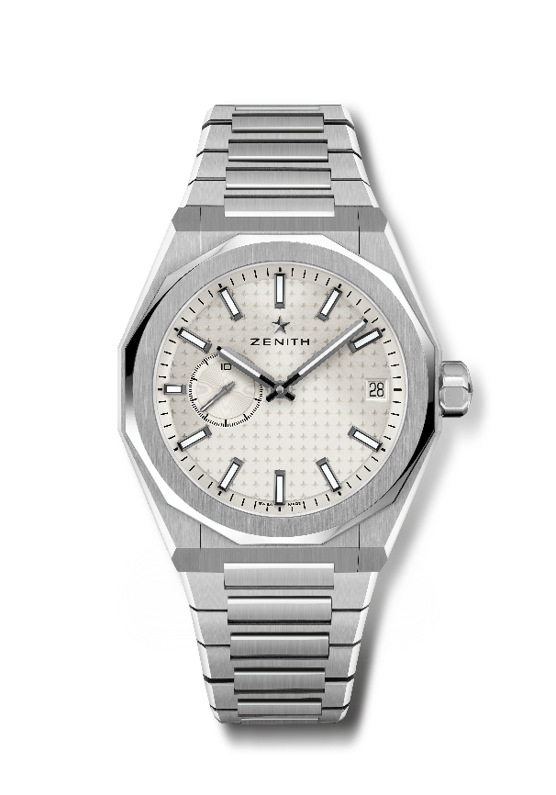
Reference: 03.9300.3620/01.I001

Key points: El Primero 3-hand watch. High frequency indication : 1/10th of a second subdial at 9 o'clock. Silicon escape-wheel and lever. Starry sky pattern on the dial. Screwed-in crown. Full Interchangeable strap system.
Movement: El Primero 3620, automatic
Frequency 36,000 VpH (5 Hz)
Power reserve approx. 60 hours
Functions : Hours and minutes in the centre. 1/10th of a second counter at 9 o'clock. Date indication at 3 o'clock.
Finishes: Special oscillating weight with satined finishings
Price 8400 CHF
Material: Stainless steel
Case: 41mm
Water resistance: 10 ATM
Dial: Silver-toned sunburst-patterned
Hour markers: Black ruthenium-plated, faceted and coated with SuperLuminova SLN C1
Hands : Black ruthenium-plated, faceted and coated with SuperLuminova SLN C1
Bracelet & Buckle: Stainless steel bracelet and folding clasp. Comes with a khaki green rubber strap with starry sky pattern and folding clasp.

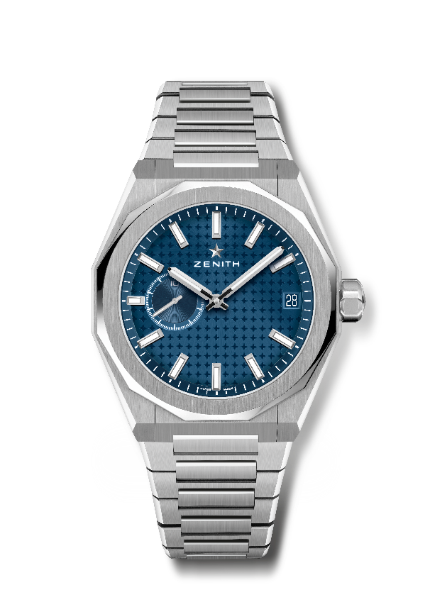
DEFY SKYLINE
Reference: 03.9300.3620/51.I001

Key points: El Primero 3-hand watch. High frequency indication : 1/10th of a second subdial at 9 o'clock. Silicon escape-wheel and lever. Starry sky pattern on the dial. Screwed-in crown. Full Interchangeable strap system.
Movement: El Primero 3620, automatic
Frequency 36,000 VpH (5 Hz)
Power reserve approx. 60 hours
Functions : Hours and minutes in the centre. 1/10th of a second counter at 9 o'clock. Date indication at 3 o'clock.
Finishes: Special oscillating weight with satined finishings
Price 8400 CHF
Material: Stainless steel
Water resistance: 10 ATM
Case: 41mm
Dial: Blue-toned sunburst-patterned
Hour markers: Rhodium-plated, faceted and coated with SuperLuminova SLN C1
Hands : Rhodium-plated, faceted and coated with SuperLuminova SLN C1
Bracelet & Buckle: Stainless steel bracelet and folding clasp. Comes with a blue rubber strap with starry sky pattern and folding clasp.

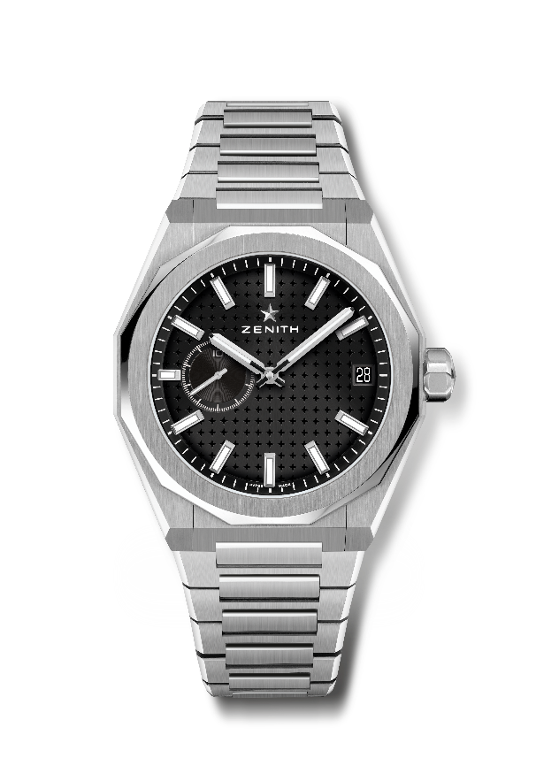
DEFY SKYLINE
Reference: 03.9300.3620/21.I001

Key points: El Primero 3-hand watch. High frequency indication : 1/10th of a second subdial at 9 o'clock. Silicon escape-wheel and lever. Starry sky pattern on the dial. Screwed-in crown. Full Interchangeable strap system.
Movement: El Primero 3620, automatic
Frequency 36,000 VpH (5 Hz)
Power reserve approx. 60 hours
Functions : Hours and minutes in the centre. 1/10th of a second counter at 9 o'clock. Date indication at 3 o'clock.
Finishes: Special oscillating weight with satined finishings
Price 8400 CHF
Material: Stainless steel
Water resistance: 10 ATM
Case: 41mm
Dial: Black-toned sunburst-patterned
Hour markers: Rhodium-plated, faceted and coated with SuperLuminova SLN C1
Hands : Rhodium-plated, faceted and coated with SuperLuminova SLN C1
Bracelet & Buckle: Stainless steel bracelet folding clasp. Comes with a black rubber strap with starry sky pattern and folding clasp.

DEFY REVIVAL A3642
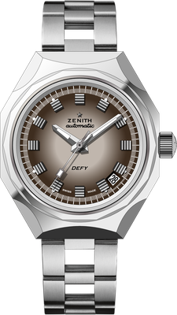
Reference: 03.A3642.670/75.M3642

Key points: Original Revival of the 1969 Reference A3642. Octogonal case with iconic 14-sided bezel. Limited edition of 250 pieces.
Movement: Elite 670, automatic
Frequency 28,800 VpH (4 Hz)
Power reserve min. 50 hours
Functions : Hours and minutes in the centre. Central seconds hand. Date indication at 4:30
Finishes: New star-shaped oscillating weight with satined finishings
Price 6900 CHF
Material: Stainless steel
Water resistance: 30 ATM
Case: 37mm
Dial: Gradient brown
Hour markers: Rhodium-plated and faceted
Hands : Rhodium-plated and faceted with SuperLuminova SLN C1
Bracelet & Buckle: Stainless steel "Ladder" bracelet.

DEFY 21 CHROMA
Reference: 49.9010.9004/01.R947

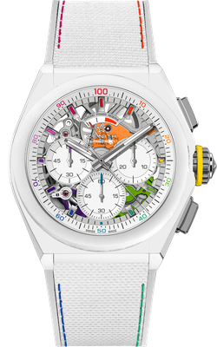
Key points: 1/100th of a second Chronograph movement. Exclusive dynamic signature of one rotation per second for the Chrono hand.1 escapement for the Watch (36,000 VpH - 5 Hz) ; 1 escapement for the Chronograph (360,000 VpH - 50 Hz). Certified Chronometer. Limited edition of 200 pieces.
Movement: El Primero 9004 automatic
Frequency 36,000 VpH (5 Hz)
Power reserve min. 50 hours
Functions : 1/100th of a second chronograph functions. Chronograph power-reserve indication at 12 o'clock. Hours and minutes in the centre. Small seconds at 9 o'clock, Central chronograph, 30-minute counter at 3 o'clock, 60-second counter at 6 o'clock
Finishes: "Rainbow" PVD-coated bridges + Special blue colored oscillating
weight with satined finishings
Price 14400 CHF
Material: Matte White Ceramic
Water resistance: 10 ATM
Case: 44mm
Dial: White Openworked
Hour markers: Rhodium-plated, faceted and coated with "Rainbow" varnish
Hands: Rhodium-plated, faceted and coated with colored varnish
Bracelet & Buckle: White rubber with white "Cordura effect" rubber and multicolored. Titanium triple folding clasp.

DEFY EXTREME CARBON
Reference: 10.9100.9004/22.I200

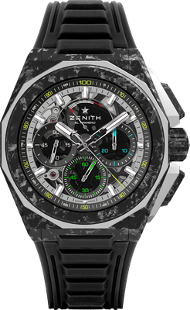
Key points: Stronger, bolder and more powerful design. 1/100th of a second Chronograph movement
Exclusive dynamic signature of one rotation per second for the Chrono hand. 1 escapement for the Watch (36,000 VpH - 5 Hz) ; 1 escapement for the Chronograph (360,000 VpH - 50 Hz)
Certified Chronometer. Screwed-in crown. Full Interchangeable strap system. 2 straps included: 1 Rubber strap with a black microblasted titanium folding buckle & 1 Velcro strap with carbon buckle. Sapphire dial.
Movement: El Primero 9004 automatic
Frequency 36,000 VpH (5 Hz)
Power reserve min. 50 hours
Functions : 1/100th of a second chronograph functions. Chronograph power-reserve indication at 12 o'clock. Hours and minutes in the centre. Small seconds at 9 o'clock, Central chronograph hand that makes one turn each second, 30-minute counter at 3 o'clock, 60-second counter at 6 o'clock
Finishes: Black colored main plate on movement + Special black colored
oscillating weight with satined finishings
Price 24900 CHF
Material: Carbon & Microblasted Titanium
Water resistance: 20 ATM
Case: 45mm
Dial: Tinted sapphire with three black-coloured counters
Hour markers: Rhodium-plated, faceted and coated with " SuperLuminova SLN C1
Hands : Rhodium-plated, faceted and coated with " SuperLuminova SLN C1
Bracelet & Buckle: Black Rubber. Titanium triple folding clasp with black DLC coating. Also comes with a red rubber strap and a black Velcro strap and carbon buckle.

DEFY MIDNIGHT SUNSET
Reference: 16.9200.670/33.MI001
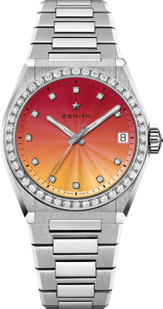
Key points: 36-MM case dedicated for Women. Gradient dial. Full interchangeable strap system. Strap box included : 3 different colors straps + an interchangeable folding buckle
Movement: Elite 670 SK, Automatic
Frequency: 28,800 VpH (4Hz)
Power-reserve: min. 50 hours
Functions: Hours and minutes in the centre. Central seconds hand. Date indication at 3 o’clock
Price 11400 CHF
Gemsetting: Carats 1.48 cts, Bezel 44 VS brilliant-cut diamonds, Dial 11 VS brilliant-cut diamonds
Material: Stainless steel with diamond-set bezel
Water-resistance: 10 ATM
Dial: Red to yellow gradient & guilloché
Case: 36 mm
Hour-markers: Diamond hour-markers
Hands: Rhodium-plated and faceted, coated with Super-Luminova SLN C1
Bracelet & Buckle: Stainless steel with interchangeable strap system. Comes with 3 different colored straps.

DEFY MIDNIGHT BOREALIS
Reference: 16.9200.670/34.MI001
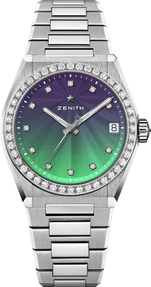
Key points: 36-MM case dedicated for Women. Gradient dial. Full interchangeable strap system. Strap box included : 3 different colors straps + an interchangeable folding buckle
Movement: Elite 670 SK, Automatic
Frequency: 28,800 VpH (4Hz)
Power-reserve: min. 50 hours
Functions: Hours and minutes in the centre. Central seconds hand. Date indication at 3 o’clock
Price 11400 CHF
Gemsetting: Carats 1.48 cts, Bezel 44 VS brilliant-cut diamonds, Dial 11 VS brilliant-cut diamonds
Material: Stainless steel with diamond-set bezel
Water-resistance: 10 ATM
Dial: Blue to green gradient & guilloché
Case: 36 mm
Hour-markers: Diamond hour-markers
Hands: Rhodium-plated and faceted, coated with Super-Luminova SLN C1
Bracelet & Buckle: Stainless steel with interchangeable strap system. Comes with 3 different colored straps.

