AN UNEXPECTED TWIST FOR THE FINAL EDITION OF THE
ZENITH X LUPIN THE THIRD SERIES

A collaboration between a Swiss watch manufacture and a Japanese manga and anime series is as unique a partnership as they come. But that’s exactly what Zenith did with Lupin The Third, which was so inspired by the El Primero shortly after its launch in 1969 that it decided to include it in the seminal series on two separate occasions. 50 years and two special editions later, Zenith is unveiling the third and final limited edition in the trilogy, the Chronomaster Revival Lupin The Third – Final Edition.

In 2019, Zenith became the first manufacture to produce a watch directly inspired by a depiction in a Japanese manga and anime series. In the very first episode of the animated Lupin The Third series, Daisuke Jigen, the right-hand man and best friend of the title character Lupin III, is portrayed wearing a watch based on the A384 with a black, grey and gilt dial that had never actually existed. And in the final episode of the first series, Jigen is again portrayed to be wearing another Zenith chronograph, but with a different “panda” dial that also never existed.

Nearly 50 years after the initial airing of the anime series, Zenith finally turned fantasy into reality in 2019 by producing the Chronomaster Revival Lupin The Third, using the instantly recognizable A384 tonneau-shaped case and recreating the unusual black dial depicted in the first episode. The following year, the second white and “panda” dial version was released. Now, the third and final limited edition in this exceptional collaboration has arrived, and it couldn’t be more unexpected: both dials in one!

Limited to 250 pieces, the Chronomaster Revival Lupin The Third – Final Edition combines two dials, featuring two distinct and asymmetrical halves combining all the elements from both the Zenith chronographs depicted in the first and final episode of the animated series’ first season. On one side, the first Chronomaster Revival Lupin The Third edition’s semi-glossy black dial with deep grey counters and golden applied markers and hands, and on the other side, the second edition’s creamy-white dial with contrasting black counters in a “panda” configuration with beige SuperLumiNova. Whimsical, playful and certainly polarizing, there’s more than meets the eye when it comes to creating such a singular dial, which presented the teams at the Zenith Manufacture with a new and unprecedented kind of challenge.

A delicate and long process, the blank dial is first finished entirely in a silvery-white colour on the right half, then the black chronograph counters are milled while the rest of the dial is protected with a layer of transparent and colourless lacquer. As the second half of the dial must be painted black, the other white half of the dial is given a protective layer. If the protection isn’t correctly applied, colours can bleed into each other, ruining the dial. Another layer of complexity is added in that a third grey colour must be applied for the counters. With each step in the process, the chances of something going wrong increases. Successfully completing one dial is challenging enough. Reproducing the dual-dial effect with perfectly separated elements for an entire series proved nearly impossible, but the uniquely intriguing result made it well worth the effort.

This truly unequalled dial is housed in a 37mm titanium barrel-shaped case that is a reproduction of the 1969 A384 case in proportions and finish. It’s paired with a titanium ladder bracelet originally designed by the famed Gay Frères company with a distinctly retro touch. Beating within it is the El Primero automatic high-frequency integrated chronograph calibre, visible through the sapphire display back engraved with a drawing of Daisuke Jigen.

For those who missed out on the first and second special editions or simply wish to complete their set and enjoy the dial’s dual personalities, The Chronomaster Revival Lupin The Third – Final Edition is available at Zenith physical boutiques and online boutiques around the world.

ZENITH: TIME TO REACH YOUR STAR.

Zenith exists to inspire individuals to pursue their dreams and make them come true – against all odds. Since its establishment in 1865, Zenith became the first watch manufacture in the modern sense of the term, and its watches have accompanied extraordinary figures that dreamt big and strived to achieve the impossible – from Louis Blériot’s history-making flight across the English Channel to Felix Baumgartner’s record-setting stratospheric free-fall jump. Zenith is also highlighting visionary and trailblazing women – past and present – by celebrating their accomplishments and creating the DREAMHERS platform where women share their experiences and inspire others to fulfill their dreams.

Zenith exclusively uses its own in-house developed and manufactured movements across all of its watches. Since the creation of the El Primero in 1969, the world’s first automatic chronograph calibre, Zenith has gone on to master the complication with even more precision, capable of measurements to the closest 1/10th of a second in the most recent Chronomaster lines, and 1/100th of a second in the DEFY collection. Zenith has been shaping the future of Swiss watchmaking since 1865, accompanying those who dare to challenge themselves and break barriers. The time to reach your star is now.

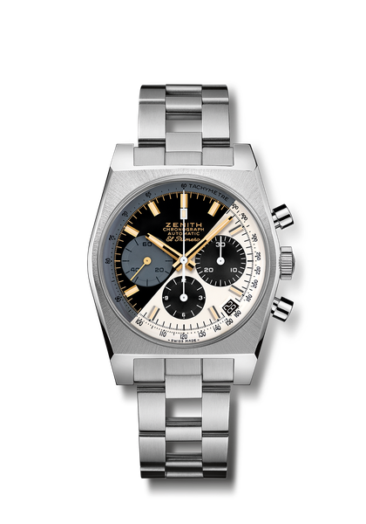
Chronomaster Revival Lupin The Third – Final Edition
Reference: 95.L384.400/50.M384

Key points: Original 1969 case with 37 mm diameter. Automatic El Primero column-wheel chronograph movement. Splitted dial taking inspiration from the former 2 Editions. Limited edition of 250 pieces.
Movement: El Primero 400 Automatic
Frequency: 36,000 VpH (5 Hz)
Power reserve: min. 50 hours
Functions: Hours and minutes in the centre. Small seconds at nine o’clock. Chronograph: central chronograph hand, 12-hour counter at six o’clock, 30-minute counter at three o’clock. Tachymetric scale. Date indication at 4:30
Case: 37-mm
Material: Titanium
Dial: Black & white
Water-resistance: 5 ATM
Price: 9900 CHF
Hour-markers: Rhodium-plated or Gold-plated, faceted and coated with Beige SuperLuminova ®SLN
Hands: Rhodium-plated or Gold-plated, faceted and coated with Beige SuperLuminova ®SLN
Bracelet & Buckle: Titanium "ladder" bracelet and double folding clasp.

