ZENITH x Revolution & The Rake – Chronomaster Revival A3818
“The Airweight Cover Girl”

Zenith and Revolution & The Rake are teaming up once again to create an alternate version of one of the most sought-after vintage El Primero models, the A3818. Nicknamed “The Airweight Cover Girl”, this special edition Chronomaster Revival combines the original’s striking blue dial with the line’s first-ever case and ladder bracelet in titanium.

In 2020, Zenith collaborated with Revolution & The Rake to bring back one of the most coveted El Primero references ever made, the A3818. Affectionately dubbed the “Cover Girl” by vintage watch collectors and El Primero aficionados after its appearance on the cover of Manfred Rossler’s book “Zenith - Swiss Watchmaking Since 1865”, the A3818 was introduced in 1971 for a brief time and produced in limited quantities, making it one of the most elusive and sought-after vintage El Primero watches. Its modern remake, the Zenith x Revolution Chronomaster Revival A3818 “Cover Girl”, was an instant hit among vintage watch aficionados and Zenith fans, selling out all 100 pieces in a matter of hours. Now, Zenith has once again come together with Revolution & The Rake to bring back the Cover Girl with a modern twist. Meet the Chronomaster Revival A3818 “The Airweight Cover Girl”.

Upon a first look, it may appear just like the previous Cover Girl. That is, until you take in your hands. Weighing only 78.2 grams on its ladder bracelet, the Airweight Cover Girl is crafted entirely in grade 5 titanium, the only quality of titanium that can be mirror polished. Switching from steel to light yet rugged titanium while retaining the same overall finish was not without challenges and required an arduous process of experimentation to get it just right. And as a first for Zenith, the ladder bracelet originally designed by the famed Gay Frères company in the 1960s is made for the first time in titanium, denoted by the polished centre link.
“At Zenith, our tradition has always been to push boundaries as we did all the way back in 1969 with the introduction of the world’s first integrated automatic chronograph movement. We had used titanium for some of our A386 style cases such as our Chronomaster “Shadow” limited edition but, so far, not yet in a bracelet. But we thought this would be the perfect time to try it. We love to work on limited editions that are ambitious and bring something of real value to collectors” shared Julien Tornare on this unprecedented use of titanium by Zenith.
One of the most striking features of the original A3818 is undoubtedly its dial. Faithfully reproduced in this special series, the vertically brushed finish and Superman blue tone of the dial have been preserved, while the shark tooth scale, tachymeter scale, logo and text are given a modern touch with an execution entirely in SuperLuminova. Compared to the first Chronomaster Revival A3818 Cover Girl, the Airweight’s SuperLumiNova is done in a more natural “C1” white colour rather than the slightly green “C3” tone of the previous Revival edition.

Visible through the sapphire display back, the El Primero 400 calibre — the direct descendant of the original 1969 El Primero automatic high-frequency chronograph movement — beats at the rate of 5Hz (36’000 VpH).
The Zenith × Revolution & The Rake Chronomaster Revival A3818 “The Airweight Cover Girl” is a limited edition of 250 examples, available from Revolution & The Rake as well as Zenith boutiques around the world.

ZENITH: TIME TO REACH YOUR STAR.

Zenith exists to inspire individuals to pursue their dreams and make them come true – against all odds. Since its establishment in 1865, Zenith became the first watch manufacture in the modern sense of the term, and its watches have accompanied extraordinary figures that dreamt big and strived to achieve the impossible — from Louis Blériot’s history-making flight across the English Channel to Felix Baumgartner’s record-setting stratospheric free-fall jump. Zenith is also highlighting visionary and trailblazing women — past and present — by celebrating their accomplishments and creating the DREAMHERS platform where women share their experiences and inspire others to fulfill their dreams.

Zenith exclusively uses its own in-house developed and manufactured movements across all of its watches. Since the creation of the El Primero in 1969, the world’s first automatic chronograph caliber, Zenith has gone on to master the complication with even more precision, capable of measurements to the closest 1/10th of a second in the most recent Chronomaster lines, and 1/100th of a second in the DEFY collection. Zenith has been shaping the future of Swiss watchmaking since 1865, accompanying those who dare to challenge themselves and break barriers. The time to reach your star is now.

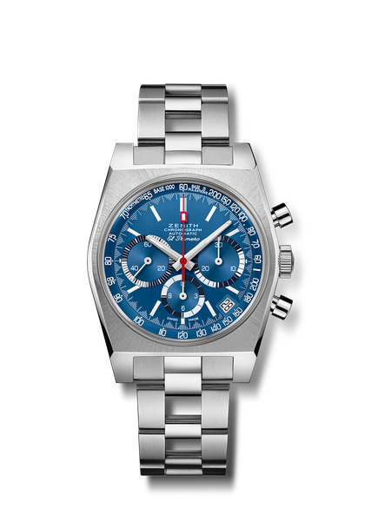
Chronomaster Revival A3818 “The Airweight Cover Girl”
Reference: 95.A3818.400/51.M3818

Key points: Original Revival of the 1971 Reference A3818. Automatic El Primero column-wheel chronograph movement.1st Ever Titanium ladder bracelet. Limited edition of 250 pieces.
Movement: El Primero 400. Oscillating weight with “Côtes de Genève” motif.
Frequency: 36,000 VpH (5 Hz)
Power reserve: min. 50 hours
Functions: Hours and minutes in the centre. Small seconds at nine o’clock. Central chronograph hand, 12h counter at six o’clock, 30 minute counter at three o’clock. Tachymetric & pulsometric scales
Date indication at 4:30.
Case: 37-mm
Material: Grade 5 titanium
Dial: "Superman" vertical brushed blue
Water-resistance: 5 ATM
Caseback: transparent sapphire crystal
Price: 9900 CHF
Hour-markers: Rhodium-plated, faceted and coated with Super-LumiNova®SLN
Hands: Rhodium-plated, faceted and coated with Super-LumiNova®SLN C1
Bracelet & Buckle: Titanium ladder bracelet and Blue "Cordura" effect strap with white stitchings.

