ZENITH INAUGURATES ITS “MASTER OF CHRONOGRAPHS” EXHIBITION AT WATCHES & WONDERS 2022 WITH THE NEWLY REVAMPED CHRONOMASTER OPEN COLLECTION

Geneva, March 30, 2022 – During Watches & Wonders, where Zenith’s “Master of Chronographs” exhibition highlights its milestones and trajectory in becoming the preeminent manufacture and innovator of automatic chronographs, Zenith unveils the latest generation of the Chronomaster Open with a tri-colour dial that inventively reveals its high-frequency beating heart.

For Zenith, “Master of Chronographs” is a testament to the manufacture’s illustrious past and its countless achievements that contributed to the advancement of mechanical chronographs for over 50 years. In particular, it highlights Zenith’s commitment to the pursuit of perpetual innovation when it comes to watchmaking’s most complex and sought-after complications. Since the launch of the revolutionary El Primero calibre in 1969 as the world’s first automatic high-frequency integrated chronograph movement, Zenith has maintained and cultivated its spirit of innovation without ever ceasing break new boundaries and offer even greater levels of precision and performance. It has mastered not only the automatic chronograph, but also the fractional measurement of time by offering 1/10th and 1/100th of a second high-frequency calibres.

But performance and precision aren’t the only areas where Zenith has made its mark in the world of chronographs. After all, pioneering movements deserve to stand out in inspired and unprecedented designs to truly highlight their ingenuity. In 2003, Zenith introduced the Chronomaster Open with the aim of making the high frequency beating heart of its El Primero calibre as prominently visible as possible. It marked the first time in the history of watchmaking that a chronograph featured a partially open dial solely to reveal the regulating organ and escapement. The Chronomaster Open was an instant hit, lauded for its daring design that is often imitated but never matched. For Zenith, the partially open dial has remained a prominent and coveted feature in many of its Chronomaster references for nearly 20 years.

With 2021’s introduction of the new and improved El Primero 3600 that boasts a 1/10th of a second chronograph function and improved efficiency, the time had come to adapt and incorporate the latest developments into the emblematic Chronomaster Open. More than a simple facelift, the new Chronomaster Open is imbued with the lines and attributes of the latest generation of the Chronomaster collection. Somewhere between the sleek sportiness of the Chronomaster Sport and the historically inspired Chronomaster Original for a modern distillation of the essential Zenith El Primero chronograph.

Revisiting the iconic tri-colour dial configuration that debuted with the iconic A386 in 1969 and which remains a distinctive and instantly recognizable El Primero design element, the latest iteration of the Chronomaster Open retains it entirely with a transparent twist. Instead of cutting out the small seconds counter at 9 o’clock entirely as was the case with the previous versions of the Chronomaster Open, the three counter colours are retained thanks to a hesalite crystal element that serves as a readable sub-dial while allowing a view of the silicon star-shaped escape wheel. The opening itself has also been reinterpreted, foregoing the former version’s applied “frame” and instead opting for circular openings with chamfered edges, revealing the movement with more straight bridges and a more contemporary grey tone.

Catering to the prevalent demand for watches with more modest proportions, the round case now measures 39.5mm wide compared to the previous 42mm model, with slimmer lugs and more pronounced polished bevels on the edges. The pump-style pushers now feature rounded tips for a more ergonomic touch. The steel bracelet option follows the contours and mixed polished and satin-brushed finishes of the case.

Visible through the sapphire display back, the El Primero 3604 1/10th of a second automatic chronograph movement is a modified version of the 3600 that debuted in the Chronomaster Sport, featuring an open base plate and bridges that allow for a clearer view of the high-frequency 5Hz escapement with lubricant-free silicon escape wheel and pallet lever. The automatic winding mechanism with an open star-shaped oscillating mass efficiently delivers a power reserve of 60 hours.

Available at all Zenith boutiques and authorized retailers around the world, the Chronomaster Open is available in steel with a white or black dial, delivered with either a steel bracelet or cordura-effect rubber strap. A rose gold version featuring a white dial with a blue cordura-effect rubber strap is also introduced in the new line.

The reintroduction of the Chronomaster Open marks the completion of Zenith’s seminal chronograph collection; respectful of the past but assertively modern in its form and function.

ZENITH: TIME TO REACH YOUR STAR.

Zenith exists to inspire individuals to pursue their dreams and make them come true – against all odds. Since its establishment in 1865, Zenith became the first watch manufacture in the modern sense of the term, and its watches have accompanied extraordinary figures that dreamt big and strived to achieve the impossible – from Louis Blériot’s history-making flight across the English Channel to Felix Baumgartner’s record-setting stratospheric free-fall jump. Zenith is also highlighting visionary and trailblazing women – past and present – by celebrating their accomplishments and creating in 2020 its first-ever collection dedicated entirely to them, Defy Midnight.

With innovation as its guiding star, Zenith features exceptional in-house developed and manufactured movements in all its watches. Since the creation of the El Primero in 1969, the world’s first automatic chronograph calibre, Zenith has gone on to master fractions of the second with the Chronomaster Sport and its 1/10th of a second precision and the DEFY 21 with a precision of 1/100th of a second. Zenith has been shaping the future of Swiss watchmaking since 1865, accompanying those who dare to challenge themselves and break barriers. The time to reach your star is now.

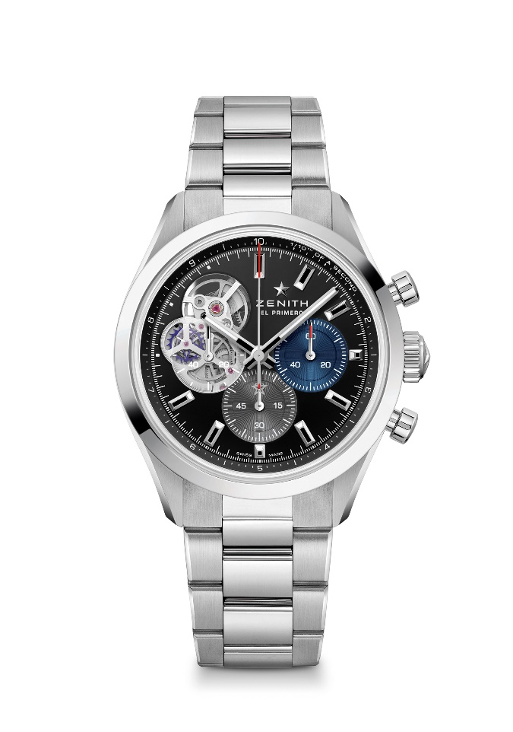
CHRONOMASTER OPEN
Reference: 03.3300.3604/21.M3300

Key points: Automatic El Primero column-wheel chronograph able to measure and display 1/10th of a second. Opening revealing the legendary beating heart of the El Primero movement. Silicon escape-wheel and lever. Increased power reserve of 60 hours. Stop-second mechanism.
Movement: El Primero 3604 automatic
Frequency 36,000 VpH (5 Hz)
Power reserve approx. 60 hours
Functions : 1/10th of a second chronograph functions. Hours and minutes in the centre. Small seconds at 9 o'clock, Central chronograph hand that makes one turn in 10 seconds, 60-minute counter at 6 o'clock, 60-second counter at 3 o'clock
Finishes: New star-shaped oscillating weight with satined finishings
Price 9900 CHF
Material: Stainless Steel
Water resistance: 10 ATM
Case: 39.5mm
Dial: Black matte with two different-coloured counters & a translucent polymer counter
Hour markers: Rhodium-plated, faceted and coated with " SuperLuminova SLN C1
Hands : Rhodium-plated, faceted and coated with " SuperLuminova SLN C1
Bracelet & Buckle: Metal Bracelet with a double folding clasp

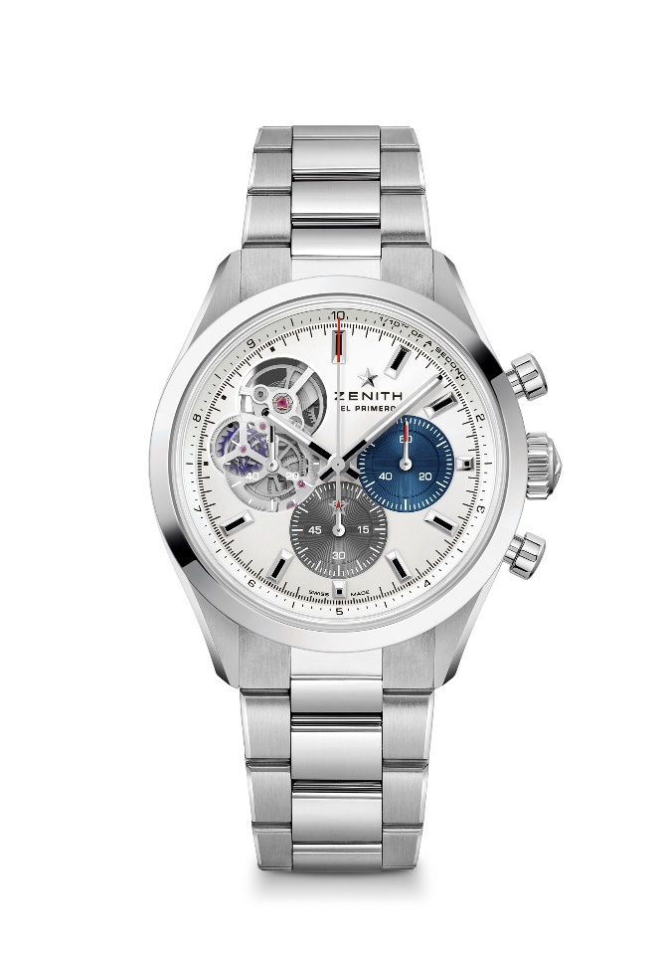
CHRONOMASTER OPEN
Reference: 03.3300.3604/69.M3300

Key points: Automatic El Primero column-wheel chronograph able to measure and display 1/10th of a second. Opening revealing the legendary beating heart of the El Primero movement. Silicon escape-wheel and lever. Increased power reserve of 60 hours. Stop-second mechanism.
Movement: El Primero 3604 automatic
Frequency 36,000 VpH (5 Hz)
Power reserve approx. 60 hours
Functions : 1/10th of a second chronograph functions. Hours and minutes in the centre. Small seconds at 9 o'clock, Central chronograph hand that makes one turn in 10 seconds, 60-minute counter at 6 o'clock, 60-second counter at 3 o'clock
Finishes: New star-shaped oscillating weight with satined finishings
Price 9900 CHF
Material: Stainless Steel
Water resistance: 10 ATM
Case: 39.5mm
Dial: Silver matte with two different-coloured counters & a translucent polymer counter
Hour markers: Rhodium-plated, faceted and coated with " SuperLuminova SLN C1
Hands : Rhodium-plated, faceted and coated with " SuperLuminova SLN C1
Bracelet & Buckle: Metal Bracelet with a double folding clasp

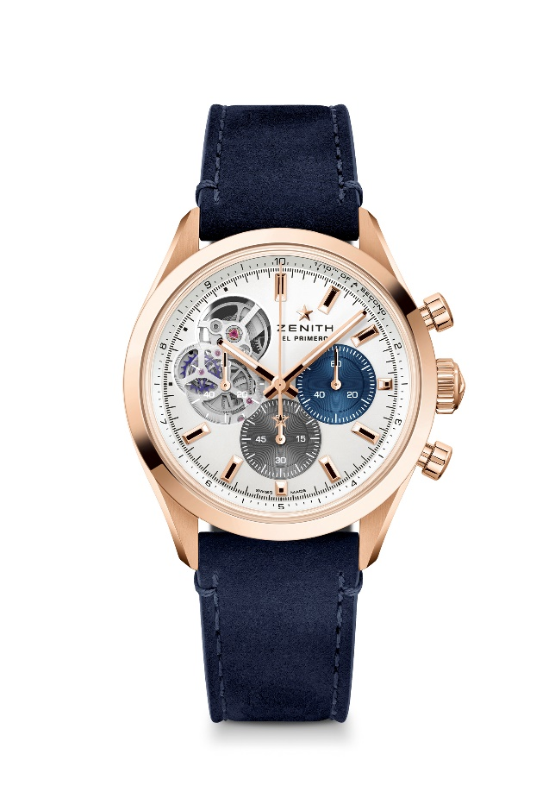
CHRONOMASTER OPEN
Reference: 18.3300.3604/69.C922

Key points: Automatic El Primero column-wheel chronograph able to measure and display 1/10th of a second. Opening revealing the legendary beating heart of the El Primero movement. Silicon escape-wheel and lever. Increased power reserve of 60 hours. Stop-second mechanism.
Movement: El Primero 3604 automatic
Frequency 36,000 VpH (5 Hz)
Power reserve approx. 60 hours
Functions : 1/10th of a second chronograph functions. Hours and minutes in the centre. Small seconds at 9 o'clock, Central chronograph hand that makes one turn in 10 seconds, 60-minute counter at 6 o'clock, 60-second counter at 3 o'clock
Finishes: New star-shaped oscillating weight with satined finishings
Price: 19900 CHF
Material: 18-ct Rose gold
Water resistance: 10 ATM
Case: 39.5mm
Dial: Silver matte with two different-coloured counters & a translucent polymer counter
Hour markers: Gold plated, faceted and coated with " SuperLuminova SLN C1
Hands : Gold plated, faceted and coated with " SuperLuminova SLN C1
Bracelet & Buckle: Blue calfskin leather with a gold triple folding clasp

