GOING FOR GOLD: ZENITH EXPANDS THE AWARD-WINNING CHRONOMASTER SPORT LINE WITH GOLD AND TWO-TONE VERSIONS

With the unveiling of the Chronomaster Sport in 2021, Zenith once again set a new gold standard for automatic sporty chronographs. Crowned with the Grand Prix d’Horlogerie de Genève 2021 “Chronograph” prize, the Chronomaster Sport is already a modern chronograph icon in the making. Now, Zenith is expanding the collection with new versions incorporating precious metals while retaining the performance-centric allure of the model.

On the Chronomaster Sport’s immediate success, Zenith CEO Julien Tornare shared “In just one year, the Chronomaster Sport has catapulted into becoming one of the most sought-after modern chronograph watches, as well as a significant pillar for Zenith that brings together our unique know-how in high-frequency chronographs with a distinctive aesthetic direction. Today, we’re pleased to expand the collection with new versions and materials that bring another dimension to the Chronomaster Sport.”

During Watches & Wonders, Zenith has publicly unveiled the first boutique edition of the steel Chronomaster Sport, exclusively available at Zenith physical and online boutiques around the world. This version stands out with its engraved ceramic bezel, which consists of three separate coloured ceramic elements in the traditional El Primero tricolour palette of grey, anthracite and blue that have been seamlessly forged together within the base of the bezel – also in ceramic. The colours of the bezel are extended from those of the dial's registers, allowing for easier reading of the 1/10th of a second chronograph in clearly segmented parts. Making this special edition even more outstanding is its silver sunray-patterned dial with tricolour counters.

Full gold chronographs have a special place in Zenith history that even predate the El Primero. Because performance and preciousness don’t have to be mutually exclusive, Zenith has crafted the Chronomaster Sport entirely in rose gold - including the bracelet and engraved bezel with 1/10th of a second scale. Available with either a black or white dial with the signature El Primero tricolour counters with golden hands and applied markers, the Chronomaster Sport in rose gold is meticulously finished with satin-brushed and polished surfaces to bring out the warm radiance of the precious metal.

The Chronomaster Sport is now also available in a “two-tone” aesthetic, combining the durability of stainless steel and the splendour of rose gold. The case as well as the side links of the bracelet are crafted in stainless steel, while the bezel, crown, pushers and the bracelet’s centre links are in rose gold. The silver sunray-patterned tricolour dial adds a shimmery effect that emphasizes the mix of tones and textures.

The result of over 50 years of perfecting the El Primero, the world’s first automatic high-frequency chronograph calibre, the Chronomaster Sport line is equipped with the newest version of the venerable movement, the El Primero 3600. With its high frequency of 5 Hz (36’000 VpH), the movement is able to precisely offer a 1/10th of second function that’s easily readable, displayed directly on the bezel as well as the dial. Its autonomy has also been rendered more efficient, with an extended power reserve of 60 hours. Visible through the sapphire display back, the new architecture is strikingly evident, revealing a blue column wheel and open rotor marked with the five-pointed star Zenith.

With these new references, the Chronomaster Sport line is expanded to deliver the same groundbreaking performance in new materials and executions that are bound to please an ever-growing audience seeking the perfect modern sporty chronograph.

ZENITH: TIME TO REACH YOUR STAR.

Zenith exists to inspire individuals to pursue their dreams and make them come true – against all odds. Since its establishment in 1865, Zenith became the first watch manufacture in the modern sense of the term, and its watches have accompanied extraordinary figures that dreamt big and strived to achieve the impossible – from Louis Blériot’s history-making flight across the English Channel to Felix Baumgartner’s record-setting stratospheric free-fall jump. Zenith is also highlighting visionary and trailblazing women – past and present – by celebrating their accomplishments and creating in 2020 its first-ever collection dedicated entirely to them, Defy Midnight.

With innovation as its guiding star, Zenith features exceptional in-house developed and manufactured movements in all its watches. Since the creation of the El Primero in 1969, the world’s first automatic chronograph calibre, Zenith has gone on to master fractions of the second with the Chronomaster Sport and its 1/10th of a second precision and the DEFY 21 with a precision of 1/100th of a second. Zenith has been shaping the future of Swiss watchmaking since 1865, accompanying those who dare to challenge themselves and break barriers. The time to reach your star is now.

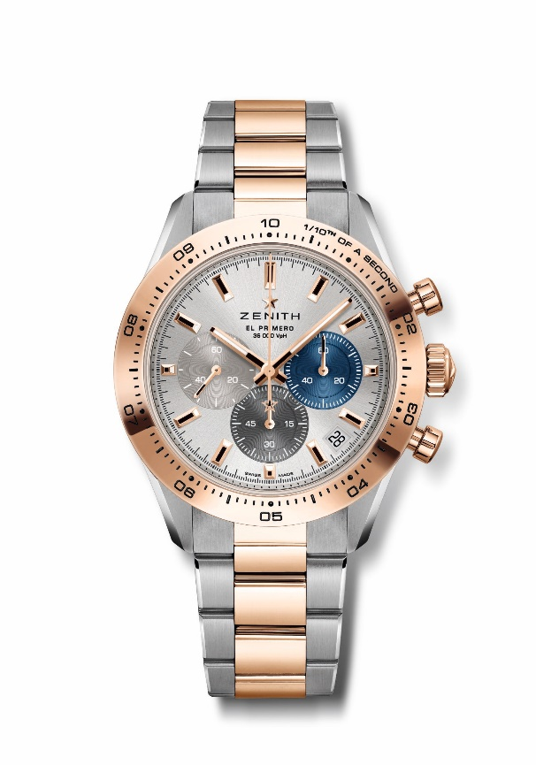
CHRONOMASTER SPORT
Reference: 51.3100.3600/69.M3100

Key points: Automatic El Primero column-wheel chronograph able to measure and display 1/10th of a second. 1/10th of a second indication on the gold bezel. Increased power reserve of 60 hours. Date indication at 4:30. Stop-second mechanism.
Movement: El Primero 3600 automatic
Frequency: 36,000 VpH (5 Hz)
Power reserve: approx. 60 hours
Functions: 1/10th of a second chronograph functions. Hours and minutes in the centre. Small seconds at 9 o'clock. Central chronograph hand that makes one turn in 10 seconds, 60-minute counter at 6 o'clock, 60-second counter at 3 o'clock
Finishes: New star-shaped oscillating weight with satined finishings
Price 16900 CHF
Material: Stainless Steel & 18-carat rose gold with gold bezel
Water resistance: 10 ATM
Case: 41mm
Dial: Silver-toned sunray-patterned dial with three different-coloured counters
Hour markers: Gold-plated, faceted and coated with SuperLuminova SLN C1
Hands : Gold-plated, faceted and coated with SuperLuminova SLN C1
Bracelet & Buckle: Stainless steel and rose gold bracelet with a double folding clasp

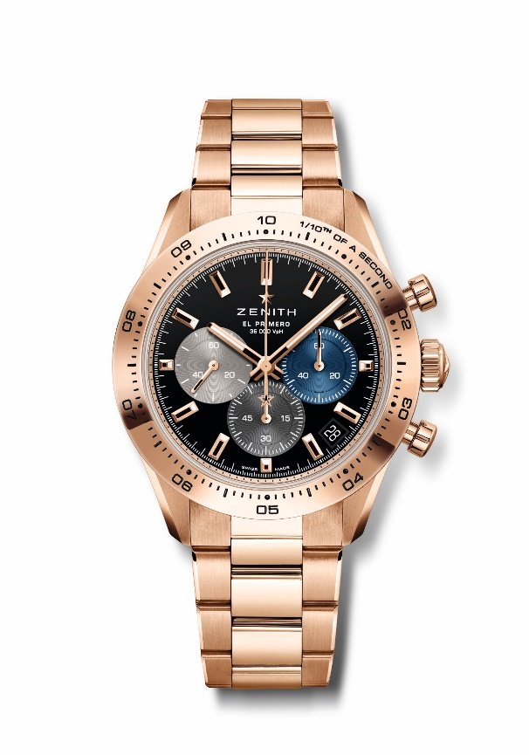
CHRONOMASTER SPORT
Reference: 18.3101.3600/21.M3100

Key points: Automatic El Primero column-wheel chronograph able to measure and display 1/10th of a second. 1/10th of a second indication on the gold bezel. Increased power reserve of 60 hours. Date indication at 4:30. Stop-second mechanism.
Movement: El Primero 3600 automatic
Frequency: 36,000 VpH (5 Hz)
Power reserve: approx. 60 hours
Functions: 1/10th of a second chronograph functions. Hours and minutes in the centre. Small seconds at 9 o'clock. Central chronograph hand that makes one turn in 10 seconds, 60-minute counter at 6 o'clock, 60-second counter at 3 o'clock
Finishes: New star-shaped oscillating weight with satined finishings
Price 37900 CHF
Material: 18-carat Rose gold with gold bezel
Water resistance: 10 ATM
Case: 41mm
Dial: Black-lacquered dial with three different-coloured counters
Hour markers: Gold-plated, faceted and coated with SuperLuminova SLN C1
Hands : Gold-plated, faceted and coated with SuperLuminova SLN C1
Bracelet & Buckle: Rose gold bracelet with a double folding clasp

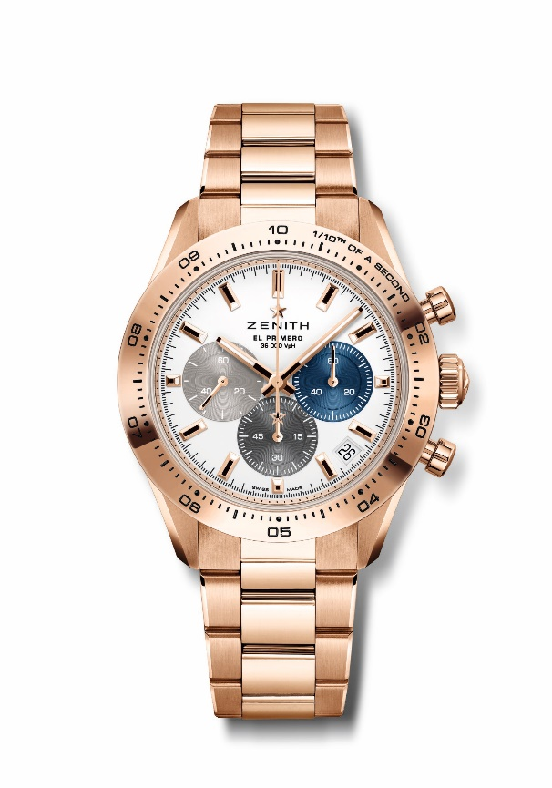
CHRONOMASTER SPORT
Reference: 18.3101.3600/69.M3100

Key points: Automatic El Primero column-wheel chronograph able to measure and display 1/10th of a second. 1/10th of a second indication on the gold bezel. Increased power reserve of 60 hours. Date indication at 4:30. Stop-second mechanism.
Movement: El Primero 3600 automatic
Frequency: 36,000 VpH (5 Hz)
Power reserve: approx. 60 hours
Functions: 1/10th of a second chronograph functions. Hours and minutes in the centre. Small seconds at 9 o'clock. Central chronograph hand that makes one turn in 10 seconds, 60-minute counter at 6 o'clock, 60-second counter at 3 o'clock
Finishes: New star-shaped oscillating weight with satined finishings
Price 37900 CHF
Material: 18-carat Rose gold with gold bezel
Water resistance: 10 ATM
Case: 41mm
Dial: White matte with three different applied coloured counters
Hour markers: Gold-plated, faceted and coated with SuperLuminova SLN C1
Hands : Gold-plated, faceted and coated with SuperLuminova SLN C1
Bracelet & Buckle: Rose gold bracelet with a double folding clasp

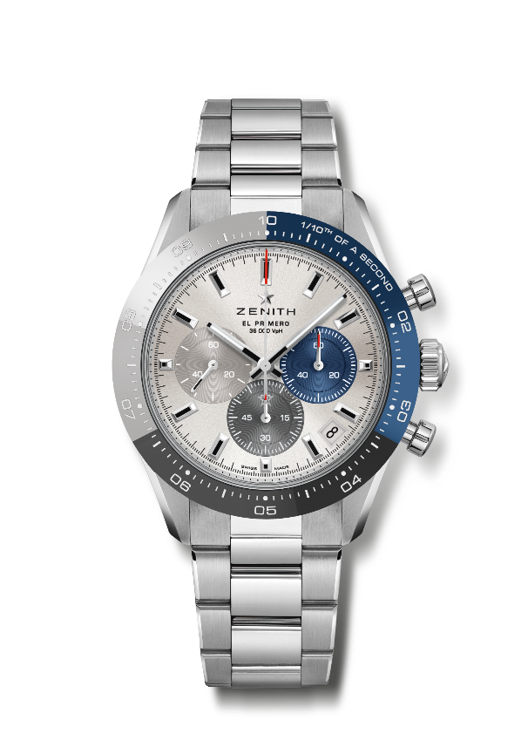
CHRONOMASTER SPORT BOUTIQUE EDITION
Reference: 03.3103.3600/69.M3100

Key points: Special tri-coloured ceramic bezel. Automatic El Primero column-wheel chronograph able to measure and display 1/10th of a second. 1/10th of a second indication on the ceramic bezel. Increased power reserve of 60 hours. Date indication at 4:30. Stop-second mechanism.
Movement: El Primero 3600 automatic
Frequency: 36,000 VpH (5 Hz)
Power reserve: approx. 60 hours
Functions: 1/10th of a second chronograph functions. Hours and minutes in the centre. Small seconds at 9 o'clock. Central chronograph hand that makes one turn in 10 seconds, 60-minute counter at 6 o'clock, 60-second counter at 3 o'clock
Finishes: New star-shaped oscillating weight with satined finishings
Price 11900 CHF
Material: Stainless steel with tri-color ceramic bezel
Water resistance: 10 ATM
Case: 41mm
Dial: Silver-toned sunray-patterned dial with three different-coloured counters
Hour markers: Rhodium-plated, faceted and coated with SuperLuminova SLN C1
Hands : Rhodium-plated, faceted and coated with SuperLuminova SLN C1
Bracelet & Buckle: Metal Bracelet with a double folding clasp

