ZENITH UNVEILS ITS SECOND DEFY EXTREME E SPECIAL EDITION DURING THE ISLAND X PRIX IN SARDINIA

The second season of Extreme E is at full throttle. As the teams prepare for the first part of the double header Island X Prix this weekend on the Italian island of Sardinia, ZENITH is unveiling the second edition of its special series crafted for the electric rally racing championship of which it proudly continues its role as Official Timekeeper and Founding Partner. Based on the DEFY Extreme Carbon, the world’s lightest and most rugged 1/100th of a second automatic high-frequency chronograph, the DEFY Extreme E “Island X Prix” incorporates upcycled elements from the championship with the back-to-back races’ official colour in vivid orange.
Inspired by the world of motorsports and built to take on Extreme E’s adrenaline-infused off-road courses in some of the wildest and most remote locations around the world, the DEFY Extreme E “Island X Prix” edition is crafted in incredibly light yet highly robust carbon fibre, including the crown and chronograph pushers. Emphasizing the boldly angular geometry of the case, the pusher protectors as well as the twelve-sided bezel are made in microblasted titanium.
The dashboard of this futuristic race-inspired chronograph is an open multi-layered dial with tinted sapphire crystal elements, embellished with fiery orange accents – the official colour of the “Island X Prix” – evoking the scorching-hot temperatures of the Italian island during the summer season. Partially visible through the dial as well as the case back is the fastest automatic high-frequency chronograph calibre in production, offering 1/100th of a second time measurements, with two escapements independently beating at 5Hz (36’000 VpH) for the timekeeping part and 50Hz (360’000 VpH) for the chronograph function. The movement is also visible through the sapphire display back, emblazoned with the Island X Prix logo.

In line with the message of sustainability that’s at the core of Extreme E and the ZENITH HORIZ-ON initiative, the DEFY Extreme E “Island X Prix” is delivered with a rubber strap infused with materials of recycled Continental CrossContact tires that were used in the first season’s races. Matching the Island X Prix bright orange accents on the dial, the Velcro strap features a black rubber central element surrounded by an orange cordura-effect rubber inlay. The DEFY Extreme E “Island X Prix” edition also comes with two additional straps in black rubber and black Velcro, which can be easily swapped without any tools by using the case back’s ingenious and intuitive quick strap-change mechanism.

The DEFY Extreme E “Island X Prix” comes packaged in a suitably sturdy waterproof and crushproof watch case inspired by the extreme conditions of the rally, incorporating various recycled and upcycled elements from the side-lines of the first season’s races. The case’s lid coating is made from recycled E-grip tires, while the plate covering is made from parts of an Extreme E Season 1 racing tarpaulin.
The DEFY Extreme E “Island X Prix” will be made in a limited edition of only 20 pieces and will be available at ZENITH physical and online boutiques around the world.

ZENITH: TIME TO REACH YOUR STAR.

ZENITH exists to inspire individuals to pursue their dreams and make them come true – against all odds. Since its establishment in 1865, ZENITH became the first vertically integrated Swiss watch manufacture, and its watches have accompanied extraordinary figures that dreamt big and strived to achieve the impossible – from Louis Blériot’s history-making flight across the English Channel to Felix Baumgartner’s record-setting stratospheric free-fall jump. Zenith is also highlighting visionary and trailblazing women by celebrating their accomplishments and creating the DREAMHERS platform where women share their experiences and inspire others to fulfil their dreams.

With innovation as its guiding star, ZENITH exclusively features in-house developed and manufactured movements in all its watches. Since the creation of the El Primero in 1969, the world’s first automatic chronograph calibre, ZENITH has gone on to master high-frequency precision and offers time measurements in fractions of a second, including 1/10th of a second in the Chronomaster collection and 1/100th of a second in the DEFY collection. Because innovation is synonymous with responsibility, the ZENITH HORIZ-ON initiative affirms the brand's commitments to inclusion & diversity, sustainability and employee wellbeing. ZENITH has been shaping the future of Swiss watchmaking since 1865, accompanying those who dare to challenge themselves and reach new heights. The time to reach your star is now

DEFY EXTREME E “ISLAND X PRIX” EDITION
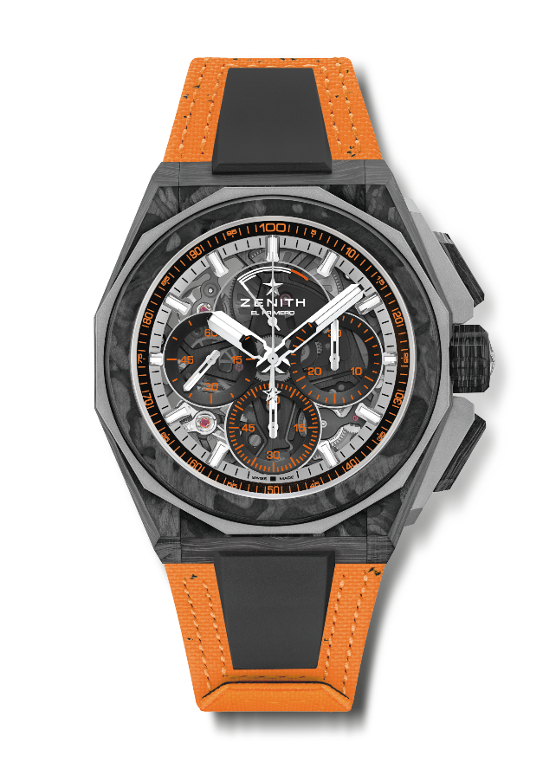
Reference: 10.9100.9004-4/26.I305

Key points: Extreme E capsule collection. Stronger, bolder and more powerful design. 1/100th of a second Chronograph movement. Exclusive dynamic signature of one rotation per second for the Chrono hand. 1 escapement for the Watch (36,000 VpH - 5 Hz) ; 1 escapement for the Chronograph (360,000 VpH - 50 Hz)
Screwed-in crown. Full Interchangeable strap system. Orange Recycled tires Velcro Strap. Sapphire dial. 2 additional straps included: 1 Rubber strap with a black microblasted titanium folding buckle & 1 Velcro strap with carbon buckle.
Movement: El Primero 9004 automatic
Frequency 36,000 VpH (5 Hz)
Power reserve min. 50 hours
Functions : 1/100th of a second chronograph functions. Chronograph power-reserve indication at 12 o'clock. Hours and minutes in the centre. Small seconds at 9 o'clock, Central chronograph hand that makes one turn each second, 30-minute counter at 3 o'clock, 60-second counter at 6 o'clock
Finishes: Black colored main plate on movement + Special black colored
oscillating weight with satined finishings
Price: 26 900 CHF
Material: Carbon & Microblasted Titanium
Water resistance: 20 ATM
Case: 45mm. Special engraving on case back with “Island X Prix” logo
Dial: Tinted sapphire with three black-coloured counters
Hour markers: Rhodium-plated, faceted and coated with SuperLuminova SLN C1
Hands : Rhodium-plated, faceted and coated with SuperLuminova SLN C1
Bracelet & Buckle: Orange Velcro bracelet made with parts of Continental recycled tires. Also comes with a black Velcro strap and a black rubber strap.

