INTRODUCING THE ZENITH CHRONOMASTER ORIGINAL LIMITED EDITION FOR HODINKEE

JULY 26, 2022, 4 PM CET — Hodinkee and ZENITH are joining forces once again on a new iteration of the legendary ZENITH El Primero. A celebration of an innovative legacy, The Zenith Chronomaster Original Limited Edition For Hodinkee reinterprets the modern chronograph iconic in unexpected hues. The first limited style in the Chronomaster Original line, its late 1960’s-era aesthetic is modernized just enough with the powerful El Primero 3600 automatic 1/10th of a second chronograph caliber inside and an unprecedented opaline salmon dial with counters in three shades of grey. This collaborative edition is exclusively available on the online Hodinkee Shop and ZENITH online boutiques around the world.

As the leading destination for all things watches and horology, Hodinkee’s appreciation of both ZENITH’s 1969 release of the first fully integrated automatic chronograph movement, along with their Chronomaster Original line that was unveiled last year with the latest generation of the seminal calibre featuring 1/10th of a second measurement, inspired this partnership. The result is a refreshed look that is rooted in ZENITH’s rich history. The first El Primero caliber was born in a game-changing era for watches, with its name meaning "the first." The El Primero’s ethos of invention continued into design with one of the most subtle, comfortable and well-proportioned cases of the era, along with a dial that still feels extraordinary more than 50 years on. Altogether, ZENITH watches have become an enduring symbol of chronograph design and engineering.

The Zenith Chronomaster Original Limited Edition For Hodinkee captures this legacy through the wrist-hugging ergonomics, the angularity of the lugs, and the classic tri-color registers — and comes together to form a modern version that pushes the storied El Primero into a brand-new era.

DISTINGUISHED BY DESIGN
The Zenith Chronomaster Original Limited Edition For Hodinkee demonstrates the strength and versatility of the original El Primero while providing a silhouette that feels like a contemporary, well-made, and luxurious ZENITH. This is where the perfectly sized 38mm x 12.6mm case of the Chronomaster Original came in. Introduced in 2021, the Chronomaster Original instantly recalls the original ZENITH A386 of 1969, but with updates in both design and performance that ensure both modernity and a unique function true to the innovative spirit of the El Primero.

The colors are where Hodinkee pushed the boundaries while connecting the timepiece to the world of classically complex watchmaking. The timepiece is outfitted with a matte salmon opaline dial, providing a dynamic and warm backdrop uncommon for this dial configuration.

Chosen by the Hodinkee team, the salmon leans more towards an orange colorway as opposed to red, and the matte opaline finish allows that color to shine without any unnecessary finishing. This is anything but simple — the color has depth and a bit of flash that holds up against the muted silver and gray hues elsewhere. On the wrist, the dial "pops" and can move quite seamlessly between bright and sunny and

formal and moody. With the strong salmon base tone, the chronograph reinterprets ZENITH’s emblematic tricolor registers in three shades of grey. Also, the signature 4:30 date window is preserved with the date wheel matching the color of the dial.

Beyond the tones, the watch’s case and dial are enclosed with a raised sapphire crystal, calling to mind the acrylic lenses found on vintage ZENITH timepieces like the A386. Flanked by familiar pump-style pushers and brushed lugs, the case is met by a tapered bracelet with polished center links, outer links with polished edges, and a folding clasp to ensure the look—and feel—of a modern high-performance sports watch.

EL PRIMERO: THE DRIVING FORCE
Housed inside the 38mm case, and entirely visible through the sapphire caseback, sits the ZENITH El Primero Automatic Caliber 3600 movement. The Caliber 3600 shares the same high-beat rate and column-wheel design that has defined the El Primero since its inception, but with modern technical enhancements that ensure smooth running and reliability. For instance, the chronograph seconds hand traverses the dial once every ten seconds or six times per minute. Also, rather than drive the chronograph via the movement's fourth wheel, as the original caliber 400 did, the El Primero 3600 runs the chronograph directly off its high-tech silicon escape wheel, made possible by ZENITH’s longstanding chronograph design and engineering excellence.

The Zenith Chronomaster Original Limited Edition For Hodinkee is available as a 300-piece limited edition for $9,500 through the HODINKEE Shop and ZENITH’s online boutique.

ZENITH: TIME TO REACH YOUR STAR.
ZENITH exists to inspire individuals to pursue their dreams and make them come true – against all odds. Since its establishment in 1865, ZENITH became the first vertically integrated Swiss watch manufacture, and its watches have accompanied extraordinary figures that dreamt big and strived to achieve the impossible – from Louis Blériot’s history-making flight across the English Channel to Felix Baumgartner’s record-setting stratospheric free-fall jump. Zenith is also highlighting visionary and trailblazing women by celebrating their accomplishments and creating the DREAMHERS platform where women share their experiences and inspire others to fulfill their dreams.

With innovation as its guiding star, ZENITH exclusively features in-house developed and manufactured movements in all its watches. Since the creation of the El Primero in 1969, the world’s first automatic chronograph calibre, ZENITH has gone on to master high-frequency precision and offers time measurements in fractions of a second, including 1/10th of a second in the Chronomaster collection and 1/100th of a second in the DEFY collection. Because innovation is synonymous with responsibility, the ZENITH HORIZ-ON initiative affirms the brand's commitments to inclusion & diversity, sustainability and employee wellbeing. ZENITH has been shaping the future of Swiss watchmaking since 1865, accompanying those who dare to challenge themselves and reach new heights. The time to reach your star is now.

HODINKEE
Hodinkee is building a better world of watches. Founded in 2008 by Benjamin Clymer as a watch blog, Hodinkee is now a multi-channel online destination for watch enthusiasts, including: print, digital, and video content, an e-commerce platform as an authorized retailer of over 40+ brands in every style and price point, along with a wide assortment of pre-owned and vintage watches, and best-in-class services like Hodinkee Insurance. With years of experience and expertise, Hodinkee’s work brings every aspect of the watch world to life through color-rich journalism, meticulous engineering of Limited Edition timepieces, and curation of the most extensive assortment of watch brands and accessories to shop. As a true destination for everything watch-related, Hodinkee has built a dedicated community that’s brought the brand to the forefront. Headquartered in NYC, visit www.hodinkee.com.

THE ZENITH CHRONOMASTER ORIGINAL LIMITED EDITION FOR HODINKEE

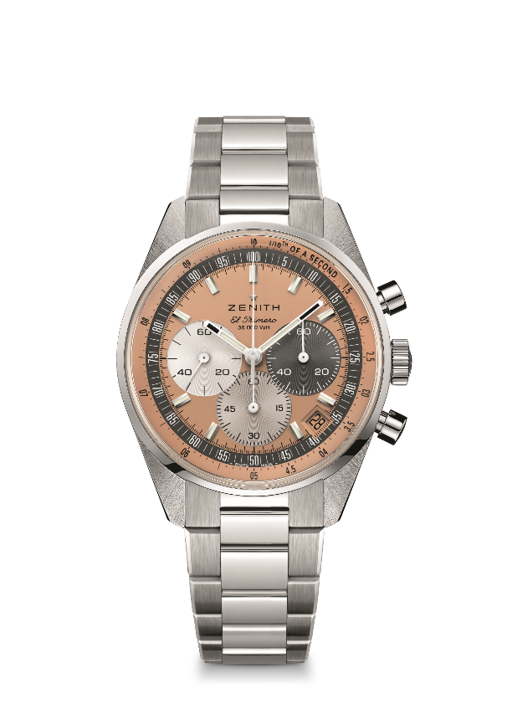
Reference 03.3201.3600/18.M3200.T3/P

Key points: The Zenith Chronomaster Original Limited Edition For Hodinkee demonstrates the strength and versatility of the original El Primero while providing a silhouette that feels like a modern. Powered by the El Primero 3600 automatic high-frequency chronograph movement with 1/10th of a second chronograph function and a power reserve of 60 hours. One of 300 Limited edition.
Movement: El Primero 3600
Frequency 36,000 VpH (5 Hz)
Power reserve approx. 60 hours
Functions: Hours, minutes, small seconds at 9 o'clock, 1/10th of a second chronograph, Central chronograph hand that makes one turn in 10 seconds 60-minute counter at 6 o'clock 60-second counter at 3 o'clock
Finishes: New star-shaped oscillating weight with satined finishings
Price 9400 CHF / 9500 USD
Material: Stainless steel
Water resistance: 5 ATM
Case: 38mm
Dial: Salmon opaline
Hour markers: Rhodium-plated, faceted and coated with SuperLuminova SLN C1
Hands: Rhodium-plated, faceted and coated with SuperLuminova SLN C1
Bracelet & Buckle: Stainless steel Chronomaster Original Bracelet

