ZENITH AND RABAT CELEBRATE SUMMER TO THE BEAT OF CARL COX IN IBIZA

IBIZA, July 21, 2022: Together with longstanding Spanish retail partner RABAT, ZENITH hosted a private party at the rooftop of the NOBU Hotel overlooking the Talamanca beach. Guests were treated to a private set by Carl Cox as they discovered some of the Manufacture’s latest creations in unique and up-tempo setting.

After three years since the last official summer party season in Ibiza, the Balearic island is ecstatically welcoming back partygoers from around the world. A mainstay on the revered party island, ZENITH friend of the brand Carl Cox is finally back in his element behind the decks and in front of a euphoric live crowd during his summer residency at the legendary DC-10 club in Ibiza. ZENITH’s and RABAT’s guests as well as members of the press got to experience the raw energy of a party hosted by the legendary English electronic music pioneer at his summer residency, followed by an intimate private party with the superstar DJ the following night.

On this special get-together, ZENITH CEO Julien Tornare shared, “This is something that we’ve been wanting to do for a long time, and I am thrilled that we’re finally able to share this exceptional moment with our dear friends RABAT and Carl Cox in Ibiza”.

Carl Cox added, “It‘s an absolute pleasure to be back in Ibiza this summer. Sharing the spirit of the island with my friends from ZENITH while overlooking Talamanca Bay was magical. It’s moments like these when we remember how important it is to cherish the good times.”

Jordi Rabat, CEO and president of RABAT, a high jewelry brand and leader in watch distribution, stated, “We are truly delighted to have been able to celebrate ZENITH’s strong momentum and the spirit of the island of Ibiza with someone as legendary as Carl Cox. Offering unique experiences to our clients is what it’s all about”.

A SUMMER FULL OF COLOURS - DEFY 21 CHROMA
Colour is light; colour is emotion. Like the flashing strobes at a rave or a dreamy sunset on the beach, the DEFY 21 Chroma exhibits vivid colours in a most unexpected way. Crafted in a pure white ceramic case, the DEFY 21 Chroma stands out with its open dial giving way to a whole spectrum of colours on the automatic 1/100th of a second chronograph movement, with a perfectly transitioning gradient of colours spanning the entire rainbow marking the dial as well as the strap and crown. This chromatically playful limited edition of 200 pieces is now available at ZENITH boutiques and authorized retailers.

FOLLOWING THE LIGHT - DEFY SKYLINE
The boldest yet most versatile line within the modernistic DEFY collection, the DEFY Skyline draws inspiration from the unique octagonal geometry of the early DEFY models without attempting to merely recreate the past. It is crafted in an octagonal steel case with a faceted bezel, featuring the Manufacture’ first patterned dial revisiting the emblematic four-pointed star found in past Zenith references. It is powered by a high-frequency automatic El Primero

manufacture movement with the very first 1/10th of a second indicator. Effortlessly adapting to any situation, the quick strap-change mechanism allows for easy switching between the steel bracelet and provided straps.

ON THE BEAT - DEFY 21 CARL COX EDITION
Also making a rare appearance at the party was Carl Cox’s eponymous limited edition of the DEFY 21, a 1/100th of a second chronograph that moves to the tempo of the superstar DJ. Befitting the Ibiza summer spirit with parties from sunset to sunrise and beyond, the DEFY 21 Carl Cox Edition features a glow-in-the-dark carbon fiber bezel and strap stitching, with a miniature vinyl record as a seconds indicator on the open dial. Carl Cox went as far as creating a special remix of his track "This is our Time", printed on a double-sided vinyl exclusively for owners of the watch and included in the box along with a pair of Pioneer HDJ-X10 headphones; the same pair that Carl Cox mixes with.

ZENITH: TIME TO REACH YOUR STAR.

ZENITH exists to inspire individuals to pursue their dreams and make them come true – against all odds. Since its establishment in 1865, ZENITH became the first vertically integrated Swiss watch manufacture, and its watches have accompanied extraordinary figures that dreamt big and strived to achieve the impossible – from Louis Blériot’s history-making flight across the English Channel to Felix Baumgartner’s record-setting stratospheric free-fall jump. Zenith is also highlighting visionary and trailblazing women by celebrating their accomplishments and creating the DREAMHERS platform where women share their experiences and inspire others to fulfill their dreams.

With innovation as its guiding star, ZENITH exclusively features in-house developed and manufactured movements in all its watches. Since the creation of the El Primero in 1969, the world’s first automatic chronograph calibre, ZENITH has gone on to master high-frequency precision and offers time measurements in fractions of a second, including 1/10th of a second in the Chronomaster collection and 1/100th of a second in the DEFY collection. Because innovation is synonymous with responsibility, the ZENITH HORIZ-ON initiative affirms the brand's commitments to inclusion & diversity, sustainability and employee wellbeing. ZENITH has been shaping the future of Swiss watchmaking since 1865, accompanying those who dare to challenge themselves and reach new heights. The time to reach your star is now.

DEFY EL PRIMERO 21 CHROMA
Reference: 49.9010.9004/01.R947

Key points:. The DEFY 21 Chroma is a colourful execution of the high frequency El Primero 21 1/100th of a second Chronograph movement. Exclusive dynamic signature of one rotation per second for the Chrono hand 1 escapement for the Watch (36,000 VpH - 5 Hz) 1 escapement for the Chronograph (360,000 VpH - 50 Hz) and certified Chronometer
The white rubber strap also features rainbow stitching. Limited edition of 200 pieces.
Movement: El Primero 9004
Frequency 36,000 VpH (5 Hz)
Power reserve min. 50 hours
Functions : 1/100th of a second chronograph functions. Chronograph power-reserve indication at 12 o'clock. Hours and minutes in the centre. Small seconds at 9 o'clock, Central chronograph hand that makes one turn each second, 30-minute counter at 3 o'clock, 60-second counter at 6 o'clock
Finishes: "Rainbow" PVD-coated bridges + Special blue colored oscillating weight with satined finishings
Price: 14 400 CHF
Material: Matte White Ceramic
Water resistance: 10 ATM
Case: 44mm. Transparent sapphire crystal
Dial: White Openworked
Hour markers: Rhodium-plated, faceted and coated with "Rainbow" varnish
Hands : Rhodium-plated, faceted and coated with colored varnish
Bracelet & Buckle: White rubber with white "Cordura effect" rubber and multicolored stitchings. And the buckle is a titanium double folding clasp

DEFY EL PRIMERO 21 CARL COX
Reference: 10.9001.9004/99.R941

Key points: The DEFY 21 CARL COX is a full Carbon model execution of the high frequency El Primero 21 1/100th of a second Chronograph movement. Exclusive dynamic signature of one rotation per second for the Chrono hand 1 escapement for the Watch (36,000 VpH - 5 Hz) ; 1 escapement for the Chronograph (360,000 VpH - 50 Hz) and certified Chronometer Black rubber with red "Cordura Effect" rubber & Super Luminova stitchings. Limited edition of 200 pieces.
Movement: El Primero 9004
Frequency 36,000 VpH (5 Hz)
Power reserve min. 50 hours
Functions: 1/100th of a second chronograph functions. Central chronograph hand that makes one turn each second. Special rotating small second disc at 9 o'clock. Hours and minutes in the centre. 30-minute counter at 3 o'clock. 60-second counter at 6 o'clock.
Chronograph power-reserve indication at 12 o'clock.
Finishes: Black colored main plate on movement + Special black colored oscillating weight with satined finishings
Price: 19 500 CHF
Material: Black carbon
Water resistance: 10 ATM
Case: 44mm. Transparent sapphire crystal
Dial: White Open worked
Hour markers: Black ruthenium-plated, faceted and coated with SuperLuminova
Hands: Black ruthenium-plated, faceted and coated with SuperLuminova SLN C1
Bracelet & Buckle: White rubber with white "Cordura effect" rubber and multicolored stitchings. And the buckle is a titanium double folding clasp

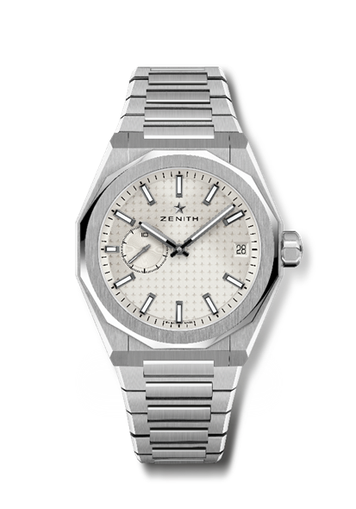
DEFY SKYLINE
Reference: 03.9300.3620/01.I001

Key points: El Primero 3-hand watch. High frequency indication: 1/10th of a second subdial at 9 o'clock. Silicon escape-wheel and lever. Starry sky pattern on the dial. Screwed-in crown. Full Interchangeable strap system.
Movement: El Primero 3620, automatic
Frequency 36,000 VpH (5 Hz)
Power reserve approx. 60 hours
Functions: Hours and minutes in the centre. 1/10th of a second counter at 9 o'clock. Date indication at 3 o'clock.
Finishes: Special oscillating weight with satined finishings
Price 8400 CHF
Material: Stainless steel
Water resistance: 10 ATM
Case: 41mm
Dial: Silver-toned sunburst-patterned
Hour markers: Black ruthenium-plated, faceted and coated with SuperLuminova SLN C1
Hands: Black ruthenium-plated, faceted and coated with SuperLuminova SLN C1
Bracelet & Buckle: Stainless steel bracelet and folding clasp. Comes with a khaki green rubber strap with starry sky pattern and folding clasp.

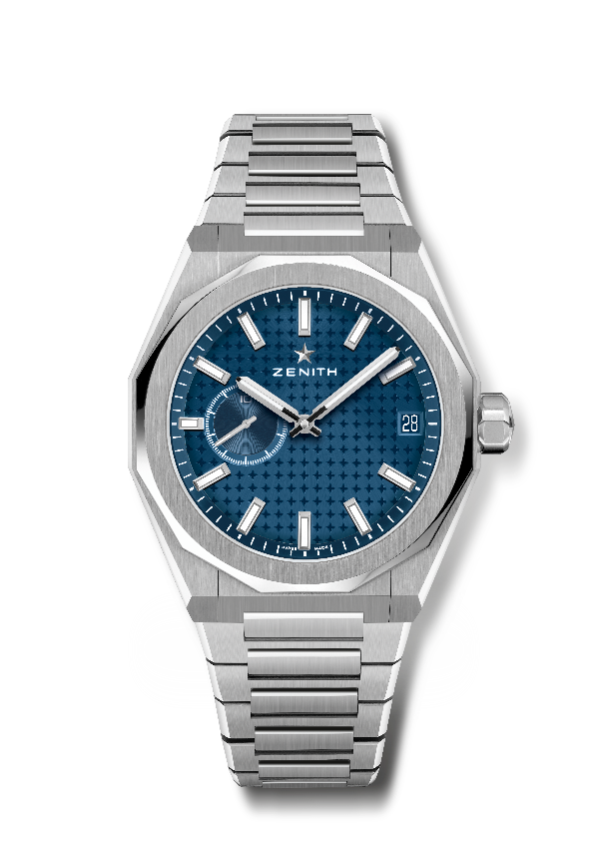
DEFY SKYLINE
Reference: 03.9300.3620/51.I001

Key points: El Primero 3-hand watch. High frequency indication: 1/10th of a second subdial at 9 o'clock. Silicon escape-wheel and lever. Starry sky pattern on the dial. Screwed-in crown. Full Interchangeable strap system.
Movement: El Primero 3620, automatic
Frequency 36,000 VpH (5 Hz)
Power reserve approx. 60 hours
Functions: Hours and minutes in the centre. 1/10th of a second counter at 9 o'clock. Date indication at 3 o'clock.
Finishes: Special oscillating weight with satined finishings
Price 8400 CHF
Material: Stainless steel
Water resistance: 10 ATM
Case: 41mm
Dial: Blue-toned sunburst-patterned
Hour markers: Rhodium-plated, faceted and coated with SuperLuminova SLN C1
Hands: Rhodium-plated, faceted and coated with SuperLuminova SLN C1
Bracelet & Buckle: Stainless steel bracelet and folding clasp. Comes with a blue rubber strap with starry sky pattern and folding clasp.

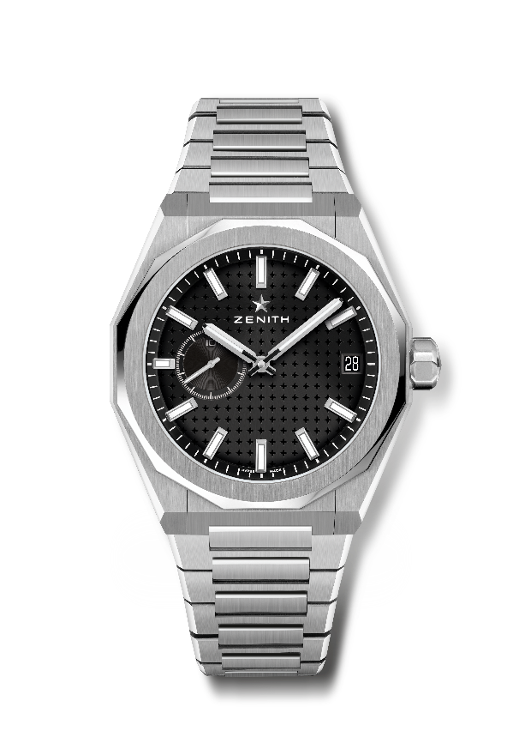
DEFY SKYLINE
Reference: 03.9300.3620/21.I001

Key points: El Primero 3-hand watch. High frequency indication: 1/10th of a second subdial at 9 o'clock. Silicon escape-wheel and lever. Starry sky pattern on the dial. Screwed-in crown. Full Interchangeable strap system.
Movement: El Primero 3620, automatic
Frequency 36,000 VpH (5 Hz)
Power reserve approx. 60 hours
Functions: Hours and minutes in the centre. 1/10th of a second counter at 9 o'clock. Date indication at 3 o'clock.
Finishes: Special oscillating weight with satined finishings
Price 8400 CHF
Material: Stainless steel
Water resistance: 10 ATM
Case: 41mm
Dial: Black-toned sunburst-patterned
Hour markers: Rhodium-plated, faceted and coated with SuperLuminova SLN C1
Hands: Rhodium-plated, faceted and coated with SuperLuminova SLN C1
Bracelet & Buckle: Stainless steel bracelet folding clasp. Comes with a black rubber strap with starry sky pattern and folding clasp.

