THE THIRD ZENITH SPECIAL EDITION FOR EXTREME E IS HERE: INTRODUCING THE DEFY EXTREME E COPPER X PRIX

For this next race of the 2022 Extreme E championship, the teams are heading far off the beaten path to South America, a first for the electric rally racing championship. One of the world’s foremost copper mining areas and one that is incorporating an innovative and sustainable approach to its operations, the Atacama Desert, Chile, sets the stage for the unveiling of ZENITH’s third special edition watch commemorating an Extreme E race. The DEFY Extreme E Copper X Prix, a limited edition of 20 pieces, combines carbon fibre and titanium with earthy tones that recall the copper mines of the region, while incorporating recycled and upcycled elements from the championship.

Inspired by the world of extreme motorsports and conceived with ruggedness in mind, the DEFY Extreme E Copper X Prix is designed to take on the electric rally’s thrilling off-road courses in some of the world’s most remote environments. Based on the DEFY Extreme Carbon, the world’s lightest and most robust 1/100th of a second automatic high-frequency chronograph, the DEFY Extreme E “Copper X Prix” incorporates upcycled elements from the championship with the back-to-back races’ official colour of warm coppery-brown.
The DEFY Extreme E “Copper X Prix” edition is crafted in lightweight yet highly durable carbon fibre, including the crown and chronograph pushers. Emphasizing the boldly angular geometry of the case, the pusher protectors as well as the twelve-sided bezel are made in microblasted titanium.
The open multi-layered dial consists of tinted sapphire crystal elements, embellished with coppery-brown accents that evoke the dry, rocky terrain and copper mines of the Chilean desert. Partially visible through the dial as well as the sapphire case back is the fastest automatic high-frequency chronograph calibre in production, offering 1/100th of a second time measurements, with two escapements independently beating at 5Hz (36’000 VpH) for the timekeeping part and 50Hz (360’000 VpH) for the chronograph function. The movement is also visible through the sapphire display back, emblazoned with the Copper X Prix logo.

Bringing sustainability and environmental awareness to the forefront of ZENITH and Extreme E’s partnership, the DEFY Extreme E “Copper X Prix” is delivered with a rubber strap infused with materials of upcycled Continental CrossContact tires that were used in the first season’s races. Matching the Copper X Prix copper-brown accents on the dial, the Velcro strap features a black rubber central element surrounded by a brown cordura-effect rubber inlay. The DEFY Extreme E “Copper X Prix” is delivered with two additional straps in black rubber and black Velcro, which can be easily swapped without any tools by using the case back’s ingenious and intuitive quick strap-change mechanism.

The DEFY Extreme E “Copper X Prix” comes packaged in a suitably sturdy waterproof and crushproof watch case inspired by the extreme conditions of the rally, incorporating various upcycled elements from the side-lines of the first season’s races. The case’s lid coating is made from E-grip recycled tires, while the plate covering is made from parts of an Extreme E racing tarpaulin.
The DEFY Extreme E “Copper X Prix” will be made in a limited edition of only 20 pieces and will be available exclusively at ZENITH physical and online boutiques around the world.

ZENITH: TIME TO REACH YOUR STAR.

ZENITH exists to inspire individuals to pursue their dreams and make them come true – against all odds. Since its establishment in 1865, ZENITH became the first vertically integrated Swiss watch manufacture, and its watches have accompanied extraordinary figures that dreamt big and strived to achieve the impossible – from Louis Blériot’s history-making flight across the English Channel to Felix Baumgartner’s record-setting stratospheric free-fall jump. Zenith is also highlighting visionary and trailblazing women by celebrating their accomplishments and creating the DREAMHERS platform where women share their experiences and inspire others to fulfil their dreams.

With innovation as its guiding star, ZENITH exclusively features in-house developed and manufactured movements in all its watches. Since the creation of the El Primero in 1969, the world’s first automatic chronograph calibre, ZENITH has gone on to master high-frequency precision and offers time measurements in fractions of a second, including 1/10th of a second in the Chronomaster collection and 1/100th of a second in the DEFY collection. Because innovation is synonymous with responsibility, the ZENITH HORIZ-ON initiative affirms the brand's commitments to inclusion & diversity, sustainability and employee wellbeing. ZENITH has been shaping the future of Swiss watchmaking since 1865, accompanying those who dare to challenge themselves and reach new heights. The time to reach your star is now.

DEFY EXTREME E – COPPER X PRIX EDITION
Reference: 10.9100.9004-5/27. I307
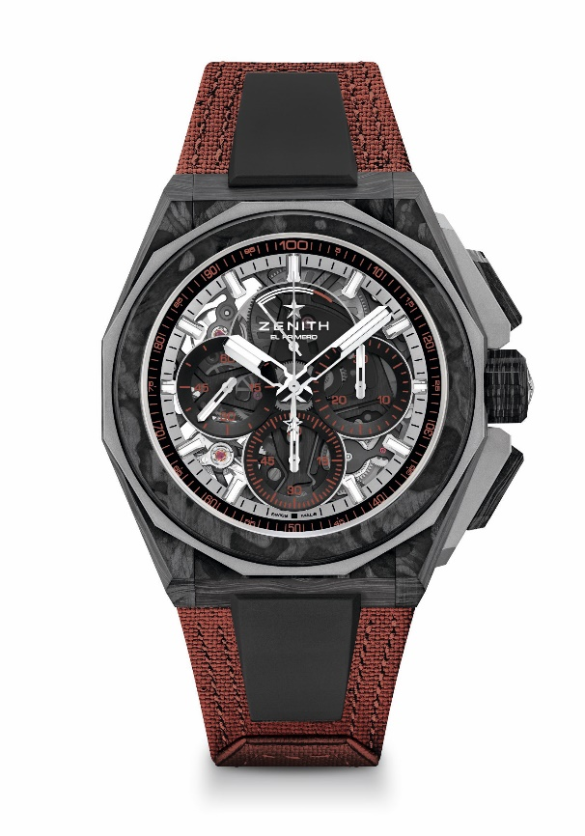
Key points: Extreme E Capsule collection. 1/100th of a second Chronograph movement. Exclusive dynamic signature of one rotation per second for the Chrono hand. 1 escapement for the Watch (36,000 VpH - 5 Hz); 1 escapement for the Chronograph (360,000 VpH - 50 Hz). Certified Chronometer. Sapphire dial
Movement: El Primero 9004
Frequency 36,000 VpH (5 Hz)
Power reserve min. 50 hours
Functions: Hours and minutes in the centre. Small seconds at 9 o'clock. 1/100th of a second Chronograph: Central chronograph hand that makes one turn each second. 30-minute counter at 3 o'clock. 60-second counter at 6 o'clock. Chronograph power-reserve indication at 12 o'clock
Finishes: Black colored main plate on movement + Special black colored oscillating weight with satined finishings
Price: 26 900 CHF
Material: Carbon & Microblasted Titanium
Water resistance: 20 ATM
Case: 45mm. Transparent sapphire crystal caseback.
Dial: Tinted sapphire with three black-coloured counters
Hour markers: Rhodium-plated, faceted and coated with SuperLuminova SLN C1
Hands: Rhodium-plated, faceted and coated with SuperLuminova SLN C1
Bracelet & Buckle: Full Interchangeable strap system. Copper Recycled tires Velcro Strap and a 2nd strap included. Microblasted Titanium Triple folding clasp

