ZENITH CONTINUES ITS SUPPORT FOR THE GLOBAL FIGHT AGAINST BREAST CANCER WITH THE CHRONOMASTER ORIGINAL PINK IN SUPPORT OF SUSAN G. KOMEN®

Today, ZENITH is proud to announce its support of Susan G. Komen® with a special edition Chronomaster Original Pink, available only during Breast Cancer Awareness Month in October and with a portion of sales proceeds directly benefitting the organization.

A worthy cause that deeply resonates with the Manufacture. Women’s empowerment is one of the main pillars of the ZENITH HORIZ-ON initiative, driving many of the brand’s commitments and actions. For many years, ZENITH has been working to raise awareness about breast cancer, an indiscriminate disease that affects one in every eight women and impacts countless lives around the world. Whether it’s via education and promoting the practice of screening or supporting organisations that are ceaselessly searching for a cure, ZENITH’s support of Susan G. Komen® further solidifies its commitment to reaching more women and raising global awareness about breast cancer by offering access to education, hope and support.

Founded by Nancy G. Brinker, who promised her sister, Susan G. Komen, that she would end the disease that claimed Susan’s life, Komen is committed to supporting those affected by breast cancer today, while tirelessly searching for tomorrow’s cures. Considered the world’s leading non-profit breast cancer organization, Susan G. Komen’s mission is to rid the world of the disease forever. Komen’s holistic approach has brought it to the forefront of the fight against the disease, supporting millions of people in the U.S. and across the world. The foundation advocates for patients, drives research breakthroughs, improves access to high-quality care, offers direct patient support and empowers people with trustworthy information. ZENITH is committed to supporting Susan G. Komen over the coming years and looks forward to sharing the progress of this partnership built on hope.

On ZENITH’s support for the foundation, CEO Julien Tornare shared: “Supporting the Susan G. Komen foundation, with its rapport and incredible impact, is a partnership of great significance for ZENITH. The Chronomaster Original Pink will help fund impactful research and support for patients undergoing treatment, a cause we are proud and eager to be a part of over the coming years.”

Added Komen’s President and CEO Paula Schneider, “ZENITH has been an incredible advocate and supporter for the breast cancer community for many years, and when two organizations come together under one shared mission, we can truly be unstoppable. With ZENITH’s partnership, creating a world without breast cancer becomes a more achievable reality every day, and we’re beyond grateful for their support.”

In support of Susan G. Komen, ZENITH is pleased to present the Chronomaster Original Pink, a special edition based on the seminal retro-inspired chronograph collection launched last year. Crafted in a unisex 38mm steel case and equipped with the latest generation of the El Primero automatic high-frequency chronograph calibre with 1/10th of a second measurement, the Chronomaster Original Pink Edition stands out with its striking metallic pink dial, honouring the colour globally associated with breast cancer awareness.

The special edition Chronomaster Original Pink is not a limited edition in the traditional numbered sense but will be limited in time. Available only during the annual international Breast Cancer Awareness Month campaign from October 1 to October 31, and exclusively from ZENITH’s physical and online boutiques around the world, the Manufacture is doing its part to raise awareness and give back to this noble cause. 20% of the proceeds from the sale of the Chronomaster Original Pink will directly be donated to Susan G. Komen, supporting its efforts to make a positive impact on their community by allowing patients everywhere to live better, longer lives.

Beyond the special edition Chronomaster Original Pink, ZENITH looks forward to supporting Susan G. Komen over the coming years, actively participating in fundraising events, charity auctions and other initiatives. On Sunday, October 2, ZENITH will join the foundation during the 2022 Komen Greater NYC Race for the Cure, where the Manufacture will take on the role of timekeeper and will have its team members, clients and members of the press taking part in the race. ZENITH also looks forward to hosting representatives from Susan G. Komen at DREAMHERS events around the world. The brand’s unique platform which offers visionary, independent and inspirational women a space to share their voices and passions, will help grow awareness, share important information and promote good practices related to breast cancer. The next DREAMHERS event will take place in Singapore later in the month of October.

ZENITH: TIME TO REACH YOUR STAR.

ZENITH exists to inspire individuals to pursue their dreams and make them come true – against all odds. Since its establishment in 1865, ZENITH became the first vertically integrated Swiss watch manufacture, and its watches have accompanied extraordinary figures that dreamt big and strived to achieve the impossible – from Louis Blériot’s history-making flight across the English Channel to Felix Baumgartner’s record-setting stratospheric free-fall jump. Zenith is also highlighting visionary and trailblazing women by celebrating their accomplishments and creating the DREAMHERS platform where women share their experiences and inspire others to fulfil their dreams.

With innovation as its guiding star, ZENITH exclusively features in-house developed and manufactured movements in all its watches. Since the creation of the El Primero in 1969, the world’s first automatic chronograph calibre, ZENITH has gone on to master high-frequency precision and offers time measurements in fractions of a second, including 1/10th of a second in the Chronomaster collection and 1/100th of a second in the DEFY collection. Because innovation is synonymous with responsibility, the ZENITH HORIZ-ON initiative affirms the brand's commitments to inclusion & diversity, sustainability and employee wellbeing. ZENITH has been shaping the future of Swiss watchmaking since 1865, accompanying those who dare to challenge themselves and reach new heights. The time to reach your star is now

About Susan G. Komen®

Susan G. Komen® is the world’s leading nonprofit breast cancer organization, working to save lives and end breast cancer forever. Komen has an unmatched, comprehensive 360-degree approach to fighting this disease across all fronts and supporting millions of people in the U.S. and in countries worldwide. We advocate for patients, drive research breakthroughs, improve access to high-quality care, offer direct patient support and empower people with trustworthy information. Founded by Nancy G. Brinker, who promised her sister, Susan G. Komen, that she would end the disease that claimed Suzy’s life, Komen remains committed to supporting those affected by breast cancer today, while tirelessly searching for tomorrow’s cures. Visit komen.org or call 1-877 GO KOMEN. Connect with us on social at ww5.komen.org/social.

CHRONOMASTER ORIGINAL PINK
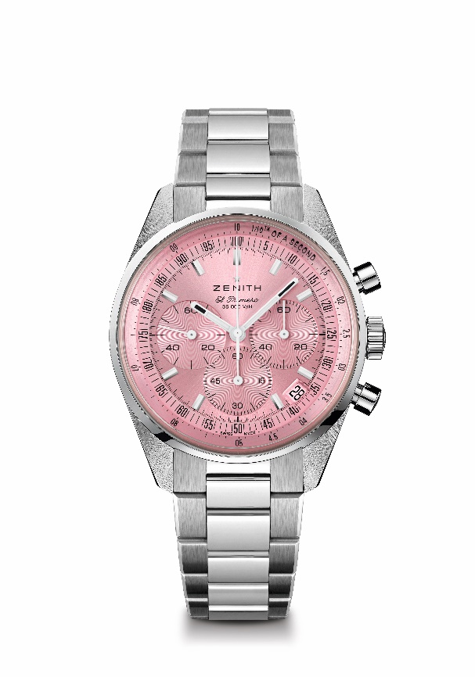
Reference: 03.3202.3600/33.M3200
Key points: Only available during the Month of October. Automatic El Primero column-wheel chronograph able to measure and display 1/10th of a second. Increased power reserve of 60 hours. Date indication at 4:30. Stop-second mechanism
Movement: El Primero 3600
Power-reserve: min. 60 hours
Functions: Hours and minutes in the centre. Small seconds at 9 o'clock. 1/10th of a second Chronograph. Central chronograph hand that makes one turn in 10 seconds. 60-minute counter at 6 o'clock. 60-second counter at 3 o'clock
Finishes: New star-shaped oscillating weight with satined finishings
Price 9900CHF
Material: Stainless steel
Water-resistance: 5 ATM
Dial: Pink-toned sunray-patterned
Case: 38 mm
Hour-markers: Rhodium-plated, faceted and coated with SuperLuminova SLN C1
Hands: Rhodium-plated, faceted and coated with SuperLuminova SLN C1
Bracelet & Buckle: Stainless steel bracelet & double folding clasp

