THE STAKES ARE RAISED DURING THE PENULTIMATE RACE OF EXTREME E’S SECOND SEASON AT THE “COPPER X PRIX” IN CHILE

With just one race to go for the sophomore season of Extreme E, the Antofagasta Minerals Copper X Prix in Chile set the stage for the grand finale in a most thrilling fashion. Taking the teams to uncharted territories far across the Atlantic, the Antofagasta Minerals Copper X Prix marked the first Extreme E race to be held in Latin America. A region of Chile known for its copper and mineral mines, the race was held in Calama, south of the Centinela Mine - one of the largest mines in the world. With the aim of making mining more sustainable through innovative methods, Antofagasta Minerals are taking decisive steps to manage and mitigate the effects of climate change on their operations and areas of influence. Overlooking the mine, the terrain of the course is dry, sandy and rocky, featuring challenging elevation changes to navigate as well as jumps and step-downs in a higher altitude than what the Extreme E teams have faced so far.

World Rally Championship legend Sébastien Loeb and Cristina Gutierrez took their first Extreme E success of the season in Chile's Antofagasta Minerals Copper X-Prix for X44 Vida Carbon Racing after final winners NEOM McLaren Extreme E duo Tanner Foust and Emma Gilmour were penalised and dropped to fifth as a result.

Made with Extreme E: DEFY Extreme E Copper X Prix
As a Founding Partner and Official Timekeeper of Extreme E since the very beginning, ZENITH has built the perfect watch to take on the wild terrains and harsh environments that the electric rally racing championship seeks out around the world, all while promoting the same message of sustainability through innovation as Extreme E. Crafted in light yet durable carbon fibre and titanium, the DEFY Extreme E Copper X Prix features copper-coloured accents recalling the mines and arid terrain of Antofagasta. Limited to 20 pieces, it incorporates various recycled upcycled elements from the side-lines of the first season’s races. The case’s lid coating is made from E-grip recycled tires, while the plate covering is made from parts of an Extreme E racing tarpaulin. The DEFY Extreme E is delivered with a rubber strap containing sustainable materials from recycled Continental tyres that were used in the first season races. Available exclusively at ZENITH physical and online boutiques.

Antofagasta Minerals Copper X Prix “Moment In Time” winner - Klara Andersson, ABT CUPRA XE
Since the very first race of Extreme E, ZENITH has sought to highlight some of the most extraordinary feats and awe-inspiring performances in the rally championship with The ZENITH “Moment In Time”, awarding one driver at the end of each race. For the Antofagasta Minerals Copper X Prix, ABT CUPRA XE’s female driver Jutta Kleinschmidt had injured herself during a Free Practice run, and so 22-year-old Rallycross star and Extreme E Championship Driver Klara Andersson was called in to take her place behind the wheel.

The Swede showed no sign of nerves, earning the ‘Moment in Time’ award with amazing performances for ABT CUPRA XE in Semi-Final 2 and the Final, which ended with the team stepping onto the podium to take third.
In her first Extreme E appearance, Klara supported the team to achieve a podium finish – marking ABT CUPRA XE’s first podium of Extreme E Season 2 and an incredible accomplishment for a first timer. Reflecting on her debut, Klara said: “The weekend in Chile has been like a little motorsport fairytale for me - from the first phone call on Friday until the podium on Sunday. Being awarded with the ‘ZENITH Moment in Time’ award makes me really proud and is the cherry on the cake - and my teammate Nasser [Al-Attiyah] presented it in a very charming way. I would like to thank all the fans and media for their great support over the last weekend.”

LEGACY PROGRAMME – Saving the indigenous Loa Frog with the Museum of Natural and Cultural History

As the Atacama Desert is one of the most arid places on earth, there is little in the way of biodiversity. Therefore, it is vital to preserve whatever lifeforms there are. More than half of the country’s fauna and flora are endemic to Chile. Among them is the Loa water frog, a critically endangered aquatic frog endemic to a small stream in Calama. Following the destruction of its habitat prior to 2019 through mining, agriculture and real estate developments, 14 remaining frogs were rescued and taken into captivity to avoid the species’ extinction. Because they have permeable skin, frogs are very sensitive to pollutants. Moreover, as they can live on both land and in the water, the Loa water frog is a good indicator of the health of these two different environments.

Supported by ZENITH, Extreme E will work alongside the Museum of Natural and Cultural History of the Atacama Desert and focus on biodiversity, specifically on the protection and reintroduction of the Loa Water frog near Ojo de Apache - within 10km from Calama. Antofagasta Minerals will be releasing information on their strategies to reduce impact on local water supplies. Over the past three years, the National Santiago Zoo has been working on a breeding plan and recently made headlines when it announced the birth of 200 frogs. Extreme E will be supporting the habitat preparation and reintroduction of the Loa Frog in Calama over the coming months.

The final race of the 2022 Extreme E season, the “Energy X Prix”, will take place in Punta Del Este, Uruguay, on November 26-27, 2022.

ZENITH: TIME TO REACH YOUR STAR.

ZENITH exists to inspire individuals to pursue their dreams and make them come true – against all odds. Since its establishment in 1865, ZENITH became the first vertically integrated Swiss watch manufacture, and its watches have accompanied extraordinary figures that dreamt big and strived to achieve the impossible – from Louis Blériot’s history-making flight across the English Channel to Felix Baumgartner’s record-setting stratospheric free-fall jump. Zenith is also highlighting visionary and trailblazing women by celebrating their accomplishments and creating the DREAMHERS platform where women share their experiences and inspire others to fulfil their dreams.

With innovation as its guiding star, ZENITH exclusively features in-house developed and manufactured movements in all its watches. Since the creation of the El Primero in 1969, the world’s first automatic chronograph calibre, ZENITH has gone on to master high-frequency precision and offers time measurements in fractions of a second, including 1/10th of a second in the Chronomaster collection and 1/100th of a second in the DEFY collection. Because innovation is synonymous with responsibility, the ZENITH HORIZ-ON initiative affirms the brand's commitments to inclusion & diversity, sustainability and employee wellbeing. ZENITH has been shaping the future of Swiss watchmaking since 1865, accompanying those who dare to challenge themselves and reach new heights. The time to reach your star is now

DEFY EXTREME E – COPPER X PRIX EDITION
Reference: 10.9100.9004-5/27. I307
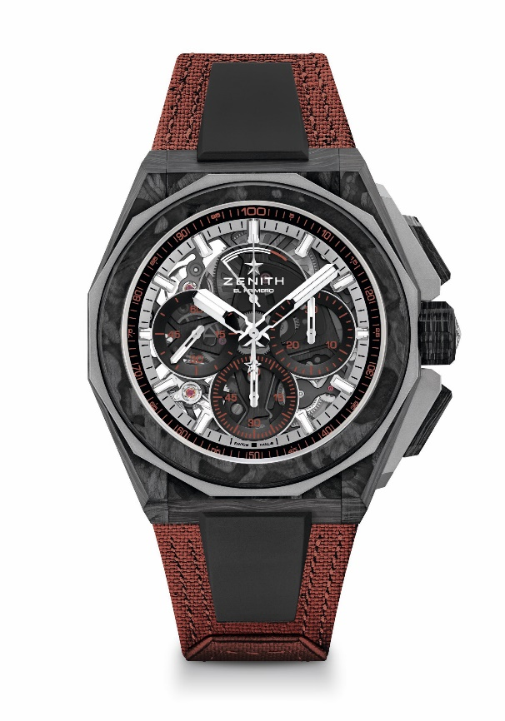
Key points: Extreme E Capsule collection. 1/100th of a second Chronograph movement. Exclusive dynamic signature of one rotation per second for the Chrono hand. 1 escapement for the Watch (36,000 VpH - 5 Hz); 1 escapement for the Chronograph (360,000 VpH - 50 Hz). Certified Chronometer. Sapphire dial
Movement: El Primero 9004
Frequency 36,000 VpH (5 Hz)
Power reserve min. 50 hours
Functions: Hours and minutes in the centre. Small seconds at 9 o'clock. 1/100th of a second Chronograph: Central chronograph hand that makes one turn each second. 30-minute counter at 3 o'clock. 60-second counter at 6 o'clock. Chronograph power-reserve indication at 12 o'clock
Finishes: Black colored main plate on movement + Special black colored oscillating weight with satined finishings
Price: 26 900 CHF
Material: Carbon & Microblasted Titanium
Water resistance: 20 ATM
Case: 45mm. Transparent sapphire crystal caseback.
Dial: Tinted sapphire with three black-coloured counters
Hour markers: Rhodium-plated, faceted and coated with SuperLuminova SLN C1
Hands: Rhodium-plated, faceted and coated with SuperLuminova SLN C1
Bracelet & Buckle: Full Interchangeable strap system. Copper Recycled tires Velcro Strap and a 2nd strap included. Microblasted Titanium Triple folding clasp

