CELEBRATING WOMEN’S EMPOWERMENT WITH ZENITH AT THE
“MEET THE DREAMHERS” EVENT IN SINGAPORE

Singapore, October 12, 2022: As part of its ongoing “MEET THE DREAMHERS” events held across the world, ZENITH invited its guests in Singapore to celebrate women’s empowerment by introducing its newest DREAMHERS and highlighting its partnership with Susan G. Komen®, the world’s leading breast cancer organization and largest funder of breast cancer research, outside of the U.S. government.

Gender equality and women’s empowerment are at the core of ZENITH’s HORIZ-ON initiative, driving many of the brand’s commitments and actions. With DREAMHERS, the Manufacture has created a platform for independent women to share their experiences and inspire others to fulfill their dreams. Now entering its third year, DREAMHERS is represented by women across the world and from all walks of life. Tonight, in Singapore, ZENITH is inviting guests to meet these accomplished, approachable and relatable women, who are all charting their own paths in their respective pursuits.

On the evolution of the DREAMHERS platform, Julien Tornare, ZENITH CEO stated, “I’m extremely proud to welcome so many inspiring women at ZENITH. They are showing the world that no dream is too big, and that if you set your eyes on a star and dedicate yourself with passion and integrity, you can reach it. The ZENITH DREAMHERS exemplify women’s empowerment across countless fields, and we look forward to sharing their stories and inspiring other women to chase their dreams.”

CHRONOMASTER ORIGINAL PINK – THE COLOUR OF HOPE
For several years now, ZENITH has been playing its part to raise awareness about breast cancer, an indiscriminate disease that affects one in every eight women and impacts countless lives around the world. Its latest contribution to the ongoing fight to spread awareness and lend support in all those affected by breast cancer is the Chronomaster Original Pink, a special edition based on the seminal retro-inspired chronograph collection launched last year.

Crafted in a unisex 38mm steel case and equipped with the latest generation of the El Primero automatic high-frequency chronograph calibre with 1/10th of a second measurement, the Chronomaster Original Pink Edition stands out with its striking metallic pink dial, honouring the colour globally associated with breast cancer awareness.

The special edition Chronomaster Original Pink is not a limited edition in the traditional numbered sense, but will be limited in time, available only during the annual international Breast Cancer Awareness Month campaign from October 1 to October 31 and exclusively from ZENITH’s physical and online boutiques around the world. 20% of the proceeds from the sale of the Chronomaster Original Pink will be directly donated to Susan G. Komen®.

Victoria Wolodzko, Senior Vice President of Mission at Susan G. Komen®, has come all the way from the United States to join the DREAMHERS to discuss the importance of Breast Cancer Awareness Month and Komen’s role in driving breast cancer research discoveries, providing patient care services, taking policy action and uniting the breast cancer community. “Komen is committed to improving outcomes for all women who have been impacted by breast cancer, and we are grateful for this partnership with ZENITH to amplify our message of women empowerment. Together, we can make a bigger impact in our collective fight against breast cancer,” said Wolodzko-Smart.

Alongside previously introduced DREAMHERS Sheila Sim and Melody Hsu, ZENITH is delighted to unveil the newest members of the ever-growing platform. Five incredibly passionate and driven women who have set out to reach their stars in widely different fields, united in their ceaseless pursuit of excellence against all odds.

CATIE MUNNINGS
Those who have been following the Extreme E electric rally racing championship, of which ZENITH is a founding partner and official timekeeper and will undoubtedly be familiar with Catie Munnings. An athlete and motorsport prodigy, Catie Munnings races for the Andretti United team. Making her mark in a male-dominated sport, Catie now works closely with organisations to advocate women’s equality in the workplace and encourage the next generation to challenge gender stereotypes.

CHIAKI HORAN
Out of her comfort zone is where Chiaki Horan shines brightest. Born in Tokyo to a Japanese mother and an Irish father, Chiaki knew that she wanted to be on TV. After struggling during her school years in Japan, Chiaki attended college in the U.S.A, where she learned to express herself not only through acting, but also through words. Upon her return to Japan, she tried new fields and finally got the role of news anchor for one of the most popular evening news programmes. And when she’s not presenting the news, Chiaki is a beloved TV personality on a variety of programmes, a radio DJ and weekly radio show host.

ESTHER ABRAMI
Sensational 26-year-old violinist Esther Abrami is the perfect example of an artist’s success story in the internet age. Her courage, determination and willingness have led her to the grandest stages and secured a coveted recording contract with a major label. Her openness and willingness to share the ups and downs of a musician’s life with her massive online audience have made her amongst the most beloved classical musicians of her generation. After honing her craft at the world-leading Royal College of Music in London, the French violinist has been awarded a full scholarship for a master's degree at the Royal Birmingham Conservatoire under the guidance of Professor Wen Zhou Li.

LOLA RODRIGUEZ
Breaking boundaries comes natural to young model and actress Lola Rodríguez. Hailing from the Canary Islands, Lola came out as transgender at the age of 11 with the unconditional support of her parents. After high school, she went on to study psychology, but knew that her true calling was in acting. Lola has gone on to star in leading roles in television and film roles, including the award-winning and critically acclaimed Spanish series Veneno and Netflix series Welcome to Eden. When she’s not on set, Lola is an LGBTQ+ rights activist, using her fame and personal experience as a platform for progress and change.

ANETT KONTAVEIT
With a fiery passion and unrelenting drive, Anett Kontaveit’s story is one of a lifelong pursuit of excellence. Inspired by her mother, a tennis coach, Anett began playing at the age of 6 and won her first youth title three years later. Determined to take on the global arena, Anett quickly became a rising star in international tournaments and went on to represent her country around the world, including at the 2020 Tokyo Olympic Games. She has won six singles titles on the WTA Tour and has been ranked as high as world No.2 in 2022 by the Women's Tennis Association (WTA). Today, she is the highest ranked Estonian tennis player of all time and the only one to have qualified all the way to WTA finals in 2021.

ZENITH: TIME TO REACH YOUR STAR.

ZENITH exists to inspire individuals to pursue their dreams and make them come true – against all odds. Since its establishment in 1865, ZENITH became the first vertically integrated Swiss watch manufacture, and its watches have accompanied extraordinary figures that dreamt big and strived to achieve the impossible – from Louis Blériot’s history-making flight across the English Channel to Felix Baumgartner’s record-setting stratospheric free-fall jump. Zenith is also highlighting visionary and trailblazing women by celebrating their accomplishments and creating the DREAMHERS platform where women share their experiences and inspire others to fulfil their dreams.

With innovation as its guiding star, ZENITH exclusively features in-house developed and manufactured movements in all its watches. Since the creation of the El Primero in 1969, the world’s first automatic chronograph calibre, ZENITH has gone on to master high-frequency precision and offers time measurements in fractions of a second, including 1/10th of a second in the Chronomaster collection and 1/100th of a second in the DEFY collection. Because innovation is synonymous with responsibility, the ZENITH HORIZ-ON initiative affirms the brand's commitments to inclusion & diversity, sustainability and employee wellbeing. ZENITH has been shaping the future of Swiss watchmaking since 1865, accompanying those who dare to challenge themselves and reach new heights. The time to reach your star is now

About Susan G. Komen®

Susan G. Komen® is the world’s leading nonprofit breast cancer organization, working to save lives and end breast cancer forever. Komen has an unmatched, comprehensive 360-degree approach to fighting this disease across all fronts and supporting millions of people in the U.S. and in countries worldwide. We advocate for patients, drive research breakthroughs, improve access to high-quality care, offer direct patient support and empower people with trustworthy information. Founded by Nancy G. Brinker, who promised her sister, Susan G. Komen, that she would end the disease that claimed Suzy’s life, Komen remains committed to supporting those affected by breast cancer today, while tirelessly searching for tomorrow’s cures. Visit komen.org or call 1-877 GO KOMEN. Connect with us on social at ww5.komen.org/social. www.komen.org/contact-us/follow-us/

CHRONOMASTER ORIGINAL PINK
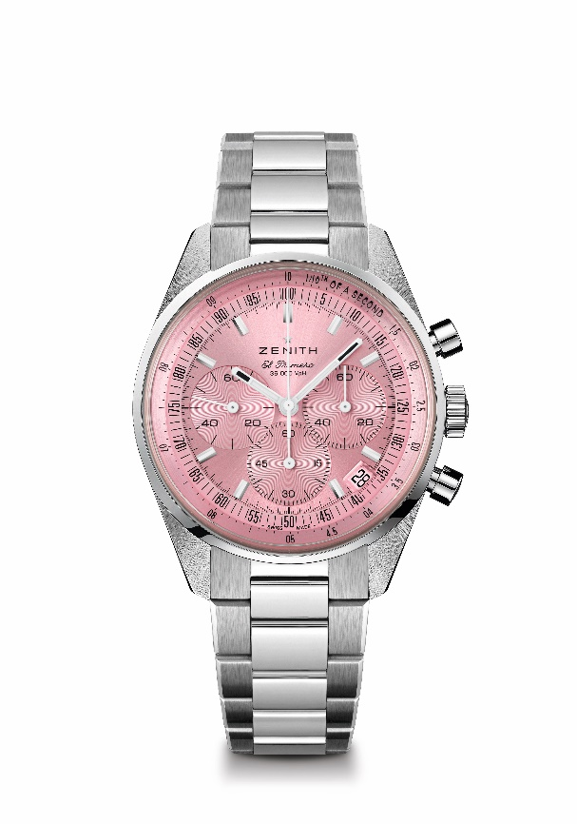
Reference: 03.3202.3600/33.M3200
Key points: Only available during the Month of October. Automatic El Primero column-wheel chronograph able to measure and display 1/10th of a second. Increased power reserve of 60 hours. Date indication at 4:30. Stop-second mechanism
Movement: El Primero 3600
Power-reserve: min. 60 hours
Functions: Hours and minutes in the centre. Small seconds at 9 o'clock. 1/10th of a second Chronograph. Central chronograph hand that makes one turn in 10 seconds. 60-minute counter at 6 o'clock. 60-second counter at 3 o'clock
Finishes: New star-shaped oscillating weight with satined finishings
Price 9900CHF
Material: Stainless steel
Water-resistance: 5 ATM
Dial: Pink-toned sunray-patterned
Case: 38 mm
Hour-markers: Rhodium-plated, faceted and coated with SuperLuminova SLN C1
Hands: Rhodium-plated, faceted and coated with SuperLuminova SLN C1
Bracelet & Buckle: Stainless steel bracelet & double folding clasp

