FUSALP X ZENITH: TWO ALPINE STARS COME TOGETHER TO CELEBRATE THE ART OF MOVEMENT WITH AN EXCLUSIVE CAPSULE COLLECTION

Zurich, November 16, 2022: Zenith and Fusalp explore their shared historical know-how and legacy of innovation to create a collection of watches and apparel to take on the winter season in style.

Driven by a shared passion for technical innovation and contemporary design, Zenith, leading innovator in its field since 1865 and Fusalp, French iconic luxury ski and ready-to-wear brand, have combined their historical know-how and innovative prowess to release a unique capsule collection. This capsule, which coincides also with the 70th year anniversary of the Fusalp brand features two bespoke watches and a contemporary sport-chic wardrobe that perfectly embodies the spirit of innovation and penchant for assertive style shared by the Le Locle watchmaker and the Annecy tailor.

With an emphasis on couture cuts and crafted with cutting-edge materials and tailoring techniques, Fusalp and Zenith share a common vision of heritage, paving the way for innovation, style, and performance, created together impeccably. This meeting of two distinct Maisons is about celebrating the art of movement and the perpetual motion towards achieving greatness that resonates far beyond the mountains that both brands call home.

On this one-of-a-kind collaboration, Zenith CEO Julien Tornare shared, “This is an exciting new kind of partnership for Zenith, and one that is very close to our hearts. More than just a fashion House, Fusalp are innovators. Their never-ending quest to produce highly technical yet fashionable clothing is something that Zenith totally relates to.”

Fusalp CEO Alexandre Fauvet said, “Fusalp and Zenith have respectively revolutionized their industries. The mastery of time and movement, embodied by Zenith, as inventor of the world's first automatic chronograph movement in 1969. Two years earlier Fusalp invented the first competition ski suit, with France’s national ski team going on to win seven gold medals at the Portillo Alpine World Championships in 1966. These feats shape Fusalp and Zenith as pioneers, who nurture the precision for exceptional products, which are designed with refined modernity, accuracy and craftsmanship.’’

FUSALP ON ZENITH TIME: DEFY CLASSIC SKELETON FUSALP
Versatile in its styling and resolutely futuristic in its lines, the DEFY Classic Skeleton was chosen as a senseful template for this collaboration. As stylish as it is endurant, the DEFY Classic is ideally proportioned as a unisex sport-chic watch that stands out with its symmetric open dial. Whether speeding down a slope or just lounging beside a fireplace in a cosy chalet, the DEFY Classic Skeleton brings a cosmic radiance to the winter wonderland.
Limited to 300 pieces in a black ceramic case and 100 pieces in white ceramic, the DEFY Classic Skeleton Fusalp features a new open dial. Zenith worked with Fusalp to develop this new open dial that combines the two universes of the brands, by retaining the signature five-pointed star of the Manufacture while incorporating a snowflake into its design. The result is a dial full of depth and contrast, highlighted by a rose gold coloured lower open layer and surrounded by a ring in the French tricolore tones of blue, red and white, a nod to the tailor’s French origin and a recurring design element in its sought-after creations.

The rubber strap has also been designed to incorporate elements inspired by the clothing capsule collection designed by Fusalp exclusively for this collaboration. As durable as it is stylish, the rubber features a fabric-like structure, featuring a raised motif consisting of concentric rectangles providing a bold graphical element in line with the open dial.

A star among Zenith’s vast repertoire of manufacture movements, the DEFY Classic Skeleton Fusalp special editions are driven by the Elite automatic high-frequency movement with a power reserve of 50 hours.

TAILORED FOR THE MOUNTAINS

For this winter-ready collaboration, Fusalp tailored a capsule collection of ski wear for men and women, specifically designed around Zenith and the DEFY Classic Skeleton Fusalp watches. True to Fusalp’s philosophy, utilizing its unique expertise to the fullest extent, designs are effortlessly chic, taking on a couture look while boasting technical materials, without compromising on performance and freedom of movement.

Crafted using a durable yet supremely comfortable softshell by Swiss fabric-maker Schoeller, the outfits are soft and stretchy without any of the bulkiness associated with traditional ski clothing – while remaining warm and breathable for a day on the ski slopes. In a timeless palette of black and white, the quilting design takes on an exclusively designed graphic linear motif, also found on the straps of the watches. The outfits are adorned with a specially developed logo for this capsule, consisting of a superimposed star and snowflake that also make up the watches’ open dial motif.

Fusalp x Zenith ski jackets have another trick up their sleeves – literally. A first for Fusalp and specially developed for this collaboration, the “storm cuff” sleeves feature a zippered opening, designed to be able to comfortably wear and view your watch between the outer shell layer and the soft, fine knit fabric underneath that’s adorned with the blue, white and red stripes, representing Fusalp’s French heritage.

The Fusalp x Zenith collection will make its public debut in Zurich during the opening of the new Fusalp boutique in November, after which the watches will be available at Zenith physical and online boutiques around the world, as well as selected Fusalp boutiques.

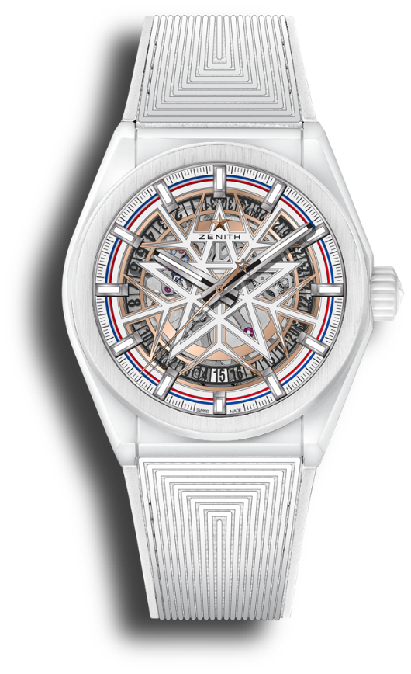
DEFY CLASSIC FUSALP
Reference: 49.9002.670-1/02.R796

Key points: Silicon escape-wheel and lever, 41-MM white ceramic case, In house ELITE skeletonised movement. Retail Exclusive: Limited 100 pieces
Movement: Elite 670 skeleton, automatic.
Functions: Hours and minutes in the centre. Central seconds hand. Date indication at 6 o'clock
Finishes: Special oscillating weight with satined finishings
Price 10 900 CHF
Material: White ceramic
Water resistance: 10 ATM
Frequency: 28,800 VpH (4Hz)
Power-reserve: min. 48 hours
Case: 41mm
Dial: Skeleton dial with special snowflake star design. Applied indexes
Hour markers: Rhodium-plated, faceted and coated with SuperLuminova SLN C1
Hands: Rhodium-plated, faceted and coated with SuperLuminova SLN C1
Bracelet & Buckle: Special texturised rubber with folding clasp

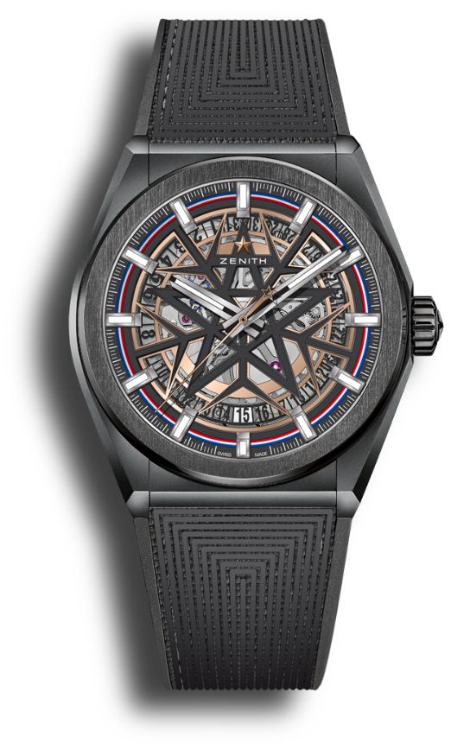
DEFY CLASSIC FUSALP
Reference: 49.9000.670-1/22.R797

Key points: Silicon escape-wheel and lever, 41-MM black ceramic case, In house ELITE skeletonised movement. Retail Exclusive: Limited 300 pieces
Movement: Elite 670 skeleton, automatic.
Functions: Hours and minutes in the centre. Central seconds hand. Date indication at 6 o'clock
Finishes: Special oscillating weight with satined finishings
Price 9 900 CHF
Material: Black ceramic
Water resistance: 10 ATM
Frequency: 28,800 VpH (4Hz)
Power-reserve: min. 48 hours
Case: 41mm
Dial: Skeleton dial with special snowflake star design. Applied indexes.
Hour markers: Rhodium-plated, faceted and coated with SuperLuminova SLN C1
Hands: Rhodium-plated, faceted and coated with SuperLuminova SLN C1
Bracelet & Buckle: Special texturised rubber with folding clasp

ZENITH: TIME TO REACH YOUR STAR.
ZENITH exists to inspire individuals to pursue their dreams and make them come true – against all odds. Since its establishment in 1865, ZENITH became the first vertically integrated Swiss watch manufacture, and its watches have accompanied extraordinary figures that dreamt big and strived to achieve the impossible – from Louis Blériot’s history-making flight across the English Channel to Felix Baumgartner’s record-setting stratospheric free-fall jump. Zenith is also highlighting visionary and trailblazing women by celebrating their accomplishments and creating the DREAMHERS platform where women share their experiences and inspire others to fulfill their dreams.

With innovation as its guiding star, ZENITH exclusively features in-house developed and manufactured movements in all its watches. Since the creation of the El Primero in 1969, the world’s first automatic chronograph calibre, ZENITH has gone on to master high-frequency precision and offers time measurements in fractions of a second, including 1/10th of a second in the Chronomaster collection and 1/100th of a second in the DEFY collection. Because innovation is synonymous with responsibility, the ZENITH HORIZ-ON initiative affirms the brand's commitments to inclusion & diversity, sustainability and employee wellbeing. ZENITH has been shaping the future of Swiss watchmaking since 1865, accompanying those who dare to challenge themselves and reach new heights. The time to reach your star is now.

FUSALP: PASSION FOR EXCELLENCE SINCE 1952.
Fusalp was born in 1952 in the heart of the French Alps. Since its creation by a duo of tailors in Annecy, the brand has revolutionised Alpine skiwear by creating the first technical stirrup pants that was worn by the French ski team in the 60s. Iconic partner of the greatest alpine skiing champions, Fusalp has since tirelessly worked on achieving the perfect balance between technicality, comfort and style. A design signature that reflects a community of faithful and demanding connoisseurs in France and abroad. Through its collections, Fusalp celebrates the art of movement, a movement inspired by Alpine skiing and adapted to our modern urban lifestyles. The Fusalp collections can be found in the brand’s 50 stores over 25 countries. Also available on fusalp.com.

