A GREAT AUCTION RESULT FOR A NOBLE CAUSE: ZENITH CALIBRE 135-O UNIQUE PIECE IN COLLABORATION WITH PHILLIPS IN ASSOCIATION WITH BACS & RUSSO AND KARI VOUTILAINEN

Geneva, November 5, 2022: During the Phillips Geneva Watch Auction: XVI and after intense bidding, the one-off ZENITH Calibre 135-O Unique Piece made in collaboration with Phillips in Association with Bacs & Russo auction house and independent watchmaker and restoration expert Kari Voutilainen fetched CHF 315’000 (USD 315'662/ GBP 277'484). All proceeds from the sale of this exceptional piece, endowed with a historical and award-winning observatory chronometer movement housed in a niobium case and salmon guilloché dial, will be donated to Susan G. Komen®.

When the ZENITH X Voutilainen X Phillips 10-piece limited edition Calibre 135-O in platinum was unveiled this summer, it struck a deeply resonating chord in discerning collectors. It marked the first time ever that ZENITH had made its most prized movement from the golden age of chronometry competitions available for acquisition. The Manufacture and its Heritage Department had entrusted renowned watchmaker Kari Voutilainen with the task of restoring a batch of Calibre 135-O movements and hand-decorating them to the highest possible degree. The 11th watch to feature one of these priceless movements, the Calibre 135-O unique piece is rendered even more exceptional as the only example crafted in a niobium case and paired with a guilloché salmon dial and rose gold coloured movement.

The auctioning of this singular piece by Phillips marks the finishing act to a month when ZENITH has been actively rallying behind the cause of Breast Cancer Awareness. It follows the launch of the Chronomaster Original Pink edition, from which a portion of the sales proceeds were donated to Susan G. Komen® and the MEET THE DREAMHERS event held in Singapore that bolstered the Manufacture’s commitment to fight breast cancer and support one of the world’s leading foundations.

On the auction of this unique piece and the overall support ZENITH is lending to Susan G. Komen®, ZENITH CEO Julien Tornare shared, “I'm honoured to come together again with Phillips and Kari Voutilainen for a truly exceptional piece, and for a cause that is truly close to our hearts. The Calibre 135 Observatoire Unique Piece is more than just a highly embellished and invaluable piece of ZENITH history, it's a symbol of our hope and promise to continue fighting against breast cancer alongside Susan G. Komen®. 100% of the proceeds from the sale of the Calibre 135-O Unique Piece will directly be donated to Susan G. Komen, which we’re proud to continue supporting in the coming months and years. I sincerely thank Phillips, Kari Voutilainen and everyone who bid on this piece and has helped contribute to a noble cause”.

Aurel Bacs, Senior Consultant, Bacs & Russo and Alexandre Ghotbi, Head of Watches, Continental Europe & Middle East, jointly stated, “We are incredibly proud to be continuing our collaborative journey with Zenith and Kari Voutilainen to produce an 11th example of the Cal 135-O, this time uniquely cased in Niobium with a striking salmon dial and a movement finish matching the dial colour. From the beginning, this project has been one of friendship and we couldn’t think of a better way to close the adventure with a unique piece going to such a good cause.”

Kari Voutilainen added, “This stunning salmon colour dial ZENITH Calibre 135-O, with the unique history behind it, in a unique case, with a unique dial, will be the only one now and forever."

The movement selected for this unique piece belongs to the famous “serial-winning” years from 1950-1954, when the Calibre 135-O won the Neuchâtel Observatory chronometry competition 5 years in a row – an unheard of and unmatched feat. It was prepared and fine-tuned all year by the ZENITH Laboratoire de Chronométrie, with dedicated chronométriers building it up as ZENITH’s champion movement. It was awarded a prize within the 1st category range and had been regulated by celebrated ZENITH chronométrier René Gygax, who worked with Charles Fleck on the prize-winning movement for several years and bolstered ZENITH’s reputation as an undisputed leader in precision chronometry.

A singular watch with an unmatched legacy, the Calibre 135 Observatoire Unique Piece draws inspiration from several 1950s references by combining the most emblematic details with contemporary accents. The 38mm round case is crafted in niobium, a metal used for the very first time by ZENITH and features tapered lugs that seamlessly fit under the bezel, as well as an oversized notched crown emblazoned with the modern ZENITH star logo.

Beneath the sapphire glass box, the slightly domed salmon dial in sterling silver by Kari Voutilainen’s Comblémine atelier features guilloché engraving in a fish-scale motif. Triangular hour markers and applied polished dot markers for the minutes are juxtaposed in a blend of vintage elegance and contemporary opulence. The oversized second counter at 6 o’clock is inscribed with the movement’s serial number, a subtle nod to the observatory chronometers of the past. The dial is signed “Neuchâtel” at the bottom, as ZENITH, Kari Voutilainen and the historical Observatory where the Calibre 135-O competed and won during the golden years of chronometry competitions are all based in the Canton of Neuchâtel.

For the first time in the history of the Calibre 135, the observatory chronometer movement, which has been impeccably decorated and finished by Kari Voutilainen in a striking 5N red gold tone, is visible through the display back.

With such a rare and historically significant creation, no detail is overlooked – including the packaging. The Calibre 135 Observatoire Unique Piece is delivered in a wooden box crafted from walnut wood with brass fasteners, inspired by the containers in which the chronometry competition calibres were transported from the ZENITH Manufacture to the Neuchâtel Observatory when competing for a first prize at the time. Secured within it is a book-shaped leather box containing the watch as well as the original historical wooden transport box for the movement.

Unlike the commercial versions of the Calibre 135 that were fitted into wristwatch cases, the 135-O variant in this unique piece was solely intended for competitions, and was never cased in a pocket or wristwatch, with the wooden box as its only sort of covering. For the Calibre 135 Observatoire Unique Piece, ZENITH has accurately reproduced a larger version of the box using materials inspired by the historical original.

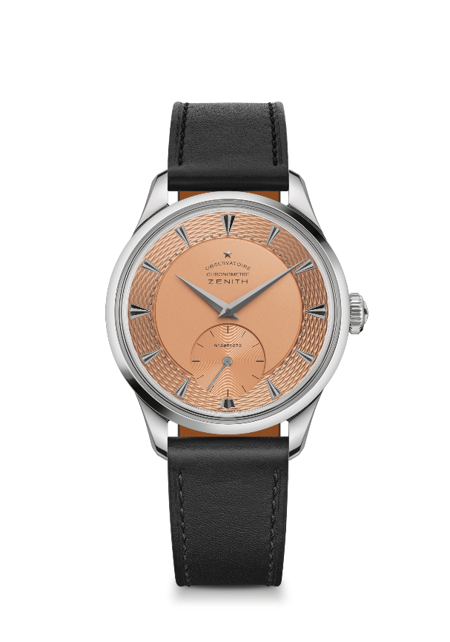
ZENITH CALIBRE 135 UNIQUE PIECE
Reference: 13.1350.135/35.C100

Key points:
UNIQUE PIECE to be auction on Saturday 5th of November.
All the proceeds to be given to Susan G Komen to help fulfill their vision of a world without breast cancer
Unique Niobium case with Salmon guilloche dial and 5N-color movement
Unique Collaboration with renowned watchmaker & restorer Kari Voutilainen
Movement: Calibre 135, Manual
Frequency 18,000 VpH (2.5 Hz)
Power reserve approx. 40 hours
Functions : Hours and minutes in the centre. Small seconds at 6 o'clock
Finishes: Meticulous traditional hand-finishing and decoration on the movement
Material: Niobium
Water resistance: 3 ATM
Case: 38 mm
Dial: Sterling silver dial with salmon matte finishing. Applied indexes and dot markers
Hour markers: Ruthenium-plated and faceted German silver
Hands: Ruthenium-plated and faceted Gold hands
Bracelet & Buckle: Black calfskin leather with titanium pin Buckle
Thickness: 10.35 mm
Lug to lug: 46.50 mm
Lug width: 19 mm

ZENITH: TIME TO REACH YOUR STAR.

ZENITH exists to inspire individuals to pursue their dreams and make them come true – against all odds. Since its establishment in 1865, ZENITH became the first vertically integrated Swiss watch manufacture, and its watches have accompanied extraordinary figures that dreamt big and strived to achieve the impossible – from Louis Blériot’s history-making flight across the English Channel to Felix Baumgartner’s record-setting stratospheric free-fall jump. Zenith is also highlighting visionary and trailblazing women by celebrating their accomplishments and creating the DREAMHERS platform where women share their experiences and inspire others to fulfil their dreams.

With innovation as its guiding star, ZENITH exclusively features in-house developed and manufactured movements in all its watches. Since the creation of the El Primero in 1969, the world’s first automatic chronograph calibre, ZENITH has gone on to master high-frequency precision and offers time measurements in fractions of a second, including 1/10th of a second in the Chronomaster collection and 1/100th of a second in the DEFY collection. Because innovation is synonymous with responsibility, the ZENITH HORIZ-ON initiative affirms the brand's commitments to inclusion & diversity, sustainability and employee wellbeing. ZENITH has been shaping the future of Swiss watchmaking since 1865, accompanying those who dare to challenge themselves and reach new heights. The time to reach your star is now.

ABOUT PHILLIPS IN ASSOCIATION WITH BACS & RUSSO
The team of specialists at Phillips Watches is dedicated to an uncompromised approach to quality, transparency, and client service, achieving a global auction sale total of $209.3 million in 2021, the most successful year for any auction house in watch auction history.
A selection of our record-breaking prices:
Paul Newman’s Rolex “Paul Newman” Daytona reference 6239 (CHF 17,709,894 / US$17,752,500) – New York Auction: Winning Icons – 26 October 2017 – Highest result ever achieved for any vintage wristwatch at auction.
Patek Philippe reference 1518 in stainless steel (CHF 11,020,000 / US$11,112,020) – Geneva Watch Auction: FOUR – 12 November 2016 – Highest result ever achieved for a vintage Patek Philippe wristwatch at auction.

ABOUT PHILLIPS
Phillips is a leading global platform for buying and selling 20th and 21st century art and design. With dedicated expertise in the areas of 20th Century and Contemporary Art, Design, Photographs, Editions, Watches, and Jewelry, Phillips offers professional services and advice on all aspects of collecting. Auctions and exhibitions are held at salerooms in New York, London, Geneva, and Hong Kong, while clients are further served through representative offices based throughout Europe, the United States and Asia. Phillips also offers an online auction platform accessible anywhere in the world. In addition to providing selling and buying opportunities through auction, Phillips brokers private sales and offers assistance with appraisals, valuations, and other financial services.
Visit www.phillips.com for further information.

*Estimates do not include buyer’s premium; prices achieved include the hammer price plus buyer’s premium.

About Voutilainen

Independant watch manufacture creating bespoke time pieces, Voutilainen fabricates its movements in house. Design, fabrication, finishings, dials and cases are all made in house. Due to large amount of hand work, the number of watches produced remains limited.

About Susan G. Komen®

Susan G. Komen® is the world’s leading nonprofit breast cancer organization, working to save lives and end breast cancer forever. Komen has an unmatched, comprehensive 360-degree approach to fighting this disease across all fronts and supporting millions of people in the U.S. and in countries worldwide. We advocate for patients, drive research breakthroughs, improve access to high-quality care, offer direct patient support and empower people with trustworthy information. Founded by Nancy G. Brinker, who promised her sister, Susan G. Komen, that she would end the disease that claimed Suzy’s life, Komen remains committed to supporting those affected by breast cancer today, while tirelessly searching for tomorrow’s cures. Visit komen.org or call 1-877 GO KOMEN. Connect with us on social at www5.komen.org/social.

