ZENITH UNVEILS THE DEFY EXTREME E “ENERGY X PRIX” AHEAD OF THE SEASON 2 FINALE IN URUGUAY

The grand finale of Extreme E’s sophomore season is at hand. After four races on three continents across wildly different terrains, the final electric rally racing showdown of 2022 is taking place in the seaside city of Punta del Este in Uruguay. A country that’s leading the way when it comes to renewable energy production and electrification, the country currently generates over 98% of its electricity from renewable sources, primarily wind and hydropower. Extreme E is committed to promoting the switch to electric vehicles and decarbonising transport, which is also a main focus of the Uruguayan government as the next step in its renewable energy journey. Much like Uruguay, Extreme E is actively trialling new renewable energy sources onsite to reduce the need for fossil fuels.
It is against this seemingly paradoxical yet optimistic backdrop of innovative solutions to renewable energy and the preservation of fragile ecosystems that ZENITH is presenting the DEFY Extreme E “Energy X Prix”, a limited edition of 20 pieces that combines carbon fibre and titanium with striking purple accents that evoke streaks of lightning in a stormy sky. True to the purpose of Extreme E and ZENITH’s HORIZ-ON initiative, it incorporates recycled and upcycled elements from the championship in the strap as well as the packaging.

Rugged in form and function, the DEFY Extreme E “Energy X Prix” is the world’s lightest and most robust 1/100th of a second chronograph, designed to brave the harshest environments in some of the world’s most remote destinations. Tried and tested on the electric rally’s off-road courses, it is crafted in lightweight, durable and visually striking carbon fibre. The DEFY Extreme E “Energy X Prix”’s angular geometry exuding is further emphasised by the contrasting microblasted titanium pusher protectors and twelve-sided bezel.

The open multi-layered dial consists of tinted sapphire crystal elements, embellished with purple accents that evoke the lightning-lit skies of Uruguay. Partially visible through the dial as well as the sapphire case back is the fastest automatic high-frequency chronograph calibre in production, offering 1/100th of a second time measurements, with two escapements independently beating at 5Hz (36’000 VpH) for the timekeeping part and 50Hz (360’000 VpH) for the chronograph function. The movement is also visible through the sapphire display back, emblazoned with the Energy X Prix logo.

Sustainability and environmental awareness are the forefront of ZENITH and Extreme E’s partnership and is immediately tangible across their shared endeavours. As such, the DEFY Extreme E “Energy X Prix” is delivered with a rubber strap infused with materials of upcycled Continental CrossContact tires that were used in the first season’s races. Matching the Energy X Prix purple accents on the dial, the Velcro strap features a black rubber central element surrounded by a purple cordura-effect rubber inlay. The DEFY Extreme E “Energy X Prix” is delivered with two additional straps in black rubber and black Velcro, which can be easily swapped without any tools by using the case back’s ingenious and intuitive quick strap-change mechanism.

The DEFY Extreme E “Energy X Prix” comes packaged in a suitably sturdy waterproof and crushproof watch case inspired by the extreme conditions of the rally, incorporating various upcycled elements from the side-lines of the first season’s races. The case’s lid coating is made from E-grip recycled tires, while the plate covering is made from parts of an Extreme E racing tarpaulin.
The DEFY Extreme E “Energy X Prix” will be made in a limited edition of only 20 pieces and will be available exclusively at ZENITH physical and online boutiques around the world.

ZENITH: TIME TO REACH YOUR STAR.

ZENITH exists to inspire individuals to pursue their dreams and make them come true – against all odds. Since its establishment in 1865, ZENITH became the first vertically integrated Swiss watch manufacture, and its watches have accompanied extraordinary figures that dreamt big and strived to achieve the impossible – from Louis Blériot’s history-making flight across the English Channel to Felix Baumgartner’s record-setting stratospheric free-fall jump. Zenith is also highlighting visionary and trailblazing women by celebrating their accomplishments and creating the DREAMHERS platform where women share their experiences and inspire others to fulfil their dreams.

With innovation as its guiding star, ZENITH exclusively features in-house developed and manufactured movements in all its watches. Since the creation of the El Primero in 1969, the world’s first automatic chronograph calibre, ZENITH has gone on to master high-frequency precision and offers time measurements in fractions of a second, including 1/10th of a second in the Chronomaster collection and 1/100th of a second in the DEFY collection. Because innovation is synonymous with responsibility, the ZENITH HORIZ-ON initiative affirms the brand's commitments to inclusion & diversity, sustainability and employee wellbeing. ZENITH has been shaping the future of Swiss watchmaking since 1865, accompanying those who dare to challenge themselves and reach new heights. The time to reach your star is now.

DEFY EXTREME E – ENERGY X PRIX EDITION
Reference: 10.9100.9004-2/24.I301
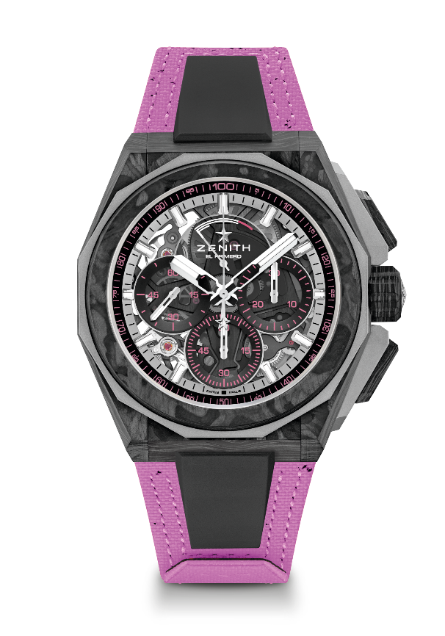
Key points: Extreme E Capsule collection. 1/100th of a second Chronograph movement. Exclusive dynamic signature of one rotation per second for the Chrono hand. 1 escapement for the Watch (36,000 VpH - 5 Hz); 1 escapement for the Chronograph (360,000 VpH - 50 Hz). Certified Chronometer. Sapphire dial. Limited edition of 20 pieces.
Movement: El Primero 9004
Frequency 36,000 VpH (5 Hz)
Power reserve min. 50 hours
Functions: Hours and minutes in the centre. Small seconds at 9 o'clock. 1/100th of a second Chronograph: Central chronograph hand that makes one turn each second. 30-minute counter at 3 o'clock. 60-second counter at 6 o'clock. Chronograph power-reserve indication at 12 o'clock
Finishes: Black colored main plate on movement + Special black colored oscillating weight with satined finishings
Price: 26 900 CHF
Material: Carbon & Microblasted Titanium
Water resistance: 20 ATM
Case: 45mm. Transparent sapphire crystal caseback with Extreme E Energy X Prix engraving.
Dial: Tinted sapphire with three black-coloured counters
Hour markers: Rhodium-plated, faceted and coated with SuperLuminova SLN C1
Hands: Rhodium-plated, faceted and coated with SuperLuminova SLN C1
Bracelet & Buckle: Full Interchangeable strap system. Coming with a Energy X Prix Recycled tires Velcro Strap and a 2nd strap included. Microblasted Titanium Triple folding clasp.

