AN EXHILARATING END TO EXTREME E’S SECOND SEASON AT THE “ENERGY X PRIX” IN URUGUAY

After five races in four countries across three continents, the second season of Extreme E has come to a spectacular close. The Energy X Prix in Uruguay marked the final showdown for the teams to clinch the championship title of the electric rally’s sophomore season. The second race to take place in South America, the Uruguay Natural Energy X Prix provided a completely new terrain for the final Extreme E showdown of 2022.

Set on the outskirts of Punta del Este overlooking the Atlantic Ocean, Uruguay was a natural choice for Extreme E as a country that’s leading the way when it comes to renewable energy production and electrification. Uruguay currently generates over 98% of all electricity from renewable sources, primarily wind and hydropower. Extreme E is committed to promoting the switch to electric vehicles and decarbonising transport, which is also a primary focus of the Uruguayan government as the next step in its renewable energy journey. Much like Uruguay, Extreme E is actively trialling new renewable energy sources onsite to reduce the need for fossil fuels.

A coastal region with sandy beaches surrounded by low-lying grasslands, the Uruguay Natural Energy X Prix course provided a mixed terrain with numerous challenging turns, ascensions and drops, rendered more difficult by obscured visibility due to the dry and sandy terrain. A dynamic race full of surprises, ABT CUPRA XE secured its maiden X Prix victory in the decisive season finale.

X44 Vida Carbon Racing - EXTREME E 2022 CHAMPIONS
Up until the Energy X Prix, X44 Vida Carbon Racing (X44) was trailing by 17 points’ behind inaugural Extreme E champions Rosberg X Racing (RXR), continuing the two team’s rivalry from the first season.
However, However, after being disqualified for having too many mechanics attempting to fix the car at the Switch Zone, X44 Vida Carbon Racing was closer than ever to grabbing the championship title. X44 Vida Carbon Racing drivers Sébastien Loeb and Cristina Gutiérrez secured the podium finish needed to take their maiden Extreme E title, just two points clear of RXR in the standings.

On the final showdown at the Energy X Prix, X44 Vida Carbon Racing driver Sébastien Loeb said, “We could only go and compete with everything we had and try to score maximum points.” Cristina Gutiérrez added, “It was a rollercoaster, but it is much better than that for us as we can now believe in what we have achieved."

Made with Extreme E: DEFY Extreme E Energy X Prix
In its continued role as the Official Timekeeper and Founding Partner of Extreme E, ZENITH has crafted its most rugged chronograph to date to take on the wild terrains and harsh environments that the electric rally racing championship seeks out around the world, all while promoting the same message of sustainability through innovation as Extreme E. Crafted in light yet durable carbon fibre and titanium as the final of four special editions made for Extreme E’s 2022 championship, the DEFY Extreme E Energy X Prix limited edition of 20 pieces stands out with its striking purple accents, the race’s official colour that’s inspired by lightning bolts shooting across the skies over Uruguay. Embodying the message of sustainability at the core of Extreme E as well as ZENITH’s HORIZ-ON initiative, it incorporates various recycled upcycled elements from the side-lines of the first season’s races. The case’s lid coating is made from E-grip recycled tires, while the plate covering is made from parts of an Extreme E racing tarpaulin. The DEFY Extreme E Energy X Prix is delivered with a rubber strap containing sustainable materials from recycled Continental tyres that were used in the first season races. Available exclusively at ZENITH physical and online boutiques.

Uruguay Naturals Energy X Prix “Moment In Time” winner - LAIA SANZ , ACCIONA | SAINZ XE TEAM
Since the very first race of Extreme E, ZENITH has sought to highlight some of the most extraordinary feats and awe-inspiring performances in the rally championship with The ZENITH “Moment In Time”, awarding one driver at the end of each race. For the Energy X Prix, ACCIONA | SAINZ XE TEAM’s female driver Laia Sanz surprised everybody when after flipping her car, she kept going and completed the semi-final race. “It is an honour to receive this Zenith watch in recognition of what happened in the Energy X-Prix, where I carried on after a double rollover crash. It’s a super cool watch and I’m so thankful for this. The Championship was at stake at that point, so there was no way I was going to back down from the challenge. When the car landed on its wheels, I just pressed the throttle instinctively and pushed on because there was a big prize on the horizon. Sadly, it wasn’t meant to be this time, but now when I wear my Zenith watch, I will be remembered that you always have to go for it, no matter what.”, shared Laia Sanz.

LEGACY PROGRAMME – Energy, Ecology and Ecotourism

While boasting an incredible record of converting to clean and renewable energy production, Uruguay is nonetheless vulnerable to the ravages of climate change and climate variability. As such, ZENITH supports Extreme E in its three Legacy Programme aims for the Uruguay Natural Energy X Prix.

The first will be to raise awareness around renewable energy, by visiting a UTE windfarm and learn how Uruguay is able to run off 98% renewable energy, and how its approach can be applied in other countries. Extreme E is also partnering with the Organization for the Conservation of Cetaceans (OCC) on a locally driven ocean education project in Punta del Este. It carries out conservation of the marine ecosystem as well as the environment of coastal communities including the Punta del Este coastline, classified as a marine life sanctuary. And finally, Extreme E will be working with the Uruguay government to promote ecotourism in Punta del Este.

ZENITH ON BOARD FOR SEASON 3
The second season of Extreme E has certainly raised the stakes for the world’s first electric rally racing championship. More teams, new destinations and an even stronger commitment towards the Legacy Programme’s wide range of initiatives.

ZENITH CEO Julien Tornare shared, “The second season of Extreme E has certainly raised the bar from last year in every way. Not only has the championship gotten bigger with more teams and more races, but the enthusiasm we’ve felt from fans around the world as well as local support in the remote destinations where we’ve set up Legacy Programme actions have proven that Extreme E is indeed the future of rally racing. 2023 promises to be an even bigger adventure, and we can’t wait to get back to another thrilling Extreme E championship.”

ZENITH looks forward to continuing its support for Extreme E in its third season, which is set to return in early 2023 and bring the pioneering electric rally championship to new destinations as well as return to familiar courses from the past two seasons. ZENITH and Extreme E will also seek new Legacy Programme actions to put in place across the world, while also doubling down on their commitments to existing ones throughout the 2023 championship and beyond.

Among them is the MEDSEA project, which ZENITH was introduced to in 2021 through Extreme E and has chosen to support over the coming years as part of its HORIZ-ON initiative. The foundation aims to restore the carbon-sequestering Posidonia oceanica meadows in the Mediterranean Sea, the jewel of Europe and the closest open body of water to Switzerland.

Extreme E will begin its third season in NEOM, Saudi Arabia in March 2023.

ZENITH: TIME TO REACH YOUR STAR.

ZENITH exists to inspire individuals to pursue their dreams and make them come true – against all odds. Since its establishment in 1865, ZENITH became the first vertically integrated Swiss watch manufacture, and its watches have accompanied extraordinary figures that dreamt big and strived to achieve the impossible – from Louis Blériot’s history-making flight across the English Channel to Felix Baumgartner’s record-setting stratospheric free-fall jump. Zenith is also highlighting visionary and trailblazing women by celebrating their accomplishments and creating the DREAMHERS platform where women share their experiences and inspire others to fulfil their dreams.

With innovation as its guiding star, ZENITH exclusively features in-house developed and manufactured movements in all its watches. Since the creation of the El Primero in 1969, the world’s first automatic chronograph calibre, ZENITH has gone on to master high-frequency precision and offers time measurements in fractions of a second, including 1/10th of a second in the Chronomaster collection and 1/100th of a second in the DEFY collection. Because innovation is synonymous with responsibility, the ZENITH HORIZ-ON initiative affirms the brand's commitments to inclusion & diversity, sustainability and employee wellbeing. ZENITH has been shaping the future of Swiss watchmaking since 1865, accompanying those who dare to challenge themselves and reach new heights. The time to reach your star is now.

DEFY EXTREME E – ENERGY X PRIX EDITION
Reference: 10.9100.9004-2/24.I301
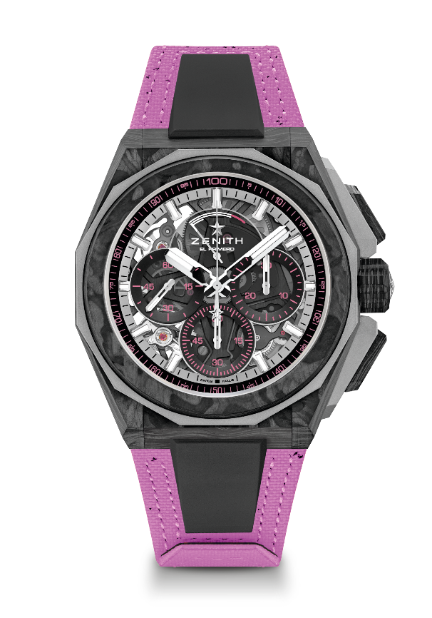
Key points: Extreme E Capsule collection. 1/100th of a second Chronograph movement. Exclusive dynamic signature of one rotation per second for the Chrono hand. 1 escapement for the Watch (36,000 VpH - 5 Hz); 1 escapement for the Chronograph (360,000 VpH - 50 Hz). Certified Chronometer. Sapphire dial. Limited edition of 20 pieces.
Movement: El Primero 9004
Frequency 36,000 VpH (5 Hz)
Power reserve min. 50 hours
Functions: Hours and minutes in the centre. Small seconds at 9 o'clock. 1/100th of a second Chronograph: Central chronograph hand that makes one turn each second. 30-minute counter at 3 o'clock. 60-second counter at 6 o'clock. Chronograph power-reserve indication at 12 o'clock
Finishes: Black colored main plate on movement + Special black colored oscillating weight with satined finishings
Price: 26 900 CHF
Material: Carbon & Microblasted Titanium
Water resistance: 20 ATM
Case: 45mm. Transparent sapphire crystal caseback with Extreme E Energy X Prix engraving.
Dial: Tinted sapphire with three black-coloured counters
Hour markers: Rhodium-plated, faceted and coated with SuperLuminova SLN C1
Hands: Rhodium-plated, faceted and coated with SuperLuminova SLN C1
Bracelet & Buckle: Full Interchangeable strap system. Coming with a Energy X Prix Recycled tires Velcro Strap and a 2nd strap included. Microblasted Titanium Triple folding clasp.

