BACK IN BLUE: THE DEFY A3690 RETURNS AS A BOUTIQUE-EXCLUSIVE DEFY REVIVAL MODEL

Following last year’s return of the very first DEFY wristwatch model from 1969, the A3642, and the A3691 from 1971 during this year’s LVMH Watch Week, ZENITH continues to bring back some of its most emblematically colourful DEFY references with the DEFY Revival A3690.

First launched in 1970, shortly after the introduction of the DEFY wristwatch collection with its rugged “bank vault” case and daring dial design, the A3690 was among the earliest references to incorporate striking colours. Unheard of at the time, ZENITH was among the very first brands to offer coloured dials with a marked gradient effect, from as far as early as the 1960s. In keeping with the evolving tastes of the time, the 1970s saw the Manufacture go a step further with more punchy colours, including the tropical teal blue of the DEFY A3690, as well as its warmer counterpart, the DEFY A3691 with its deep crimson red dial.

Something of a ZENITH signature, many of the brand’s Boutique Editions across the main collections have featured highlights in blue - including in the dial and movement. As such, the DEFY Revival A3690 is available exclusively at ZENITH physical and online boutiques around the world.

Reproduced in stunningly accurate detail using the historical production plans, the DEFY Revival A3690 brings back all the details and singular design elements that made the first-ever DEFY wristwatch model such an outstanding reference of its era; one which established the codes that continues to inspire the DEFY collection today. This includes a faceted octagonal case paired with a fourteen-sided bezel, a teal-blue dial with a prominent vignette effect that darkens towards the edges, unusual applied square hour markers feature horizontal grooves, and the now-iconic Gay Frères steel “ladder” bracelet, which has now been updated with a more modern and ergonomic folding clasp.

In fact, the only cosmetic differences between the Revival and the historical reference are the sapphire crystal, the display case back and the type of luminescent pigments. The water-resistance of 30ATM (300 metres) has also been maintained from the original, even with the addition of a display back.

The other main difference beats away inside. Instead of the original’s solid case back emblazoned with a four-pointed star that became one of the brand’s logos and recurring design element for years, the DEFY Revival A3690 features a sapphire display back showing the automatic Elite 670 manufacture movement, operating at a frequency of 4 Hz (28,800 VpH) and providing an autonomy of 50 hours.

Available now at ZENITH physical and online boutiques around the world.

ZENITH: TIME TO REACH YOUR STAR.

ZENITH exists to inspire individuals to pursue their dreams and make them come true – against all odds. Since its establishment in 1865, ZENITH became the first vertically integrated Swiss watch manufacture, and its watches have accompanied extraordinary figures that dreamt big and strived to achieve the impossible – from Louis Blériot’s history-making flight across the English Channel to Felix Baumgartner’s record-setting stratospheric free-fall jump. Zenith is also highlighting visionary and trailblazing women by celebrating their accomplishments and creating the DREAMHERS platform where women share their experiences and inspire others to fulfil their dreams.

With innovation as its guiding star, ZENITH exclusively features in-house developed and manufactured movements in all its watches. Since the creation of the El Primero in 1969, the world’s first automatic chronograph calibre, ZENITH has gone on to master high-frequency precision and offers time measurements in fractions of a second, including 1/10th of a second in the Chronomaster collection and 1/100th of a second in the DEFY collection. Because innovation is synonymous with responsibility, the ZENITH HORIZ-ON initiative affirms the brand's commitments to inclusion & diversity, sustainability and employee wellbeing. ZENITH has been shaping the future of Swiss watchmaking since 1865, accompanying those who dare to challenge themselves and reach new heights. The time to reach your star is now.

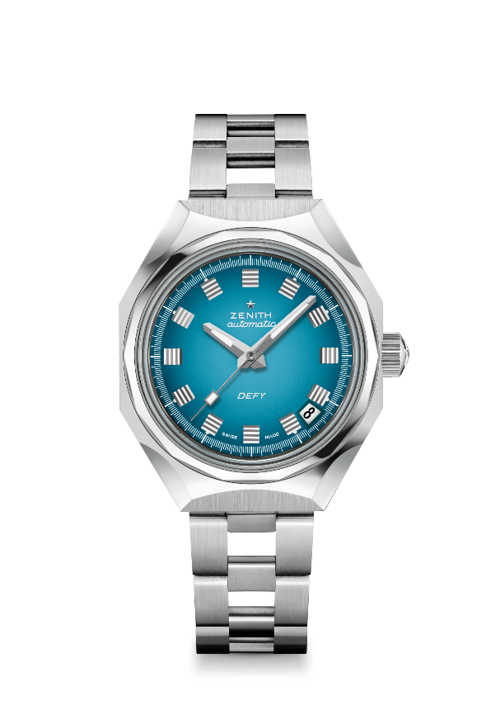
DEFY REVIVAL A3690
Reference: 03.A3642.670/3690.M3642

Key points: Original Revival of the Reference A3690.Octogonal case with iconic 14-sided bezel
Movement: ELITE 670 automatic
Frequency 28 800 VpH (4 Hz)
Power reserve approx. 50 hours
Functions: Hours and minutes in the centre. Central seconds hand. Date indication at 4:30
Finishes: New star-shaped oscillating weight with satined finishings
Price 6900 CHF
Material: Stainless steel
Water resistance: 30 ATM
Case: 37 mm
Dial: Turquoise gradient dial
Hour markers: Rhodium-plated and faceted
Hands: Rhodium-plated, faceted and coated with SuperLuminova SLN C1
Bracelet & Buckle: Stainless steel "Ladder" bracelet.

