ZENITH UNVEILS THE LATEST ADDITIONS TO THE DEFY COLLECTION AT LVMH WATCH WEEK 2023

Kicking off 2023 with a focus on its most creative and daring platform for horological innovation, ZENITH is unveiling some of its latest DEFY creations at LVMH Watch Week 2023 alongside LVMH Maisons Bulgari, Hublot and Tag Heuer. Taking on a hybrid format of on-location and digital presentations, this year LVMH Watch Week is heading to Singapore followed by New York. In parallel, ZENITH will host presentations in local markets.

ZENITH is further building up the different lines within the DEFY collection, synonymous with the Manufacture’s unique take on progressive watchmaking. The DEFY Skyline Skeleton introduces a new expression of the modern skeleton watch, equipped with an El Primero calibre and boasting a uniquely symmetrical open dial. The DEFY Skyline is also proposed in a new mid-size, unisex 36mm version, incorporating new pastel colours into the instantly recognizable case design. The DEFY Skyline in 41mm also receives its first Boutique Edition, masterfully blending dark and golden tones. In the rugged spirit of the DEFY Extreme, ZENITH continues to seek inspiration from the raw, elemental beauty of wild terrains with the DEFY Extreme Glacier.

On the evolution of the DEFY collection, ZENITH CEO Julien Tornare shared, “In just one year, the DEFY Skyline has become one of the most in-demand lines for ZENITH. Its strong visual identity, unique movement and effortless versatility have made it a compelling choice within the sporty steel bracelet segment. It’s a purely modern creation that’s full of details that carry on the enduring legacy of the DEFY collection that goes back to 1969. This year, the collection is growing with a new skeleton version featuring a bold and futuristic design, as well as mid-size unisex version of the DEFY Skyline in 36mm with some vibrant dial colours. We’re really excited to witness the completion of the DEFY collection with these dynamic new references.”

DEFY Skyline Skeleton
Introduced last year as the latest chapter in the enduring DEFY legacy of sturdy and singularly futuristic timekeepers, the DEFY Skyline collection was conceived for an ever-fast-moving world where every fraction of a second can be a decisive one. Taking cues from modern cityscapes where structures and light are bound in a constantly moving interplay, the DEFY Skyline Skeleton reaches even further towards the light on the horizon and opens a whole new world of possibilities to what a skeleton watch can be.

Housed within an angular 41mm steel case, the harmoniously symmetrical skeleton dial takes on the form of a four-pointed stars, in a nod to the ZENITH “double Z” logo of the 1960s. The chapter ring’s applied baton hour markers as well as the central hour and minute hands are filled with Super-LumiNova for easy legibility; something that is usually sacrificed in skeleton watches. A constantly running 1/10th of a second counter at 6 o’clock makes steady jumps in fixed increments, completing one revolution every 10 seconds. The open dial comes in black or blue, with the skeleton movement’s main plate as well as the bridges and open star-shaped oscillating weight finished in the same colour as the open dials for a cohesive and architectural look. The different finishes combining matte, satin-brushed and polished surfaces further accentuate the depth of the moment and intensity of the colour.

Following the unique octagonal geometry of the early DEFY models of the 1960s, the sculpted steel case of the DEFY Skyline Skeleton retains the same DNA of robustness and durability as its predecessors while bringing an edgier and more architectural aesthetic, as well as a host of new functions to the metropolis-ready companion. Fixed atop the 41mm stainless steel case with sharply defined edges, the faceted bezel is reminiscent of those from early DEFY models, reimagined with twelve sides that are positioned as extensions to the hour markers. With an emphasis on performance in the largest possible range of activities and situations, the screw-down crown emblazoned with the star emblem provides a water-resistance of 10 ATM (100 metres).

Visible from the front as well as the sapphire display back is the openworked version of the high-frequency automatic El Primero calibre, the 3620 SK. Built with a similar architecture as the El Primero 3600 1/10th of a second chronograph, this automatic manufacture movement drives the 1/10th of a second hand directly from the escapement, which beats at 5Hz (36’000 VpH), thus making it a “natural” fraction-of-a-second indication. Its efficient automatic bi-directional winding mechanism with a star-shaped rotor delivers a power reserve of approximately 60 hours.

With versatility at its core, the DEFY Skyline Skeleton features an ingenious quick strap-change mechanism consisting of secure buttons on the back. The steel bracelet with a satin-brushed surface with chamfered and polished edges can easily be swapped with the supplied rubber strap and steel folding clasp with a starry sky pattern that’s colour-matched to the dial.

Bringing a new dimension to the DEFY line and reimagining the possibilities of skeleton watches in form as well as function, the DEFY Skyline Skeleton is available at ZENITH boutiques and authorized retailers around the world.

Alongside the DEFY Skyline Skeleton, ZENITH is also presenting other new creations from across the DEFY collection.

DEFY Skyline – Now in 36mm
New size, new colours, same striking silhouette and stellar brilliance. The DEFY Skyline is now available in a 36mm version, keeping the angular form of the original while introducing more modest, unisex proportions that perfectly fit those who prefer a smaller fit.

The mid-size DEFY Skyline comes in three dial colours. The first is the same metallic deep blue found in the 41mm version, while the other two take on totally new tones in the DEFY line, which has always dared to explore more striking chromatics since 1969. These pastel tones, in pink or green, have a metallic base that is polished then satin-brushed, with rays emanating from the applied ZENITH five-pointed star at the top of the dial. The geometrical pattern consists of engraved four-pointed stars, which are in fact a modern reimagining of the Zenith “double Z” logo of the 1960s. Adding more architectural depth, the raised and sloped chapter ring takes on the same dodecagonal form as the bezel. Perfectly integrated, the date wheels are done in colours matched to the dials.

Available with or without brilliant-cut white diamonds on the bezel, the mid-size DEFY Skyline retains the faceted steel case and twelve-sided bezel of its larger counterpart. Intended as a watch for all occasions and situations, its screw-down crown ensures a water-resistance of 10 ATM (100 metres). For added versatility, the quick strap-change mechanism on the case back allows for easy swapping between the steel bracelet and supplied starry sky-patterned rubber strap with folding clasp in the same colour as the dial.

The mid-size version of the DEFY Skyline is powered by the Elite 670 automatic manufacture movement, which has been decorated with a sleek and modern grey finish, with a rotor in the shape of an open star in the same aesthetic as other DEFY lines. It delivers a power reserve of 50 hours when fully wound.

DEFY Skyline Boutique Edition
Following the phenomenal reception of the DEFY Skyline collection last year, ZENITH is pleased to introduce its first boutique-exclusive edition of the groundbreaking model, offering an alluring combination of contrasting tones.

Housed in a 41mm angular steel case with a dodecagonal bezel that recalls the earliest DEFY wristwatches from 1969, the DEFY Skyline Boutique Edition stands out with its radiant anthracite dial, engraved with a rose gold motif and set with rose gold hands and hour markers. The visual animation is one of a constellation of golden starts twinkling against the night sky. To achieve this eye-catching effect the four-pointed stars, recalling the ZENITH emblem found in past references, are first engraved on the dial, then plated with rose gold.

Powered by the El Primero 3620 automatic high-frequency calibre, the DEFY Skyline features a unique running 1/10th of a second indicator that’s driven directly from the 5Hz escapement. Built with a similar architecture as the El Primero 3600 1/10th of a second chronograph, this automatic manufacture movement visible through the sapphire display back and is also endowed with a stop-second mechanism for precise time-setting. The efficient automatic winding mechanism with bi-directional rotor with a futuristic star motif delivers a power reserve of approximately 60 hours.
The DEFY Skyline Boutique Edition is delivered on a steel bracelet with a satin-brushed surface with chamfered and polished edges, seamlessly following the contours of the angular case. A black rubber strap with a starry sky pattern is also provided with a steel folding clasp and can be easily swapped without any tools using the DEFY case’s ingenious quick strap-change mechanism consisting of secure buttons on the back.

The DEFY Skyline Boutique Edition will be available exclusively from ZENITH physical and online boutiques around the world.

DEFY Extreme Glacier
As a watch made to brave the elements no matter how far off the beaten path, ZENITH sought to highlight the environments that the DEFY Extreme was destined for with a series of evocative special editions that integrate natural stones within the ruggedness of the toughest 1/100th of a second chronograph around. Following the DEFY Extreme Desert launched in 2021, ZENITH is going to the opposite kind of landscape for the second edition: Meet the DEFY Extreme Glacier.

Blurring the lines between precision watchmaking and sculptural, wearable art, the DEFY Extreme Glacier is directly inspired by frozen barren landscapes, where only those truly adapted to endure the harsh and extreme environment can thrive.

An integral part of the titanium case, the component that protects the pushers as well as the dodecagonal bezel are crafted from chalcedony, a crystalline semi-translucent stone with a pale blue hue that evokes the frozen glaciers. Meticulously cut and polished by hand, each stone is different and exhibits slightly different colours and fibrous structures, making each of the 50 examples of the DEFY Extreme Glacier essentially a unique piece.
The open dial of the DEFY Extreme Glacier reveals the inner workings of the innovative and singular El Primero 1/100th of a second automatic high-frequency chronograph calibre and its two regulating organs beating at 50Hz for the chronograph and 5Hz for the timekeeping. Keeping with the ice-cold theme, the chronograph counters are made in transparent sapphire crystal that’s given a frosted finish, recalling a layer of ice that allows light to pass through.

Completing the look of this conceptual piece are the supplied durable black Velcro strap and white rubber strap, which can be easily swapped with the titanium bracelet using the quick strap-change mechanism on the back of the case.

The DEFY Extreme Glacier is made in a limited edition of 50 pieces, available exclusively at ZENITH physical and online boutiques.

Representing the culmination point of the DEFY collection and its different lines, which now share a common futuristic design language and spirit of endurance, these latest creations unveiled during LVMH Watch Week set the forward momentum for the year, with another emblematic ZENITH collection set to make a grand return during Watches & Wonders in March 2023.

ZENITH: TIME TO REACH YOUR STAR.

ZENITH exists to inspire individuals to pursue their dreams and make them come true – against all odds. Since its establishment in 1865, ZENITH became the first vertically integrated Swiss watch manufacture, and its watches have accompanied extraordinary figures that dreamt big and strived to achieve the impossible – from Louis Blériot’s history-making flight across the English Channel to Felix Baumgartner’s record-setting stratospheric free-fall jump. Zenith is also highlighting visionary and trailblazing women by celebrating their accomplishments and creating the DREAMHERS platform where women share their experiences and inspire others to fulfil their dreams.

With innovation as its guiding star, ZENITH exclusively features in-house developed and manufactured movements in all its watches. Since the creation of the El Primero in 1969, the world’s first automatic chronograph calibre, ZENITH has gone on to master high-frequency precision and offers time measurements in fractions of a second, including 1/10th of a second in the Chronomaster collection and 1/100th of a second in the DEFY collection. Because innovation is synonymous with responsibility, the ZENITH HORIZ-ON initiative affirms the brand's commitments to inclusion & diversity, sustainability and employee wellbeing. ZENITH has been shaping the future of Swiss watchmaking since 1865, accompanying those who dare to challenge themselves and reach new heights. The time to reach your star is now.

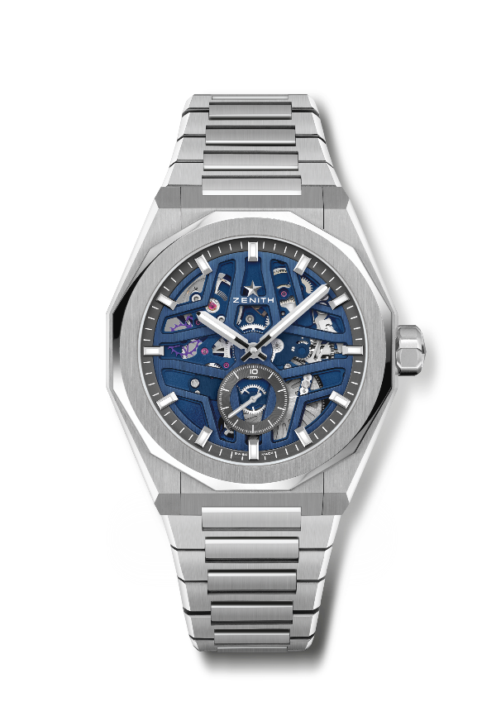
DEFY SKYLINE SKELETON
Reference: 03.9300.3620/79.I001

Key points: El Primero 3-hand watch. High frequency indication : 1/10th of a second subdial at 6 o'clock. Silicon escape-wheel and lever. Screwed-in crown. Full Interchangeable strap system.
Movement: El Primero 3620, automatic
Frequency 36,000 VpH (5 Hz)
Power reserve approx. 60 hours
Functions : Hours and minutes in the centre. 1/10th of a second counter at 6 o'clock.
Finishes: Special oscillating weight with satined finishings
Price 10900 CHF
Material: Stainless steel
Water resistance: 10 ATM
Case: 41mm
Dial: Blue-toned Openworked dial
Hour markers: Rhodium-plated, faceted and coated with SuperLuminova SLN C1
Hands : Rhodium-plated, faceted and coated with SuperLuminova SLN C1
Bracelet & Buckle: Stainless steel bracelet and folding clasp. Comes with a blue rubber strap with starry sky pattern and folding clasp.

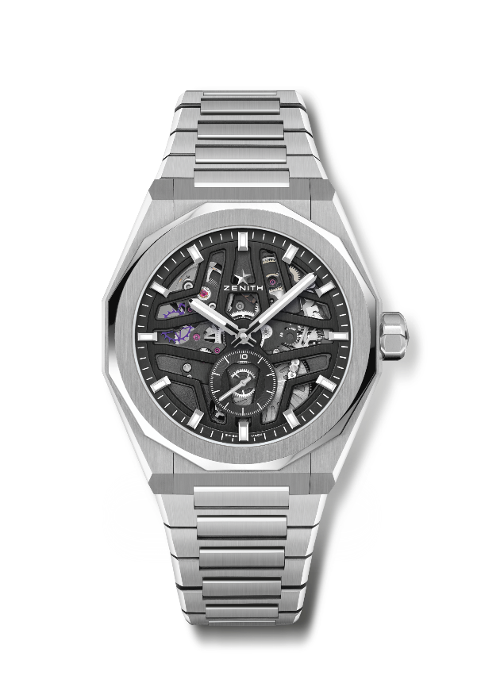
DEFY SKYLINE SKELETON
Reference: 03.9300.3620/78.I001

Key points: El Primero 3-hand watch. High frequency indication : 1/10th of a second subdial at 6 o'clock. Silicon escape-wheel and lever. Screwed-in crown. Full Interchangeable strap system.
Movement: El Primero 3620, automatic
Frequency 36,000 VpH (5 Hz)
Power reserve approx. 60 hours
Functions : Hours and minutes in the centre. 1/10th of a second counter at 6 o'clock.
Finishes: Special oscillating weight with satined finishings
Price 10900 CHF
Material: Stainless steel
Water resistance: 10 ATM
Case: 41mm
Dial: Black-toned Openworked dial
Hour markers: Rhodium-plated, faceted and coated with SuperLuminova SLN C1
Hands : Rhodium-plated, faceted and coated with SuperLuminova SLN C1
Bracelet & Buckle: Stainless steel bracelet folding clasp. Comes with a black rubber strap with starry sky pattern and folding clasp.

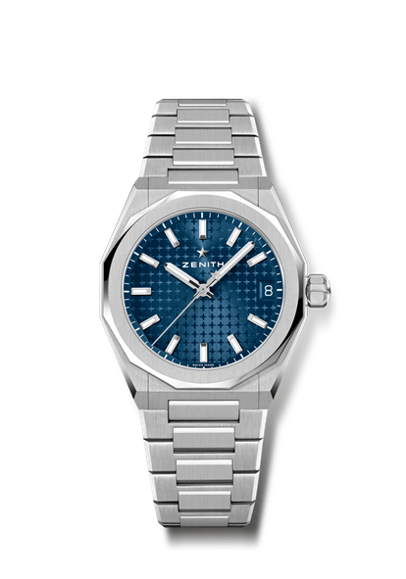
DEFY SKYLINE
Reference: 03.9400.670/51.I001

Key points: 36-MM Unisex size for all wrists. Starry sky pattern on the dial. Screwed-in crown
Full Interchangeable strap system
Movement: ELITE 670
Frequency 28 800 VpH (4 Hz)
Power reserve approx. 50 hours
Functions : Hours and minutes in the centre. Central seconds hand.
Date indication at 3 o'clock
Finishes: New star-shaped oscillating weight with satined finishings
Price 8400 CHF
Material: Stainless steel
Water resistance: 10 ATM
Case: 36 mm
Dial: Blue sunray-patterned
Hour markers: Rhodium-plated, faceted and coated with SuperLuminova SLN C1
Hands : Rhodium-plated, faceted and coated with SuperLuminova SLN C1
Bracelet & Buckle: Stainless steel bracelet and folding clasp. Comes with a blue rubber strap with starry sky pattern and folding clasp.

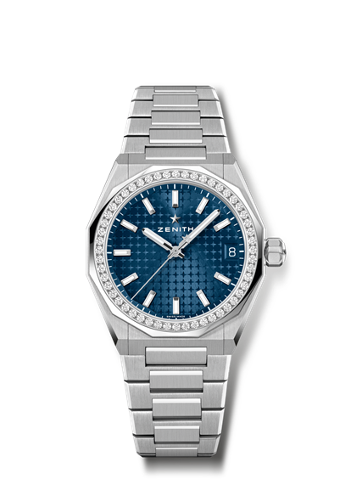
DEFY SKYLINE
Reference: 16.9400.670/51.I001

Key points: 36-MM Unisex size for all wrists. Starry sky pattern on the dial. Screwed-in crown
Full Interchangeable strap system
Movement: ELITE 670
Frequency 28 800 VpH (4 Hz)
Power reserve approx. 50 hours
Functions : Hours and minutes in the centre. Central seconds hand.
Date indication at 3 o'clock
Finishes: New star-shaped oscillating weight with satined finishings
Price 11900 CHF
Material: Stainless steel
Carats ~1.00 cts
Brilliant quality: F -G
Bezel 52 VVS brilliant-cut diamonds
Water resistance: 10 ATM
Case: 36 mm
Dial: Blue sunray-patterned
Hour markers: Rhodium-plated, faceted and coated with SuperLuminova SLN C1
Hands : Rhodium-plated, faceted and coated with SuperLuminova SLN C1
Bracelet & Buckle: Stainless steel bracelet and folding clasp. Comes with a blue rubber strap with starry sky pattern and folding clasp.
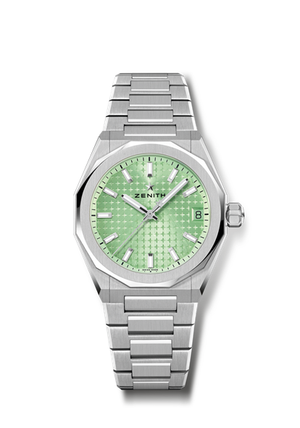
DEFY SKYLINE
Reference: 03.9400.670/61.I001

Key points: 36-MM Unisex size for all wrists. Starry sky pattern on the dial. Screwed-in crown
Full Interchangeable strap system
Movement: ELITE 670
Frequency 28 800 VpH (4 Hz)
Power reserve approx. 50 hours
Functions : Hours and minutes in the centre. Central seconds hand.
Date indication at 3 o'clock
Finishes: New star-shaped oscillating weight with satined finishings
Price 8400 CHF
Material: Stainless steel
Water resistance: 10 ATM
Case: 36 mm
Dial: Light, green-toned sunray-patterned
Hour markers: Rhodium-plated, faceted and coated with SuperLuminova SLN C1
Hands : Rhodium-plated, faceted and coated with SuperLuminova SLN C1
Bracelet & Buckle: Stainless steel bracelet and folding clasp. Comes with a Light, green-toned rubber strap with starry sky pattern and folding clasp.

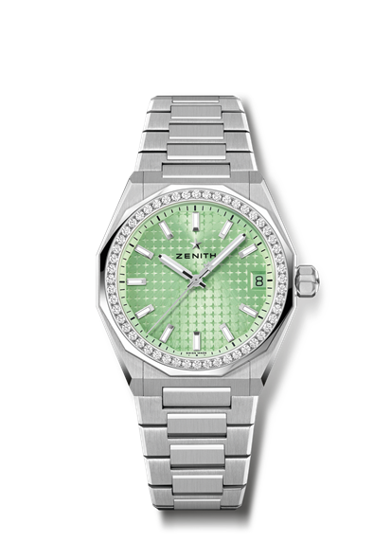
DEFY SKYLINE
Reference: 16.9400.670/61.I001

Key points: 36-MM Unisex size for all wrists. Starry sky pattern on the dial. Screwed-in crown
Full Interchangeable strap system
Movement: ELITE 670
Frequency 28 800 VpH (4 Hz)
Power reserve approx. 50 hours
Functions : Hours and minutes in the centre. Central seconds hand.
Date indication at 3 o'clock
Finishes: New star-shaped oscillating weight with satined finishings
Price 11900 CHF
Material: Stainless steel
Carats ~1.00 cts
Brilliant quality: F -G
Bezel 52 VVS brilliant-cut diamonds
Water resistance: 10 ATM
Case: 36 mm
Dial: Light, green-toned sunray-patterned
Hour markers: Rhodium-plated, faceted and coated with SuperLuminova SLN C1
Hands : Rhodium-plated, faceted and coated with SuperLuminova SLN C1
Bracelet & Buckle: Stainless steel bracelet and folding clasp. Comes with a Light, green-toned rubber strap with starry sky pattern and folding clasp.

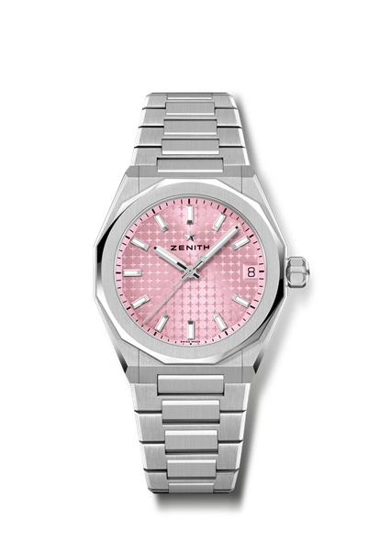
DEFY SKYLINE
Reference: 03.9400.670/18.I001

Key points: 36-MM Unisex size for all wrists. Starry sky pattern on the dial. Screwed-in crown
Full Interchangeable strap system
Movement: ELITE 670
Frequency 28 800 VpH (4 Hz)
Power reserve approx. 50 hours
Functions : Hours and minutes in the centre. Central seconds hand.
Date indication at 3 o'clock
Finishes: New star-shaped oscillating weight with satined finishings
Price 8400 CHF
Material: Stainless steel
Water resistance: 10 ATM
Case: 36 mm
Dial: Pink-toned sunray-patterned
Hour markers: Rhodium-plated, faceted and coated with SuperLuminova SLN C1
Hands : Rhodium-plated, faceted and coated with SuperLuminova SLN C1
Bracelet & Buckle: Stainless steel bracelet and folding clasp. Comes with a pink rubber strap with starry sky pattern and folding clasp.

DEFY SKYLINE
Reference: 16.9400.670/18.I001
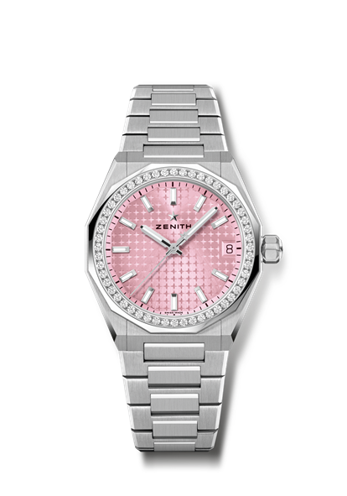
Key points: 36-MM Unisex size for all wrists. Starry sky pattern on the dial. Screwed-in crown
Full Interchangeable strap system
Movement: ELITE 670
Frequency 28 800 VpH (4 Hz)
Power reserve approx. 50 hours
Functions : Hours and minutes in the centre. Central seconds hand.
Date indication at 3 o'clock
Finishes: New star-shaped oscillating weight with satined finishings
Price 11900 CHF
Material: Stainless steel
Carats ~1.00 cts
Brilliant quality: F -G
Bezel 52 VVS brilliant-cut diamonds
Water resistance: 10 ATM
Case: 36 mm
Dial: Pink-toned sunray-patterned
Hour markers: Rhodium-plated, faceted and coated with SuperLuminova SLN C1
Hands : Rhodium-plated, faceted and coated with SuperLuminova SLN C1
Bracelet & Buckle: Stainless steel bracelet and folding clasp. Comes with a pink rubber strap with starry sky pattern and folding clasp.
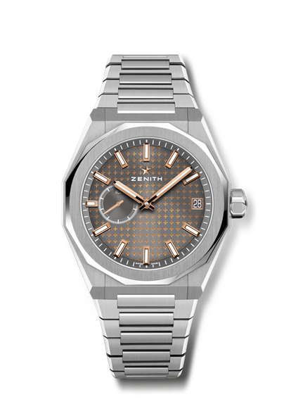
DEFY SKYLINE BOUTIQUE EDITION
Reference: 03.9300.3620/02.I001

Key points: El Primero 3-hand watch. High frequency indication: 1/10th of a second subdial at 9 o'clock. Silicon escape-wheel and lever. Starry sky pattern on the dial. Screwed-in crown. Full Interchangeable strap system.
Movement: El Primero 3620
Frequency 36,000 VpH (5 Hz)
Power reserve approx. 60 hours
Functions: Hours and minutes in the centre. 1/10th of a second indication at 9 o'clock. Date indication at 3 o'clock
Finishes: Special oscillating weight with satined finishings.
Price 8900 CHF
Material: Stainless steel
Water resistance: 10 ATM
Case: 41mm
Dial: Slate-grey-toned sunray-patterned
Hour markers: Rhodium-plated, faceted and coated with SuperLuminova SLN C1
Hands: Gold-plated, faceted and coated with SuperLuminova SLN C1
Bracelet & Buckle: Stainless steel bracelet and folding clasp. Comes with a black rubber strap with starry sky pattern and folding clasp.

DEFY EXTREME GLACIER
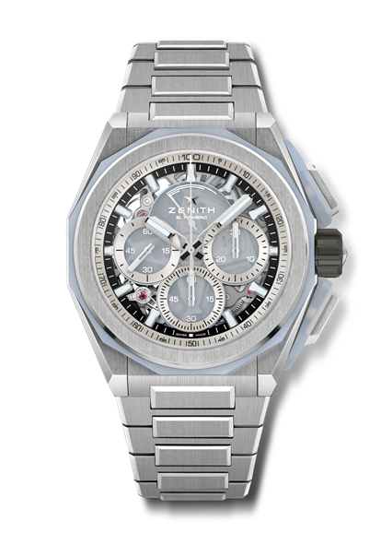
Reference: 95.9201.9004/25.I001

Key points: Pusher’s protectors & bezel made of Calcedony. Stronger, bolder and more powerful design. 1/100th of a second Chronograph movement. Exclusive dynamic signature of one rotation per second for the Chrono hand. 1 escapement for the Watch (36,000 VpH - 5 Hz) ; 1 escapement for the Chronograph (360,000 VpH - 50 Hz). Certified Chronometer. Screwed-in crown. Full Interchangeable strap system. 2 straps included: 1 Rubber with folding buckle & 1 Velcro. Sapphire dial.
Movement: El Primero 9004, automatic
Frequency 36,000 VpH (5 Hz)
Power reserve approx. 60 hours
Functions: Hours and minutes in the centre. Small seconds at 9 o'clock
1/100th of a second Chronograph: Central chronograph hand that makes one turn each second, 30-minute counter at 3 o'clock, 60-second counter at 6 o’clock, Chronograph power-reserve indication at 12 o'clock
Finishes: Special oscillating weight with satined finishings
Price 25900 CHF
Material: Brushed Titanium & Calcedony
Water resistance: 20 ATM
Case: 45 mm
Dial: Tinted sapphire with three silver-coloured counters
Hour markers: Rhodium-plated, faceted and coated with SuperLuminova SLN C1
Hands: Rhodium-plated, faceted and coated with SuperLuminova SLN C1
Bracelet & Buckle: Brushed titanium bracelet. Full Interchangeable strap system. 2 straps included: 1 White Rubber with folding buckle & 1 Velcro. Titanium Triple folding clasp.

