ZENITH WELCOMES DJ & MULTIMEDIA CREATIVE “KLAUS” AS ITS NEWEST FRIEND OF THE BRAND AT WATCHES & WONDERS PILOT PARTY

Geneva, March 29, 2023: During ZENITH’s Watches & Wonders party, held in the historical Brasserie des Halles de l’ile on the riverbank of the Rhône, the Manufacture celebrated the launch of its new Pilot collection by having its newest friend of the brand animate the evening: Italian DJ and content creator Tudor Laurini, better known as Klaus.

Artist, creator, storyteller and avid ZENITH collector, Klaus is part of a new generation of dream-chasers that have made it in the digital era. Klaus began his journey in his early teen years, where his passion for music pushed him to begin composing and recording electronic music. Beyond the music however, Klaus was compelled to share his adventures, emotions and experiences encountering other likeminded people from all over the world. So, in 2013, he began making videos to share his creative process, which in turn led him to learn all about video editing, graphics and 3D modelling. Before he knew it, Klaus had garnered a loyal following on YouTube and other platforms and became one of the most wide-reaching Italian personalities of his time.

Despite his early setbacks in trying to become a musical producer and DJ at such a young age, Klaus never gave up on his dreams. Without abandoning his traditional education, Klaus taught himself what it takes to become a successful music producer, documenting his progress for all to see. By creating an ever-growing YouTube channel and reaching people through his music as well as hic creative endeavours, Klaus reached his star by finding a way to incorporate all his different pursuits, without sacrificing his sincerity and values.

On what it means to reach his star, Klaus shared “Stars have always served as guides for humanity. To me, they represent a landmark in the night. Considering that the logo of my personal project, Wanderlust Vision, is a star and our claim is “a strong desire to wander”, my mission as a human being is to keep traveling mentally and physically, absorbing knowledge and being inspired by the world outside. The idea of getting close to the stars takes me on a constant journey towards the future, accepting daily challenges and stimulating minds.”

When he’s not in the music studio or behind a set of turntables, Klaus manages his “Wanderlust Vision” project, which combines his many passions across multiple sectors in a constant dialogue between tradition and innovation. The aim of Wanderlust Vision is to inform and promote culture around the concept of travel as an experience to grow and learn, by merging multiple environments such as music, cuisine, art, sport, clothing and more. The collaborations and uniquely immersive experiences that the project offers have allowed Klaus to build bridges connecting his different pursuits, allowing him to reach an even larger audience and bring people out of their comfort zones and keep discovering new horizons.

Watchmaking is also a source of fascination that was instilled early on in Klaus’ upbringing. “Since I was a child, my father passed on to me the passion for watchmaking and for all the little things behind this world full of heritage. Being curious by nature, I’m fascinated by how things work and, specifically, how those small mechanisms are able to beat on time, define days and moon phases, and always in the pursuit of perfection. Culture, research and learning are lifetime drivers that give me the energy and the opportunity to be innovative and go beyond the schemes and the ordinary. I’m really proud to join the ZENITH family as a friend of the brand since I feel a real emotional connection to the values that the Brand is fostering, from the conservation of craftsmanship and boundless innovation to the contemporary multimedia approach.”

Much of Klaus’ Wanderlust Vision projects revolve around the experience of travel, where the journeys and encounters are just as captivating as the destination; an approach perfectly echoed in the new ZENITH Pilot collection. Naturally, Klaus has chosen a ZENITH Pilot Big Date Flyback chronograph as his go-to timepiece. ZENITH looks forward to creating and sharing unique experiences with Klaus.

ZENITH: TIME TO REACH YOUR STAR.

ZENITH exists to inspire individuals to pursue their dreams and make them come true – against all odds. Since its establishment in 1865, ZENITH became the first vertically integrated Swiss watch manufacture, and its watches have accompanied extraordinary figures that dreamt big and strived to achieve the impossible – from Louis Blériot’s history-making flight across the English Channel to Felix Baumgartner’s record-setting stratospheric free-fall jump. Zenith is also highlighting visionary and trailblazing women by celebrating their accomplishments and creating the DREAMHERS platform where women share their experiences and inspire others to fulfil their dreams.

With innovation as its guiding star, ZENITH exclusively features in-house developed and manufactured movements in all its watches. Since the creation of the El Primero in 1969, the world’s first automatic chronograph calibre, ZENITH has gone on to master high-frequency precision and offers time measurements in fractions of a second, including 1/10th of a second in the Chronomaster collection and 1/100th of a second in the DEFY collection. Because innovation is synonymous with responsibility, the ZENITH HORIZ-ON initiative affirms the brand's commitments to inclusion & diversity, sustainability and employee wellbeing. ZENITH has been shaping the future of Swiss watchmaking since 1865, accompanying those who dare to challenge themselves and reach new heights. The time to reach your star is now.

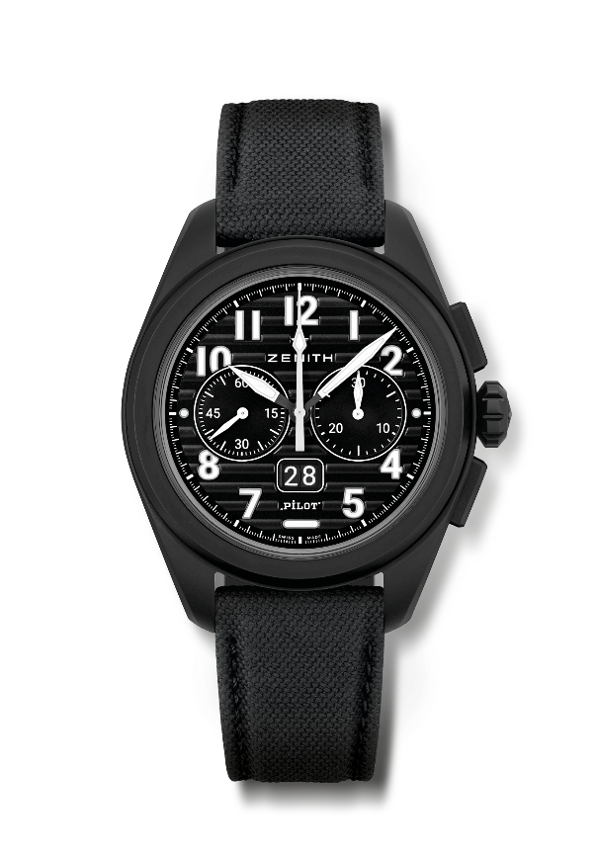
PILOT BIG DATE FLYBACK
Reference: 49.4000.3652/21.I001

Key points: Automatic El Primero column-wheel chronograph with flyback function. Patented Big Date at 6 o'clock. Instanteanous Big Date jump in 0.007 sec (0.02 for discs jump & stabilization). Fully Interchangeable strap system
Movement: El Primero 3652, automatic
Frequency 36,000 VpH (5 Hz)
Power reserve approx. 60 hours
Functions : Hours and minutes in the centre. Small seconds at 9 o'clock
Instantaneous Big Date at 6 o'clock. Flyback Chronograph. 30-minute counter at 3 o'clock
Finishes: Special "Pilot artificial horizon" black oscillating weight
Price 13400 CHF
Material: Black microblasted ceramic
Water resistance: 10 ATM
Case: 42.5mm
Dial: Black with horizontal grooves
Hour markers: Applied arabic numerals in SuperLuminova SLN C1
Hands : Black & white with SLN C1
Bracelet & Buckle: Comes with 2 straps: Black cordura effect rubber strap and a khaki cordura effect strap. Steel with black PVD coating triple folding clasp.

