ZENITH PRESENTS THE DEFY REVIVAL SHADOW, GIVING THE ORIGINAL DEFY SILHOUETTE AN UNEXPECTEDLY MODERN MAKEOVER

For its latest addition to the DEFY Revival collection, ZENITH imagines an alternate possibility for the very first DEFY silhouette from 1969 in a decidedly modern and stealthy rendition. While there is some historical precedent for blacked-out ZENITH watches, which the manufacture produced in very small numbers as working prototypes as far as back as 1970, the DEFY Revival Shadow is a modern creation in a vintage silhouette. In the same vein as the Chronomaster Revival Shadow that precedes it, the DEFY Revival Shadow creatively blends the historic model’s heritage with a contemporary accent through dark tones and muted textures.

Beginning with the A3642 in 1969, the DEFY’s signature angular steel case stood out with its brightly polished and satin-brushed surfaces. The DEFY Revival Shadow however takes on a decidedly muted and monolithic look. Crafted in titanium, a metal lauded for its light weight yet impressive durability and resistance to corrosion, the highly angular DEFY Revival case with its fourteen-sided bezel is entirely microblasted for a matte finish, revealing the dark grey tone of titanium and enhancing the geometry of the singular and instantly recognizable case. For a design that dates back to 1969, such a modern choice of tones and textures further emphasizes just how ahead of its time ZENITH was with the DEFY line. In fact, the silhouette remains utterly contemporary and literally edgy decades later.

A first for ZENITH and its iconic “ladder” bracelet, which was originally conceived by the famed Gay Frères company exclusively for the brand in 1969, the links and clasp are crafted in titanium, and finished with the same matte texture as the case. The light weight of titanium further enhances the comfort and ergonomics of this time-tested bracelet. It is fitted on an updated folding clasp with a more ergonomic and streamlined feel.

Almost paradoxical, considering that the original DEFY line of wristwatches prominently featured vibrant dial colours and striking gradient effects, the DEFY Revival Shadow’s dial is matte black with a distinctly vintage look. The hands, filled with a cream-coloured Super-LumiNova pigment, as well as the applied square hour markers with horizontal grooves are polished and finished in rhodium for optimum legibility.

Visible through the sapphire display back, which does not compromise the case’s impressive water-resistance of 30ATM (300 metres), the automatic Elite 670 manufacture movement operates at a frequency of 4 Hz (28,800 VpH) with a power reserve of 50 hours.

The DEFY Revival Shadow demonstrates how the historical DEFY’s uncanny form was so singular and far ahead of its time; just as relevant today as it was in 1969.

The DEFY Revival Shadow is available from ZENITH physical and online boutiques as well as authorized retailers around the world.

ZENITH: TIME TO REACH YOUR STAR.

ZENITH exists to inspire individuals to pursue their dreams and make them come true – against all odds. Since its establishment in 1865, ZENITH became the first vertically integrated Swiss watch manufacture, and its watches have accompanied extraordinary figures that dreamt big and strived to achieve the impossible – from Louis Blériot’s history-making flight across the English Channel to Felix Baumgartner’s record-setting stratospheric free-fall jump. Zenith is also highlighting visionary and trailblazing women by celebrating their accomplishments and creating the DREAMHERS platform where women share their experiences and inspire others to fulfil their dreams.

With innovation as its guiding star, ZENITH exclusively features in-house developed and manufactured movements in all its watches. Since the creation of the El Primero in 1969, the world’s first automatic chronograph calibre, ZENITH has gone on to master high-frequency precision and offers time measurements in fractions of a second, including 1/10th of a second in the Chronomaster collection and 1/100th of a second in the DEFY collection. Because innovation is synonymous with responsibility, the ZENITH HORIZ-ON initiative affirms the brand's commitments to inclusion & diversity, sustainability and employee wellbeing. ZENITH has been shaping the future of Swiss watchmaking since 1865, accompanying those who dare to challenge themselves and reach new heights. The time to reach your star is now.

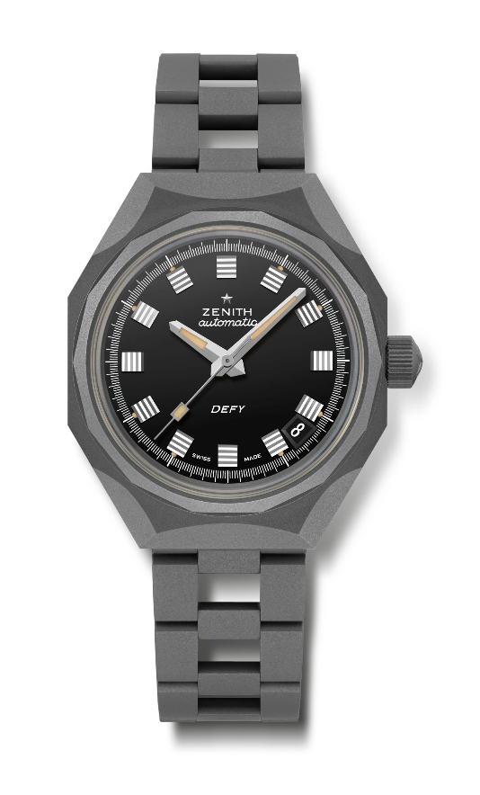
DEFY REVIVAL SHADOW
Reference: 97.A3642.670/21.M3642

Key points: Shadow version (Microblasted titanium) of the original DEFY Octogonal case with iconic 14-sided bezel
Movement: Elite 670, Automatic
Frequency 28,800 VpH (4 Hz)
Power reserve approx. 50 hours
Functions : Hours and minutes in the centre. Central seconds hand. Date indication at 4:30.
Finishes: New star-shaped oscillating weight with satined finishings
Price 7400 CHF
Material: Microblasted titanium
Water resistance: 30 ATM
Case: 37 mm
Dial: Black
Hour markers: Rhodium-plated, faceted
Hands: Rhodium-plated, faceted and coated with Beige SuperLuminova
Bracelet & Buckle: Micoblasted titanium "Ladder" bracelet

