BOLDER IN BLACK: THE DEFY SKYLINE & DEFY SKYLINE SKELETON
NOW IN BLACK CERAMIC

Clad entirely in black ceramic, the DEFY Skyline and DEFY Skyline Skeleton take on a distinct aura of their own. At once brilliant, bold and sleek, the collection’s modernistic form takes on a decidedly dark look that’s as visually outstanding as it is resilient.

Introduced in 2022 as the modern successor to the ZENITH DEFY line of rugged and boldly designed wristwatches from 1969, the DEFY Skyline collection builds on its legacy with the same singular edginess and a new level of performance from the Manufacture’s latest generation of the seminal El Primero high-frequency calibre. The collection’s two main pillars – the DEFY Skyline and DEFY Skyline Skeleton – now take on alluring blacked-out look with two new references crafted entirely in black ceramic – including the bracelet.

Much harder than traditional metals and alloys like stainless steel, ceramic boasts many properties that make it a compelling choice for all-situations watches like the DEFY Skyline and DEFY Skyline Skeleton. Its extreme hardness, which requires diamond-tipped tools to cut the sharp lines of the DEFY Skyline and decorate it with a mix of satin-brushed and polished surfaces, makes ceramic highly resistant to scratches and visible wear. Unlike blackened metal elements which are simply plated, the ceramic itself is black and will never wear off. Even the integrated bracelet that follows the contours of the case is crafted in black ceramic. A black patterned rubber strap with a blackened steel folding clasp is also included, and swapping between it and the ceramic bracelet is effortless using the quick strap-change mechanism integrated directly in the case back.

The DEFY Skyline Ceramic features a black galvanic dial with a sunray finish, shimmering as the light hits its surface. The entire dial features a geometric pattern, consisting of the ZENITH four-pointed stars that historically featured prominently on the case backs of vintage DEFY references as a “double Z”. Evoking the starry night sky, the blackened star-shaped sunken into the dial feature sharp inward facets, with different angles catching light.

For the DEFY Skyline Skeleton Ceramic, the open dial features a blackened large central four-pointed star element, revealing the skeleton movement with black bridges and main plate. An exceptional feat, the Manufacture’s engineers successfully incorporated the shape of the open dial into the skeletonisation of the movement’s bridges and main plate, forming an integral whole. With its subtle contrast of dark tones, the visual depth further enhanced in this unique skeleton watch with a 1/10th of a second indicator. Both the DEFY Skyline Ceramic and DEFY Skyline Skeleton Ceramic feature faceted polished hands and applied indices filled with white Super-LumiNova for effortless readability - day and night.

Both references are powered by the El Primero 3620 automatic high-frequency manufacture movement, beating at the rate of 5Hz (36’000VpH), providing a 1/10th of a second indicator directly driven by the escapement. Its efficient automatic bi-directional winding mechanism with a blackened star-shaped rotor delivers a power reserve of approximately 60 hours.

With these two new references, the DEFY Skyline welcomes a cutting-edge material that offers the singular silhouette an intriguingly dark facet to be discovered.
The DEFY Skyline and DEFY Skyline Skeleton are available from ZENITH physical and online boutiques, as well as authorized ZENITH retailers around the world.

ZENITH: TIME TO REACH YOUR STAR.

ZENITH exists to inspire individuals to pursue their dreams and make them come true – against all odds. Since its establishment in 1865, ZENITH became the first vertically integrated Swiss watch manufacture, and its watches have accompanied extraordinary figures that dreamt big and strived to achieve the impossible – from Louis Blériot’s history-making flight across the English Channel to Felix Baumgartner’s record-setting stratospheric free-fall jump. Zenith is also highlighting visionary and trailblazing women by celebrating their accomplishments and creating the DREAMHERS platform where women share their experiences and inspire others to fulfil their dreams.

With innovation as its guiding star, ZENITH exclusively features in-house developed and manufactured movements in all its watches. Since the creation of the El Primero in 1969, the world’s first automatic chronograph calibre, ZENITH has gone on to master high-frequency precision and offers time measurements in fractions of a second, including 1/10th of a second in the Chronomaster collection and 1/100th of a second in the DEFY collection. Because innovation is synonymous with responsibility, the ZENITH HORIZ-ON initiative affirms the brand's commitments to inclusion & diversity, sustainability and employee wellbeing. ZENITH has been shaping the future of Swiss watchmaking since 1865, accompanying those who dare to challenge themselves and reach new heights. The time to reach your star is now.

DEFY SKYLINE BLACK CERAMIC
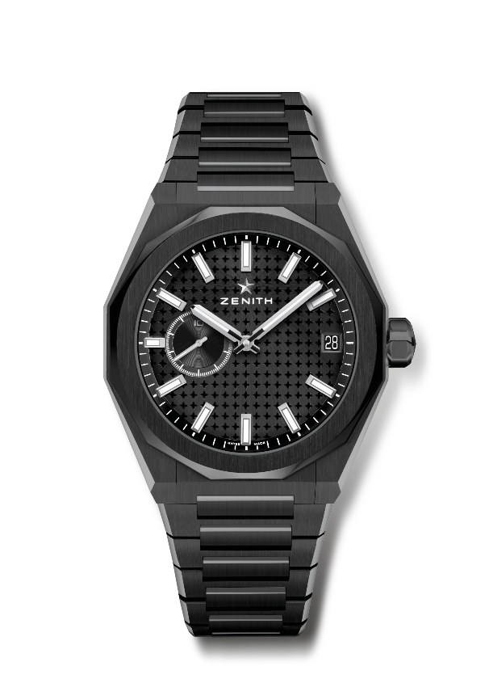
Reference: 49.9300.3620/21.I001

Key points: El Primero 3-hand watch. High frequency indication: 1/10th of a second subdial at 9 o'clock. Silicon escape-wheel and lever. Starry sky pattern on the dial. Screwed-in crown. Full Interchangeable strap system.
Movement: El Primero 3620, Automatic
Frequency 36,000 VpH (5 Hz)
Power reserve approx. 60 hours
Functions: Hours and minutes in the centre. 1/10th of a second indication at 9 o'clock. Date indication at 3 o'clock.
Finishes: Special oscillating weight with satined finishings.
Price 14900 CHF
Material: Black Ceramic
Water resistance: 10 ATM
Case: 41mm
Dial: Black-toned sunray-patterned
Hour markers: Rhodium-plated, faceted and coated with SuperLuminova SLN C1
Hands: Rhodium-plated, faceted and coated with SuperLuminova SLN C1
Bracelet & Buckle: Black Ceramic bracelet and folding clasp. Comes with a black rubber strap with starry sky pattern and with a black PVD stainless buckle with folding clasp.

DEFY SKYLINE BLACK CERAMIC SKELETON
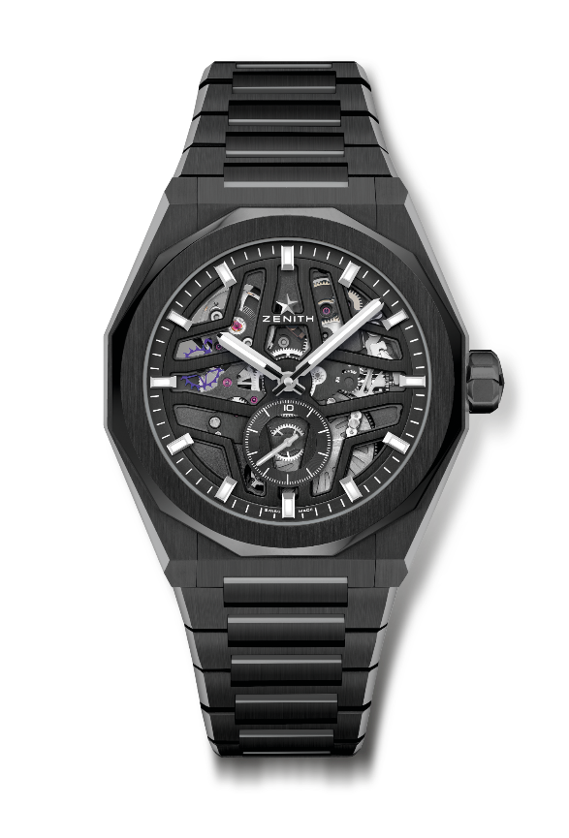
Reference: 49.9300.3620/78.I001

Key points: El Primero 3-hand watch. High frequency indication: 1/10th of a second subdial at 6 o'clock. Silicon escape-wheel and lever. Screwed-in crown. Full Interchangeable strap system.
Movement: El Primero 3620, Automatic
Frequency 36,000 VpH (5 Hz)
Power reserve approx. 60 hours
Functions: Hours and minutes in the centre. 1/10th of a second indication at 6 o'clock.
Finishes: Special oscillating weight with satined finishings.
Price 16900 CHF
Material: Black Ceramic
Water resistance: 10 ATM
Case: 41mm
Dial: Openworked
Hour markers: Rhodium-plated, faceted and coated with SuperLuminova SLN C1
Hands: Rhodium-plated, faceted and coated with SuperLuminova SLN C1
Bracelet & Buckle: Black Ceramic bracelet and folding clasp. Comes with a black rubber strap with starry sky pattern and with a black PVD stainless buckle with folding clasp.

