ZENITH UNVEILS A UNIQUE BOX SET OF THE FOUR DEFY EXTREME E LIMITED EDITIONS IN NEOM SAUDI ARABIA

The third season of EXTREME E is set to start this weekend in NEOM, promising to be even more action-packed than ever. To mark the occasion, ZENITH is offering the rare opportunity to acquire all four DEFY Extreme E Season 2 pieces numbered 0/20 in a one-of-a-kind box set.

Ahead of the debut of the 2023 Extreme E championship, which ZENITH is proudly continuing to support as its Official Timekeeper and Founding Partner, the Manufacture is offering a unique opportunity to acquire all four editions of the DEFY Extreme E pieces in a single boxed set – all bearing the special limited edition number of “0/20”. Crafted in lightweight yet rugged carbon fibre and titanium and featuring the high-frequency 1/100th of a second El Primero 21 movement, each of the four pieces bears the official colours of a championship race: Yellow for Desert X Prix, orange for Island X Prix, purple for Energy X Prix and coppery-brown for Copper X Prix.

Bringing sustainability and environmental awareness to the forefront of ZENITH and Extreme E’s partnership, the DEFY Extreme E limited editions are delivered with a rubber strap infused with materials of upcycled Continental CrossContact tires that were used in the first season’s races. These four watches come packaged in a suitably sturdy waterproof and crushproof watch case inspired by the extreme conditions of the rally, incorporating various upcycled elements from the side-lines of the first season’s races. The case’s lid coating is made from E-grip recycled tires, while the plate covering is made from parts of an Extreme E racing tarpaulin.

In addition to the box set, the buyer will receive rare collectibles and gain access to unique experiences, including a helmet from season 2 signed by Extreme E teams and drivers. An invitation to one race from the upcoming Extreme E 2023 season is also offered as part of the set, complete with a VIP pass and accommodation aboard the St Helena ship for one night. The buyer will also have the opportunity to spend time with Extreme E founder Alejandro Agag and ZENITH CEO Julien Tornare on the sidelines of the race.

Indeed, the buyer of the unique box set is in for an exceptional treat, as this season of Extreme E is shaping up to be the most exciting one yet. With a new format featuring back-to-back championship races in each location, Extreme E is also welcoming new teams to the competition – including ZENITH friend of the brand Carl Cox’s own team. An avid racing fan, Carl Cox was amazed by what he discovered when he attended the Island X Prix in Sardinia last year. Committed to the cause of Extreme E and fascinated by the thrill of the off-road rallies, the internationally acclaimed DJ decided to establish an Extreme E division within Carl Cox Motorsport, which is already active in other fields like motorcycle and drag racing.

For the first race of the season, Extreme E will once again return to the emerging futuristic city NEOM for the double-header Desert X Prix. Modelled as a template for future sustainable developments, NEOM is located on the north-western coast of the Kingdom of Saudi Arabia and features a unique topography of coastline,
desert and mountainous terrain that will undoubtedly put the Extreme E drivers’ skills to the test in the thrilling season opener.

Resuming its role of Official Timekeeper and Founding Partner, ZENITH CEO Julien Tornare shared “After the incredible adventures we got to experience around the world last year, we’re all so excited to see what Extreme E has in store for us in its third championship. By returning to NEOM, we also get to witness the progress made on the various Legacy Programme actions we began with Extreme E last year, which aim to mitigate the effects of climate change and desertification in this region by rewilding and regreening the desert. ZENITH has got a lot of surprises planned with Extreme E this year, and we can’t wait to share them with you as we make our way through the season.”

Like all Extreme E races held so far, sustainability and environmental awareness are very much at the core of the innovative rally racing championship. Its Legacy Programme’s activities and initiatives are tailored specifically for each destination. For the Desert X Prix in NEOM, a unique set of challenges are presented, Extreme E will be picking up right where it left off on its rewilding project from last year, including the introduction of the Arabian Oryx, Arabian Sand Gazelles and Red Neck Ostriches into the region.

Extreme E will also continue its work in a major regreening initiative by planting yet more trees in the region. Through the establishment of a world-class protected area, the mission is to preserve 95 per cent of NEOM's land and sea for nature, and implement a science-based program of protection, restoration, and rewilding.

The Extreme E Desert X Prix races will take place in NEOM on March 11-12, 2023.

ZENITH: TIME TO REACH YOUR STAR.

ZENITH exists to inspire individuals to pursue their dreams and make them come true – against all odds. Since its establishment in 1865, ZENITH became the first vertically integrated Swiss watch manufacture, and its watches have accompanied extraordinary figures that dreamt big and strived to achieve the impossible – from Louis Blériot’s history-making flight across the English Channel to Felix Baumgartner’s record-setting stratospheric free-fall jump. Zenith is also highlighting visionary and trailblazing women by celebrating their accomplishments and creating the DREAMHERS platform where women share their experiences and inspire others to fulfil their dreams.

With innovation as its guiding star, ZENITH exclusively features in-house developed and manufactured movements in all its watches. Since the creation of the El Primero in 1969, the world’s first automatic chronograph calibre, ZENITH has gone on to master high-frequency precision and offers time measurements in fractions of a second, including 1/10th of a second in the Chronomaster collection and 1/100th of a second in the DEFY collection. Because innovation is synonymous with responsibility, the ZENITH HORIZ-ON initiative affirms the brand's commitments to inclusion & diversity, sustainability and employee wellbeing. ZENITH has been shaping the future of Swiss watchmaking since 1865, accompanying those who dare to challenge themselves and reach new heights. The time to reach your star is now.

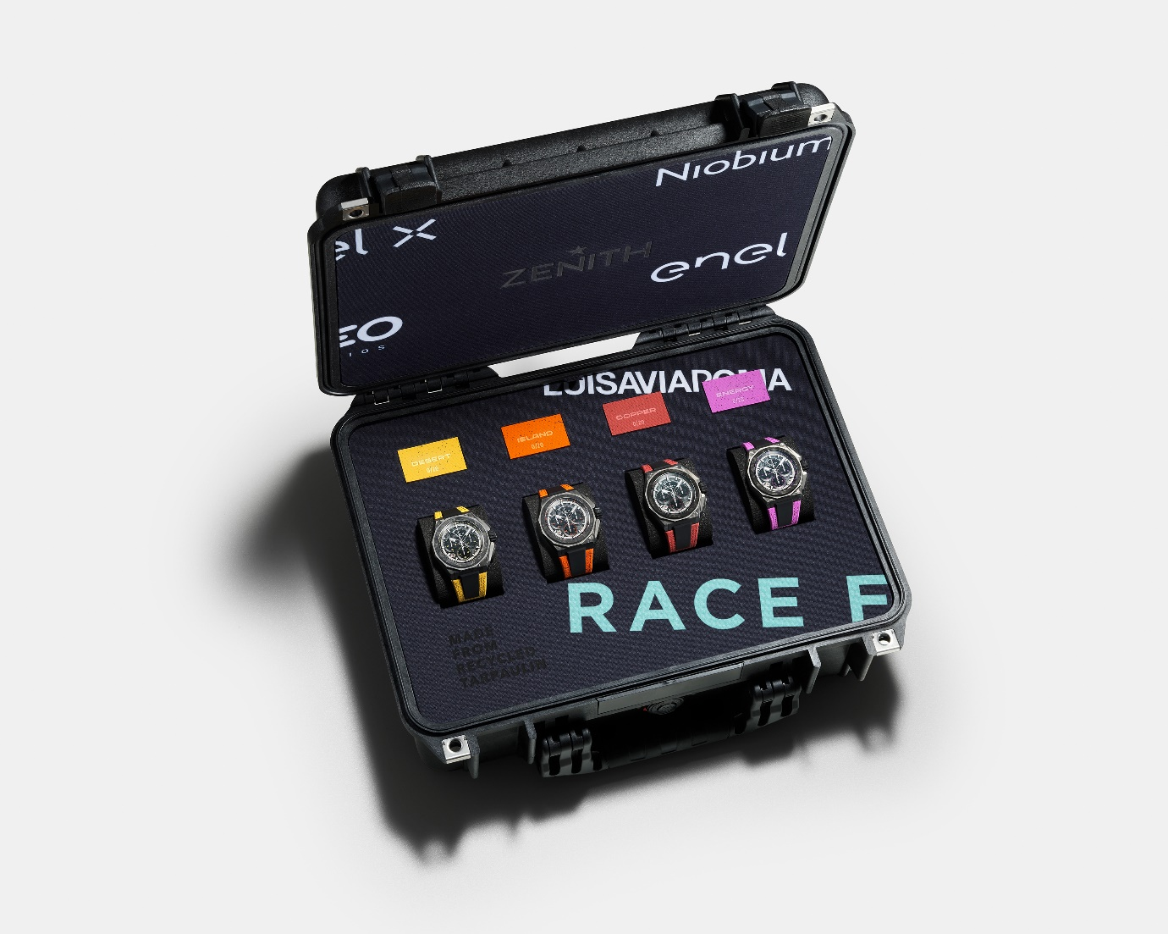

DEFY EXTREME E “DESERT X PRIX” EDITION
Reference: 10.9100.9004-1/23.I303

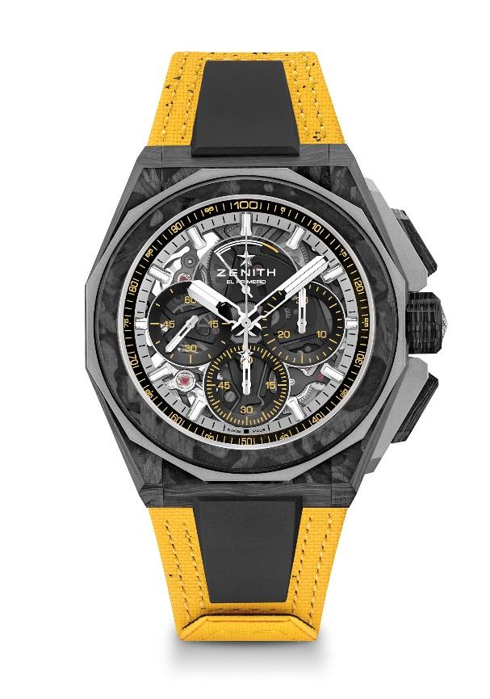
Key points: Extreme E capsule collection. Stronger, bolder and more powerful design. 1/100th of a second Chronograph movement. Exclusive dynamic signature of one rotation per second for the Chrono hand. 1 escapement for the Watch (36,000 VpH - 5 Hz) ; 1 escapement for the Chronograph (360,000 VpH - 50 Hz)
Screwed-in crown. Full Interchangeable strap system. Yellow Recycled tires Velcro Strap. Sapphire dial. 2 straps included: 1 Rubber strap with a black microblasted titanium folding buckle & 1 Velcro strap with carbon buckle.
Movement: El Primero 9004 automatic
Frequency 36,000 VpH (5 Hz)
Power reserve min. 50 hours
Functions : 1/100th of a second chronograph functions. Chronograph power-reserve indication at 12 o'clock. Hours and minutes in the centre. Small seconds at 9 o'clock, Central chronograph hand that makes one turn each second, 30-minute counter at 3 o'clock, 60-second counter at 6 o'clock
Finishes: Black colored main plate on movement + Special black colored
oscillating weight with satined finishings
Price: 26900 CHF
Material: Carbon & Microblasted Titanium
Water resistance: 20 ATM
Case: 45mm. Special engraving on case back with “Desert X Prix” logo
Dial: Tinted sapphire with three black-coloured counters
Hour markers: Rhodium-plated, faceted and coated with " SuperLuminova SLN C1
Hands : Rhodium-plated, faceted and coated with " SuperLuminova SLN C1
Bracelet & Buckle: Yellow Velcro bracelet made with parts of Continental recycled tires. Also comes with a black Velcro strap and a black rubber strap.

DEFY EXTREME E “ISLAND X PRIX” EDITION
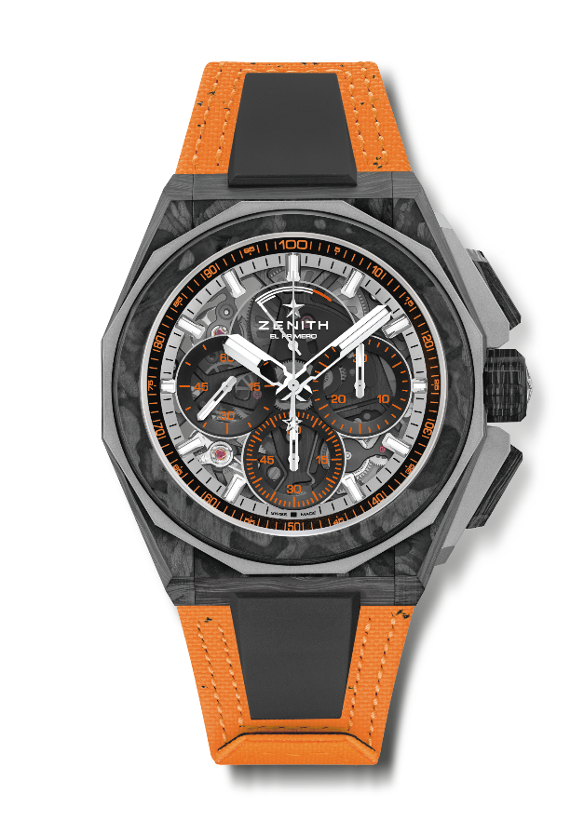
Reference: 10.9100.9004-4/26.I305

Key points: Extreme E capsule collection. Stronger, bolder and more powerful design. 1/100th of a second Chronograph movement. Exclusive dynamic signature of one rotation per second for the Chrono hand. 1 escapement for the Watch (36,000 VpH - 5 Hz) ; 1 escapement for the Chronograph (360,000 VpH - 50 Hz)
Screwed-in crown. Full Interchangeable strap system. Orange Recycled tires Velcro Strap. Sapphire dial. 2 additional straps included: 1 Rubber strap with a black microblasted titanium folding buckle & 1 Velcro strap with carbon buckle.
Movement: El Primero 9004 automatic
Frequency 36,000 VpH (5 Hz)
Power reserve min. 50 hours
Functions : 1/100th of a second chronograph functions. Chronograph power-reserve indication at 12 o'clock. Hours and minutes in the centre. Small seconds at 9 o'clock, Central chronograph hand that makes one turn each second, 30-minute counter at 3 o'clock, 60-second counter at 6 o'clock
Finishes: Black colored main plate on movement + Special black colored
oscillating weight with satined finishings
Price: 26900 CHF
Material: Carbon & Microblasted Titanium
Water resistance: 20 ATM
Case: 45mm. Special engraving on case back with “Island X Prix” logo
Dial: Tinted sapphire with three black-coloured counters
Hour markers: Rhodium-plated, faceted and coated with SuperLuminova SLN C1
Hands : Rhodium-plated, faceted and coated with SuperLuminova SLN C1
Bracelet & Buckle: Orange Velcro bracelet made with parts of Continental recycled tires. Also comes with a black Velcro strap and a black rubber strap.

DEFY EXTREME E – COPPER X PRIX EDITION
Reference: 10.9100.9004-5/27. I307

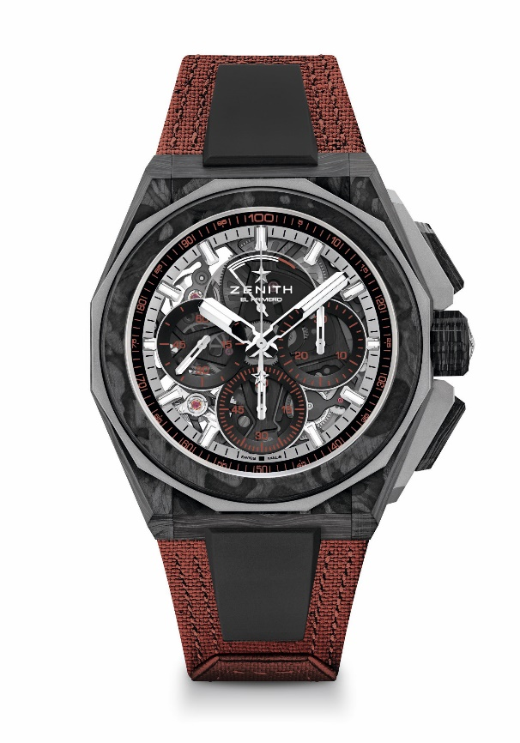
Key points: Extreme E Capsule collection. 1/100th of a second Chronograph movement. Exclusive dynamic signature of one rotation per second for the Chrono hand. 1 escapement for the Watch (36,000 VpH - 5 Hz); 1 escapement for the Chronograph (360,000 VpH - 50 Hz). Certified Chronometer. Sapphire dial
Movement: El Primero 9004
Frequency 36,000 VpH (5 Hz)
Power reserve min. 50 hours
Functions: Hours and minutes in the centre. Small seconds at 9 o'clock. 1/100th of a second Chronograph: Central chronograph hand that makes one turn each second. 30-minute counter at 3 o'clock. 60-second counter at 6 o'clock. Chronograph power-reserve indication at 12 o'clock
Finishes: Black colored main plate on movement + Special black colored oscillating weight with satined finishings
Price: 26900 CHF
Material: Carbon & Microblasted Titanium
Water resistance: 20 ATM
Case: 45mm. Transparent sapphire crystal caseback.
Dial: Tinted sapphire with three black-coloured counters
Hour markers: Rhodium-plated, faceted and coated with SuperLuminova SLN C1
Hands: Rhodium-plated, faceted and coated with SuperLuminova SLN C1
Bracelet & Buckle: Full Interchangeable strap system. Copper Recycled tires Velcro Strap and a 2nd strap included. Microblasted Titanium Triple folding clasp

DEFY EXTREME E – ENERGY X PRIX EDITION
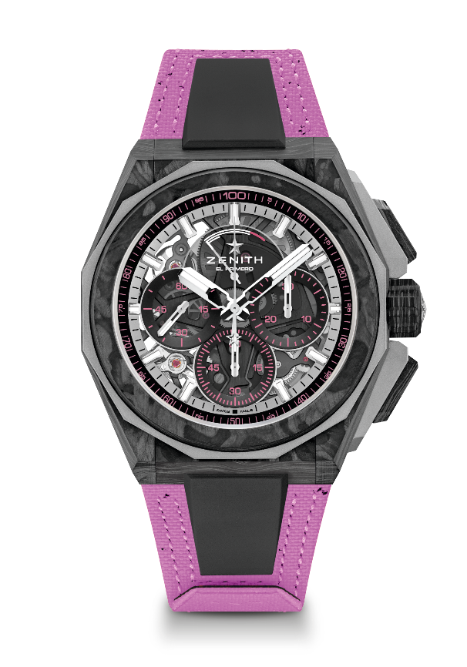
Reference: 10.9100.9004-2/24.I301
Key points: Extreme E Capsule collection. 1/100th of a second Chronograph movement. Exclusive dynamic signature of one rotation per second for the Chrono hand. 1 escapement for the Watch (36,000 VpH - 5 Hz); 1 escapement for the Chronograph (360,000 VpH - 50 Hz). Certified Chronometer. Sapphire dial. Limited edition of 20 pieces.
Movement: El Primero 9004
Frequency 36,000 VpH (5 Hz)
Power reserve min. 50 hours
Functions: Hours and minutes in the centre. Small seconds at 9 o'clock. 1/100th of a second Chronograph: Central chronograph hand that makes one turn each second. 30-minute counter at 3 o'clock. 60-second counter at 6 o'clock. Chronograph power-reserve indication at 12 o'clock
Finishes: Black colored main plate on movement + Special black colored oscillating weight with satined finishings
Price: 26900 CHF
Material: Carbon & Microblasted Titanium
Water resistance: 20 ATM
Case: 45mm. Transparent sapphire crystal caseback with Extreme E Energy X Prix engraving.
Dial: Tinted sapphire with three black-coloured counters
Hour markers: Rhodium-plated, faceted and coated with SuperLuminova SLN C1
Hands: Rhodium-plated, faceted and coated with SuperLuminova SLN C1
Bracelet & Buckle: Full Interchangeable strap system. Coming with a Energy X Prix Recycled tires Velcro Strap and a 2nd strap included. Microblasted Titanium Triple folding clasp.

